Software Architecture and Design Specification
Project: Customer Relationship Management: Reach, Acquire, Convert, Retain and Loyalty (CRM-RACRL)
Version: 1.0
Authors: Balla Santhosh, Dhriti Kamani, Disha Lokesh, Diya Agarwal (Section B, PES University RR Campus)
Date: 27-10-2026
Status: Submitted for review (baseline before Sprint 1)

Revision History
Version | Date | Author | Change Summary
0.1 | 22-10-2026 | Team | Architecture options and stack selection
1.0 | 27-10-2026 | Team | Complete SAD: component and class diagrams, 3 sequence diagrams, API design, STRIDE threat model

Approvals
Role | Name | Signature/Date
Course Coordinator
Team Lead
Architecture Owner

1. Introduction
1.1 Purpose
This document specifies the architecture and design of CRM-RACRL, a Customer Relationship Management system covering Reach, Acquire, Convert, Retain and Loyalty. It is the design baseline the team follows in Sprint 1 (27-31 Oct 2026) and Sprint 2 (2-7 Nov 2026).
1.2 Scope
Covers the web client, the REST API with its seven domain modules (Auth, Reach, Acquire, Convert, Retain, Loyalty, Analytics), the PostgreSQL data model, security architecture, deployment and the CI/CD pipeline. Real payment and messaging providers are out of scope and stubbed.
1.3 Audience
Developers, QA engineers, the course coordinator and evaluators, and anyone maintaining the system after the project.
1.4 Definitions
CRM, RBAC, JWT, ORM (Object-Relational Mapper), SPA (Single-Page Application), ADR (Architecture Decision Record), STRIDE, CI/CD, SLA, CLV, DPDP Act 2023.

2. Document Overview
2.1 How to use this document
Section 3 gives the architecture: goals, stakeholders, component and class diagrams, the chosen pattern, technology, risks, traceability and security. Section 4 gives the design: sequence diagrams for key flows, API definitions, error handling, logging, monitoring and UX. Requirement IDs (CRM-F, CRM-NF, CRM-SR) refer to the SRS.
2.2 Related Documents
Software Requirements Specification (SRS) v1.0, Software Test Plan (STP) v1.0, Requirements Traceability Matrix (in the SRS), Jira product backlog for Sprints 1 and 2.

3. Architecture
3.1 Goals & Constraints
Goals: one shared customer record across all five lifecycle stages; secure by default (server-side RBAC, validated input); p95 API latency under 500 ms; easy to build and test by four people in two weeks; automated, gated deployment. Constraints: two one-week sprints, free hosting tiers, DPDP Act 2023 consent rules, TypeScript skills of the team.
3.2 Stakeholders & Concerns
Sales and marketing users: speed, few clicks, accurate pipeline and campaign numbers
Support agents: complete Customer 360 view, SLA visibility
Customers: privacy of personal data, correct loyalty points
Business owner / management: reliable KPIs and funnel
Course evaluators: traceability, working CI/CD, documented deviations
Developers: modularity, clear module boundaries, fast local setup

3.3 Component (UML) Diagram
Figure 1 shows the main components arranged in layers. All requests from the web UI go through the API gateway, which checks the token, role and input before passing the call to one of the seven business modules. Modules read and write data only through the repository layer.
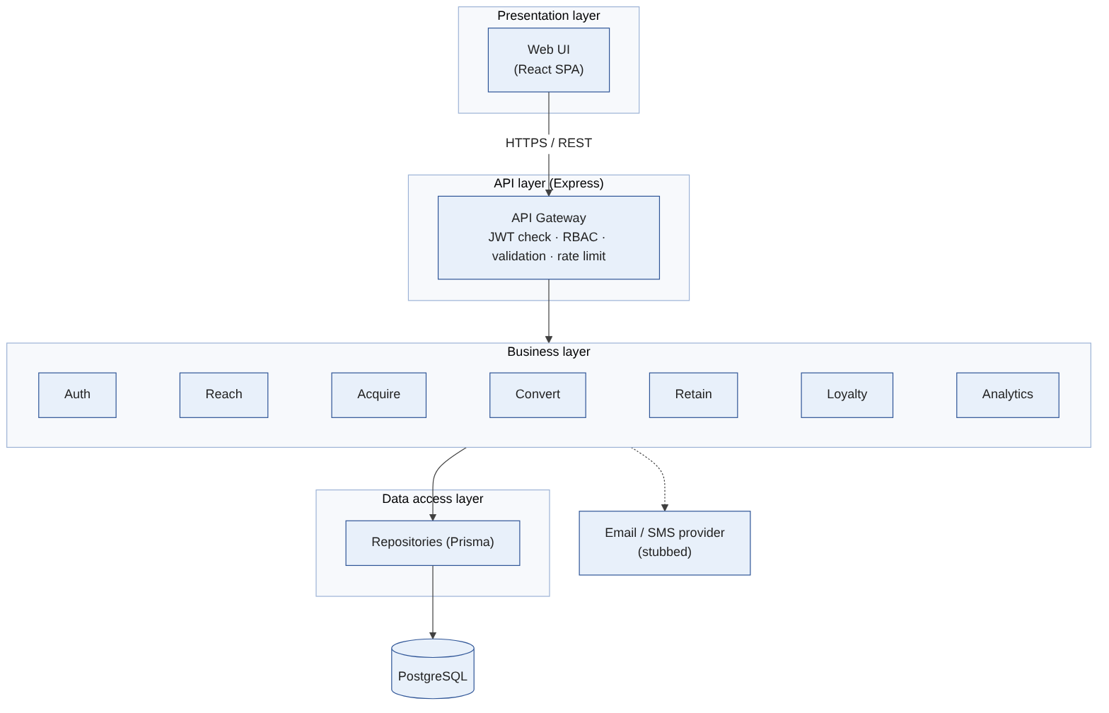
Figure 1: Component diagram (layered architecture)
Figure 2 is the class diagram for the core domain. Contact sits in the middle and links to deals, tickets, orders and loyalty points.
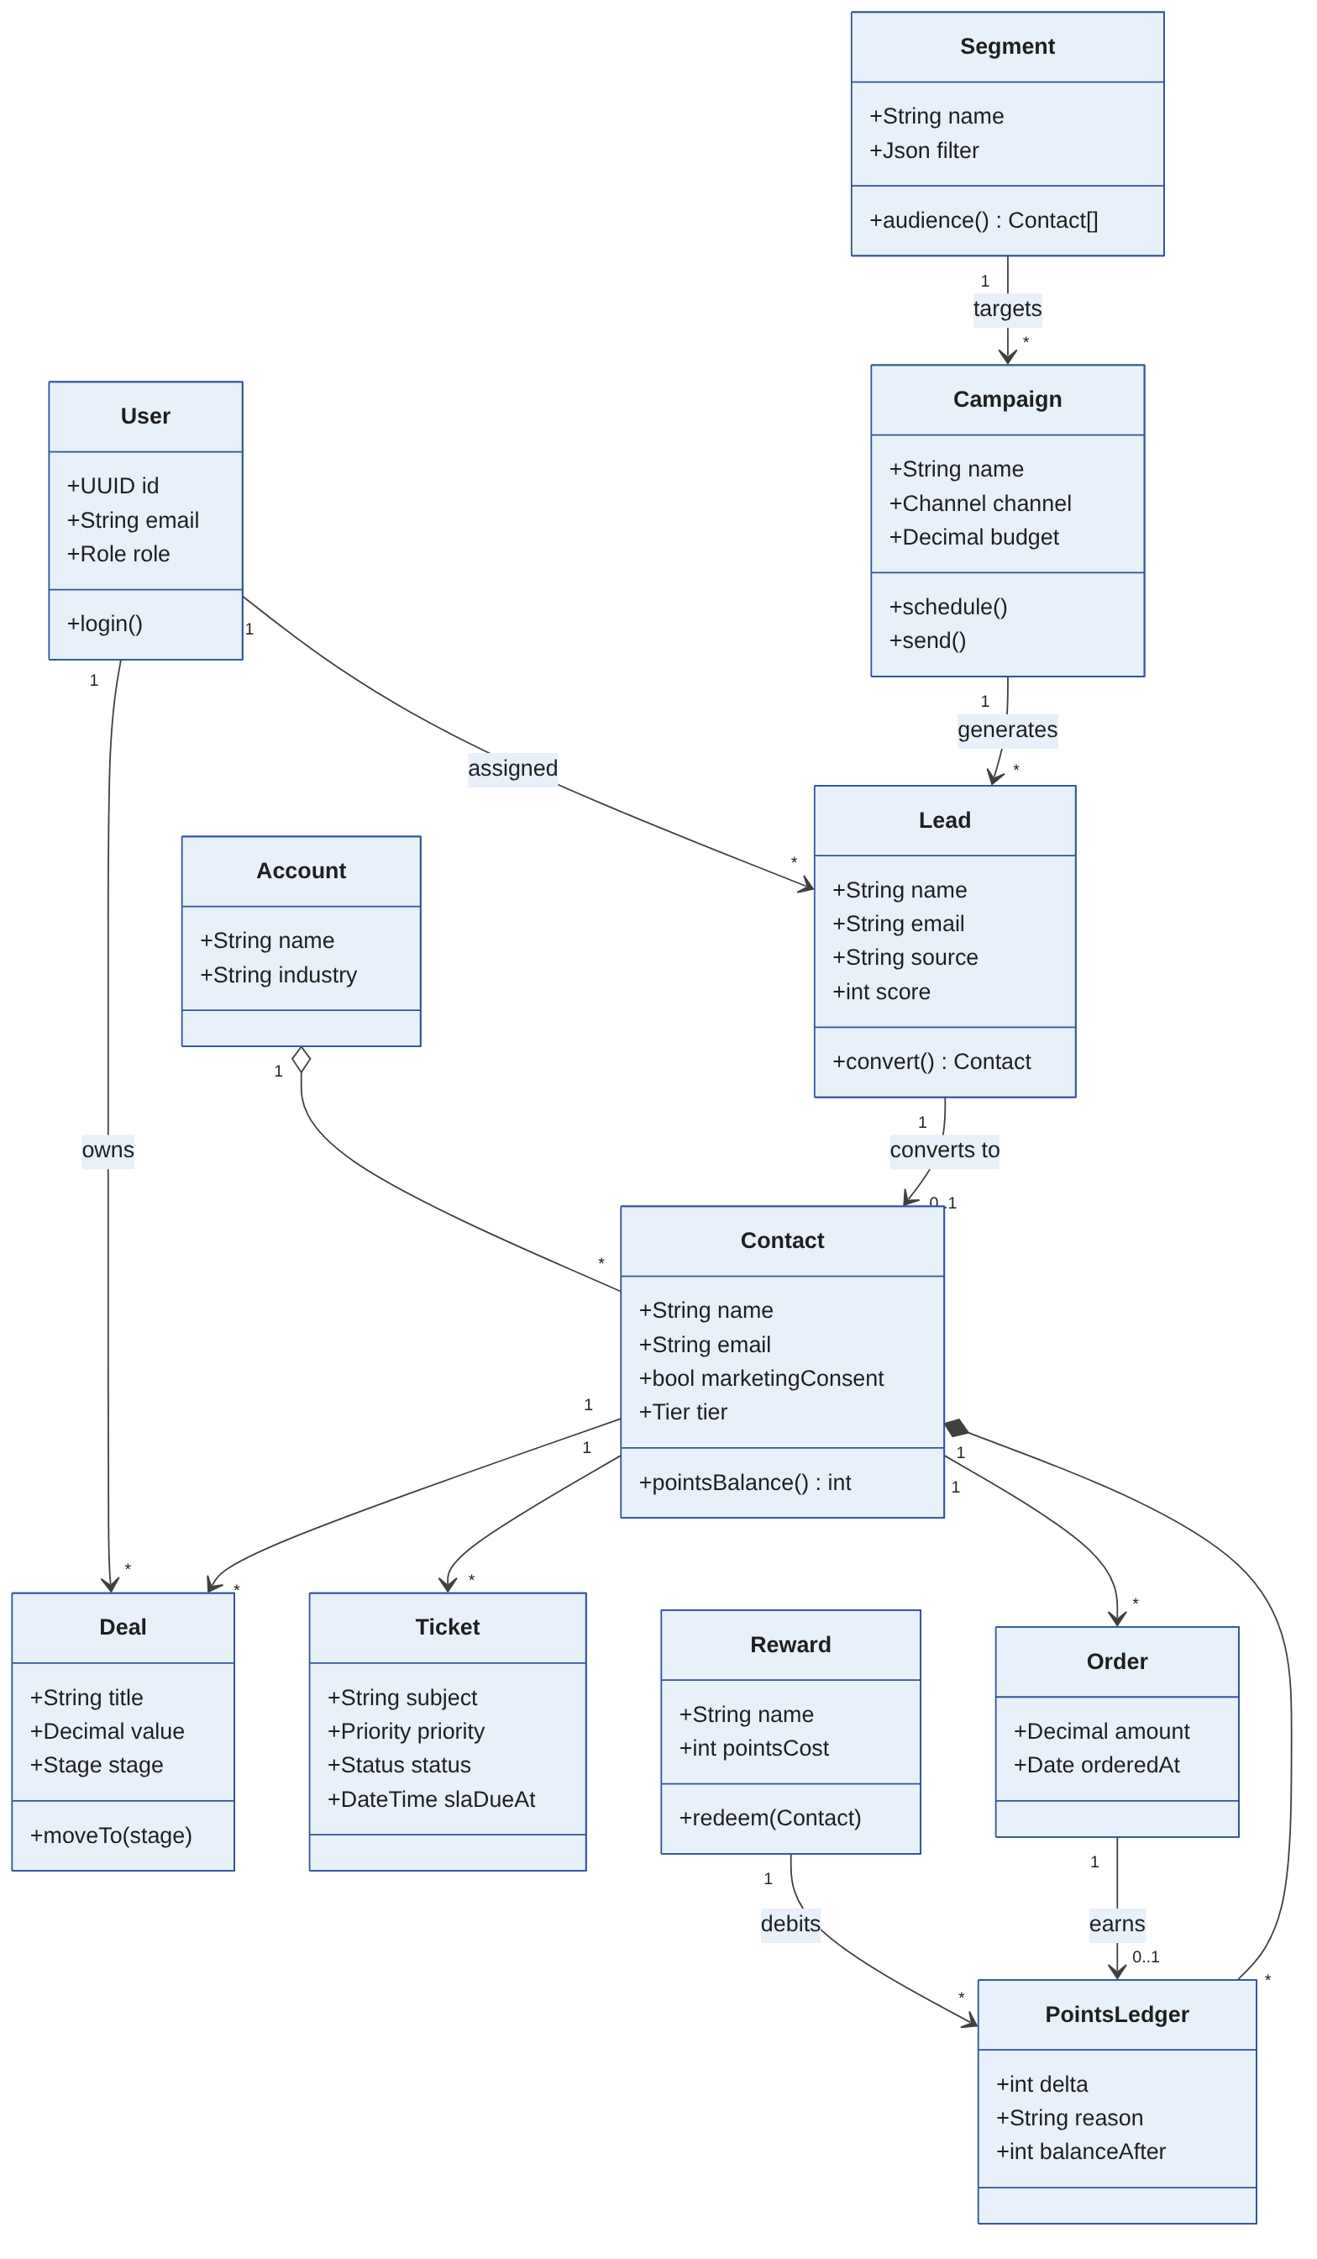
Figure 2: Class diagram (domain model)

3.4 Component Descriptions
Component | Responsibility | Main classes / tables | Requirements
React SPA | All screens, client-side validation, role-based route guards, Kanban board, dashboard charts | Pages per module, TanStack Query hooks | All FRs (UI), CRM-NF-004/005
Security Middleware | helmet headers, CORS, rate limiting, JWT verification, role checks, Zod schema validation | authenticate(), authorize(roles), validate(schema) | CRM-SR-001..006
Auth Module | Login, token issue, user administration | User, Role | CRM-F-001..003
Reach Module | Segments, campaigns, simulated sends, campaign metrics | Segment, Campaign, CampaignEvent | CRM-F-010..012
Acquire Module | Web-form and manual capture, CSV import, scoring, assignment | Lead, LeadScoreRule | CRM-F-020..023
Convert Module | Contacts, accounts, deals pipeline, lead conversion, activities, quotes | Contact, Account, Deal, Activity, Quote | CRM-F-030..034
Retain Module | Tickets and SLA, Customer 360 aggregation, churn-risk rule | Ticket | CRM-F-040..042
Loyalty Module | Orders, points ledger, tiers, rewards, redemption, referrals | Order, PointsLedger, Tier, Reward, Redemption, Referral | CRM-F-050..053
Analytics Module | KPIs, funnel, CSV export, global search, audit log viewer | AuditLog, read-only SQL views | CRM-F-060..064
Common | Logger (pino), error handler, pagination helper, audit hook | - | CRM-NF-006, CRM-F-064
Prisma ORM + PostgreSQL | Persistence, migrations, transactions, indexes | schema.prisma | CRM-NF-008/009
NotificationService | Interface for email/SMS; logging stub in this release | NotificationService | CRM-F-012

3.5 Chosen Architecture Pattern and Rationale
Pattern: a three-tier, layered modular monolith. Tier 1 is the React SPA; tier 2 is one Express API split into domain modules; tier 3 is PostgreSQL. Inside each module the layers are Router -> Controller -> Service -> Repository, and only the Service layer may be called by another module.
ADR | Decision | Alternatives considered | Rationale
ADR-1 | Layered modular monolith | Microservices; serverless functions | One deployable and one database suit four developers and two sprints; module boundaries keep the code organised and allow later extraction
ADR-2 | PostgreSQL (relational) | MongoDB | CRM data is highly relational; lead conversion and redemption need ACID transactions
ADR-3 | Append-only points ledger | Single balance column | Full history for audit, easy tier recalculation, prevents silent balance edits
ADR-4 | JWT (stateless) auth | Server sessions | Simple horizontal scaling and a clean API for the SPA
ADR-5 | Simulated campaign sends behind an interface | Real email/SMS provider | Out of scope and costly; a real adapter can be added without changing modules

3.6 Technology Stack & Data Stores
Layer | Technology
Frontend | React 18, Vite, TypeScript, Tailwind CSS, shadcn/ui, TanStack Query, React Router, React Hook Form + Zod, Recharts, dnd-kit
Backend | Node.js 20 LTS, Express, TypeScript, Zod, jsonwebtoken, bcrypt, helmet, express-rate-limit, pino
Data store | PostgreSQL 16 via Prisma ORM (migrations in Git); daily managed backups on Render
Testing | Jest + Supertest, Vitest + React Testing Library, Playwright, k6, Lighthouse CI, OWASP ZAP
DevOps | Docker, Docker Compose, GitHub Actions (CI and CD), GitHub Container Registry, Vercel (web), Render (API + DB)
Project management | Jira Software (Scrum board, burndown) linked to GitHub with the GitHub for Jira app

3.7 Risks & Mitigations
Risk | Impact | Mitigation
Free-tier hosting sleeps or is slow | Demo or performance tests affected | Warm-up request before demos and k6 runs; health monitor; record tier in results
Short sprints leave features unfinished | Must requirements missed | Must items scheduled first; Low items (quote, referral, audit, churn) dropped first and logged as deviations
Partial writes during conversion or redemption | Inconsistent data, negative points | Database transactions with row locks; tests TC-CONV-06 and TC-OPS-04
Secrets leaked in repository | Account compromise | Secrets only in GitHub/Render/Vercel settings; .env in .gitignore; secret scanning enabled
Broken build deployed | Demo URL down | CI gate with branch protection; smoke test and automatic rollback in CD

3.8 Traceability to Requirements
Each functional requirement group maps to one module; NFRs and security requirements map to cross-cutting components.
Requirements | Component / design element
CRM-F-001..003 | Auth Module, Security Middleware
CRM-F-010..012 | Reach Module, NotificationService
CRM-F-020..023 | Acquire Module (public lead endpoint)
CRM-F-030..034 | Convert Module (Sequence Diagram 1 for CRM-F-032)
CRM-F-040..042 | Retain Module
CRM-F-050..053 | Loyalty Module (Sequence Diagram 2 for CRM-F-052)
CRM-F-060..064 | Analytics Module, Common audit hook
CRM-NF-001, 002, 008 | Pagination, indexes, aggregate SQL views, client caching
CRM-NF-003, 009, 010 | Health endpoint, transactions, backups, CI/CD gate and rollback
CRM-SR-001..007 | Security Middleware, Auth Module, consent filter in Reach Module (section 3.9)

3.9 Security Architecture
Threat modelling uses STRIDE against the main assets: customer personal data, user credentials, loyalty points and audit records.
STRIDE threat | Example in CRM-RACRL | Control | Req
Spoofing | Stolen or guessed password; forged token | bcrypt hashes, rate-limited login, signed JWT with 60-min expiry | CRM-SR-002, 003, 006
Tampering | Rep edits another rep's deal; crafted request changes points | Server-side RBAC + ownership checks; schema validation; points only via ledger service | CRM-SR-004, 005
Repudiation | User denies deleting a contact | Audit log of every create/update/delete with user and time | CRM-F-064
Information disclosure | PII exposed in transit or logs; marketing to non-consenting contacts | HTTPS + HSTS; no PII/secrets in logs; consent filter on segments | CRM-SR-001, 002, 007
Denial of service | Bot flood on public lead form or login | Rate limit 100 req/min/IP, honeypot field, pagination caps | CRM-SR-006, CRM-NF-008
Elevation of privilege | Sales Rep calls Admin user routes | authorize(roles) on every route; automated route-role matrix test | CRM-SR-004

4. Design

4.1 Design Overview
Each module follows the same four layers so any team member can work in any module: Router (routes and middleware), Controller (input parsing and HTTP responses), Service (business rules, transactions, cross-module calls) and Repository (Prisma queries). The SPA mirrors this with one feature folder per module. Shared Zod schemas validate data identically on client and server.
Repository layout: apps/web (React), apps/api/src/modules/<module>/{router,controller,service,repository,schema}.ts, apps/api/prisma (schema, migrations, seed), e2e (Playwright), load (k6), docs, .github/workflows (ci.yml, cd.yml, pr-checks.yml).

4.2 UML Sequence Diagrams

4.2.1 Converting a lead into a customer
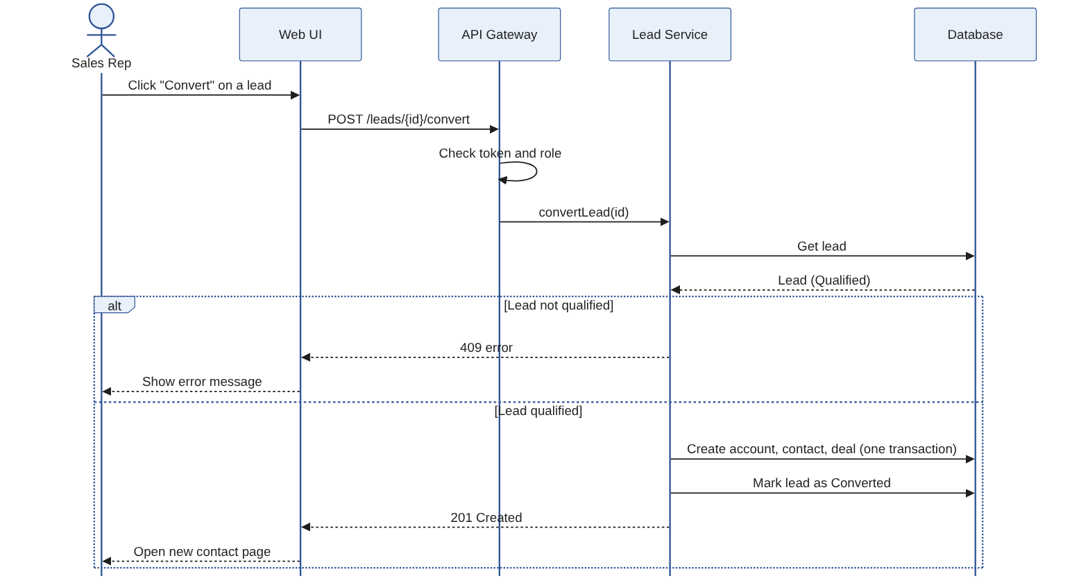
Figure 3: Lead conversion flow (CRM-F-032)

4.2.2 Redeeming a loyalty reward
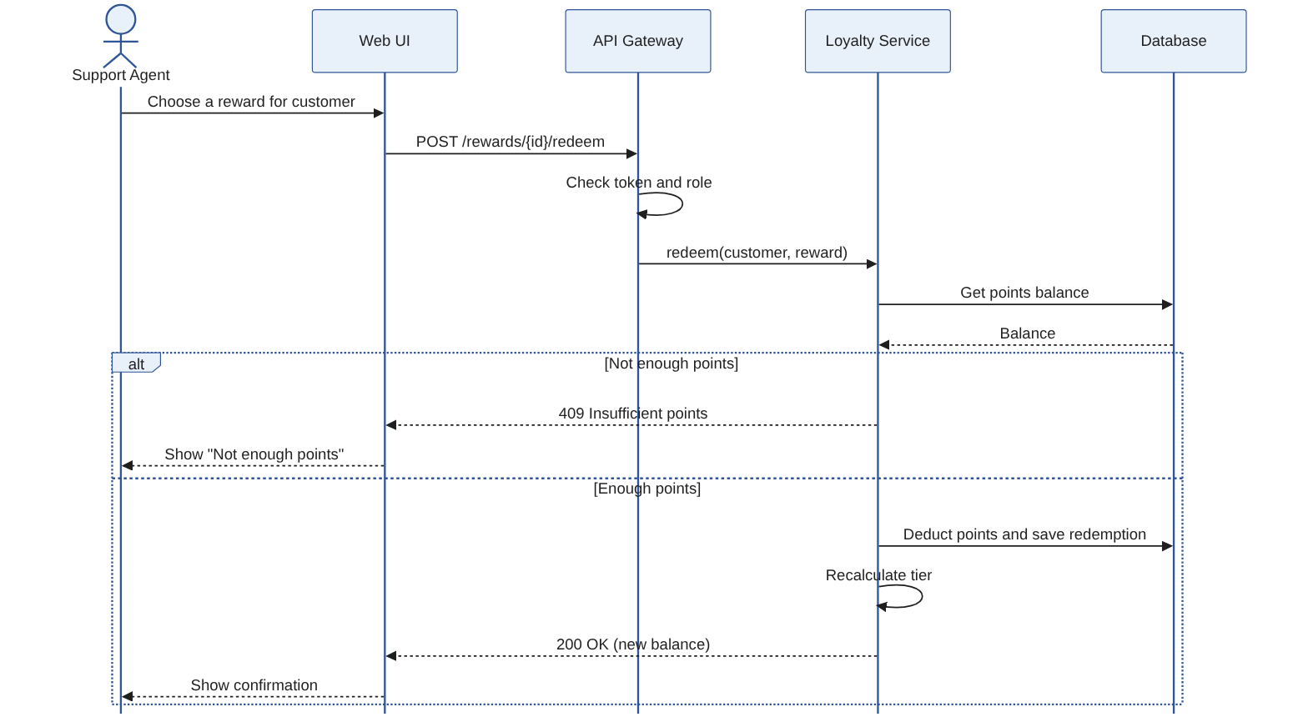
Figure 4: Reward redemption flow (CRM-F-052)

4.2.3 Logging in
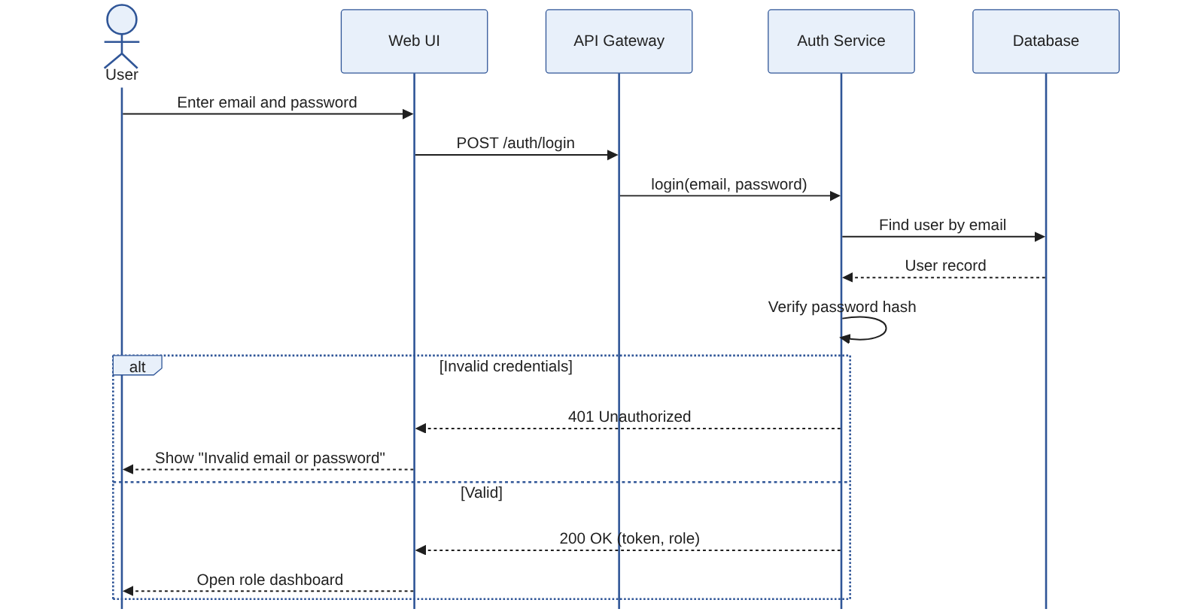
Figure 5: Login flow (CRM-F-001, CRM-F-002)

4.3 API Design
All endpoints are REST/JSON under /api/v1 and require a Bearer JWT unless marked public. Lists return {data, page, pageSize, total} with pageSize capped at 100. Full specification is generated as OpenAPI 3 at /api/docs. Interface definitions for the main components are given below.
Convert Module - convert lead
Endpoint: /api/v1/leads/{id}/convert
Method: POST
Access: Sales Representative (owner), Sales Manager
Request: { "createAccount": true, "accountName": "Acme Traders", "createDeal": true, "dealTitle": "Annual plan", "dealValue": 120000 }
Response: 201 { "contactId": "uuid", "accountId": "uuid", "dealId": "uuid" }
Errors: 400 VALIDATION_ERROR, 401 UNAUTHENTICATED, 403 FORBIDDEN (not owner), 404 NOT_FOUND, 409 LEAD_NOT_QUALIFIED
Acquire Module - public lead form
Endpoint: /api/v1/public/leads
Method: POST
Access: Public (rate limited)
Request: { "name": "Priya S", "email": "priya@example.com", "phone": "+91...", "source": "WEB", "campaignId": "uuid?", "website": "" }
Response: 201 { "id": "uuid", "isDuplicate": false }
Errors: 400 VALIDATION_ERROR, 429 RATE_LIMITED
Loyalty Module - redeem reward
Endpoint: /api/v1/rewards/{id}/redeem
Method: POST
Access: Support Agent, Admin
Request: { "contactId": "uuid" }
Response: 200 { "redemptionId": "uuid", "newBalance": 120, "tier": "SILVER" }
Errors: 401, 403, 404 NOT_FOUND, 409 INSUFFICIENT_POINTS / OUT_OF_STOCK
Convert Module - move deal stage
Endpoint: /api/v1/deals/{id}/stage
Method: PATCH
Access: Sales Representative (owner), Sales Manager
Request: { "stage": "PROPOSAL" }
Response: 200 { "id": "uuid", "stage": "PROPOSAL", "wonAt": null }
Errors: 400 INVALID_STAGE, 401, 403, 404
Auth Module - login
Endpoint: /api/v1/auth/login
Method: POST
Access: Public (rate limited)
Request: { "email": "rep@crm.test", "password": "********" }
Response: 200 { "token": "<jwt>", "expiresIn": 3600, "role": "SALES_REP" }
Errors: 400 VALIDATION_ERROR, 401 INVALID_CREDENTIALS, 429 RATE_LIMITED
Module | Other key endpoints
Auth | GET /auth/me; GET/POST/PATCH /users (Admin)
Reach | GET/POST/PATCH /segments; GET/POST/PATCH /campaigns; POST /campaigns/{id}/send; GET /campaigns/{id}/metrics
Acquire | GET/POST/PATCH/DELETE /leads; POST /leads/import; POST /leads/assign
Convert | CRUD /contacts, /accounts, /deals, /activities; POST /deals/{id}/quote
Retain | GET/POST/PATCH /tickets; GET /customers/{id}/360
Loyalty | GET/POST /orders; GET /customers/{id}/points; GET/POST/PATCH /rewards; GET /tiers
Analytics | GET /dashboard/kpis?from&to; GET /reports/funnel; GET /reports/{name}/export.csv; GET /search?q=; GET /audit-logs
Operations | GET /health (public)

4.4 Error Handling, Logging & Monitoring
Errors: one central error handler returns { "error": { "code", "message", "details" } } with codes 400, 401, 403, 404, 409, 429 and 500. Messages never reveal whether an email exists or include stack traces in production.
Logging: structured JSON logs (pino) with request id, user id, route, status and latency. Passwords, tokens and full personal data are never logged (CRM-SR-002). Business actions are also written to the AuditLog table (CRM-F-064).
Monitoring: GET /health checks the API and a database ping and is polled by an uptime monitor (CRM-NF-003). The CD pipeline smoke-tests /health after each deploy and rolls back on failure (CRM-NF-010). Tracked metrics: request error rate, p95 latency, uptime, failed logins, SLA breaches.
CI/CD: ci.yml runs lint, type-check, unit and integration tests against PostgreSQL with a 70% coverage gate, web tests, build, Docker build and Playwright E2E on pull requests; cd.yml builds the image to GHCR, deploys to Render and Vercel, smoke-tests and rolls back; pr-checks.yml requires a Jira key (CRM-n) in branch and PR title so Jira moves issues automatically and the burndown stays accurate.

4.5 UX Design
Left navigation by lifecycle stage, a global search bar and a role-specific dashboard on login. Key flows (create lead, convert lead, redeem reward) take at most three clicks. Deals use a drag-and-drop Kanban board with column totals; tickets past SLA are highlighted in red; Customer 360 shows one reverse-chronological timeline. Layout is responsive down to 360 px, fields are labelled, colours meet WCAG 2.1 AA contrast and every action is keyboard accessible.

4.6 Open Issues & Next Steps
Open issues: final loyalty tier thresholds and point rate to be confirmed with the product owner before Sprint 2; SLA hours per priority to be confirmed. Future enhancements: real email/SMS provider adapter, customer self-service loyalty portal, WhatsApp channel, AI-assisted lead scoring, multi-tenant support.

5. Appendices
5.1 Glossary: CRM, Lead, Contact, Account, Deal, Segment, SLA, CLV, RBAC, JWT, ORM, SPA, ADR, STRIDE, CI/CD.
5.2 References: IEEE 42010, IEEE 830, OWASP Top 10, OWASP ASVS, Digital Personal Data Protection Act 2023, project SRS and STP.
5.3 Tools: PlantUML (diagrams), Swagger/OpenAPI, Jira, GitHub Actions, Docker.

