Software Requirements Specification (SRS)

Project: Customer Relationship Management: Reach, Acquire, Convert, Retain and Loyalty (CRM-RACRL)
Version: 1.0
Authors: Balla Santhosh, Dhriti Kamani, Disha Lokesh, Diya Agarwal (Section B, PES University RR Campus)
Date: 27-10-2026
Status: Submitted for review (baseline before Sprint 1)

Revision history
Version | Date | Author | Change summary | Approval
0.1 | 20-10-2026 | Team | Initial requirements draft
1.0 | 27-10-2026 | Team | Full SRS with 27 FRs, 10 NFRs, 7 security requirements, use-case diagrams and RTM

Approvals
Role | Name | Signature / Email | Date
Course Coordinator
Team Lead

Table of Contents
1. Introduction
2. Overall description
3. External interfaces
4. System features (detailed)
5. Non-functional requirements (detailed)
6. Quality attributes & Acceptance tests
7. UML Use-Case Diagram
8. Requirements Traceability Matrix (RTM)

1. Introduction
1.1 Purpose
This document is the Software Requirements Specification for CRM-RACRL, a web-based Customer Relationship Management system that supports the full customer lifecycle: Reach, Acquire, Convert, Retain and Loyalty. It defines the functional and non-functional requirements, security requirements, interfaces and acceptance criteria that the team will build and test in Sprint 1 (27-31 Oct 2026) and Sprint 2 (2-7 Nov 2026).

1.2 Scope
The system lets a small or medium business run marketing campaigns (Reach), capture and route leads (Acquire), convert leads into customers through a sales pipeline (Convert), support customers through tickets with SLAs (Retain) and reward repeat customers through points, tiers and rewards (Loyalty), with one analytics dashboard across the funnel. Out of scope: real payment processing, real bulk email/SMS delivery (sends are simulated and logged), telephony integration and native mobile apps.

1.3 Audience
Developers, QA engineers, the Scrum team (product owner and scrum master), the course coordinator and assessment evaluators.

1.4 Definitions
CRM (Customer Relationship Management), Lead (prospective customer not yet qualified), Contact (qualified person the business deals with), Account (company or household a contact belongs to), Deal (sales opportunity in a pipeline stage), Segment (saved filter over contacts), CLV (Customer Lifetime Value), SLA (Service Level Agreement), RBAC (Role-Based Access Control), JWT (JSON Web Token), API, UI, CSV, CI/CD, DPDP Act (Digital Personal Data Protection Act, 2023).

2. Overall description
2.1 Product perspective
CRM-RACRL is a new, self-contained web application. A React single-page application talks over HTTPS to a REST API built with Node.js and Express, which stores data in PostgreSQL. All five lifecycle modules share one customer record, so every interaction appears on a single Customer 360 timeline. External email/SMS providers are behind a NotificationService interface and are stubbed in this release.

2.2 Major product functions (detailed)
- Authenticate users and enforce roles
- Build consent-aware audience segments and run marketing campaigns
- Capture leads from a web form, CSV import and manual entry; score and assign them
- Manage contacts, accounts and deals on a drag-and-drop pipeline; convert leads
- Log activities and generate quotes
- Handle support tickets with SLA tracking and a Customer 360 view
- Record orders, award loyalty points, manage tiers, rewards and referrals
- Show KPI dashboard, funnel report, CSV export, global search and audit log

2.3 User roles and characteristics (expanded)
- Admin: manages users, roles, reward catalogue and settings; full access.
- Marketing Executive: builds segments and campaigns; comfortable with spreadsheets, not technical.
- Sales Manager: assigns leads, monitors pipeline and team performance.
- Sales Representative: works own leads, deals and activities daily; needs fast, few-click flows.
- Support Agent: handles tickets, views Customer 360 and redeems rewards for customers.
- Customer / Website Visitor (external): submits the lead form and uses referral codes; no login.
2.4 Operating environment
- Client: current Chrome, Firefox, Edge and Safari on desktop and mobile (minimum 360 px width)
- Server: Node.js 20 LTS in Docker; PostgreSQL 16
- Hosting: web on Vercel, API and database on Render; source on GitHub with GitHub Actions CI/CD; work tracked in Jira

2.5 Constraints
- Delivered in two one-week sprints by a team of four
- Personal data handled in line with India's DPDP Act, 2023 (consent for marketing, export and deletion on request)
- Free and open-source tools and free hosting tiers only
- Every change reaches the main branch only through a reviewed pull request with a passing CI pipeline
2.6 Assumptions and dependencies
- Single business (single tenant) uses the system
- Campaign sends and orders are simulated or entered manually; no live gateways
- Hosting providers' free tiers remain available during the evaluation period

3. External interface requirements
3.1 User interfaces
Responsive web UI with a left navigation (Dashboard, Campaigns, Leads, Contacts, Accounts, Deals, Tickets, Loyalty, Reports, Admin) and a global search bar. Forms show inline validation messages; lists support sort, filter and pagination; the deal pipeline is a drag-and-drop Kanban board. Accessibility: labelled fields, keyboard navigation and WCAG 2.1 AA contrast.

3.2 Hardware interfaces
- No special hardware; any device with a modern browser
- Server runs in a Docker container on cloud infrastructure (Render)
3.3 Software interfaces
- REST/JSON API under /api/v1, documented with OpenAPI (Swagger UI at /api/docs)
- PostgreSQL 16 accessed through Prisma ORM
- NotificationService interface for email/SMS (logging stub in this release)
- GitHub for Jira integration linking branches and pull requests to Jira issues

3.4 Communications
- HTTPS (TLS 1.2+) for all traffic; JWT sent in the Authorization: Bearer header
- CORS restricted to the web application's origin
- Public endpoint POST /api/v1/public/leads for the website lead form, rate limited

Summary: 27 functional requirements (section 4), 10 non-functional requirements (section 5), 3 security objectives and 7 security requirements (section 5.1).

4. System features (detailed)
Each requirement below includes acceptance criteria and a reference test case from the Software Test Plan. IDs follow CRM-F-### (grouped by module in steps of 10). Priority High = must ship and be demoed; Medium = should ship; Low = stretch goal. The planned sprint is shown in the Comments column.

4.1 Authentication and User Administration
Description: Sign-in, roles and user management for the five internal user roles.
Req ID | Requirement (shall...) | Type | Priority | Source / Stakeholder | Acceptance criteria / Test case ref | Comments / Dependencies
CRM-F-001 | The system shall let users log in with email and password and issue a signed JWT on success; invalid credentials shall get one generic error. | Functional | High | Security / All users | AC-CRM-F-001: Valid credentials return a token and open the role dashboard; wrong password or unknown email both return 401 with the same message. Test: TC-AUTH-01, TC-AUTH-02 | bcrypt, JWT library. Sprint 1
CRM-F-002 | The system shall enforce role-based access (Admin, Marketing Executive, Sales Manager, Sales Representative, Support Agent) on every API route and UI screen. | Functional | High | Security | AC-CRM-F-002: A role calling a route outside its permissions gets 403 and the screen is hidden in the UI. Test: TC-AUTH-03 | CRM-F-001. Sprint 1
CRM-F-003 | The Admin shall create users, change their role and deactivate them. | Functional | Medium | Admin | AC-CRM-F-003: A deactivated user can no longer log in; role change takes effect on next login. Test: TC-AUTH-04 | CRM-F-002. Sprint 1

4.2 Reach (Marketing Campaigns)
Description: Build audiences that respect consent, run campaigns and measure how many people they reach and convert to leads.
Req ID | Requirement (shall...) | Type | Priority | Source / Stakeholder | Acceptance criteria / Test case ref | Comments / Dependencies
CRM-F-010 | Marketing shall create, edit, schedule and archive campaigns with name, channel (email/SMS/social), budget, start and end dates and a target segment. | Functional | High | Marketing team | AC-CRM-F-010: Campaign saves with status Scheduled; end date before start date is rejected with a validation message. Test: TC-REACH-01, TC-REACH-02 | CRM-F-011. Sprint 2
CRM-F-011 | Marketing shall build saved audience segments by filtering contacts on city, tier, tags and last order date; contacts without marketing consent shall be excluded automatically. | Functional | High | Marketing / DPDP Act 2023 | AC-CRM-F-011: Segment of 10 matching contacts where 3 lack consent returns an audience of 7. Test: TC-REACH-03 | Contact data. Sprint 2
CRM-F-012 | The system shall record and show campaign metrics: recipients, opens, clicks, leads generated and cost per lead. | Functional | Medium | Marketing manager | AC-CRM-F-012: Simulated send to 7 contacts with 4 opens, 2 clicks and 1 lead shows exactly those numbers. Test: TC-REACH-04 | NotificationService stub. Sprint 2

4.3 Acquire (Lead Management)
Description: Capture leads from the website, files and manual entry, score them and route them to sales representatives.
Req ID | Requirement (shall...) | Type | Priority | Source / Stakeholder | Acceptance criteria / Test case ref | Comments / Dependencies
CRM-F-020 | The system shall capture leads from a public web-form endpoint and from manual entry, storing name, email, phone, source and campaign; duplicate emails shall be flagged. | Functional | High | Sales / Marketing | AC-CRM-F-020: Form submission creates a lead with source Web; second lead with same email is marked duplicate. Test: TC-ACQ-01, TC-ACQ-02 | Rate limiting (CRM-SR-006). Sprint 1
CRM-F-021 | Users shall import leads from a CSV file and receive a row-level report of imported and rejected rows with reasons. | Functional | Medium | Sales manager | AC-CRM-F-021: 10-row file with 2 invalid emails imports 8 rows and lists the 2 rejected row numbers. Test: TC-ACQ-03 | CRM-F-020. Sprint 1
CRM-F-022 | The system shall compute a lead score from 0 to 100 using configurable rules (source, profile completeness, engagement) and recompute it when the lead changes. | Functional | Medium | Sales manager | AC-CRM-F-022: Score equals the rule-table result and updates after an edit. Test: TC-ACQ-04 | CRM-F-020. Sprint 2
CRM-F-023 | Sales Managers shall assign leads to representatives manually or round-robin; the assigned representative shall get an in-app notification. | Functional | High | Sales manager | AC-CRM-F-023: 6 leads round-robin across 3 reps gives 2 each; a Sales Rep trying to assign gets 403. Test: TC-ACQ-05, TC-ACQ-06 | CRM-F-002. Sprint 1

4.4 Convert (Sales Pipeline)
Description: Turn qualified leads into customers: contacts, accounts, deals moving through the pipeline, activities and quotes.
Req ID | Requirement (shall...) | Type | Priority | Source / Stakeholder | Acceptance criteria / Test case ref | Comments / Dependencies
CRM-F-030 | Users shall create, view, edit, search and delete contacts and accounts; a Sales Representative shall see only their own records. | Functional | High | Sales team | AC-CRM-F-030: CRUD and search work end to end; Rep A cannot list Rep B's contacts. Test: TC-CONV-01, TC-CONV-02 | CRM-F-002. Sprint 1
CRM-F-031 | Users shall manage deals on a drag-and-drop pipeline with stages Prospecting, Qualified, Proposal, Negotiation, Won and Lost; each deal holds value, expected close date and owner. | Functional | High | Sales team | AC-CRM-F-031: Stage change persists and pipeline totals update; moving to Won records the won date. Test: TC-CONV-03, TC-CONV-04 | CRM-F-030. Sprint 1
CRM-F-032 | Users shall convert a qualified lead into a contact, an account and optionally a deal in one atomic action, keeping the lead history. | Functional | High | Sales team | AC-CRM-F-032: All records are created together; if any insert fails nothing is created and the lead is unchanged. Test: TC-CONV-05, TC-CONV-06 | CRM-F-020, CRM-F-030. Sprint 1
CRM-F-033 | Users shall log activities (task, call, meeting, note) on a lead, contact or deal, with due dates and overdue reminders. | Functional | Medium | Sales representative | AC-CRM-F-033: A task due yesterday shows as overdue with a reminder badge. Test: TC-CONV-07 | CRM-F-030. Sprint 1
CRM-F-034 | Users shall generate a quote (line items, discount, total) from a deal and download it as PDF. | Functional | Low | Sales representative | AC-CRM-F-034: Quote with 2 items and 10% discount shows the correct total and downloads as PDF. Test: TC-CONV-08 | CRM-F-031. Sprint 2

4.5 Retain (Customer Service)
Description: Keep customers through support tickets with SLAs, a single Customer 360 view and an early churn warning.
Req ID | Requirement (shall...) | Type | Priority | Source / Stakeholder | Acceptance criteria / Test case ref | Comments / Dependencies
CRM-F-040 | Support Agents shall create and manage tickets with subject, priority (Low/Medium/High/Urgent), status (Open, In Progress, Resolved, Closed) and an SLA due time set from priority; breached tickets shall be highlighted. | Functional | High | Support team | AC-CRM-F-040: An Urgent ticket gets the configured SLA due time and turns red once overdue. Test: TC-RET-01 | CRM-F-030. Sprint 2
CRM-F-041 | The system shall provide a Customer 360 page showing profile, account, deals, orders, tickets, activities, loyalty points and campaign touches on one timeline. | Functional | High | Support / Sales | AC-CRM-F-041: A contact with a deal, order, ticket and points shows all of them, newest first. Test: TC-RET-02 | Retain, Loyalty, Convert modules. Sprint 2
CRM-F-042 | The system shall flag a customer as churn-risk when they have no order in 90 days or two or more open High/Urgent tickets. | Functional | Low | Business owner | AC-CRM-F-042: Last order 91 days ago sets the flag; 89 days does not. Test: TC-RET-03 | CRM-F-050. Sprint 2

4.6 Loyalty (Rewards Programme)
Description: Reward repeat customers with points, tiers, a reward catalogue and referrals.
Req ID | Requirement (shall...) | Type | Priority | Source / Stakeholder | Acceptance criteria / Test case ref | Comments / Dependencies
CRM-F-050 | The system shall record customer orders and award loyalty points at a configurable rate (default 1 point per Rs 100) in an append-only points ledger. | Functional | High | Business owner | AC-CRM-F-050: Order of Rs 2,550 adds 25 points with an EARN ledger entry. Test: TC-LOY-01 | CRM-F-030. Sprint 2
CRM-F-051 | The system shall assign tiers (Bronze, Silver, Gold, Platinum) from points earned in the last 12 months and upgrade or downgrade automatically. | Functional | High | Business owner | AC-CRM-F-051: Crossing the Silver threshold changes the contact's tier to Silver. Test: TC-LOY-02 | CRM-F-050. Sprint 2
CRM-F-052 | The Admin shall manage a reward catalogue and Support Agents shall redeem rewards for a customer only if the balance is sufficient, debiting the ledger. | Functional | Medium | Business owner / Support | AC-CRM-F-052: Redeeming a 500-point reward with 300 points is refused with 409 and the balance is unchanged. Test: TC-LOY-03 | CRM-F-050. Sprint 2
CRM-F-053 | Each customer shall have a referral code; a new customer created with that code shall earn the referrer bonus points. | Functional | Low | Marketing | AC-CRM-F-053: Referrer's balance increases by the configured bonus. Test: TC-LOY-04 | CRM-F-050. Sprint 2

4.7 Analytics and Cross-cutting Features
Description: Dashboard, funnel report, export, global search and audit trail across all stages.
Req ID | Requirement (shall...) | Type | Priority | Source / Stakeholder | Acceptance criteria / Test case ref | Comments / Dependencies
CRM-F-060 | The dashboard shall show new leads, lead-to-customer conversion rate, open pipeline value, won revenue, average customer lifetime value, retention rate, churn-risk count and active loyalty members for a chosen date range. | Functional | High | Management | AC-CRM-F-060: KPIs computed on known seeded data match the expected values. Test: TC-ANA-01 | All modules. Sprint 2
CRM-F-061 | The system shall show a funnel report with counts and drop-off between Reached, Leads, Qualified, Customers and Repeat (loyal) customers. | Functional | Medium | Management | AC-CRM-F-061: Funnel counts match seeded data and each drop-off percentage is correct. Test: TC-ANA-02 | CRM-F-060. Sprint 2
CRM-F-062 | Users shall export any list or report view to CSV. | Functional | Low | Management | AC-CRM-F-062: Exported row count equals the list total. Test: TC-ANA-03 | -. Sprint 2
CRM-F-063 | Users shall search across leads, contacts, accounts, deals and tickets from one search bar. | Functional | Medium | All users | AC-CRM-F-063: Searching an account name returns the account and its deals. Test: TC-ANA-04 | Indexes (CRM-NF-008). Sprint 1
CRM-F-064 | The system shall keep an audit log of create, update and delete actions (who, what, when) viewable by the Admin. | Functional | Low | Admin / Security | AC-CRM-F-064: Editing a deal creates an audit entry with user, entity and time. Test: TC-ANA-05 | Common module. Sprint 2

5. Non-functional requirements (detailed)
NFRs below are measurable and tied to the test plan. IDs CRM-NF-###.
Req ID | Requirement | Category | Priority | Acceptance criteria / Measurement
CRM-NF-001 | API responses for list and detail endpoints shall have p95 latency under 500 ms with 50 concurrent users. | Performance | High | k6 run of 50 virtual users for 2 minutes: p95 < 500 ms, error rate < 1%. Test: TC-PERF-01
CRM-NF-002 | The dashboard shall render in under 3 seconds on a 10 Mbps connection. | Performance | Medium | Lighthouse performance score >= 70 and first render < 3 s. Test: TC-PERF-02
CRM-NF-003 | The deployed system shall be available at least 99% of the time during the evaluation week. | Availability | High | Uptime monitor on /health reports >= 99%. Test: TC-OPS-01
CRM-NF-004 | Creating a lead, converting a lead and redeeming a reward shall each take at most 3 clicks from the list page, and all screens shall be usable at 360 px width. | Usability | Medium | Click count recorded per flow; no horizontal scrolling at 360 px. Test: TC-UX-01
CRM-NF-005 | The UI shall meet WCAG 2.1 AA basics: labelled fields, sufficient contrast and full keyboard navigation. | Accessibility | Medium | Lighthouse accessibility >= 90 and no critical axe issues on 5 main pages. Test: TC-UX-02
CRM-NF-006 | Code shall pass linting and keep backend test line coverage at or above 70%. | Maintainability | High | CI shows 0 lint errors and coverage >= 70%. Test: TC-OPS-02
CRM-NF-007 | A developer shall start the full system locally with one command. | Portability | Medium | docker compose up starts web, API and database with seed data in < 5 minutes on a clean machine. Test: TC-OPS-03
CRM-NF-008 | All list endpoints shall be paginated (default 20, max 100) and remain fast with 10,000 contacts. | Scalability | Medium | Request for 500 rows is capped at 100 and returns in < 500 ms with 10,000 seeded contacts. Test: TC-PERF-03
CRM-NF-009 | Lead conversion and point redemption shall be atomic, and the database shall be backed up daily. | Reliability / Data integrity | High | Forced failure leaves no partial records; concurrent double redemption succeeds only once; backup visible in hosting console. Test: TC-OPS-04
CRM-NF-010 | No change shall reach the main branch without a reviewed pull request and a passing CI pipeline; a failed deployment shall roll back automatically. | Reliability (process) | High | PR with a failing test cannot merge; failed health check after deploy restores the previous release. Test: TC-OPS-05

5.1. Security

5.1.1 Security Objectives
SO-1 Confidentiality: Customer personal data (names, emails, phone numbers, orders) is visible only to users whose role needs it and is never exposed in transit or in logs.
SO-2 Integrity: Sales, ticket and loyalty records can be changed only by authorised users through validated requests; points can never be spent twice or go negative.
SO-3 Accountability: Every create, update and delete action can be traced to a user and time.

5.1.2 Security Requirements
Req ID | Requirement (shall...) | Type | Priority | Acceptance criteria / Test case ref
CRM-SR-001 | All client-server traffic shall use HTTPS (TLS 1.2+) with HSTS; plain HTTP shall redirect. | Security | High | HTTP request is redirected to HTTPS; SSL Labs grade A or better. Test: TC-SEC-01
CRM-SR-002 | Passwords shall be stored only as bcrypt hashes (cost >= 10); passwords and tokens shall never be written to logs. | Security | High | DB row holds $2b$10$ hash; log search finds no password or token values. Test: TC-SEC-02
CRM-SR-003 | Access tokens shall be signed JWTs that expire after 60 minutes, with the signing secret held only in environment secrets. | Security | High | A token used after 61 minutes returns 401; secret absent from the repository. Test: TC-SEC-03
CRM-SR-004 | Every protected API route shall check the role and record ownership on the server, independent of the UI. | Security | High | Automated matrix test: each route returns 401/403 exactly as the role table defines. Test: TC-SEC-04
CRM-SR-005 | All request input shall be schema-validated and database access shall use parameterised queries only. | Security | High | Malformed or injection-style input returns 400; OWASP ZAP baseline scan shows no High alerts. Test: TC-SEC-05
CRM-SR-006 | Login and public lead-form endpoints shall be rate limited to 100 requests per minute per IP, and the form shall include a honeypot field. | Security | Medium | Request 101 within a minute returns 429; bot submissions filling the honeypot are discarded. Test: TC-SEC-06
CRM-SR-007 | Contacts without marketing consent shall never be messaged, and a contact's data shall be exportable and deletable on request (DPDP Act 2023). | Security | High | Non-consenting contact is absent from every campaign audience; export file and delete action both work. Test: TC-SEC-07

6. Quality attributes & Acceptance tests
- Exit criteria for acceptance: all High-priority functional requirements implemented and verified on the deployed build, no Critical defects open, all security requirements passing, at least 90% of planned test cases passing, and the RTM showing every requirement linked to a passed test.
- Sprint 1 acceptance (31-10-2026): authentication, lead management, contacts and accounts, deal pipeline, lead conversion and the CI/CD pipeline demonstrated in a working 1-minute video.
- Sprint 2 acceptance (07-11-2026): campaigns, tickets, Customer 360, loyalty, dashboard and funnel demonstrated in a working 2-minute video; NFR and security test results recorded.
- Acceptance test suites: Authentication, Reach, Acquire, Convert, Retain, Loyalty, Analytics, Performance, Security, Usability/Accessibility and Operations.

7. System models and diagrams

7.1 UML Use-Case diagram
Two use-case diagrams cover the system: the first shows the marketing and sales stages (Reach, Acquire, Convert); the second shows customer service, loyalty and administration (Retain, Loyalty, Analytics).
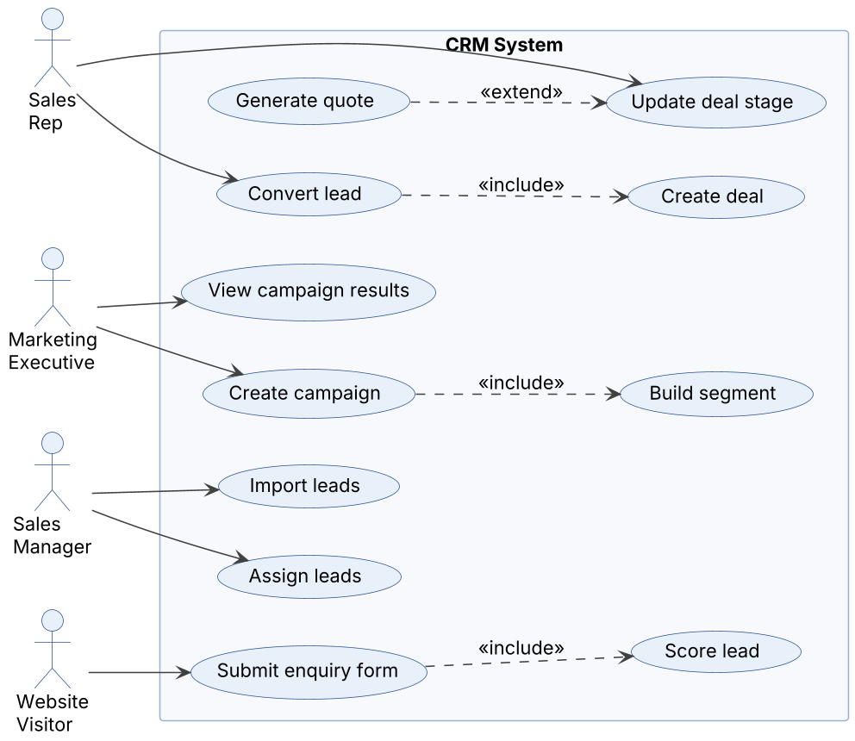
Figure 1: Use cases for marketing and sales (Reach, Acquire, Convert)
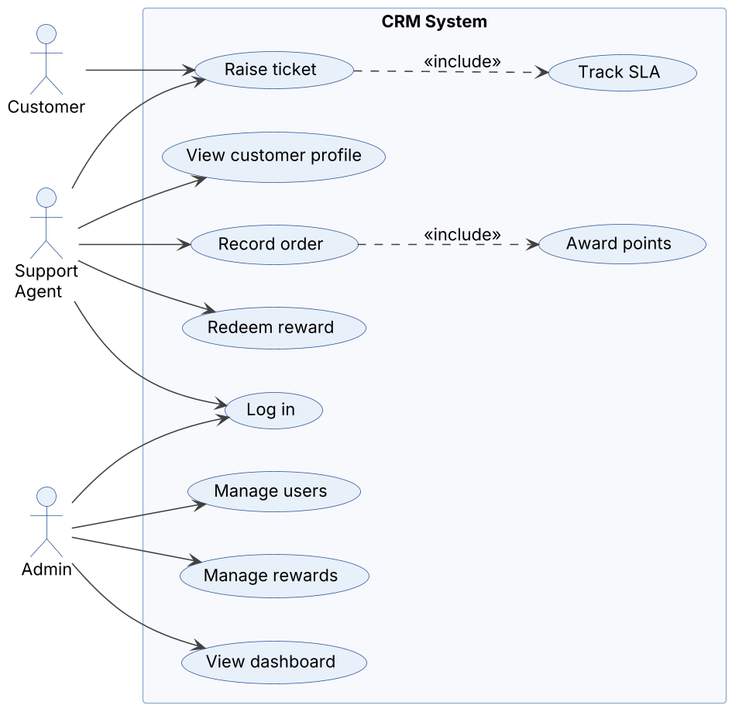
Figure 2: Use cases for support, loyalty and admin (Retain, Loyalty)

8. Requirements Traceability Matrix (RTM)
Status: N = Not started, P = In progress, A = Accepted (test passed). Design spec references point to the Software Architecture and Design Specification (SAD).
Req ID | Requirement short | Section ref / Design Spec | Module | Test case(s) | Status (N/P/A) | Comments
CRM-F-001 | Login with JWT | 4.1 / DS-Auth-01 | AuthModule | TC-AUTH-01, TC-AUTH-02 | N | Sprint 1
CRM-F-002 | Role-based access control | 4.1 / DS-Auth-01 | AuthModule | TC-AUTH-03 | N | Sprint 1
CRM-F-003 | User administration | 4.1 / DS-Auth-01 | AuthModule | TC-AUTH-04 | N | Sprint 1
CRM-F-010 | Create / schedule campaign | 4.2 / DS-Reach-01 | ReachModule | TC-REACH-01, TC-REACH-02 | N | Sprint 2
CRM-F-011 | Consent-aware segments | 4.2 / DS-Reach-01 | ReachModule | TC-REACH-03 | N | Sprint 2
CRM-F-012 | Campaign metrics | 4.2 / DS-Reach-01 | ReachModule | TC-REACH-04 | N | Sprint 2
CRM-F-020 | Capture leads (form/manual) | 4.3 / DS-Acquire-01 | AcquireModule | TC-ACQ-01, TC-ACQ-02 | N | Sprint 1
CRM-F-021 | CSV lead import | 4.3 / DS-Acquire-01 | AcquireModule | TC-ACQ-03 | N | Sprint 1
CRM-F-022 | Lead scoring | 4.3 / DS-Acquire-01 | AcquireModule | TC-ACQ-04 | N | Sprint 2
CRM-F-023 | Lead assignment | 4.3 / DS-Acquire-01 | AcquireModule | TC-ACQ-05, TC-ACQ-06 | N | Sprint 1
CRM-F-030 | Contacts and accounts CRUD | 4.4 / DS-Convert-01 | ConvertModule | TC-CONV-01, TC-CONV-02 | N | Sprint 1
CRM-F-031 | Deal pipeline (Kanban) | 4.4 / DS-Convert-01 | ConvertModule | TC-CONV-03, TC-CONV-04 | N | Sprint 1
CRM-F-032 | Convert lead | 4.4 / DS-Convert-01 | ConvertModule | TC-CONV-05, TC-CONV-06 | N | Sprint 1
CRM-F-033 | Activities and reminders | 4.4 / DS-Convert-01 | ConvertModule | TC-CONV-07 | N | Sprint 1
CRM-F-034 | Quote PDF | 4.4 / DS-Convert-01 | ConvertModule | TC-CONV-08 | N | Sprint 2
CRM-F-040 | Tickets with SLA | 4.5 / DS-Retain-01 | RetainModule | TC-RET-01 | N | Sprint 2
CRM-F-041 | Customer 360 | 4.5 / DS-Retain-01 | RetainModule | TC-RET-02 | N | Sprint 2
CRM-F-042 | Churn-risk flag | 4.5 / DS-Retain-01 | RetainModule | TC-RET-03 | N | Sprint 2
CRM-F-050 | Orders and points ledger | 4.6 / DS-Loyalty-01 | LoyaltyModule | TC-LOY-01 | N | Sprint 2
CRM-F-051 | Loyalty tiers | 4.6 / DS-Loyalty-01 | LoyaltyModule | TC-LOY-02 | N | Sprint 2
CRM-F-052 | Reward redemption | 4.6 / DS-Loyalty-01 | LoyaltyModule | TC-LOY-03 | N | Sprint 2
CRM-F-053 | Referral bonus | 4.6 / DS-Loyalty-01 | LoyaltyModule | TC-LOY-04 | N | Sprint 2
CRM-F-060 | KPI dashboard | 4.7 / DS-Analytics-01 | AnalyticsModule | TC-ANA-01 | N | Sprint 2
CRM-F-061 | Funnel report | 4.7 / DS-Analytics-01 | AnalyticsModule | TC-ANA-02 | N | Sprint 2
CRM-F-062 | CSV export | 4.7 / DS-Analytics-01 | AnalyticsModule | TC-ANA-03 | N | Sprint 2
CRM-F-063 | Global search | 4.7 / DS-Analytics-01 | AnalyticsModule | TC-ANA-04 | N | Sprint 1
CRM-F-064 | Audit log | 4.7 / DS-Analytics-01 | AnalyticsModule | TC-ANA-05 | N | Sprint 2
CRM-NF-001 | Performance target | 5 / DS-NFR | System-wide | TC-PERF-01 | N
CRM-NF-002 | Performance target | 5 / DS-NFR | System-wide | TC-PERF-02 | N
CRM-NF-003 | Availability target | 5 / DS-NFR | System-wide | TC-OPS-01 | N
CRM-NF-004 | Usability target | 5 / DS-NFR | System-wide | TC-UX-01 | N
CRM-NF-005 | Accessibility target | 5 / DS-NFR | System-wide | TC-UX-02 | N
CRM-NF-006 | Maintainability target | 5 / DS-NFR | System-wide | TC-OPS-02 | N
CRM-NF-007 | Portability target | 5 / DS-NFR | System-wide | TC-OPS-03 | N
CRM-NF-008 | Scalability target | 5 / DS-NFR | System-wide | TC-PERF-03 | N
CRM-NF-009 | Reliability / Data integrity target | 5 / DS-NFR | System-wide | TC-OPS-04 | N
CRM-NF-010 | Reliability (process) target | 5 / DS-NFR | System-wide | TC-OPS-05 | N
CRM-SR-001 | HTTPS / TLS 1.2+ | 5.1.2 / DS-Sec-01 | Security Middleware | TC-SEC-01 | N
CRM-SR-002 | Password hashing, no secrets in logs | 5.1.2 / DS-Sec-01 | Security Middleware | TC-SEC-02 | N
CRM-SR-003 | JWT expiry and secret storage | 5.1.2 / DS-Sec-01 | Security Middleware | TC-SEC-03 | N
CRM-SR-004 | Server-side RBAC and ownership | 5.1.2 / DS-Sec-01 | Security Middleware | TC-SEC-04 | N
CRM-SR-005 | Input validation, parameterised queries | 5.1.2 / DS-Sec-01 | Security Middleware | TC-SEC-05 | N
CRM-SR-006 | Rate limiting and honeypot | 5.1.2 / DS-Sec-01 | Security Middleware | TC-SEC-06 | N
CRM-SR-007 | Consent and data rights | 5.1.2 / DS-Sec-01 | Security Middleware | TC-SEC-07 | N

