SE Mini Project
(UE24CS341A)

Project: Conference Room Booking System | Date:
Topic: Software Requirements Specification | 27/10/2026

Team members:
- PES1UG25AM805 Karthik S Prabhu
- PES1UG24AM111 Harish Ramesh Kumar
- PES1UG24AM074 Dabbugunta Venya Anand
- PES1UG24AM067 Bhogala Srika

- Introduction
  - Purpose
This Software Requirements Specification defines the functional, non-functional, interface and security requirements for the Conference Room Booking System. It provides a common, testable baseline for implementation, Jira stories, the Software Architecture and Design Specification (SAD), and the Software Test Plan (STP).

  - Scope
The system is a web application for an organization or college. Signed-in staff, faculty and other permitted members can view rooms, search availability, create bookings, view their own bookings and cancel eligible bookings. Administrators can create and update room details. The system must validate booking rules, prevent overlapping active reservations, persist records and provide safe error responses.
Out of scope for this release: recurring bookings, external calendar integration, email notifications, administrator approval workflows, self-registration, editing an existing booking, deleting/deactivating rooms, changing operating hours, physical room equipment integration, and production-scale high availability.

  - Audience
The intended audience is the project team, project guide, developers, testers, system administrators and assessment evaluators.

- Overall description
  - Product perspective
The product is a browser-based, single application with a presentation layer, application/business layer and relational data layer. The browser communicates with a Node.js/Express REST API. Application modules handle authentication and access control, booking rules and room administration. PostgreSQL stores users, rooms, bookings and relevant audit information. The proposed architecture follows the layered design described in the team SAD.

  - Major product functions
- Authenticate seeded users using email and password.
- Display room name, location, capacity and facilities.
- Search for rooms available for a requested date/time interval, with an optional minimum-capacity filter.
- Validate booking input, duration, operating hours, future dates and permitted booking horizon.
- Create and immediately confirm valid bookings.
- Prevent overlapping active bookings, including simultaneous requests.
- List a signed-in user’s bookings and show details only for bookings they own.
- Allow an owner to cancel an eligible booking and release the interval for future searches.
- Allow administrators to create rooms and update room details.
- Persist committed data across application restarts and handle failures without partial booking writes.
- Return consistent HTTP status codes and safe error messages.
- Run automated build and test checks in GitHub Actions and deploy the demo application only after successful checks.
  - User roles and characteristics
Role | Characteristics and permitted use
Staff / Faculty / Member | Authenticated organization member; searches rooms, creates bookings, views own booking history and cancels own eligible bookings.
Administrator | Authenticated privileged user; performs ordinary user actions and creates or updates room information through protected administration functions.
Project team / maintainer | Develops, tests, deploys and maintains the application; accesses logs and deployment evidence according to assigned permissions.
Project guide / evaluator | Reviews requirements, demonstrable behavior, project tracking, documentation and CI/CD evidence.

  - Operating environment
The planned environment is a modern browser (Chromium and Firefox), a React + TypeScript + Tailwind CSS frontend, Node.js with Express REST APIs, Prisma data access, PostgreSQL, and a team-managed development/demo machine. The deployment is planned as one application service and one PostgreSQL service using Docker Compose. Exact runtime and browser versions must be recorded during setup.

  - Design and implementation constraints
- The proposed stack is a team baseline and should be confirmed before implementation; changes must be reflected consistently in the SRS, SAD, STP and Jira.
- PostgreSQL transactions and suitable database constraints/locking must protect booking integrity under concurrent requests.
- Only one GitHub repository is to contain the application, documentation and CI/CD configuration.
- Use synthetic test identities and data; do not use real organizational booking data.
- Accounts are seeded by deployment setup; self-registration is not in scope.

  - Assumptions and dependencies
- Room opening hours are configured as 09:00–18:00 for this release and can be confirmed by the team.
- The organization timezone is Asia/Kolkata; timestamps are stored in UTC and displayed consistently in local time.
- Users and an administrator are seeded by deployment/setup procedures.
- The team can run PostgreSQL locally or in the configured Docker Compose environment.
- GitHub Actions, repository permissions and a running team laptop are available for the required demonstration pipeline.

- External interface requirements
  - User interfaces
- The application shall provide sign-in, room listing/search, booking form, booking history/detail, cancellation controls and administrator room-management screens.
- Room listings shall display room name, location, capacity and facilities.
- Forms shall label required fields, show understandable validation feedback and preserve keyboard access with visible focus.
- Core flows shall work at viewport sizes 360×800 and 1366×768 without clipping or controls becoming inaccessible.
- Booking success, conflict and failure states shall be clearly distinguishable.

  - Hardware interfaces
No dedicated hardware interface is required. The application runs on a standard computer or server and is accessed through a browser.

  - Software interfaces
Interface | Requirement
Browser to application | Serve the React frontend and Express API from one origin in the demo deployment.
REST API | Use documented JSON request/response bodies and consistent status codes for authentication, rooms, availability and bookings.
PostgreSQL via Prisma | Persist user, room and booking records; use transactional writes and appropriate constraints for booking integrity.
Session storage | Use server-side sessions with PostgreSQL session storage; session identifiers are carried in secure cookies in HTTPS deployment.
CI/CD | GitHub Actions shall run automated checks; Docker Compose shall run the demo application and PostgreSQL service.

  - Communications
- Deployed traffic shall use HTTPS.
- Authenticated state-changing requests shall include a valid CSRF token.
- API errors shall not disclose stack traces, credentials, tokens or internal database details.
- All date/time comparisons shall use a consistent timezone policy and the defined half-open interval rule.

- System features
Requirement priority: P1 = release-critical; P2 = supporting quality requirement. Acceptance criteria are intended to be objectively testable. The linked test cases follow the shared STP catalogue; all cases remain Not Run until actually executed.
ID | Requirement (shall) | Priority | Acceptance criteria | Test ref.
FR01 | Authenticate seeded users with email and password; reject invalid credentials. | P1 | Valid credentials establish an authenticated session; invalid credentials are rejected without revealing whether an account exists. | TC16
FR02 | Display room name, location, capacity and facilities to signed-in users. | P1 | Displayed room details match the stored room record. | TC01
FR03 | Search rooms available for a date/start/end interval with an optional minimum-capacity filter. | P1 | Conflicting rooms are unavailable; free rooms are returned; capacity filters work below, equal to and above room capacity; invalid filters return 400. | TC02, TC03
FR04 | Create a booking using roomId, date, startTime, endTime and purpose. | P1 | Valid input creates one booking; purpose is trimmed and contains 1–200 characters; missing or malformed fields return 400; nonexistent room returns 404. | TC04, TC05
FR05 | Immediately confirm a successful booking and return its booking ID. | P1 | Successful creation returns HTTP 201, a booking ID and status CONFIRMED; exactly one correct record is stored and visible to its owner. | TC04
FR06 | Enforce booking date, duration, interval and operating-hour rules on the server. | P1 | Accept valid 09:00/18:00 boundaries and 30–240 minute durations; reject past starts, dates over 30 local calendar days ahead, cross-midnight intervals, invalid boundaries and equal/reversed times with 400. | TC05, TC06
FR07 | Reject overlapping CONFIRMED bookings for the same room, including simultaneous requests. | P1 | Identical, contained, enclosing and partial overlaps return 409; concurrency tests leave exactly one active booking for a contested interval. | TC07, TC09
FR08 | Allow adjacent intervals without a buffer and independent bookings in different rooms. | P1 | Back-to-back intervals are accepted; a different room can be booked for the same interval when available. | TC08
FR09 | List only the signed-in user’s bookings and allow detail access to owned booking records. | P1 | GET /api/bookings returns only the current user’s records; owned detail returns 200; unknown ID returns 404; another user’s record is not disclosed. | TC10, TC12
FR10 | Allow an owner to cancel an eligible booking before its start; preserve the cancelled record. | P1 | Eligible cancellation returns 200 and status CANCELLED; repeating cancellation returns 200 without additional state change; cancellation at/after start returns 409. | TC11
FR11 | Release cancelled intervals for future availability searches. | P1 | After cancellation, the cancelled booking no longer blocks that room/time interval; the historical record remains stored. | TC02, TC11
FR12 | Allow administrators to create rooms with valid required fields and positive integer capacity. | P1 | Valid creation returns 201; missing name/location, invalid facilities or non-positive/non-integer capacity are rejected; regular users cannot create rooms. | TC13, TC14
FR13 | Allow administrators to update room details through PATCH /api/admin/rooms/{id}. | P1 | Valid changes persist and appear in room listings; invalid updates are rejected; updates do not retroactively cancel existing bookings. | TC13, TC14
FR14 | Persist room and booking records across application restarts and perform booking writes atomically. | P1 | Committed records remain available after restart; a tested failed database write leaves no partial booking or duplicate reservation. | TC15
FR15 | Return consistent status codes and safe errors for invalid input, authentication, authorization, missing records, conflicts and service failures. | P1 | Use 400 for invalid input, 401 for missing session, 403 for denied access, 404 for missing records, 409 for booking conflicts, and safe 500/503 for server/dependency failures. | TC03, TC05, TC07, TC10 -TC17
- Non-functional requirements
ID | Quality attribute | Measurable requirement | Verification
NFR01 | Performance | On the team demo machine with 5 concurrent users, 5 rooms and 100 initial bookings, availability and booking p95 response time shall be ≤ 3 seconds over a warmed-up 2-minute run; unexpected error rate shall be < 5%. Record machine specifications. | TC19
NFR02 | Reliability / data integrity | For 10 independent simultaneous-request pairs targeting one free room/interval, exactly one booking per pair shall persist; tested database failures shall create zero partial booking writes. | TC09, TC15
NFR03 | Usability / accessibility | Search, booking and cancellation shall be usable by keyboard with visible focus and labelled inputs at 360×800 and 1366×768 viewports. | TC18
NFR04 | Compatibility | Core search, booking and cancellation shall pass Chromium automated tests and a manual Firefox smoke test; record tested browser versions. | TC01–TC18
NFR05 | Build and deployment quality | Every pull request shall run unit/API tests and build checks. Deployment shall run only after successful checks, execute a smoke test and record a commit-tagged image. Demonstrate both successful deployment and failed-test blocking. | TC20

  - Security objectives
ID | Objective
SO01 | Protect booking ownership and administrative functions against unauthorized actions.
SO02 | Protect credentials and session data while preserving the integrity and accountability of booking records.

  - Security requirements
ID | Security requirement | Verification
SR01 | The server shall enforce authentication, booking ownership and administrator role checks; it shall never trust a client-supplied role. | TC12, TC14, TC16
SR02 | If local passwords are used, the system shall hash them using bcrypt cost 12; deployed traffic shall use HTTPS; session cookies shall use Secure, HttpOnly and SameSite=Lax attributes; secrets shall not be committed or written to logs. | TC16, TC17
SR03 | The system shall expire sessions after 30 minutes of inactivity, destroy sessions on logout and require a valid CSRF token for authenticated state-changing requests. | TC16
SR04 | The server shall validate all fields, use parameterized database access and limit failed sign-in attempts to five per account and client IP within a 15-minute window; subsequent attempts shall receive HTTP 429 until the window ends. | TC05, TC16, TC17
SR05 | The system shall log timestamp, actor ID, action and record ID for booking creation/cancellation and room changes, while excluding passwords, session tokens and secrets; external errors shall be safe. | TC17

- Quality attributes & acceptance tests
The following checks define the minimum acceptance evidence for the first release. They are planned criteria, not claims that tests have already passed.
Acceptance test | Method | Pass criteria
AT01 – Authentication | Use valid and invalid seeded credentials; test logout and expired sessions. | Valid sign-in succeeds; invalid sign-in fails safely; logout destroys session; session expires after 30 idle minutes.
AT02 – Availability and capacity | Seed rooms and active bookings; query conflicting and free intervals with multiple capacity filters. | Availability is accurate, capacity filtering is correct and invalid query input returns 400.
AT03 – Booking rules | Try valid booking, missing fields, invalid duration, past date, >30-day date, cross-midnight and outside-hours requests. | Valid booking is confirmed; invalid requests are rejected with no record persisted.
AT04 – Conflict and concurrency | Try overlap variants, adjacent intervals, another room and 10 simultaneous request pairs against PostgreSQL. | Overlaps return 409; adjacent intervals are allowed; each concurrent pair persists exactly one active booking.
AT05 – Ownership and administration | Attempt to view/cancel another user’s booking and call admin endpoints as a regular user. | Unauthorized operations are rejected and no data or privilege change occurs.
AT06 – Persistence and failure handling | Restart the app after writes and simulate an isolated database failure. | Committed data persists; failed write leaves no partial booking; errors are safe.
AT07 – Usability and compatibility | Complete search/booking/cancellation using keyboard at mobile and desktop sizes; smoke-test Chromium and Firefox. | Labels and focus are visible, flows remain usable, and browser versions are recorded.
AT08 – Performance | Run the STP workload: 5 concurrent users, 5 rooms, 100 bookings, 2 minutes after warm-up. | p95 ≤3 seconds and unexpected errors <5%; machine specs and results are recorded.
AT09 – CI/CD | Run a passing PR, merge/deploy from trusted main, run deployed smoke test, then demonstrate a failing-test branch. | Passing checks permit the planned deployment; failed tests block downstream deployment; commit and run evidence are retained.

- UML Use-Case Diagram
The diagram below shows the principal interactions for the proposed first release. It is a logical model and should be updated if the agreed scope changes.
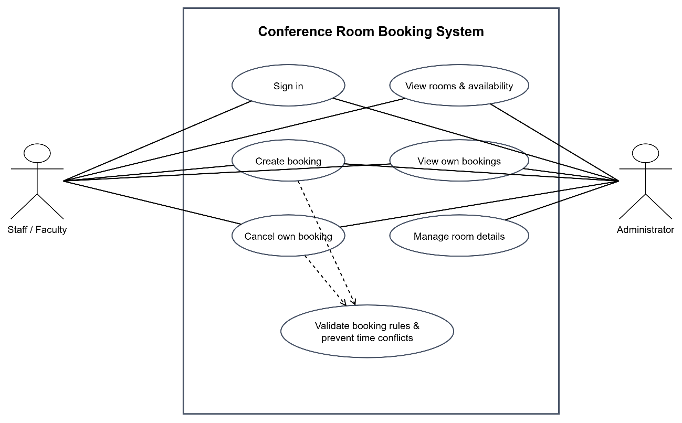
  - Actor descriptions
Actor | Use cases
Staff / Faculty / Member | Sign in; view rooms and availability; create a booking; view own bookings; cancel own eligible booking.
Administrator | All permitted member actions; create and update room details.
System / database (supporting component) | Validate rules, check conflicts, persist bookings and rooms, and record relevant audit events.

- Requirements Traceability Matrix (RTM)
The RTM maps detailed requirements to the team’s SAD references and the existing STP test catalogue. A test reference indicates planned verification; it does not mean that the test has been executed or passed.
Requirement ID | Requirement summary | SAD / source mapping | STP verification
FR01 | Authenticate seeded users | SAD 3.9 security architecture | TC16
FR02 | Display room details | SAD R1 | TC01
FR03 | Search availability and capacity | SAD R1 | TC02, TC03
FR04 | Create booking with validated fields | SAD R2 | TC04, TC05
FR05 | Confirm booking and return ID | SAD R2, R6 | TC04
FR06 | Enforce booking rules | SAD R2; STP Appendix A rules | TC05, TC06
FR07 | Prevent overlapping active bookings | SAD R3 | TC07, TC09
FR08 | Allow adjacent/different-room bookings | SAD R3 | TC08
FR09 | Owner-only booking list/detail | SAD R4 | TC10, TC12
FR10 | Cancel own booking before start | SAD R4 | TC11
FR11 | Release cancelled interval | SAD R4 | TC02, TC11
FR12 | Admin creates room | SAD R5 | TC13, TC14
FR13 | Admin updates room | SAD R5 | TC13, TC14
FR14 | Persistence and atomic writes | SAD R6 | TC15
FR15 | Consistent status codes and safe errors | SAD 3.9 and 4.4 | TC03, TC05, TC07, TC10–TC17
NFR01 | Performance target | SAD 3.1 goals/constraints | TC19
NFR02 | Concurrent integrity and atomicity | SAD R3, R6 | TC09, TC15
NFR03 | Keyboard and viewport usability | SAD 4.5 UX design | TC18
NFR04 | Browser compatibility | SAD 4.5 UX design | TC01–TC18
NFR05 | Automated build/test/deploy quality | Instructor CI/CD requirement; STP Section 8 | TC20
SO01 / SR01 | Ownership and administrative access control | SAD 3.9 security architecture | TC12, TC14, TC16
SO02 / SR02–SR05 | Credential/session protection, validation, logging and accountability | SAD 3.9 and 4.4 | TC05, TC16, TC17

