Software Architecture
and Design Specification
Project: Conference Room Booking System

Version | 1.0
Authors | Harish Ramesh Kumar, Bhogala Srika, Karthik S Prabhu, Dabbugunta Venya Anand
Date | 27-10-2026
Status | Draft

Revision History
Version | Date | Author | Change Summary
1.0 | 27-10-2026 | Bhogala Srika | Initial architecture and design specification

Approvals
Role | Name | Signature / Date
Project Guide | To be filled | To be filled
Team Representative | To be filled | To be filled

1. Introduction

1.1 Purpose
This document describes the proposed architecture and design of the Conference Room Booking System, an application for managing conference rooms in organizations, including colleges.

1.2 Scope
The system allows authorized users to view room availability, request and manage bookings, and receive booking status. Administrators manage rooms, capacity, facilities, operating hours, and booking rules. The system is intended to reduce scheduling conflicts and manual coordination.

1.3 Audience
Project team, project guide, developers, testers, system administrators, and future maintainers.

1.4 Definitions
Term | Meaning
SAD | Software Architecture and Design
User | An authenticated employee, faculty member, or other permitted organization member
Administrator | A user permitted to manage rooms and system settings
Booking | A reservation request for a room during a specified time interval
Time conflict | An overlap between two active bookings for the same room
RBAC | Role-Based Access Control

2. Document Overview

2.1 How to use this document
This document presents the system goals, stakeholders, architecture, components, technology assumptions, risks, security considerations, key design flows, API examples, and future work. Diagrams are logical designs and can be updated to match the final implementation.

2.2 Related Documents
Software Requirements Specification (SRS), Software Test Plan (STP), Requirements Traceability Matrix (RTM), and project user guide, if maintained.

3. Architecture

3.1 Goals & Constraints
- Prevent overlapping active bookings for the same room and time interval.
- Make room availability and booking status easy to understand.
- Provide role-based access for regular users and administrators.
- Keep the design modular, maintainable, and suitable for a college or organizational environment.
- Constraints: room rules, operating hours, user permissions, network availability, and the technology stack selected by the project team.

3.2 Stakeholders & Concerns
Stakeholder | Primary Concerns
Staff / Faculty / Members | Find available rooms; create, view, and cancel permitted bookings
Administrator | Maintain accurate room information, facilities, capacity, and booking rules
Organization / College | Fair room utilization, fewer scheduling conflicts, clear records
Developers | Modularity, testability, maintainability, and reliable data handling
Project Guide / Evaluator | Requirement coverage, clear design, and demonstrable functionality

3.3 Component (UML) Diagram

Proposed logical component architecture. Components and technology choices are subject to team confirmation.

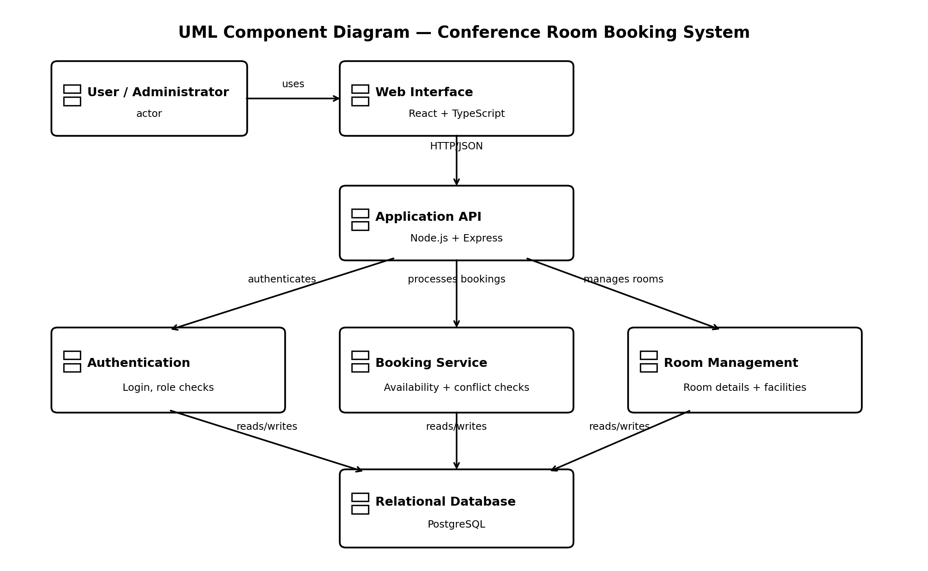

3.4 Component Descriptions
Component | Responsibility
User Interface | Displays room search, availability, booking forms, booking history, and administrative screens.
Authentication & Access Control | Verifies user identity and checks whether an action is allowed for the user's role.
Booking Service | Validates requests, checks time conflicts, creates bookings, and handles cancellations/status changes.
Room Management Service | Allows authorized administrators to add or update rooms, capacity, facilities, and availability rules.
Database | Stores user, room, booking, and audit information with relationships and constraints.

3.5 Chosen Architecture Pattern and Rationale
A layered architecture is proposed: presentation layer, application/business layer, and data layer. This separates the user interface from booking rules and persistence, making the system easier to test and maintain. A single application with clearly separated modules is sufficient for the expected project scope; a microservices architecture would add unnecessary deployment and communication complexity.

3.6 Technology Stack & Data Stores
Proposed stack for team review (not yet finalized): Front end — React with TypeScript and HTML/CSS; UI styling — Tailwind CSS; backend — Node.js with Express.js REST APIs; database — PostgreSQL; database access — Prisma ORM; authentication — session-based authentication or JSON Web Tokens (JWT), depending on the final deployment. Development tools — Visual Studio Code, Git and GitHub; API testing — Postman; UML diagrams — draw.io or PlantUML. PostgreSQL is proposed because the system stores related users, rooms and bookings and needs reliable transaction handling to prevent double-booking. The team will confirm the final stack before implementation.
.

3.7 Risks & Mitigations
Risk | Mitigation
Two users request the same room and time | Check conflicts on the server and enforce the booking operation transactionally in the database.
Unauthorized room or booking changes | Authenticate users and apply role- and ownership-based authorization.
Incorrect or incomplete room data | Validate required fields and restrict room administration to authorized users.
Network or server downtime | Show clear failure messages; use backups and recovery procedures appropriate to the deployment.
Duplicate form submissions | Disable repeated submission in the interface and validate requests on the server.

3.8 Traceability to Requirements
Requirement ID | Requirement | Responsible Component
R1 | User can view rooms and availability | User Interface + Booking Service
R2 | User can request a room booking | Booking Service
R3 | System prevents overlapping active bookings | Booking Service + Database
R4 | User can view or cancel their permitted bookings | Booking Service + Access Control
R5 | Administrator can manage room details | Room Management Service + Access Control
R6 | System stores booking and room records | Database

3.9 Security Architecture
- Authentication: require sign-in before users can create or manage bookings.
- Authorization: regular users may manage only their own bookings; administrators may manage rooms and permitted system records.
- Input validation: validate room identifiers, dates, start/end times, and required fields on the server.
- Data protection: use HTTPS in deployment and store passwords only as secure password hashes if local password authentication is implemented.
- Logging: record important booking actions and errors without logging passwords, session tokens, or other secrets.
- Availability: validate that the end time is after the start time and that the requested interval follows room operating rules.
Threat-model summary: spoofing is reduced through authentication; tampering through server-side validation and access checks; information disclosure through authorization and HTTPS; denial of service through request limits and operational monitoring; privilege escalation through role checks.

4. Design

4.1 Design Overview
A booking follows this high-level flow: the user signs in, searches rooms for a date and time, selects an available room, submits a request, and receives a success or conflict response. The server—not the browser alone—validates the request and checks for overlapping active bookings before saving it.

4.2 UML Sequence Diagrams
Flow A — Successful room booking. The sequence shows availability search, server-side validation, conflict checking, database insertion, and confirmation.
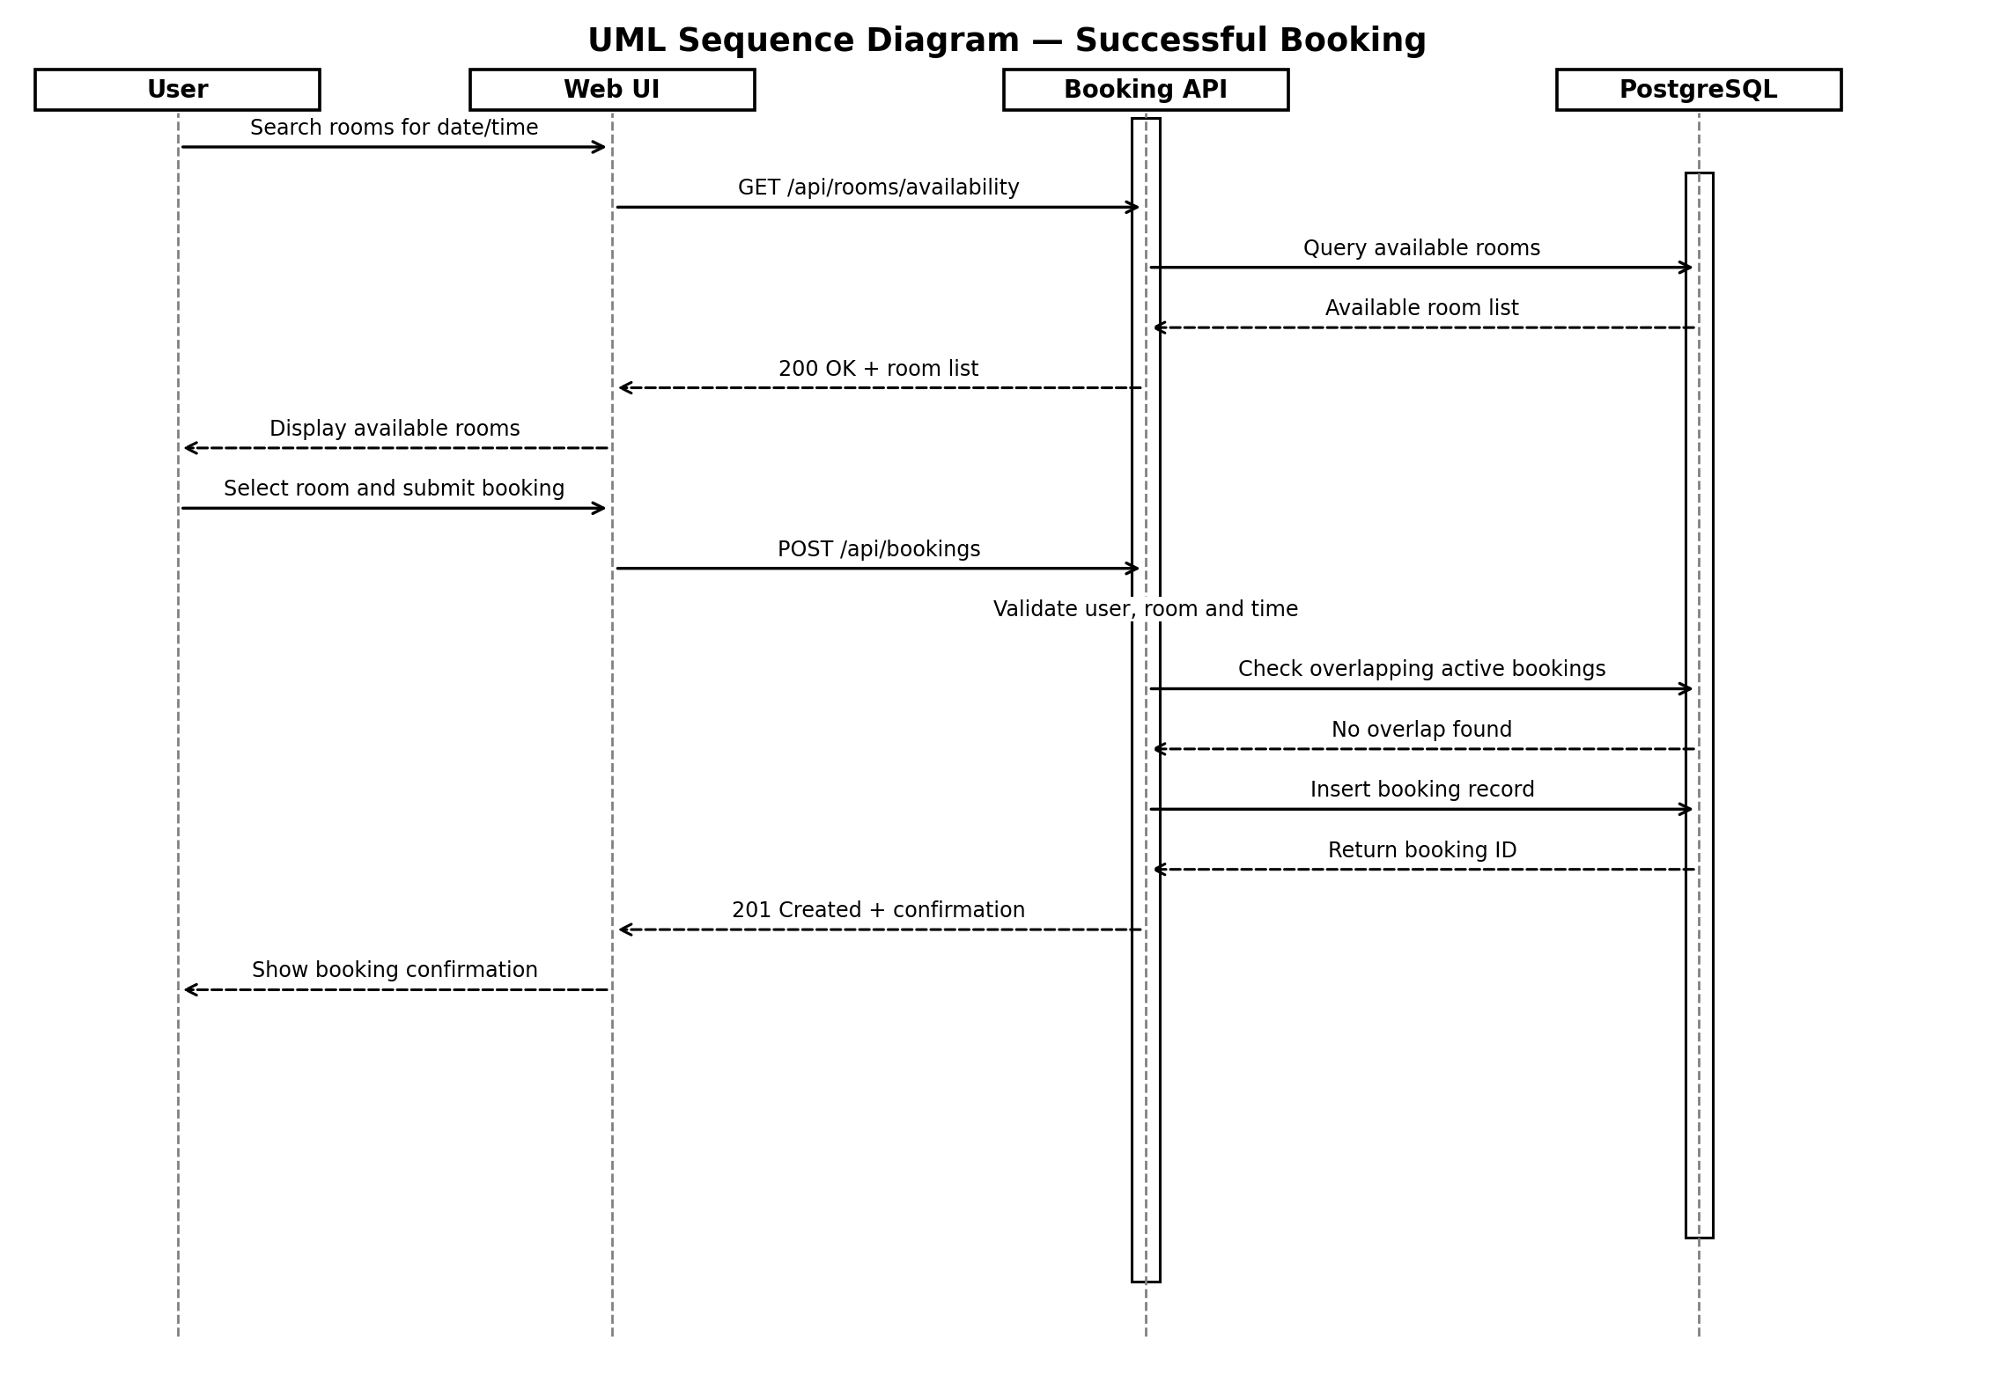

Flow B — Booking conflict. If an active booking overlaps the requested room and time, the API returns HTTP 409 Conflict and asks the user to select another time or room.
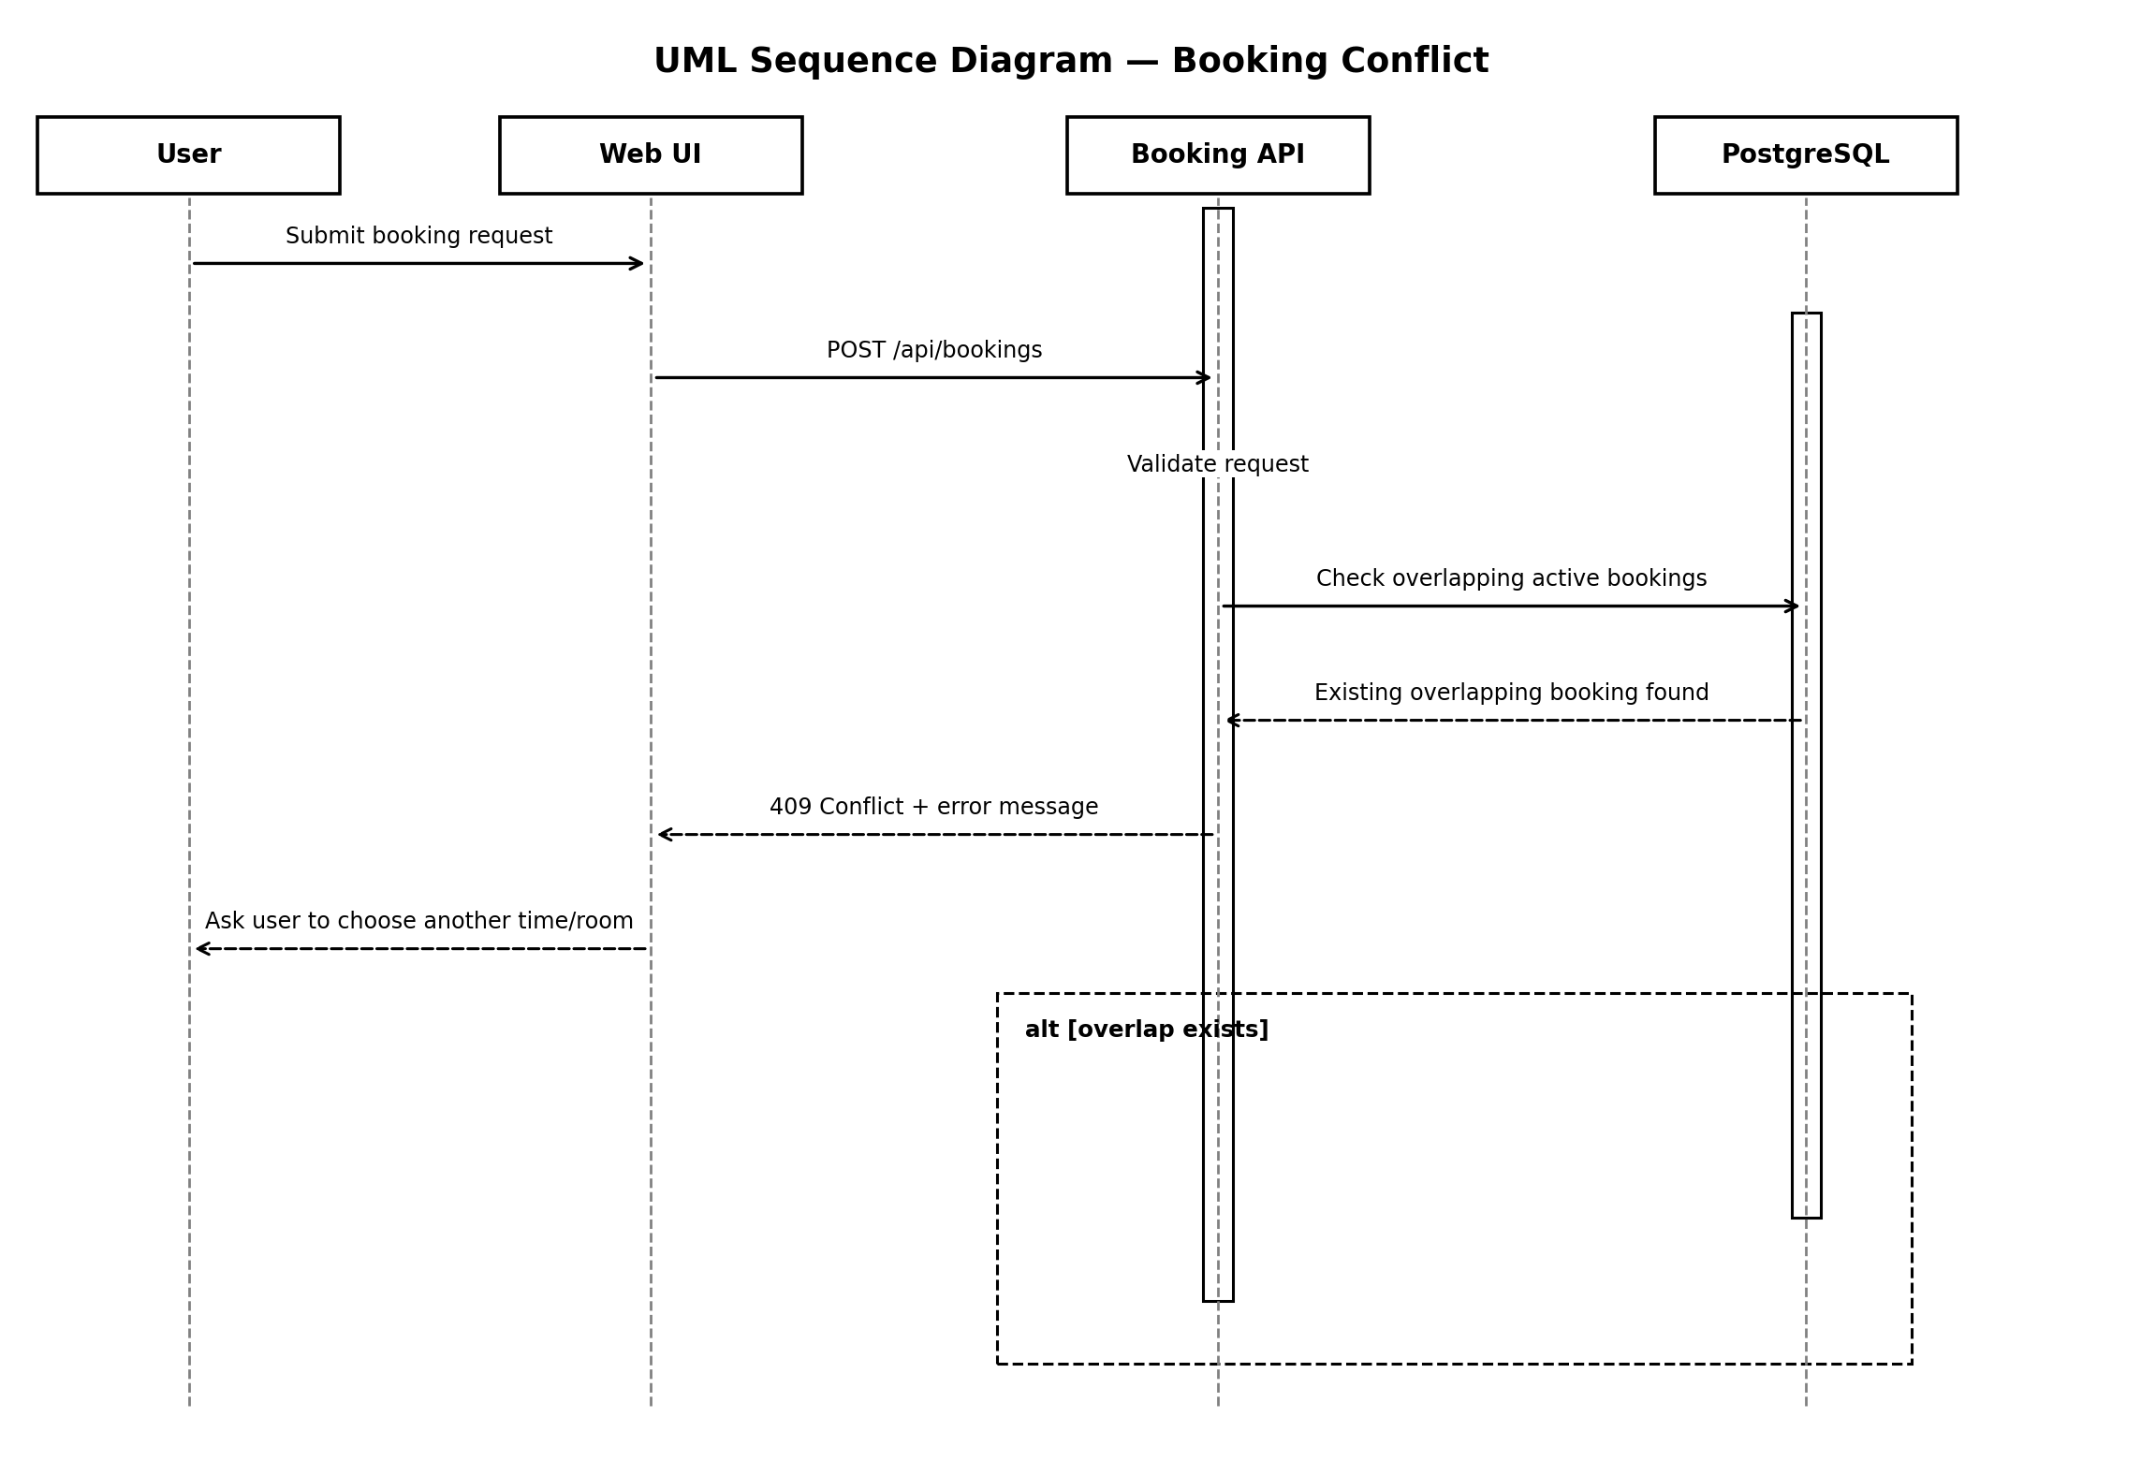

4.3 API Design
Illustrative REST API contracts. Paths and field names should be aligned with the final implementation.
Endpoint | Method | Request | Success / Error Response
/api/rooms/availability | GET | Query: date, startTime, endTime, capacity (optional) | 200: list of available rooms; 400: invalid date/time range
/api/bookings | POST | JSON: { roomId, date, startTime, endTime, purpose } | 201: { bookingId, status }; 400: invalid input; 409: time conflict; 401/403: access error
/api/bookings/{id} | GET | Path: booking ID | 200: booking details; 404: not found; 403: not permitted
/api/bookings/{id}/cancel | POST | Path: booking ID | 200: cancellation confirmed; 404: not found; 403: not permitted
/api/admin/rooms | POST | JSON: { name, capacity, facilities, location } | 201: room created; 400: invalid input; 403: administrator access required

4.4 Error Handling, Logging & Monitoring
- Return consistent error responses with a short message and suitable HTTP status code.
- Use 400 for invalid input, 401 for unauthenticated requests, 403 for forbidden actions, 404 for missing records, and 409 for booking conflicts.
- Log booking creation, cancellation, administrative room changes, and unexpected failures with timestamps and relevant record IDs.
- Monitor failed booking requests, conflict frequency, application availability, and database errors.

4.5 UX Design
- Provide a clear room list with capacity, location, facilities, and availability.
- Use a simple date/time selector and show validation messages near the relevant fields.
- Clearly distinguish pending, confirmed, and cancelled booking states if those states are implemented.
- Ask for confirmation before cancellation and show a final success or failure message.
- Support keyboard navigation, readable text, and responsive layouts.

4.6 Open Issues & Next Steps
- Confirm the final technology stack and authentication method.
- Decide whether bookings are automatically confirmed or require administrator approval.
- Define cancellation deadlines, operating hours, recurring bookings, and buffer time between meetings.
- Implement and test simultaneous booking requests to verify conflict prevention.
- Finalize UML diagrams and API contracts against the implemented code.

5. Appendices

5.1 Glossary
Term | Definition
API | Application Programming Interface used by components to exchange requests and responses.
RBAC | Role-Based Access Control; permissions depend on the user's assigned role.
REST | A common style for HTTP-based application APIs.
UML | Unified Modeling Language used to represent system structure and behavior.
Booking conflict | A time overlap with another active booking for the same room.

5.2 References
- Object Management Group (OMG). Unified Modeling Language (UML), Version 2.5.1. https://www.omg.org/spec/UML/2.5.1
- PostgreSQL Global Development Group. PostgreSQL Documentation. https://www.postgresql.org/docs/
- React. React Documentation. https://react.dev/
- OpenJS Foundation. Node.js Documentation. https://nodejs.org/docs/latest/api/
- Express.js. Express Documentation. https://expressjs.com/
- OWASP Foundation. OWASP Application Security Verification Standard (ASVS). https://owasp.org/www-project-application-security-verification-standard/

5.3 Tools
Document prepared in Microsoft Word-compatible format. UML diagrams may be refined using draw.io or PlantUML. API definitions may be documented using OpenAPI/Swagger if used by the project.

