Software Requirements Specification (SRS)
Task Manager Application
Project: Task Manager Application
Version: 1.1
Authors: Team 10
Date: 06-09-2026
Status: Draft / For Approval

Revision history
Version | Date | Author | Change summary | Approval
1.0 | 05-09-2026 | Team 10 | Initial SRS for Task Manager Application

Approvals
Role | Name | Signature / Email | Date
Course Coordinator

Table of Contents

1. Introduction

2. Overall description

3. External interface requirements

4. System features (detailed)

5. Non-functional & security requirements

5.1 Security

6. Quality attributes & Acceptance tests

7. System models and diagrams

8. Requirements Traceability Matrix (RTM)

1. Introduction

1.1 Purpose

This document is a Software Requirements Specification (SRS) for a Task Manager Application. It defines the functional and non-functional requirements, external interfaces, security expectations, verification criteria, and traceability information for a web-based application.

1.2 Scope

A web app for creating, organising, and tracking personal and shared tasks – accounts, tasks, reminders, sharing, search, a dashboard, and admin controls. Out of scope: native mobile apps, calendar sync, billing.

1.3 Audience

Developers, QA Engineers, Project Managers, Team Members, System Administrators, Maintenance Personnel, Course Instructors, and Assessment Evaluators.

1.4 Definitions

List of acronyms: SRS, UI, API, CRUD, ORM, RBAC, REST, HTTP, HTTPS, CSRF, XSS, SQL, DB, KPI, UTC.

2. Overall description

2.1 Product perspective

The Task Manager Application is a browser-based client-server system. The presentation layer is delivered through HTML/CSS/JavaScript templates and Django views, the application layer implements business rules and authorization, and the persistence layer uses Django ORM with a relational database. Optional background processing may be used for email/in-app notifications and scheduled jobs.

2.2 Major product functions (detailed)
- User registration, authentication, logout, and profile management.
- Role-based access for administrators, project managers, and team members.
- Task creation, assignment, editing, deletion, prioritization, and due-date management.
- Task organization through labels, search, filtering, sorting, and file attachments.
- Task collaboration through sharing, comments, permissions, and activity history.
- Dashboard, notifications, and task reporting.
- Administrative user management, audit logging, and system configuration.

2.3 User roles and characteristics (expanded)
- Team Member: creates and updates assigned tasks, comments on work, and views relevant projects.
- Project Manager: assigns tasks, monitors task progress, reviews reports, and manages task access and collaboration.
- Administrator: manages users and roles, reviews audit logs, configures system settings, and monitors system health.

2.4 Operating environment

Responsive web app (task list, task detail, dashboard); keyboard-navigable, screen-reader labels, high-contrast mode.

2.5 Constraints
- Compliance with applicable data-protection regulations for storing user account and personal data.
- Password and account data must be stored and handled securely, not just functionally.
- Browser-based access only for this version — no dedicated mobile app.
- Email service dependency for delivering assignment and due-date notifications.
- Single-organization / single-tenant use only for this version — no multi-company data isolation required.

3. External interface requirements

3.1 User interfaces

Primary UI: responsive web pages for login, dashboard, projects, task lists, task details, forms, reports, notifications, and administration. Forms shall provide clear labels, validation feedback, confirmation messages, and navigation appropriate to the user's role.

3.2 Hardware interfaces

No specialized hardware is required. The system shall operate on standard computers, laptops, tablets, or mobile devices with a supported web browser and network connectivity.

3.3 Software interfaces
- Django application framework and Django ORM.
- Relational database accessed through Django ORM.
- Optional SMTP/email service for notifications.
- Optional REST API endpoints for future integrations.
- Application logging and monitoring components.

3.4 Communications

Client-server communication shall use HTTP during local development and HTTPS in production. API-style endpoints, if enabled, shall use authenticated requests and JSON where appropriate. The application shall use appropriate timeout, error-handling, and retry behavior for external notification services.

4. System features (detailed)

Each requirement below includes acceptance criteria and a reference test case. IDs follow TM-F-###.

4.1 Authentication & Account Management
Req ID | Requirement (shall...) | Type | Priority | Acceptance Criteria
TM-F-001 | Guest can register with a unique e-mail and a password meeting the complexity policy. | Functional | High | Account created; confirmation email sent.
TM-F-002 | System authenticates via e-mail + password and establishes a secure, server-side session (Django session framework). | Functional | High | Correct credentials start a session; incorrect ones are rejected without revealing which field was wrong.
TM-F-003 | Account locks for 15 min after 5 failed login attempts; event is logged. | Functional | High | 5th failure locks account and logs an audit entry.
TM-F-004 | User can reset a forgotten password via a time-limited e-mail link. | Functional | Medium | Link expires in 30 min and works only once.
TM-F-005 | User can view and edit their profile (name, email, avatar) and change their password while logged in. | Functional | Medium | Changes save and appear immediately; changing the email requires re-verification.

4.2 Task Creation & Lifecycle
Req ID | Requirement (shall...) | Type | Priority | Acceptance Criteria
TM-F-010 | User can create a task with title, description, due date, priority. | Functional | High | Task saved and shown in the task list.
TM-F-011 | User can edit any field of a task they own or can edit. | Functional | High | Changes save and appear immediately.
TM-F-012 | User can delete a task they own, after confirmation. | Functional | High | Task removed from all views; recoverable for 30 days.
TM-F-013 | User can mark a task complete or reopen it. | Functional | High | Completed tasks are marked and excluded from active views.
TM-F-014 | System sends a reminder before a task's due date. | Functional | Medium | Notification sent within 1 minute of scheduled time.

4.3 Organisation & Attachments
Req ID | Requirement (shall...) | Type | Priority | Acceptance Criteria
TM-F-020 | User can assign labels/categories to a task. | Functional | Medium | Labels persist and display as chips.
TM-F-021 | User can search/filter tasks by keyword, label, priority, status, or date. | Functional | High | Filtered results match all criteria within 2 seconds.
TM-F-022 | User can attach a file (max 10 MB) to a task and download it later. | Functional | Medium | File is retrievable and scanned before storage.

4.4 Collaboration & Sharing
Req ID | Requirement (shall...) | Type | Priority | Acceptance Criteria
TM-F-030 | Owner can share a task with another user as Viewer or Editor. | Functional | Medium | Shared user sees the task with the granted permission.
TM-F-031 | Collaborators are notified when a shared task is updated. | Functional | Low | Notification sent within 5 minutes of the change.
TM-F-032 | Owner can revoke a collaborator's access at any time. | Functional | Medium | Access is removed on the next request.
TM-F-033 | User can add a comment to a task they have access to. | Functional | Medium | Comment is saved with author and timestamp and visible to everyone with access to the task.
TM-F-034 | System maintains a chronological activity history for each task (status changes, edits, comments, assignments). | Functional | Low | Activity log displays events in correct order with timestamps.

4.5 Dashboard & Analytics
Req ID | Requirement (shall...) | Type | Priority | Acceptance Criteria
TM-F-040 | Dashboard summarises open, overdue, and completed tasks over a chosen range. | Functional | Medium | Dashboard counts match underlying data.
TM-F-041 | User can export their task list and dashboard summary as a CSV file. | Functional | Low | Downloaded CSV opens correctly and matches on-screen totals.

4.6 Administration
Req ID | Requirement (shall...) | Type | Priority | Acceptance Criteria
TM-F-050 | Admin can view, disable, or delete a user account. | Functional | High | Disabled accounts can't log in; deletion is logged.
TM-F-051 | Admin can create, rename, or archive global categories. | Functional | Low | Archived categories no longer appear when creating a task.
TM-F-052 | Admin has a searchable audit log of security events. | Functional | High | Entries include actor, action, timestamp; are immutable.
TM-F-053 | Admin can view and update system-wide configuration (e.g., password policy, session timeout, notification defaults). | Functional | Medium | Updated settings take effect without a redeploy; changes are logged.

5. Non-functional & security requirements

IDs follow TM-NF-### (non-functional) and TM-SR-### (security). 5 NFRs and 5 security requirements.
Req ID | Requirement | Category | Priority | Measurement
TM-NF-001 | Common actions (create, edit, view tasks) should respond within 2 seconds under normal use. | Performance | High | Response time checked during testing
TM-NF-002 | The system shall handle errors gracefully and remain stable without crashing during normal use. | Reliability | High | No crashes during test scenarios
TM-NF-003 | The system shall support multiple concurrent users without noticeable slowdown. | Scalability | Medium | Tested with a small group of simultaneous users
TM-NF-004 | UI conforms to WCAG 2.1 AA (keyboard, contrast, screen reader). | Accessibility | Medium | Accessibility audit pass
TM-NF-005 | Audit logs and deleted tasks shall be retained for a reasonable period (e.g., 30 days) for review/recovery. | Data Retention | Medium | Retention verified in testing (own test case — see RTM)

5.1 Security

Security objectives
- Protect account credentials and task data from unauthorised access, in transit and at rest.
- Ensure only authorised users can view, edit, or delete a given task.

Security requirements
Req ID | Requirement (shall...) | Priority | Acceptance Criteria
TM-SR-001 | TLS 1.2+ enforced on all connections. | High | Plaintext connections rejected
TM-SR-002 | Passwords stored with salted, adaptive hashing (bcrypt/argon2), never plaintext. | High | DB check confirms hashed storage
TM-SR-003 | RBAC enforced – users act only on tasks they own or are granted access to. | High | Unauthorized API calls return 403
TM-SR-004 | Session is invalidated immediately on logout, and automatically expires after 24h of inactivity (Django session expiry). | Medium | Logged-out or expired sessions are rejected on the next request.
TM-SR-005 | All user input is validated/sanitised to prevent common injection attacks (e.g., SQL injection, XSS). | Medium | Malicious input is rejected or safely escaped

6. Quality attributes & Acceptance tests
- Exit criteria for acceptance: All high-priority functional and security requirements are implemented and verified; no critical NFR failures remain; and the RTM shows all planned test cases executed with acceptable results.
- Acceptance test suites:Authentication, RBAC, Task Management, Collaboration, Search/Filtering, Dashboard, Notifications, Reporting, Administration, Performance, Security, Reliability, Accessibility/Usability, and Data Recovery tests.
- Quality focus: correctness, security, reliability, usability, performance, maintainability, auditability, and data integrity.

7. System models and diagrams

7.1 Registered User

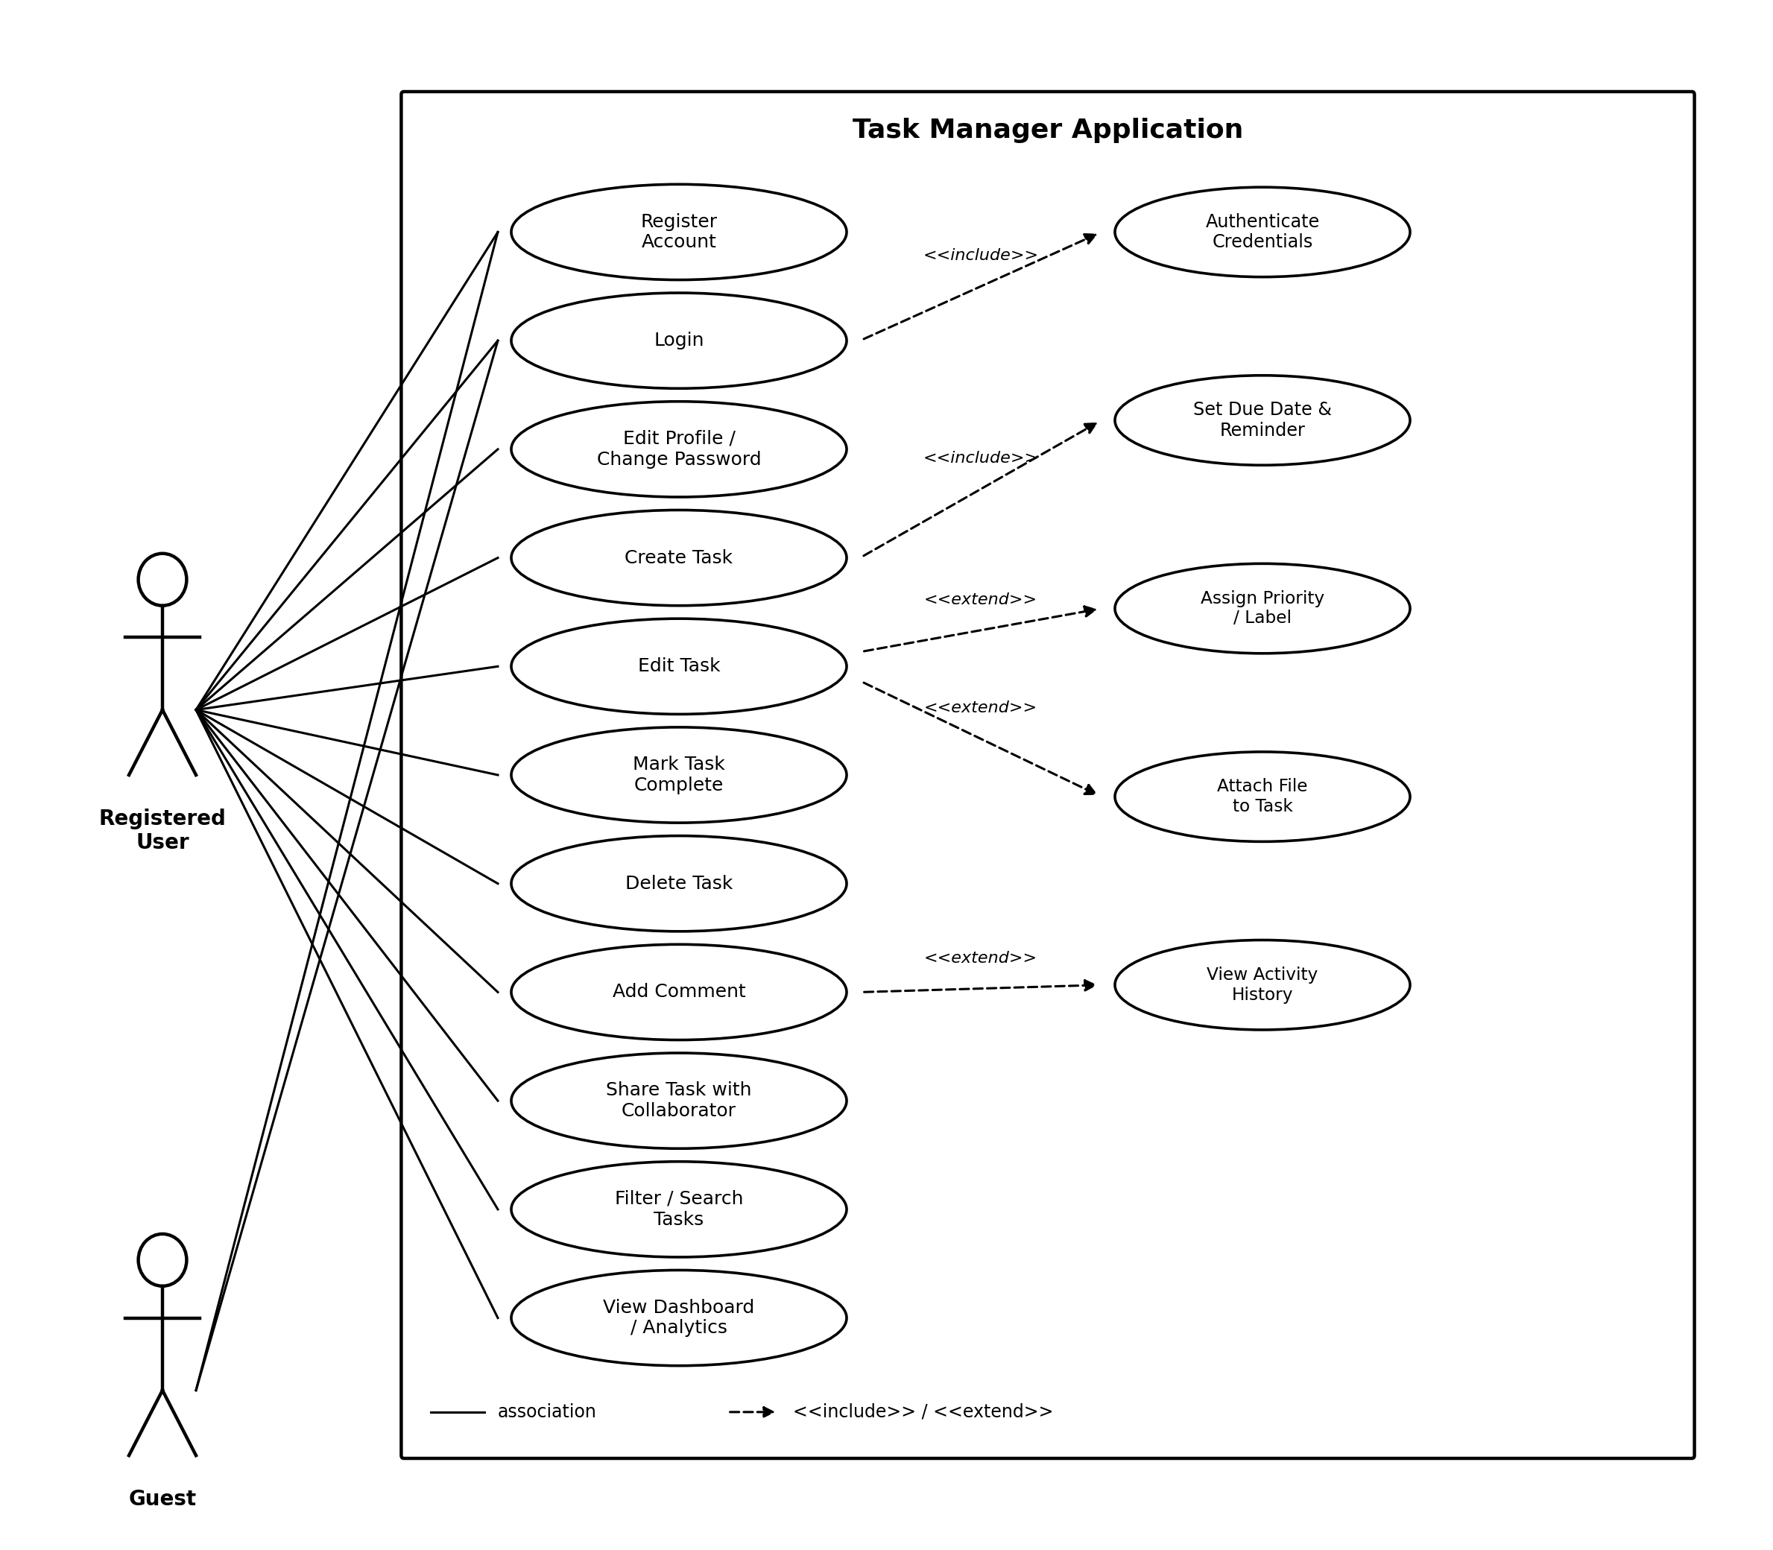

Figure 7.1: Registered User / Guest use-case diagram

7.2 Administration & Notification

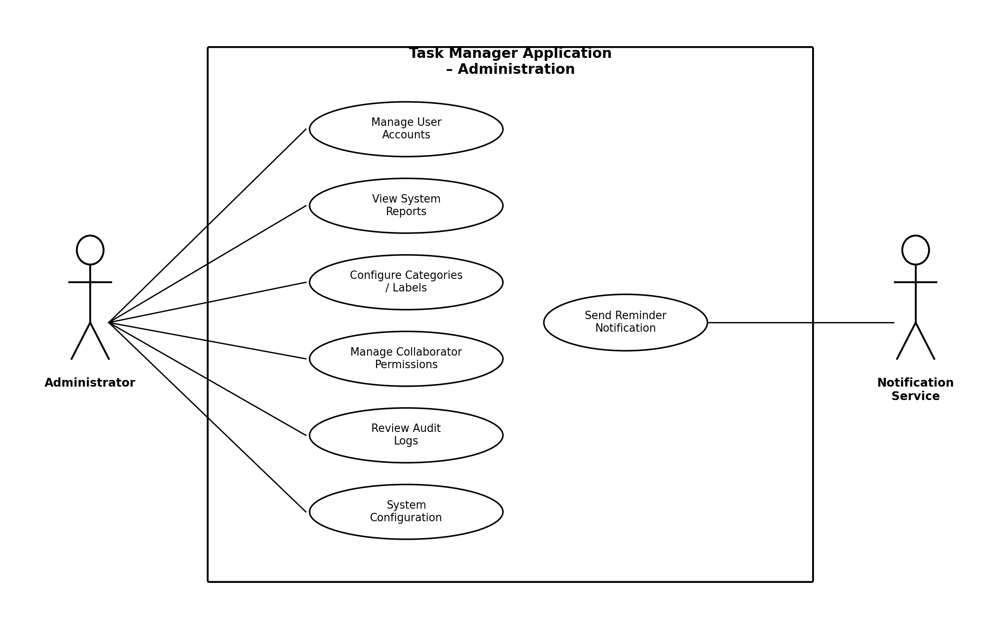

Figure 7.2: Administration & Notification use-case diagram

8. Requirements Traceability Matrix (RTM)

Every requirement from sections 4–5, mapped to its module, test case, and status (N = Not run, P = Pass, F = Fail).
Req ID | Requirement (short) | Module | Test case(s) | Status (N/P/A)
TM-F-001 | Register account | AuthModule | TC-Auth-01 | N
TM-F-002 | Authenticate user (session-based) | AuthModule | TC-Auth-02 | N
TM-F-003 | Lock account after failures | AuthModule | TC-Auth-03 | N
TM-F-004 | Reset password | AuthModule | TC-Auth-04 | N
TM-F-005 | Edit profile / change password | AuthModule | TC-Auth-05 | N
TM-F-010 | Create task | TaskModule | TC-Task-01 | N
TM-F-011 | Edit task | TaskModule | TC-Task-02 | N
TM-F-012 | Delete task | TaskModule | TC-Task-03 | N
TM-F-013 | Mark task complete | TaskModule | TC-Task-04 | N
TM-F-014 | Reminder notification | NotifModule | TC-Task-05 | N
TM-F-020 | Assign labels | TaskModule | TC-Org-01 | N
TM-F-021 | Filter / search tasks | TaskModule | TC-Org-02 | N
TM-F-022 | File attachment | StorageModule | TC-Org-03 | N
TM-F-030 | Share task | CollabModule | TC-Collab-01 | N
TM-F-031 | Collaborator notification | NotifModule | TC-Collab-02 | N
TM-F-032 | Revoke access | CollabModule | TC-Collab-03 | N
TM-F-033 | Add comment | CollabModule | TC-Collab-04 | N
TM-F-034 | Task activity history | TaskModule | TC-Collab-05 | N
TM-F-040 | Dashboard summary | DashModule | TC-Dash-01 | N
TM-F-041 | Export CSV | DashModule | TC-Dash-02 | N
TM-F-050 | Manage user accounts | AdminModule | TC-Admin-01 | N
TM-F-051 | Manage categories | AdminModule | TC-Admin-02 | N
TM-F-052 | Audit log | AdminModule | TC-Admin-03 | N
TM-F-053 | System configuration | AdminModule | TC-Admin-04 | N
TM-NF-001 | Response time target | WebUI / API | TC-Perf-01 | N
TM-NF-002 | Stability / error handling | Infra | TC-Ops-01 | N
TM-NF-003 | Concurrent user support | Infra | TC-Scale-01 | N
TM-NF-004 | Accessibility conformance | WebUI | TC-UX-01 | N
TM-NF-005 | Data retention | AdminModule | TC-Retention-01 | N
TM-SR-001 | TLS enforcement | Infra | TC-Sec-01 | N
TM-SR-002 | Password hashing | AuthModule | TC-Sec-02 | N
TM-SR-003 | RBAC enforcement | AuthModule | TC-Sec-03 | N
TM-SR-004 | Session expiry (Django sessions) | AuthModule | TC-Sec-04 | N
TM-SR-005 | Input validation | AuthModule / TaskModule | TC-Sec-05 | N

