Software Architecture and Design Specification
Project: Student Attendance Management System
Version: 1.2
Authors: Team 1
Organization: SE-Student-Attendance-Management-System
Date: 06-10-2026
Status: Draft – Updated

Revision History
Version | Date | Author | Change Summary
1.2 | 03-10-2026 | Team 1 | Added architecture design decisions, API-to-requirement traceability, and security threat considerations.

Approvals
Role | Name | Signature/Date
Project Manager | ANIRUDH M
Team Member | RAVITEJAS
Team Member | RAHUL DEVENDRA KAGAWAD

1. Introduction

1.1 Purpose
This document defines the software architecture and detailed design of the Student Attendance Management System. It translates the Phase 1 SRS into a clear logical architecture, UML component structure, service responsibilities, interfaces, interaction flows, security controls, and design decisions.

1.2 Scope
The system is a web-based application that supports user authentication, role-based access, student and course/class management, attendance recording and authorized modification, attendance viewing and percentage calculation, reporting, and role-specific dashboards.

1.3 Audience
The intended audience includes the project team, developers, testers, project manager, faculty/instructors, and other stakeholders involved in development, verification, maintenance, deployment, and evaluation.

1.4 Definitions
Term | Definition
SAD | Software Architecture and Design Specification
SRS | Software Requirements Specification
RBAC | Role-Based Access Control
API | Application Programming Interface
HTTPS | Hypertext Transfer Protocol Secure
REQ | Functional requirement identifier
BR | Business rule identifier

2. Document Overview

2.1 How to Use This Document
Section 3 presents the architecture, UML component view, architecture rationale, risks, requirement traceability, security design, architecture design decisions, and security threat considerations. Section 4 presents detailed interaction flows, APIs, API-to-requirement traceability, error handling, logging, monitoring, UX considerations, and next steps. All design decisions are aligned with the Phase 1 SRS.

2.2 Related Documents
- Student Attendance Management System – Software Requirements Specification, Version 1.0.
- Student Attendance Management System – Phase 2 Software Test Plan.
- Requirement Traceability Matrix in the SRS.

3. Architecture

3.1 Goals & Constraints
- Role-based access for Administrator, Faculty, and Student.
- Accurate and consistent attendance data.
- Modular architecture supporting maintainability.
- Meet SRS performance targets: major pages within 3 seconds, attendance processing within 2 seconds, normal reports within 5 seconds.
- Secure authentication, authorization, protected attendance data, and HTTPS where supported.
- Support growth in students, courses, classes, and users.
- SRS permits Python with Django/Flask or Java with Spring Boot; final framework is to be confirmed.
- SRS requires persistent database storage; exact DBMS is to be finalized.

3.2 Stakeholders & Concerns
Stakeholder | Concerns
Administrator | System-level records, access control, data integrity
Faculty | Assigned classes, attendance, reports
Student | Own attendance, history, percentage
Project Manager | Requirements, traceability, maintainability
Developers | Modularity, interfaces, implementation
Testers | Testability, errors, traceability

3.3 Component (UML) Diagram

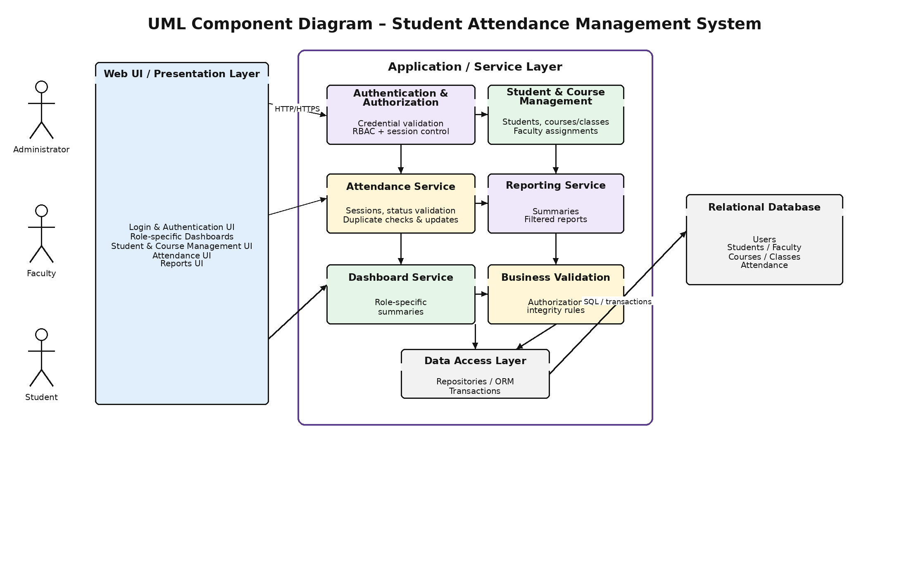
Figure 1. UML component diagram – logical system architecture.

3.4 Component Descriptions
Component | Responsibility
Web UI / Presentation Layer | Provides login, role-based dashboards, student/course screens, attendance screens, and reporting views.
Authentication & Authorization | Validates credentials, manages sessions, and enforces role-based access control.
Student & Course Management | Maintains student records, courses/classes, and faculty-to-class assignments.
Attendance Service | Creates attendance sessions, validates status values, prevents duplicates, and permits only authorized modifications.
Reporting Service | Generates attendance summaries and filtered reports for authorized users.
Dashboard Service | Builds role-specific summaries and dashboard information.
Data Access Layer | Provides validated, transaction-aware access between application services and persistent storage.
Relational Database | Stores users, students, faculty assignments, courses/classes, attendance sessions, and attendance records.

3.5 Chosen Architecture Pattern and Rationale
A layered architecture is selected for Phase 2. The presentation layer handles user interaction, application services implement business functions, the data access layer controls persistence, and the relational database stores system records. This separation improves maintainability, testability, security, and traceability while avoiding unnecessary complexity for a mini-project.

3.6 Technology Stack & Data Stores
Area | Phase 2 Design Decision
Client | Standard modern web browser
Communication | HTTP/HTTPS; HTTPS for protected data where supported
Backend | Layered application; exact framework to be confirmed (Django/Flask or Spring Boot)
API | Logical REST-style HTTP APIs
Database | Relational persistent database; exact DBMS to be confirmed
Authentication | Credential validation + RBAC
UML Tools | PlantUML / draw.io or equivalent

3.7 Risks & Mitigations
Risk | Mitigation
Framework/DB not finalized | Confirm choices before implementation; keep interfaces logical.
Unauthorized attendance modification | Perform server-side role checks and verify faculty class assignments before allowing attendance changes.
Duplicate attendance | Enforce uniqueness for the student, class, and attendance-session combination.
DB/network failure | Use transactions and provide deployment-level backup and recovery procedures.
Performance degradation | Use efficient queries, suitable indexes, filtering/pagination, and performance testing.
Inconsistent related data | Use input validation, database transactions, foreign-key constraints, and integrity checks.

3.8 Traceability to Requirements
Requirement | Primary Architecture Component
REQ-01 | Authentication & Authorization
REQ-02 | Authentication & Authorization / RBAC
REQ-03 | Student & Course Management
REQ-04 | Student & Course Management
REQ-05 | Student & Course Management
REQ-06 | Student & Course Management / Authorization
REQ-07 | Attendance Service
REQ-08 | Attendance Service / Data Access
REQ-09 | Attendance Service / Data Access
REQ-10 | Attendance Service / Dashboard
REQ-11 | Attendance Service / Dashboard
REQ-12 | Reporting Service
REQ-13 | Reporting Service
REQ-14 | Dashboard Service
REQ-15 | Dashboard / Reporting

3.9 Security Architecture
Concern | Design Response
Authentication | Require successful authentication before protected functions can be accessed.
Authorization | RBAC for Administrator, Faculty, Student.
Student privacy | Restrict students to their own attendance records, history, percentages, and summaries.
Faculty access | Allow faculty to manage attendance only for classes assigned to them.
Credential protection | Do not store passwords in plain text; use a secure password-hashing mechanism during implementation.
Transport | HTTPS where supported.
Integrity | Validation, duplicate checks, authorized modification.
Session | Invalidate the authenticated session/token on logout.

3.10 Architecture Design Decisions
The following design decisions refine the Phase 2 architecture while keeping the functional requirements and system scope defined in the Phase 1 SRS unchanged.
Decision | Rationale
Layered architecture | Separates presentation, business logic, persistence, and storage responsibilities to improve maintainability, testability, security, and traceability.
Service-based component separation | Assigns clear responsibilities to authentication, student/course management, attendance, reporting, and dashboard services.
Centralized authentication and RBAC | Provides consistent access control for Administrator, Faculty, and Student roles.
Data Access Layer | Separates database operations from business logic and supports validated, transaction-aware persistence.
REST-style APIs | Provides clear logical interfaces between the presentation layer and application services.
Transaction-based attendance persistence | Helps maintain attendance consistency and prevents partially completed attendance updates.
UML-based component and interaction modelling | Makes architecture, interactions, and requirement-to-design relationships easier to understand and trace.

3.11 Security Threat Considerations
The following threat considerations refine the existing security architecture and identify the main security risks to be addressed during implementation.
Threat | Mitigation
Unauthorized login | Credential validation and secure password hashing.
Privilege escalation | Enforce server-side RBAC checks for every protected operation.
Unauthorized attendance modification | Verify the faculty role and assigned class before allowing attendance changes.
Duplicate attendance | Use service-level validation and database uniqueness constraints.
Student data exposure | Restrict students to their own attendance records, history, percentages, and summaries.
Session misuse | Invalidate the authenticated session/token on logout and enforce authorization on protected operations.

4. Design

4.1 Design Overview
The design separates presentation, authentication/authorization, student and course management, attendance processing, reporting, dashboard functions, and data access. Each major service has a defined responsibility and interface, and the design remains traceable to the 15 functional requirements identified in the Phase 1 SRS.

4.2 UML Sequence Diagrams
Two key flows are specified below.
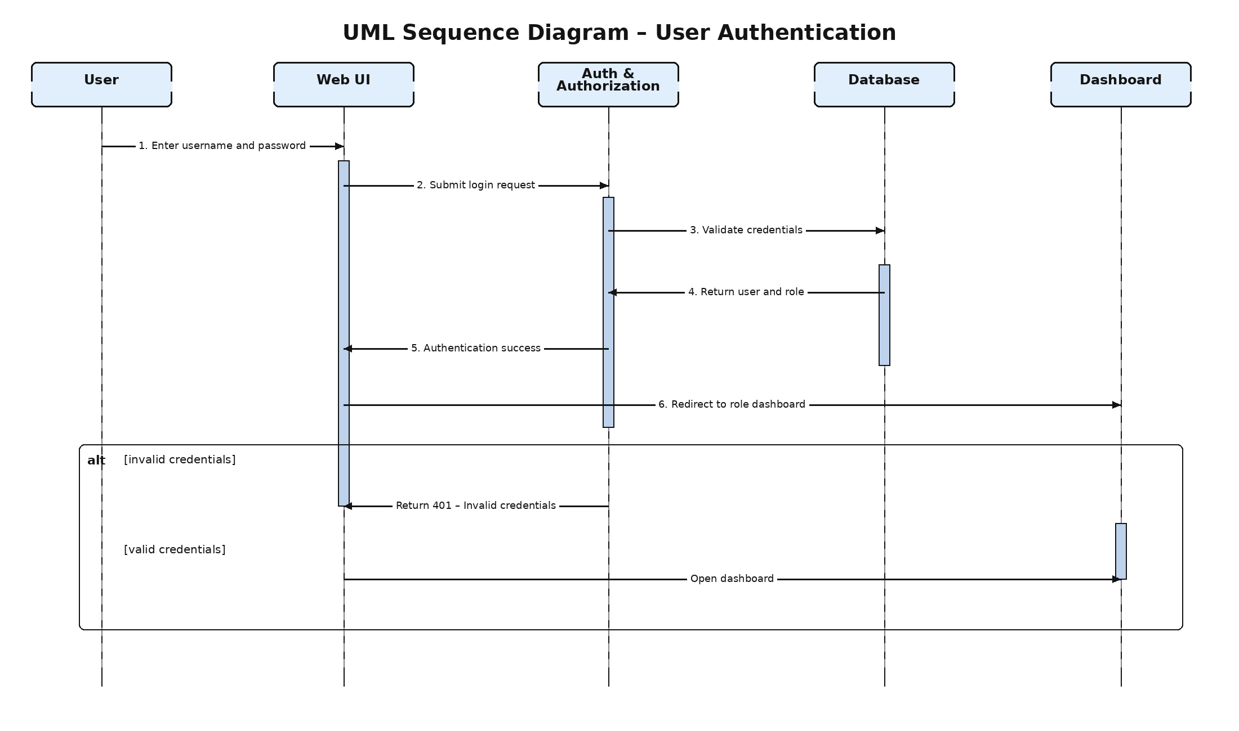
Figure 2. UML sequence diagram – user authentication.
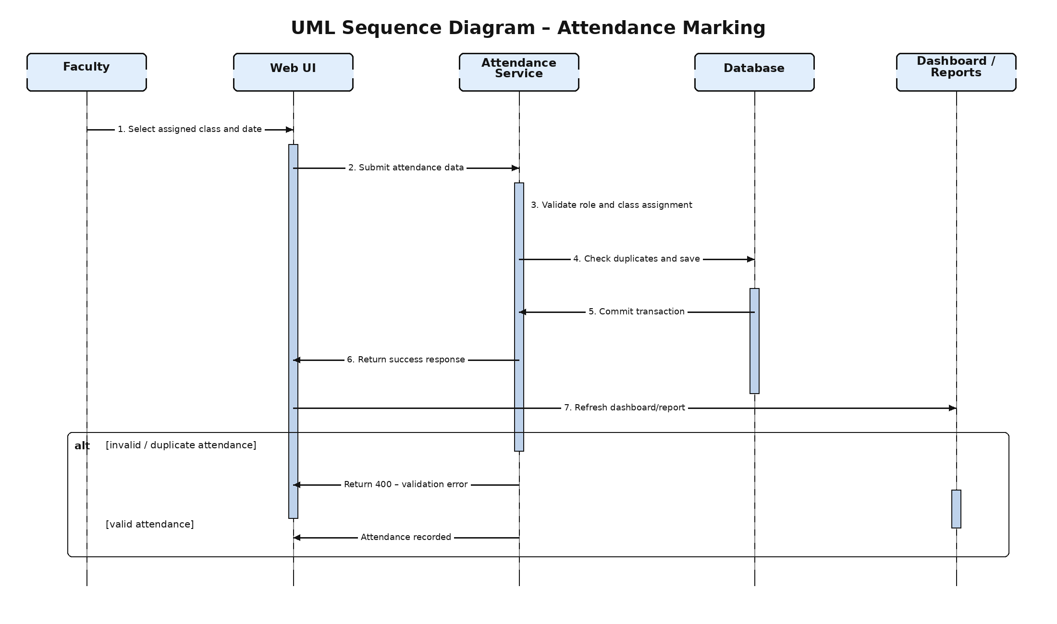
Figure 3. UML sequence diagram – attendance marking.

4.3 API Design
The following are logical API interfaces intended to define responsibilities and request/response behavior. Exact framework syntax, authentication mechanism, validation rules, and final schemas will be finalized after the backend technology and database are selected.

4.3.1 Authentication API
Item | Definition
Endpoint | POST /api/auth/login
Purpose | Authenticate a registered user and establish an authenticated session or token.
Request | { username, password }
Success | { status, userId, role }
Errors | 401 Invalid credentials; 400 Invalid request

4.3.2 Attendance API
Item | Definition
Endpoint | POST /api/attendance
Purpose | Record attendance for an authorized faculty member and an assigned class/session.
Request | { courseId, sessionDate, attendance: [{studentId, status}] }
Success | { status, message }
Errors | 400 Invalid/duplicate data; 403 Unauthorized class access

4.3.3 API ↔ Requirement Traceability
The logical API interfaces are mapped to their responsible architecture components and the functional requirements they support.
API | Responsible Component | Related Requirements
POST /api/auth/login | Authentication & Authorization | REQ-01, REQ-02
POST /api/attendance | Attendance Service | REQ-07, REQ-08, REQ-09

4.4 Error Handling, Logging & Monitoring
- Validate all client-provided inputs before business processing or database persistence.
- Return consistent error responses for invalid input, authentication or authorization failures, duplicate attendance, unavailable resources, and unexpected server errors.
- Never log passwords, authentication secrets, tokens, or other sensitive credential information.
- Record useful operational events such as authentication failures, authorization failures, attendance-processing errors, and report-generation failures.
- Monitor page response time, attendance-processing time, report-generation time, application errors, and database errors against the SRS performance targets.
- Use database transactions for attendance persistence so that a failed operation does not leave partially updated attendance records.

4.5 UX Design
- Provide a simple and consistent login flow with predictable navigation.
- Display a role-specific dashboard after successful authentication.
- Administrator screens for system-level records.
- Faculty screens for assigned classes, attendance, and reports.
- Student screens for personal attendance, history, percentage, and summaries.
- Provide clear, user-friendly validation and error messages without exposing internal implementation details.
- Keep common attendance operations accessible through minimal and consistent navigation.

4.6 Open Issues & Next Steps
- Confirm the backend framework (Django/Flask or Spring Boot) before implementation.
- Confirm the relational database technology and connection strategy.
- Finalize the database schema, primary/foreign-key relationships, constraints, and indexes.
- Finalize API request/response schemas, validation rules, authentication handling, and error codes.
- Add implementation-specific module, class, and API references to the RTM after coding begins.
- Complete the Phase 2 Test Plan and map test cases to REQ-01 through REQ-15.

5. Appendices

5.1 Glossary
Term | Definition
Administrator | System-level management user.
Faculty | Teaching staff managing assigned-class attendance.
Student | User viewing own attendance information.
Attendance Session | Class/session for which attendance is recorded.
RBAC | Role-Based Access Control.
API | Application Programming Interface.
SRS | Software Requirements Specification.
SAD | Software Architecture and Design Specification.

5.2 References
- Student Attendance Management System – Software Requirements Specification, Version 1.0, Team 1, 2026.
- IEEE Computer Society, IEEE Std 29148-2018: Systems and Software Engineering — Life Cycle Processes — Requirements Engineering, IEEE, 2018.
- Ian Sommerville, Software Engineering, 10th Edition, Pearson, 2015.
- Roger S. Pressman and Bruce R. Maxim, Software Engineering: A Practitioner's Approach, 9th Edition, McGraw-Hill, 2019.
- PES University, Department of Computer Science and Engineering, Software Architecture and Design Specification template.

5.3 Tools
- Microsoft Word – document preparation.
- PlantUML / draw.io – UML diagrams.
- GitHub – version control and collaboration.
- Selected backend framework and database tools – to be finalized.

