Software Requirements Specification

For
Student Attendance Management System

Version 1.1 approved
Prepared by: Team 1
Organization: SE-Student-Attendance-Management-System
Date created: 08 September 2026
Table of Contents
Table of Contents ii
Revision History ii
1. Introduction 1
1.1 Purpose 1
1.2 Intended Audience and Reading Suggestions 1
1.3 Product Scope 1
1.4 References 1
2. Overall Description 2
2.1 Product Perspective 2
2.2 Product Functions 2
2.3 User Classes and Characteristics 2
2.4 Operating Environment 2
2.5 Design and Implementation Constraints 2
2.6 Assumptions and Dependencies 3
3. External Interface Requirements 3
3.1 User Interfaces 3
3.2 Software Interfaces 3
3.3 Communications Interfaces 3
4. Analysis Models
5. System Features 4
5.1 System Feature 1 4
5.2 System Feature 2 (and so on) 4
6. Other Nonfunctional Requirements 4
6.1 Performance Requirements 4
6.2 Safety Requirements 5
6.3 Security Requirements 5
6.4 Software Quality Attributes 5
6.5 Business Rules 5
7. Other Requirements 5
Appendix A: Glossary 5
Appendix B: Field Layouts 5
Appendix C: Requirement Traceability matrix 6

Revision History
Name | Date | Reason For Changes | Version
Team 1 | 07-09-2026 | Initial SRS document created | 1.0
 | 08-09-2026 | Added External Interface Requirements and Analysis Models
  Team 1
  1.1

Introduction

Purpose
The purpose of the Student Attendance Management System is to provide a centralized software system for managing and tracking student attendance. The system enables authorized users to record, update, view, and generate attendance information efficiently. It aims to reduce manual effort, minimize errors in attendance records, and provide students and faculty with convenient access to attendance information.

Intended Audience
This document is intended for the project team, project manager, developers, testers, faculty members, and other stakeholders involved in the Student Attendance Management System. Project managers can use this document to understand the project scope and requirements, developers can use it to implement the system, and testers can use it to derive test cases and verify the implemented functionality. Readers are recommended to first review the Introduction and Overall Description sections, followed by System Features and Nonfunctional Requirements for detailed system requirements.

Product Scope

The Student Attendance Management System is designed to automate the process of recording, managing, monitoring, and reporting student attendance. The system provides role-based access for administrators, faculty members, and students. Faculty members can manage attendance for their assigned classes, students can view their attendance records and attendance percentage, and authorized users can generate attendance reports. The system aims to improve accuracy, reduce manual attendance management, and provide timely access to attendance information.

References(Temp)
PES University, Department of Computer Science and Engineering, Software Requirements Specification Template, Version 1.0.
PES University, Department of Computer Science and Engineering, Test Plan Document.

Overall Description

Product Perspective
The Student Attendance Management System is a new, self-contained software system developed to automate and simplify the management of student attendance. It provides a centralized platform for managing student information, recording attendance, viewing attendance records, and generating attendance reports. The system consists of user interfaces, application logic, and a database for storing and retrieving attendance-related information. The system is intended to reduce the dependence on manual attendance records and improve the accuracy and accessibility of attendance information.

Product Functions

The major functions of the Student Attendance Management System include:
- User authentication and role-based access.
- Student information management.
- Faculty and class/course management.
- Recording and managing student attendance.
- Viewing attendance records and attendance percentage.
- Generating attendance reports.
- Managing authorized attendance corrections.
- Providing role-specific information through dashboards.

User Classes and Characteristics

The system will support the following user classes:

1. Administrator:
The administrator manages system-level information, including student, faculty, and course/class records. The administrator has the highest level of access to system management functions.
2. Faculty:
Faculty members manage attendance for their assigned classes and courses. They can record attendance, view attendance information, and generate relevant attendance reports.
3. Student:
Students can access their own attendance records, attendance percentage, and attendance history. Students have read-only access to their attendance information except for functions explicitly permitted by the system.
Users will have access only to the functions permitted by their respective roles.

Operating Environment
The Student Attendance Management System will operate as a web-based application accessible through a standard web browser. The system will require a server environment for running the application and a database server for storing system data. Users will access the system through computers or other supported devices connected to the network. The specific programming framework, database, operating system, and deployment environment will be finalized during the design and implementation phase.

Design and Implementation Constraints

The following constraints apply to the development and implementation of the system:
- The system shall be developed using one of the programming technologies specified for the project: Python with Django/Flask or Java with Spring Boot.
- The system shall use a database for persistent storage of student, faculty, course, and attendance information.
- Access to system functions shall be controlled according to user roles.
- The system shall follow appropriate software development and coding practices. The system shall use standard web communication protocols for communication between the client and server.
- Attendance data shall be protected from unauthorized access or modification.

2.6 Assumptions and Dependencies

The following assumptions and dependencies are considered for the system:
- Users are assumed to have valid credentials to access the system.
- Faculty members are assumed to be authorized to manage attendance for their assigned classes.
- Student and course information required by the system is assumed to be available and accurate.
- Users are assumed to have access to a supported web browser and network connection.
- The system depends on the availability of the application server and database server.
- The system depends on the selected software framework and database technology for its implementation.
- The accuracy of attendance reports depends on the correctness of the attendance data entered into the system.

External Interface Requirements

3.1 User Interfaces
The Student Attendance Management System shall provide a web-based user interface through which users can access the functions permitted according to their roles.
The system shall provide separate access and functionality for the following user classes:
- Administrator
- Faculty
- Student
Login Interface
The system shall provide a login interface through which authorized users can access the system.
The login interface shall contain:
- User ID/Username field
- Password field
- Login button
- Appropriate error message for invalid login credentials
Administrator Interface
The Administrator interface shall provide access to system-level management functions, including:
- Student information management
- Faculty information management
- Course/class management
- Attendance-related management
- Attendance reports
Faculty Interface
The Faculty interface shall provide access to functions related to the faculty member's assigned classes and courses, including:
- Viewing assigned classes/courses
- Recording student attendance
- Viewing attendance information
- Managing authorized attendance corrections
- Generating relevant attendance reports
Student Interface
The Student interface shall provide access to the student's own attendance information, including:
- Attendance records
- Attendance percentage
- Attendance history
General User Interface Requirements
- The system shall provide consistent navigation across the application.
- The system shall display appropriate messages when invalid or incomplete information is entered.
- The system shall restrict users from accessing functions that are not permitted for their roles.
- The interface shall be accessible through a standard web browser.
- The interface shall provide clear labels for input fields, buttons, and displayed information.
The detailed user interface design may be finalized during the design and implementation phase.

3.2 Software Interfaces
The Student Attendance Management System shall interact with the software components required to provide its functionality.
Web Browser Interface
The system shall provide a web-based interface accessible through a standard web browser.
Users shall interact with the application through the browser to:
- Submit login credentials.
- Access permitted system functions.
- Enter attendance information.
- View attendance information.
- Request attendance reports.
Application Server Interface
The application server shall process requests received from users and execute the application logic of the Student Attendance Management System.
The application server shall:
- Authenticate users.
- Verify user roles.
- Process attendance-related operations.
- Retrieve and update information in the database.
- Return appropriate responses to users.
Database Interface
The system shall use a database for persistent storage of system information.
The database shall store information related to:
- Users
- Students
- Faculty
- Courses/classes
- Attendance records
The application shall communicate with the database to create, retrieve, update, and manage the required information.
The specific database technology is dependent on the technology selected during the implementation phase, as specified in the existing SRS.
Software Dependencies
The system shall depend on the selected programming framework and database technology for its implementation. The current SRS specifies that the implementation may use Python with Django/Flask or Java with Spring Boot.

3.3 Communications Interfaces
The Student Attendance Management System shall use standard web communication protocols for communication between the client and server.
The system shall support communication between:
- User's web browser
- Application server
- Database server
The following requirements shall apply:
- Communication between the web browser and application server shall use standard web protocols.
- HTTP/HTTPS shall be used for web-based communication.
- Sensitive information transmitted between the user and server shall be protected against unauthorized access.
- The system shall require a network connection for users to access the web application.
- Requests and responses between the client and server shall follow the communication mechanisms supported by the selected application framework.
The system shall not depend on specialized communication hardware for normal operation.

4 Analysis Models

The Student Attendance Management System can be represented using analysis models that describe the interaction between users and the system and the structure of the data managed by the system.

The following analysis models are applicable to the system:

Use Case Diagram

Entity-Relationship Diagram

The SRS template specifically identifies use case diagrams and, where applicable, entity-relationship diagrams as appropriate analysis models.
4.1 Use Case Diagram
The Use Case Diagram shall represent the interactions between the three user classes of the Student Attendance Management System:
- Administrator
- Faculty
- Student
Administrator Use Cases
The Administrator shall be associated with:
- Login
- Manage Student Information
- Manage Faculty Information
- Manage Course/Class Information
- View Attendance Information
- Generate Attendance Reports
Faculty Use Cases
The Faculty shall be associated with:
- Login
- View Assigned Classes
- Record Attendance
- View Attendance Information
- Manage Authorized Attendance Corrections
- Generate Attendance Reports
Student Use Cases
The Student shall be associated with:
- Login
- View Attendance Records
- View Attendance Percentage
- View Attendance History
Use Case Representation
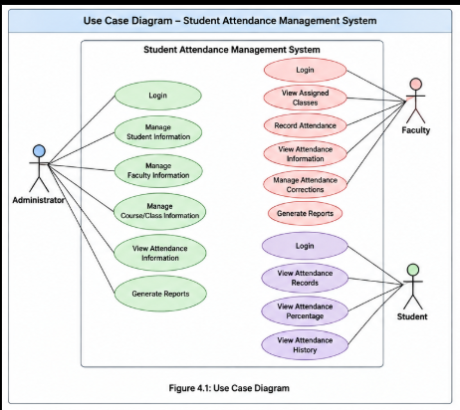
4.2 Entity-Relationship Diagram
The Entity-Relationship Diagram shall represent the major entities involved in managing student attendance.
The main entities identified from the system requirements are:
- User
- Student
- Faculty
- Course/Class
- Attendance
Entity Relationships
The major relationships are:
- A User is associated with a system role.
- A Student is enrolled in a course/class.
- A Faculty member is assigned to a course/class.
- An Attendance record is associated with a student and a course/class.
- A Faculty member records attendance for students belonging to the assigned class/course.
Simplified ER Representation
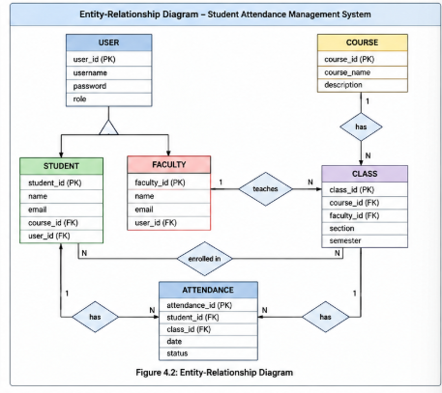
The exact attributes and database relationships can be finalized during the design phase because the current SRS does not specify a finalized database schema.
4.3 High-Level System Flow
The overall flow of the Student Attendance Management System can be represented as follows:
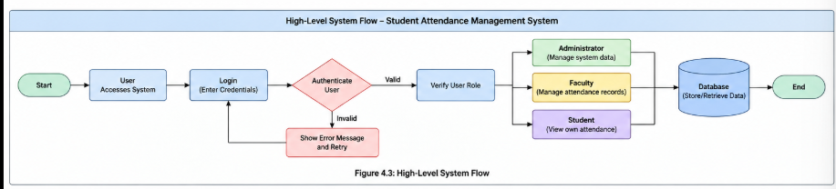
This model provides a high-level representation of how users interact with the system and how the system communicates with the database.

System Features
<This template illustrates organizing the functional requirements for the product by system features, the major services provided by the product. You may prefer to organize this section by use case, mode of operation, user class, object class, functional hierarchy, or combinations of these, whatever makes the most logical sense for your product.>

System Feature 1
<Don’t really say “System Feature 1.” State the feature name in just a few words.>
5.1.1 Description and Priority
<Provide a short description of the feature and indicate whether it is of High, Medium, or Low priority. You could also include specific priority component ratings, such as benefit, penalty, cost, and risk (each rated on a relative scale from a low of 1 to a high of 9).>
5.1.2 Stimulus/Response Sequences
<List the sequences of user actions and system responses that stimulate the behavior defined for this feature. These will correspond to the dialog elements associated with use cases.>
5.1.3 Functional Requirements
<Itemize the detailed functional requirements associated with this feature. These are the software capabilities that must be present in order for the user to carry out the services provided by the feature, or to execute the use case. Include how the product should respond to anticipated error conditions or invalid inputs. Requirements should be concise, complete, unambiguous, verifiable, and necessary. Use “TBD” as a placeholder to indicate when necessary information is not yet available.>

<Each requirement should be uniquely identified with a sequence number or a meaningful tag of some kind.>

REQ-1:
REQ-2:

System Feature 2 (and so on)

Other Nonfunctional Requirements

Performance Requirements
<If there are performance requirements for the product under various circumstances, state them here and explain their rationale, to help the developers understand the intent and make suitable design choices. Specify the timing relationships for real time systems. Make such requirements as specific as possible. You may need to state performance requirements for individual functional requirements or features.>

Safety Requirements
<Specify those requirements that are concerned with possible loss, damage, or harm that could result from the use of the product. Define any safeguards or actions that must be taken, as well as actions that must be prevented. Refer to any external policies or regulations that state safety issues that affect the product’s design or use. Define any safety certifications that must be satisfied.>

Security Requirements
<Specify any requirements regarding security or privacy issues surrounding use of the product or protection of the data used or created by the product. Define any user identity authentication requirements. Refer to any external policies or regulations containing security issues that affect the product. Define any security or privacy certifications that must be satisfied.>

Software Quality Attributes
<Specify any additional quality characteristics for the product that will be important to either the customers or the developers. Some to consider are: adaptability, availability, correctness, flexibility, interoperability, maintainability, portability, reliability, reusability, robustness, testability, and usability. Write these to be specific, quantitative, and verifiable when possible. At the least, clarify the relative preferences for various attributes, such as ease of use over ease of learning.>

Business Rules
<List any operating principles about the product, such as which individuals or roles can perform which functions under specific circumstances. These are not functional requirements in themselves, but they may imply certain functional requirements to enforce the rules.>

Also include Domain requirements here.

Other Requirements
<Define any other requirements not covered elsewhere in the SRS. This might include database requirements, internationalization requirements, legal requirements, reuse objectives for the project, and so on. Add any new sections that are pertinent to the project.>
Appendix A: Glossary
<Define all the terms necessary to properly interpret the SRS, including acronyms and abbreviations. You may wish to build a separate glossary that spans multiple projects or the entire organization, and just include terms specific to a single project in each SRS.>

Appendix B: Field Layouts
An Excel sheet containing field layouts and properties/attributes and report requirements.

Sample sheet with information required to register the customer
Field | Length | Data Type | Description | Is Mandatory
Account Number | 16 | Numeric |  | Y
ISFC code | 11 | Alphanumeric |  | Y
Card Amount | 20 | Numeric |  | Y
Mandate Start Date | 8 | Date | Date of Mandate Registration | N
Mandate End Date | 8 | Date | Date of Mandate Expiry | N
Status | 25 | Alphanumeric | Status of Registration | Y
Customer Name | 60 | String |  | Y
Reject Reason Code | 4 | String | Reject Reason code in case mandate is rejected | N

Sample Report Requirements: Include the fields to be included in the report
Registration Report | Transaction Report
Bank Account Number | Transaction Reference Number
ISFC Code | Bank Account Number
Bank Name | IFSC Code
Account Status | Bank Name
Account Type | Customer Name
Customer Name | Card Number
Card Number | Debit Transaction Amount
SI Start Date | Transaction Date
Status | Status
Remarks | Debit Attempt Number
 | Remarks

Appendix C: Requirement Traceability Matrix
Sl. No | Requirement ID | Brief Description of Requirement | Architecture Reference | Design Reference | Code File Reference | Test Case ID | System Test Case ID

