Student Attendance Management System
Initial Data Model
Explanation of entities, relationships and design decisions
Draft v0.1 | Issue #8: Review SRS Entities and Draft Initial Data Model
Based on SRS v1.0 and SAD v1 | Team 1, PES University

1. Purpose
This document explains the initial data model for the Student Attendance Management System. It describes what each table stores, how the tables relate to each other, and how the design supports the requirements in the Software Requirements Specification (SRS v1.0).
The model is a draft for team review. It is DBMS-neutral because the SRS (section 2.5) leaves the database technology to the design phase. A matching SQL script is provided separately in database/schema.sql.

2. Why the SRS Entity List Was Extended
SRS section 4.2 lists five possible entities: User, Student, Faculty, Course and Attendance. It also says the final set should be settled when the database is designed. Reviewing the requirements showed that five entities are not enough:
- Course and class are mixed. Appendix B uses one "Course/Class" table with a single Faculty ID. That ties one faculty member to a course and mixes the catalog (what a course is) with the offering (who teaches which section). The model splits it into Course and ClassSection.
- No record of enrolment. Section 5.4.2 says the system shows "the students enrolled in the selected class", but nothing stores who is enrolled. The model adds Enrollment.
- "Attendance session" is undefined. REQ-08, REQ-09, BR-06 and the SAD all refer to an attendance session, but Appendix B has only an attendance date. The model adds AttendanceSession.
- Login is not linked to a person. BR-03 to BR-05 limit what faculty and students can see, which requires knowing which student or faculty member a login belongs to. The model links User to Student and Faculty.
The result is eight entities, plus one optional audit table.
Entity | Role in the system | Source
User | Login account and role | SRS 4.2, App. B
Student | Student profile | SRS 4.2, App. B
Faculty | Faculty profile | SRS 4.2, App. B
Course | Subject in the course catalog | SRS 4.2, App. B (split)
ClassSection | A course taught as a section in a term, with its faculty | New (split from Course/Class)
Enrollment | Which students belong to which section | New
AttendanceSession | One class meeting on a date | New
AttendanceRecord | One student's status in one session | SRS "Attendance", refined
AttendanceAudit (optional) | History of changes to attendance records | New

3. Entity-Relationship Diagram
The diagram shows the entities, their main attributes (PK = primary key, FK = foreign key, UK = unique) and the cardinality of each relationship.
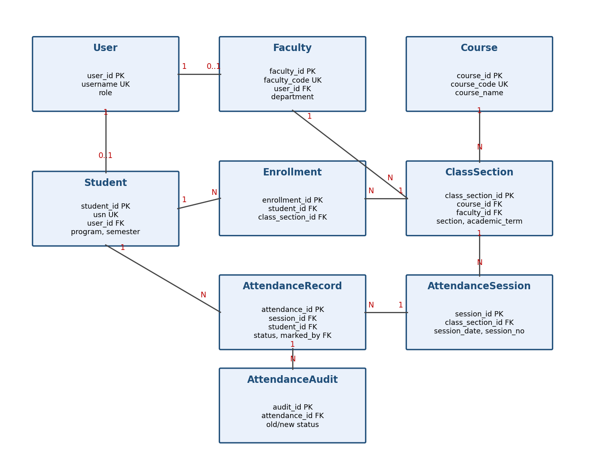

4. Entity Descriptions
Field lengths and mandatory flags follow SRS Appendix B. Each table uses a generated integer primary key. The identifiers named in the SRS (USN, Faculty ID, Course ID) are kept as unique columns, so an ID can be corrected without changing the rows that point to it.

4.1 User
Holds the login account for every person who uses the system: administrators, faculty and students. It supports authentication and role-based access (REQ-01, REQ-02, BR-01).
Attribute | Type | Key / Null | Meaning
user_id | Integer | PK | Unique identifier of the account.
username | VARCHAR(50) | UK, required | Login name.
password_hash | VARCHAR(255) | Required | Hashed password. Never stored in plain text (SRS 6.3).
role | VARCHAR(20) | Required | ADMIN, FACULTY or STUDENT.
is_active | Boolean | Required | Lets an account be disabled without deleting it.

4.2 Student
Stores student details needed for attendance (REQ-03, REQ-04). Each student may be linked to one login account.
Attribute | Type | Key / Null | Meaning
student_id | Integer | PK | Internal identifier.
usn | VARCHAR(15) | UK, required | Student ID / USN from the SRS.
user_id | Integer | FK, UK, optional | Login account of the student.
name | VARCHAR(100) | Required | Student name.
email | VARCHAR(100) | UK, required | Email address.
phone | VARCHAR(15) | Optional | Contact number.
program | VARCHAR(50) | Required | Academic program ("Course/Program" in the SRS).
semester | SMALLINT | Required | Current semester (1 to 99).
is_active | Boolean | Required | Marks students who have left, without deleting history.

4.3 Faculty
Stores teaching staff. Faculty are assigned to class sections (REQ-06) and may mark attendance only for those sections (BR-03).
Attribute | Type | Key / Null | Meaning
faculty_id | Integer | PK | Internal identifier.
faculty_code | VARCHAR(15) | UK, required | Faculty ID from the SRS.
user_id | Integer | FK, UK, optional | Login account of the faculty member.
name | VARCHAR(100) | Required | Faculty name.
email | VARCHAR(100) | UK, required | Email address.
department | VARCHAR(100) | Required | Department.
is_active | Boolean | Required | Marks staff who have left.

4.4 Course
The course catalog. A course describes a subject and does not say who teaches it or when (REQ-05).
Attribute | Type | Key / Null | Meaning
course_id | Integer | PK | Internal identifier.
course_code | VARCHAR(20) | UK, required | Course ID from the SRS.
course_name | VARCHAR(100) | Required | Name of the course.
semester | SMALLINT | Required | Semester in which the course is offered.

4.5 ClassSection
A course offered as a section in a given term, taught by one faculty member. This is the "class" that faculty see in their list of assigned classes (REQ-05, REQ-06). The combination of course, section and term is unique.
Attribute | Type | Key / Null | Meaning
class_section_id | Integer | PK | Internal identifier.
course_id | Integer | FK, required | The course being taught.
faculty_id | Integer | FK, required | The assigned faculty member.
section | VARCHAR(20) | Required | Section identifier ("Class/Section" in the SRS).
academic_term | VARCHAR(20) | Required | Term, for example 2026-ODD. Keeps the same section in different years apart.

4.6 Enrollment
Links a student to a class section. When a faculty member opens a class to mark attendance, the student list comes from this table (section 5.4.2). A student can be enrolled in a section only once.
Attribute | Type | Key / Null | Meaning
enrollment_id | Integer | PK | Internal identifier.
student_id | Integer | FK, required | The student.
class_section_id | Integer | FK, required | The section the student is enrolled in.

4.7 AttendanceSession
One class meeting of a section on a date. Attendance is recorded against a session, which gives the SRS term "attendance session" a concrete form. The session number allows more than one meeting of the same section on one day.
Attribute | Type | Key / Null | Meaning
session_id | Integer | PK | Internal identifier.
class_section_id | Integer | FK, required | The section that met.
session_date | DATE | Required | Date of the session.
session_no | SMALLINT | Required | Number of the session on that date (default 1).

4.8 AttendanceRecord
The core table: whether one student was present or absent in one session (REQ-07, REQ-08). A student can have only one record per session, which implements REQ-09 and BR-06. Course and class are found through the session, so they are not repeated here.
Attribute | Type | Key / Null | Meaning
attendance_id | Integer | PK | Attendance ID from the SRS.
session_id | Integer | FK, required | The session.
student_id | Integer | FK, required | The student.
status | VARCHAR(10) | Required | PRESENT or ABSENT.
marked_by | Integer | FK, required | User who recorded the attendance.
marked_at | Timestamp | Required | When it was recorded.
modified_at | Timestamp | Optional | When it was last changed (REQ-09).

4.9 AttendanceAudit (optional)
Keeps a history of every change to an attendance status. It supports the SRS requirements to protect and maintain the integrity of attendance data (sections 6.2 and 6.3).
Attribute | Type | Key / Null | Meaning
audit_id | Integer | PK | Internal identifier.
attendance_id | Integer | FK, required | The record that was changed.
old_status | VARCHAR(10) | Required | Status before the change.
new_status | VARCHAR(10) | Required | Status after the change.
changed_by | Integer | FK, required | User who made the change.
changed_at | Timestamp | Required | When the change was made.

5. Relationships
Relationship | Cardinality | Explanation
User to Student | 1 to 0..1 | A student account belongs to one student. Admin accounts have no student profile.
User to Faculty | 1 to 0..1 | A faculty account belongs to one faculty member.
Course to ClassSection | 1 to many | A course can be offered as many sections and terms.
Faculty to ClassSection | 1 to many | A faculty member teaches many sections. Each section has one faculty member.
Student to ClassSection | many to many | Handled through Enrollment.
ClassSection to AttendanceSession | 1 to many | A section holds many sessions over a term.
AttendanceSession to AttendanceRecord | 1 to many | A session has one record for each student.
Student to AttendanceRecord | 1 to many | A student accumulates records over time.
AttendanceRecord to AttendanceAudit | 1 to many | A record can be changed several times.

6. How the Model Supports the SRS Rules
Rule | How the model supports it
REQ-09 / BR-06: no duplicate attendance | A unique constraint on (session, student) in AttendanceRecord. The application also validates before saving.
BR-03 / BR-05: faculty act only on assigned classes | Each ClassSection has one faculty. Before saving or changing attendance, the system checks that the logged-in user's faculty profile is the section's faculty.
BR-04 / SRS 6.3: students see only their own data | The logged-in user is mapped to a student profile, and attendance is filtered by that student.
BR-07 / REQ-11: percentage from stored records | The percentage is calculated when requested and is never stored (see section 7).
REQ-13: report filters | Attendance joins to session, section and course, so reports can filter by student, course, class or date range. A date index keeps them fast.
SRS 6.2 / 6.3: no accidental deletion | Attendance foreign keys block deletion of referenced rows. Students, faculty and users are deactivated rather than deleted. The audit table records edits.
SRS 6.3: passwords | Only a password hash is stored.

7. Attendance Percentage
Attendance percentage is the number of sessions attended divided by the total sessions, multiplied by 100 (SRS glossary, BR-07). Because it can always be worked out from AttendanceRecord, storing it would risk it going out of date after an edit. The schema therefore includes a view, v_attendance_summary, which returns, for each student and class section, the total classes, classes present, classes absent and the attendance percentage. These are the fields required by the Attendance Report and Student Attendance Summary layouts in SRS Appendix B.

8. Assumptions and Open Questions
The draft makes the following assumptions. Each should be confirmed by the team or stakeholders before the model is finalised.
# | Question | Assumption in this draft
1 | Is a "class" a section of a course or a single meeting? | A section. A single meeting is an AttendanceSession.
2 | Can a section have more than one faculty member? | No, one per section.
3 | Are statuses such as Late or Excused needed? | No, only Present and Absent.
4 | Should the percentage use all sessions held, or only those with a record for the student? This matters for a student who joins mid-term. | Sessions that have a record for that student.
5 | Is an academic term needed to separate repeated sections? | Yes, academic_term is included.
6 | Use generated keys or the SRS identifiers (USN and so on) as primary keys? | Generated keys, with SRS identifiers as unique columns.
7 | Who may edit attendance: only the assigned faculty, or also admins? Is there a time limit? | Assigned faculty only, with no time limit.
8 | Should program and department be separate lookup tables? | No, kept as text as in Appendix B.
9 | Who creates enrolments? The SRS has no requirement for this. | Administrators. A new requirement is probably needed.
10 | Is the audit trail in scope for version 1? | Optional but recommended.

9. Recommended SRS Updates and Next Steps
Suggested SRS updates (through change control):
- Replace the "possible entities" list in section 4.2 with the final list in this document.
- In Appendix B, split Course/Class into Course and Class/Section, add Enrollment and Attendance Session, and change the Attendance layout (remove Course ID and Faculty ID; add session reference, marked-by and timestamps).
- Add a requirement for managing class enrolments.
- Clarify the glossary definition of Class and add Attendance Session and Enrollment.
- Add a rule on deactivating, rather than deleting, students, faculty and courses.
Next steps:
- Team review and decisions on the open questions in section 8.
- Update the SRS and the SAD data section once decisions are made.
- Convert the approved model into final SQL for the chosen database.
- Fill the Design Reference column of the requirement traceability matrix (SRS Appendix C).

