Handout Team Underwatch

Ein Projekt von Benjamin Bies, Jeremias Wolfs, Jakob Fassunge und Martin Schmidt.

Statistics of efforts
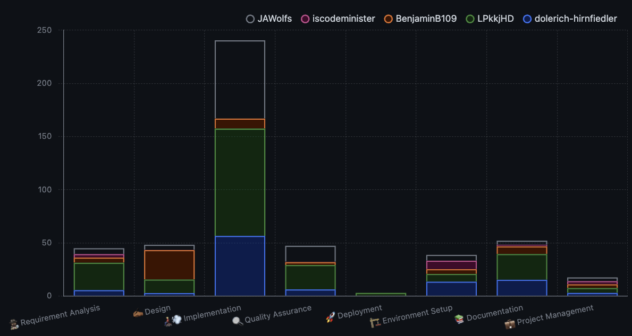
Oben aufgelistet sind die Arbeitstunden, aufgeschlüsselt nach Teammitglied:

Name | Requirement analyis | Design | Implementation | Quality Assurance | Deployment | Environment Setup | Documentation | Project Management | Summe
Jeremias | 5.55 | 4.75 | 73.5 | 15 | 0 | 5.5 | 3.75 | 3.5 | 111.55
Ting | 3.3 | 0.25 | 0 | 0.4 | 0 | 8 | 1.5 | 3 | 16.45
Benjamin | 4.8 | 27.75 | 9.5 | 5.25 | 0 | 4.5 | 7.25 | 3.5 | 62.55
Martin | 25.8 | 12.75 | 101 | 23 | 3 | 7.25 | 24.25 | 4.5 | 201.55
Jakob | 5.55 | 2.75 | 56.5 | 6.15 | 0 | 13.5 | 15.25 | 3 | 102.7
Summe | 45 | 48.25 | 240.5 | 49.8 | 3 | 38.75 | 52 | 17.5 | 494.8

General Use Case

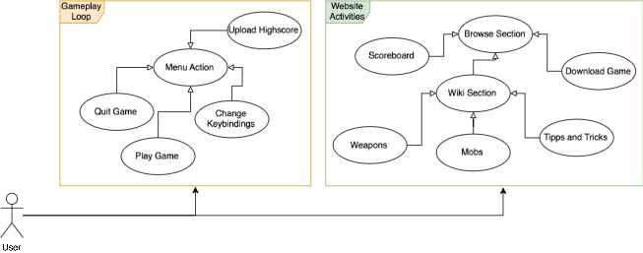
Highlights of our Demo
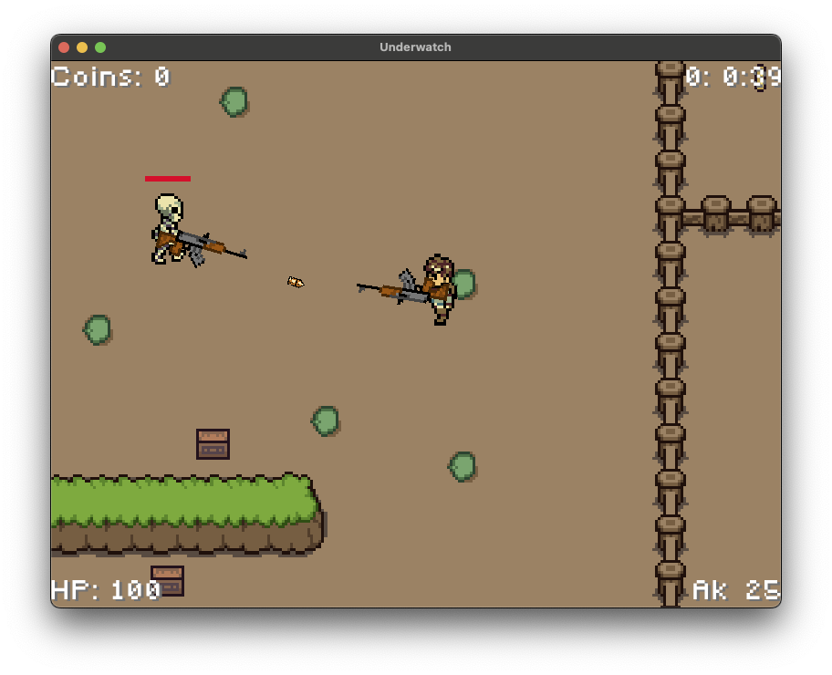
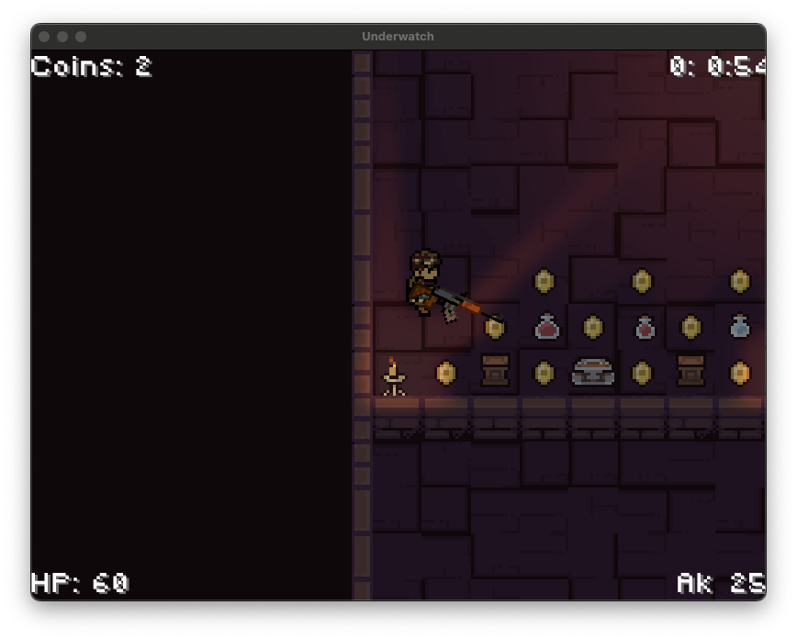
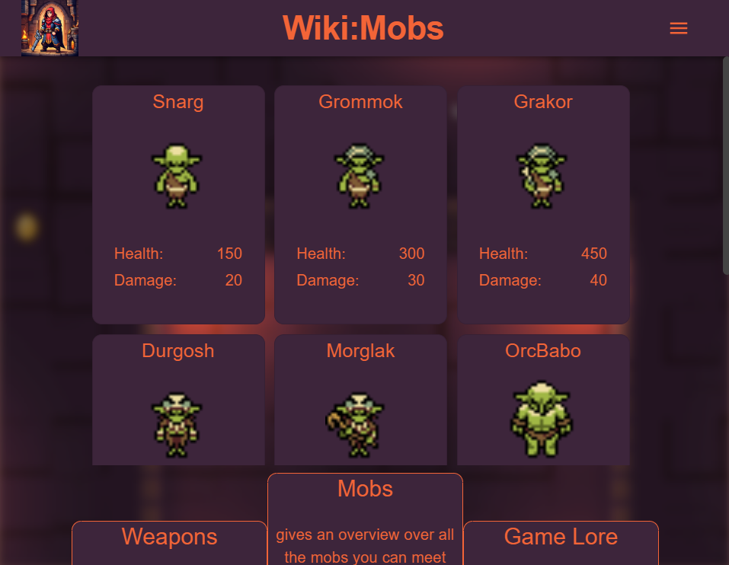

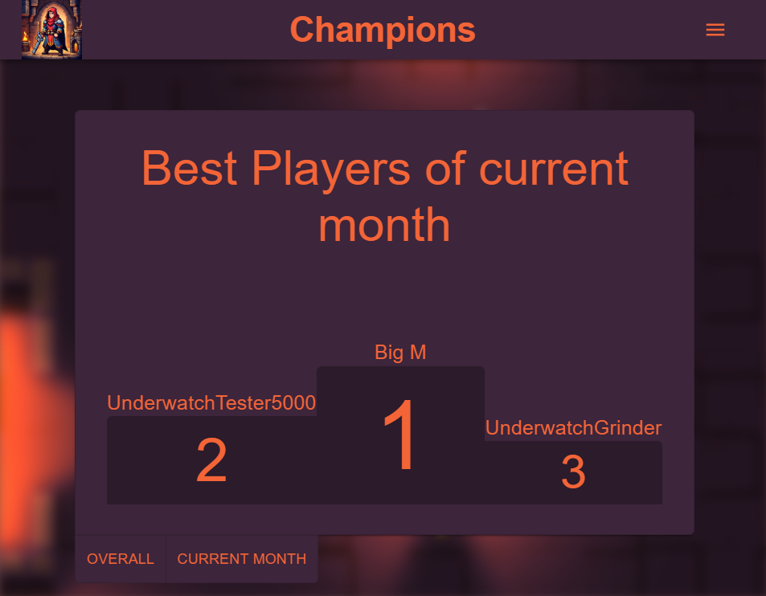
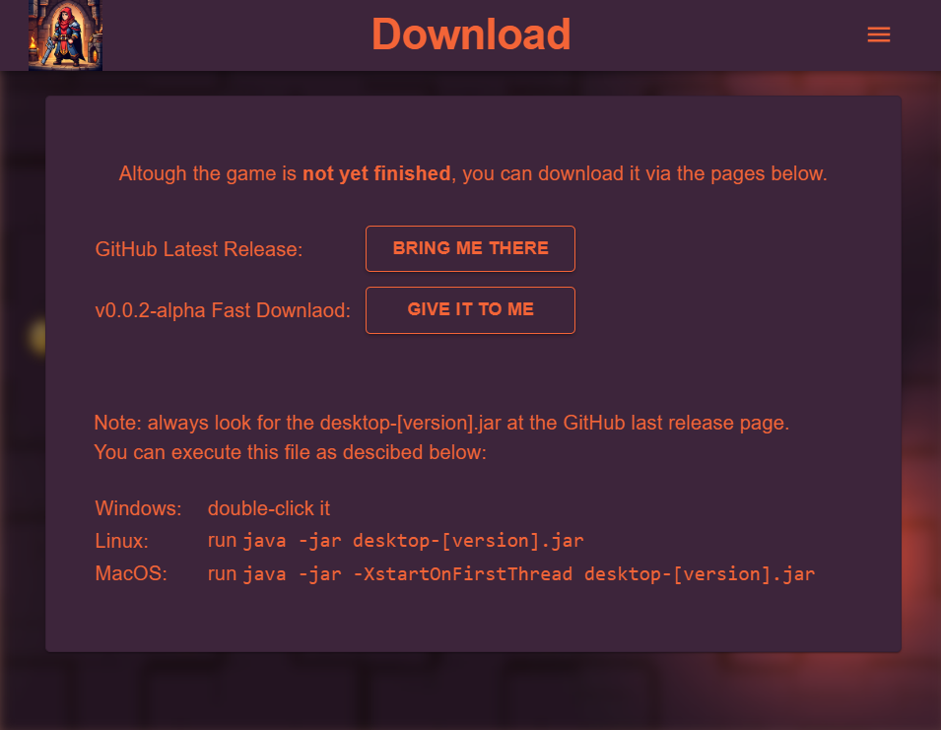
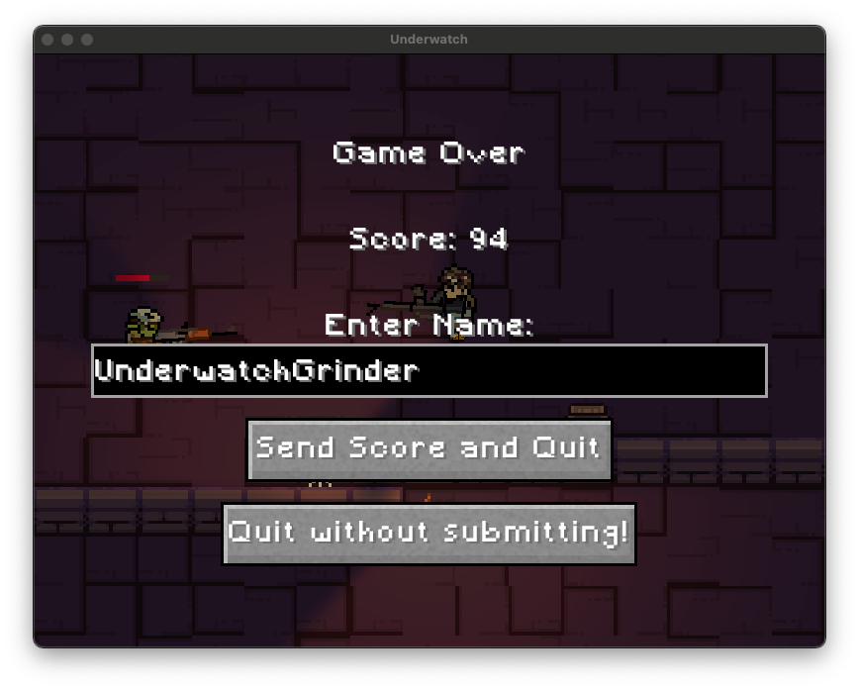

-

Artstyle
We decided on two different TileSets for the art style. There should be maps in the dungeon and in the outside world. We used a dark TileSet for the maps in the dungeon and one with rock-like textures for the outside world.
The enemies are skeletons and orcs, but we fight with modern weapons.
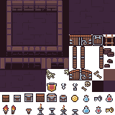
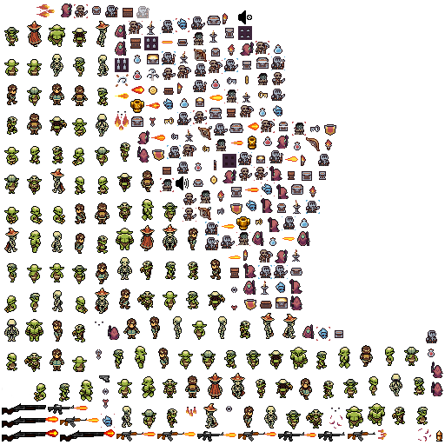
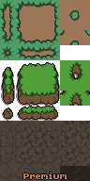

Highlights of our Project
- Box2D: We use a third party, open-source library which takes care of handling the physics simulation

- Pathfinding: We implemented the logic for the A*-Pathfinding algorithm based on tiled layers in Java.
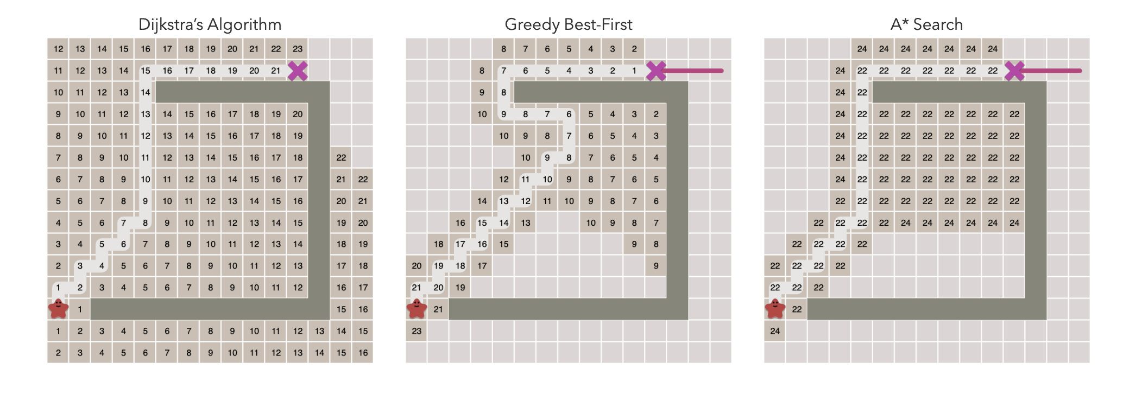
- CI/CD: We use GitHub Actions to build our project into docker containers and deploy those with a horizontal autoscaler into a kubernetes cluster.

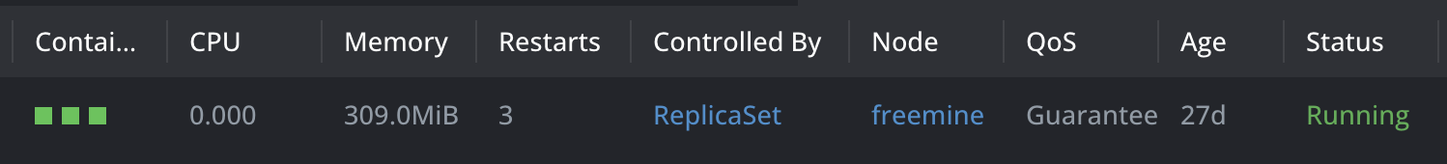
Project Environment
- Version Control Git, GitHub
- Deployment Kubernetes, Docker
- Project Management GitHub Projects
- Blog GitHub Discussions
- Design Paint, PlantUML
- Development Enviroment Java, React/Typescript

