Software Architecture and Design Specification
Online Exam Portal
Prepared according to IEEE 42010 style structure
Field | Value
Project | Online Exam Portal
Document | Software Architecture and Design Specification (SAD)
Version | 1.4
Date | 07-10-2026
Status | Final
Authors | Chhavi Siddarth Wadhwa, Dhanya Prasad, Harsha K, Gagan
Architecture Owner (P3) | Harsha K
Design Owner (P4) | Gagan
Course | Software Engineering – Mini Project (Part 1)
Technology Stack | MERN (MongoDB, Express.js, React, Node.js)

Revision History
Version | Date | Author | Change Summary
1.0 | 03-10-2026 | Harsha K (P3) | Initial Architecture section
1.1 | 04-10-2026 | Harsha K (P3) | Aligned with official SRS v1.1, real Req IDs, MERN stack, updated Traceability & STRIDE
1.2 | 05-10-2026 | Gagan (P4) | Added Section 4 Design: 3 UML sequence diagrams (UC-02, UC-09, UC-10), API design (catalogue + 4 detailed endpoints), error handling, logging & monitoring, UX design, design traceability, open issues; result release policy agreed (score immediately, review after exam end)
1.3 | 05-10-2026 | Harsha K (P3) | Corrected the component diagram
1.4 | 07-10-2026 | Gagan (P4) | Final consistency pass: version, date and status aligned; references updated to SRS v1.2 and STP v1.1

Approvals
Role | Name | Signature / Date
Project Manager / SRS (P1) | Chhavi Siddarth Wadhwa
Test Plan (P2) | Dhanya Prasad
Architecture (P3) | Harsha K
Design (P4) | Gagan
Instructor / Reviewer

1. Introduction

1.1 Purpose
This document specifies the software architecture and high-level design of the Online Exam Portal. It describes the major components, architectural pattern, technology decisions, security architecture and traceability to the official Software Requirements Specification (SRS v1.2). It serves as the architectural baseline for implementation and for the Design section owned by P4.

1.2 Scope
The architecture covers the complete MERN-based Online Exam Portal: account management, question bank, exam creation and scheduling, timed exam attempts with auto-save and auto-submit, automatic evaluation, results, notifications, focus-loss logging and audit logging. Out of scope items (webcam proctoring, descriptive answers, native mobile apps) are excluded.

1.3 Audience
Developers, QA engineers (P2), Design owner (P4), instructors and reviewers.

1.4 Definitions
MERN – MongoDB, Express.js, React, Node.js; MCQ – Multiple Choice Question; JWT – JSON Web Token; RBAC – Role-Based Access Control; STRIDE – Spoofing, Tampering, Repudiation, Information Disclosure, Denial of Service, Elevation of Privilege; TLS – Transport Layer Security; SRS / STP / RTM – Software Requirements Specification / Software Test Plan / Requirements Traceability Matrix.

2. Document Overview

2.1 How to use this document
Section 3 defines the architecture (components, pattern, security, traceability). Section 4 contains the design (sequence diagrams, API design, error handling, logging & monitoring, UX design and design traceability) owned by P4. All requirement IDs used in this document are taken from the frozen SRS v1.2 and the ID Cheat Sheet.

2.2 Related Documents
SRS Online Exam Portal v1.1, Software Test Plan (STP) v1.1, Requirements Traceability Matrix (RTM spreadsheet), ID Cheat Sheet.

3. Architecture

3.1 Goals & Constraints
Goals:
- Secure and reliable delivery of timed MCQ examinations with automatic evaluation.
- Support up to 500 concurrent students during exam windows while meeting response-time targets (NFR-OE-001 to NFR-OE-003).
- Enforce strong authentication, RBAC and exam integrity (SEC-OE series).
- Provide clear modular structure that maps cleanly to the MERN stack.
Constraints:
- Must use the MERN stack (MongoDB, Express.js, React, Node.js) as fixed in SRS v1.2.
- Academic mini-project timeline ending 07-10-2026.
- Browser-based only; no native mobile apps.
- Three primary roles: Student, Instructor, Administrator.

3.2 Stakeholders & Concerns
Stakeholder | Key Concerns
Students | Simple interface, fair evaluation, reliable timer and auto-save during exams
Instructors | Easy question/exam management, accurate results, focus-loss visibility
Administrators | User & role management, audit logs, system security
Development Team | Clear component boundaries, MERN alignment, maintainability

3.3 Component Diagram
The system follows a layered architecture mapped onto the MERN stack.
Logical Component Structure:
Presentation Layer (React)
↓ HTTPS / REST (JSON)
API Layer (Express.js Controllers / Routes)
↓
Business Services Layer (Node.js)
• Authentication & Authorization Service
• Exam Management Service
• Question Bank Service
• Evaluation Engine
• Result & Analytics Service
• Notification Service
• Audit & Logging Service
↓
Data Access Layer (Mongoose / MongoDB Drivers)
↓
MongoDB Database
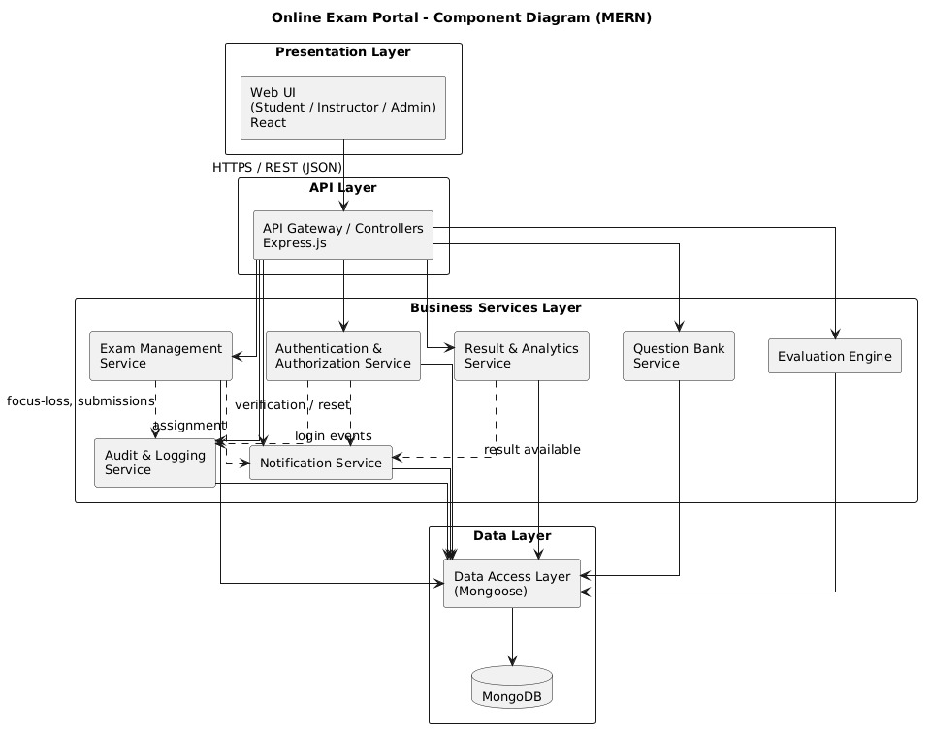

3.4 Component Descriptions
Component | Responsibility
Presentation Layer (React) | Role-specific dashboards, exam-taking UI (timer, navigator, auto-save indicators), results views.
API Layer (Express Controllers) | REST endpoints, request validation, routing to services, JWT extraction.
Authentication & Authorization Service | Registration, login, password reset, JWT issuance/validation, RBAC enforcement (SEC-OE-001 to 006).
Exam Management Service | Create/configure/publish exams, assignment to students, start/resume/submit attempt logic, timer control, focus-loss recording.
Question Bank Service | CRUD for MCQs (2–6 options, single correct), ownership by Instructor.
Evaluation Engine | Auto-evaluation of submitted attempts, score calculation including negative marking.
Result & Analytics Service | Student result views, Instructor statistics (avg/high/low/pass %), CSV export.
Notification Service | In-app and email notifications for exam assignment and result availability (via SMTP).
Audit & Logging Service | Records login events, role changes, exam publication, submissions; supports filtering (FR-OE-027, SEC-OE-011).
Data Access Layer | Mongoose models and queries for all persistent entities.
MongoDB | Primary data store for Users, Questions, Exams, Attempts, Answers, FocusEvents, AuditLogs, Notifications.

3.5 Chosen Architecture Pattern and Rationale
Selected Pattern: Layered Architecture (mapped to MERN)
Rationale:
- Clear separation between React presentation, Express API, business services and MongoDB data store.
- Natural fit for the fixed MERN technology stack.
- Supports independent development of frontend and backend.
- Easy to reason about security boundaries (authZ checks in service layer).
- Microservices were rejected as unnecessary complexity for a mini-project with a four-person team.

3.6 Technology Stack & Data Stores
Layer | Technology
Frontend | React (latest stable)
Backend / API | Node.js + Express.js
Database | MongoDB (with Mongoose ODM)
Authentication | JWT (HttpOnly + Secure cookies or Authorization header) + bcrypt/Argon2
Email | SMTP service for verification, password reset and notifications
Communication | HTTPS + REST/JSON
Security | TLS 1.2+, input sanitisation, rate limiting, RBAC

3.7 Risks & Mitigations
Risk | Mitigation
High concurrent load during exams (NFR-OE-001–003) | Efficient MongoDB indexes, connection pooling, possible caching of questions
Cheating via tab switching | Focus-loss logging (FR-OE-021) visible to Instructor
Unauthorized access / privilege escalation | Server-side RBAC on every request (SEC-OE-004)
Timer manipulation | All timing decisions use server clock (NFR-OE-010)
Data loss on crash | Auto-save every 30 s + resume capability (FR-OE-017, FR-OE-018, NFR-OE-005)
Tight schedule | Modular services allow parallel work by P3/P4

3.8 Traceability to Requirements
Mapping of frozen Requirement IDs (from SRS v1.2 / ID Cheat Sheet) to Architecture Components.
Req ID | Summary | Architecture Component(s)
FR-OE-001 | Student registration | Authentication & Authorization Service
FR-OE-002 | Email verification | Authentication & Authorization Service + Notification Service
FR-OE-003 | Login + role-based access | Authentication & Authorization Service
FR-OE-004 | Logout / session invalidation | Authentication & Authorization Service
FR-OE-005 | Password reset | Authentication & Authorization Service + Notification Service
FR-OE-006 | Admin user/role management | Authentication & Authorization Service
FR-OE-007 | Question bank CRUD | Question Bank Service
FR-OE-008 | Create exam | Exam Management Service
FR-OE-009 | Question/option shuffling | Exam Management Service
FR-OE-010 | Negative marking config | Exam Management Service + Evaluation Engine
FR-OE-011 | Publish & assign exam | Exam Management Service + Notification Service
FR-OE-012 | Lock exam after first attempt | Exam Management Service
FR-OE-013 | List assigned exams + status | Exam Management Service
FR-OE-014 | Start exam (window + once) | Exam Management Service
FR-OE-015 | Answer, navigate, flag | Exam Management Service + Presentation Layer
FR-OE-016 | Server-side countdown timer | Exam Management Service
FR-OE-017 | Auto-save every 30 s | Exam Management Service
FR-OE-018 | Resume interrupted attempt | Exam Management Service
FR-OE-019 | Manual submit + confirmation | Exam Management Service
FR-OE-020 | Auto-submit at timer zero | Exam Management Service
FR-OE-021 | Focus-loss / tab-switch logging | Exam Management Service + Audit & Logging Service
FR-OE-022 | Automatic evaluation & scoring | Evaluation Engine
FR-OE-023 | Student view own result | Result & Analytics Service
FR-OE-024 | Instructor statistics | Result & Analytics Service
FR-OE-025 | CSV export of results | Result & Analytics Service
FR-OE-026 | Notifications (assign + result) | Notification Service
FR-OE-027 | Audit log viewing | Audit & Logging Service
NFR-OE-001 | Page response ≤ 2 s (500 users) | All layers (esp. API + MongoDB)
NFR-OE-002 | Auto-save ≤ 1 s | Exam Management Service + Data Access
NFR-OE-003 | Evaluation ≤ 5 s | Evaluation Engine
NFR-OE-004 | 99.5 % availability in exam windows | Deployment + Monitoring
NFR-OE-005 | RPO ≤ 30 s (auto-save) | Exam Management Service
NFR-OE-006 | Automated backup every 24 h, retain last 7 | Deployment + Audit & Logging Service / Jobs
NFR-OE-007 | First-time Student starts exam within 3 clicks | Presentation Layer (React)
NFR-OE-008 | WCAG 2.1 Level AA (contrast + keyboard) on exam pages | Presentation Layer (React)
NFR-OE-009 | Works on latest Chrome / Firefox / Edge, ≥ 360 px | Presentation Layer (React)
NFR-OE-010 | Server clock for all timing | Exam Management Service
NFR-OE-011 | Store ≥ 10,000 questions, 1,000 users, 200 exams | MongoDB + Data Access Layer
NFR-OE-012 | Modular code + ≥ 70% unit test coverage | All Business Services (services/ folder)
NFR-OE-013 | Deployable on Linux/container in ≤ 60 min | Deployment (Docker Compose – future)
NFR-OE-014 | Retain attempts/results ≥ 1 year; Admin can delete | MongoDB + Authentication & Authorization Service
SEC-OE-001 | Password hashing (bcrypt/Argon2) | Authentication & Authorization Service
SEC-OE-002 | Password complexity | Authentication & Authorization Service
SEC-OE-003 | Account lockout after 5 failures | Authentication & Authorization Service
SEC-OE-004 | Server-side RBAC (HTTP 403) | Authentication & Authorization Service
SEC-OE-005 | HTTPS / TLS 1.2+ | API Layer + Infrastructure
SEC-OE-006 | Session expiry + HttpOnly/Secure | Authentication & Authorization Service
SEC-OE-007 | Correct answers never sent early | Exam Management + Evaluation Engine
SEC-OE-008 | Input validation, NoSQL injection, XSS, CSRF | API Layer + All Services
SEC-OE-009 | Submission only by owner before end+5s | Exam Management Service
SEC-OE-010 | Rate limiting (login/reset) | API Layer
SEC-OE-011 | Security event logging (12 months) | Audit & Logging Service
SEC-OE-012 | Encryption of personal data at rest | Data Access Layer + MongoDB

3.9 Security Architecture
Threat modelling uses STRIDE. Each threat is linked to the official Security Requirements (SEC-OE-xxx) from the SRS.
Threat | Related SEC-OE | Architectural Mitigation | Primary Component
Spoofing | SEC-OE-001, 002, 003, 006 | Salted password hashes, complexity rules, lockout, JWT with expiry + HttpOnly/Secure | Authentication & Authorization Service
Tampering | SEC-OE-008, 009 | Input sanitisation, NoSQL injection protection, owner-only submission before deadline | API Layer + Exam Management Service
Repudiation | SEC-OE-011 | Immutable audit log of login, role changes, publication, submissions | Audit & Logging Service
Information Disclosure | SEC-OE-005, 007, 012 | TLS 1.2+, correct answers withheld until release, encryption at rest | API Layer + Evaluation Engine
Denial of Service | SEC-OE-010 + NFR-OE-001/004 | Rate limiting on auth endpoints, efficient queries, availability target | API Layer
Elevation of Privilege | SEC-OE-004 | RBAC enforced on every server request; UI checks are not trusted | Authentication & Authorization Service
Key Security Decisions:
- All authentication and authorisation decisions are made on the server (never trust the React client).
- Exam timers, start/end windows and auto-submit are driven exclusively by the server clock.
- Correct answers are never included in any API response until the attempt is submitted and results are released (SEC-OE-007).
- Focus-loss events are recorded server-side and made visible only to the Instructor.

4. Design

4.1 Design Overview
The design realises the layered MERN architecture of Section 3. Each architecture component is implemented as a backend module with the same internal layering: Express route -> middleware chain -> controller -> service -> Mongoose model. The React client is a single-page application with one route tree per role. This section is owned by P4 (Gagan) and covers the sequence diagrams, REST API contracts, error handling, logging and monitoring, and UX notes.
Design principles:
- Server is the source of truth: authentication, RBAC, exam windows, timer end time and scoring are decided only on the server (SEC-OE-004, NFR-OE-010).
- Thin controllers, fat services: controllers only parse/validate the request and shape the response; all business rules live in services so they can be unit-tested (NFR-OE-012).
- Idempotent exam operations: start, auto-save and submit can be safely retried by the client without creating duplicate attempts or double scoring (NFR-OE-005).
- Least data to the client: question payloads are built with a projection that never includes the correct option (SEC-OE-007).
- Every security-relevant action passes through the Audit & Logging Service (SEC-OE-011).
Module structure (backend, Node.js + Express):
Module / folder | Contents | Architecture component (Section 3.4)
routes/ | auth.routes, user.routes, question.routes, exam.routes, attempt.routes, result.routes, audit.routes | API Layer
middleware/ | authenticate (JWT + session), authorize(role), validate(schema), rateLimit, csrf, requestId, errorHandler | API Layer + Auth & Authorization Service
services/auth | register, verifyEmail, login, logout, resetPassword, lockout logic | Authentication & Authorization Service
services/question | MCQ CRUD, option-count and single-correct validation | Question Bank Service
services/exam | exam CRUD, publish/assign, lock after first attempt, start/resume/save/submit attempt, focus events | Exam Management Service
services/evaluation | evaluate(attemptId), score and pass/fail computation | Evaluation Engine
services/result | student result view, instructor statistics, CSV export | Result & Analytics Service
services/notification | in-app notifications, SMTP email (Nodemailer) | Notification Service
services/audit | append-only audit writer and filtered reader | Audit & Logging Service
jobs/ | autoSubmit.job (every 10 s), backup.job (daily) | Exam Management Service, Deployment
models/ | Mongoose schemas listed below | Data Access Layer

Key data entities (MongoDB collections):
Collection | Key fields | Indexes / notes
users | _id, name*, email*, passwordHash, role, status, emailVerified, failedLogins, lockedUntil | unique email; * encrypted at rest (SEC-OE-012)
sessions | sid, userId, role, lastActivity, expiresAt | TTL index on expiresAt (30-min inactivity, SEC-OE-006)
questions | _id, ownerId, text, options[2..6], correctOption, marks | ownerId; correctOption excluded from student projections
exams | _id, title, durationMin, startAt, endAt, passMark, questionIds[], shuffle, negativeMark, status, locked, reviewEnabled | status + startAt
assignments | examId, studentId, assignedAt | unique (examId, studentId)
attempts | _id, examId, studentId, startedAt, endsAt, status (IN_PROGRESS / SUBMITTED), submitMode, lastSeq, score, passed | unique (examId, studentId) enforces "only once"; (status, endsAt) for auto-submit job
answers | attemptId, questionId, selectedOption, flagged, savedAt | unique (attemptId, questionId)
focusEvents | attemptId, type (BLUR / HIDDEN), serverTimestamp | attemptId
notifications | userId, type, message, read, createdAt | userId + read
auditLogs | action, userId, ip, timestamp, details | append-only; timestamp; retained >= 12 months (SEC-OE-011)

4.2 UML Sequence Diagrams
Three sequence diagrams cover the flows assigned to P4 in the ID Cheat Sheet: UC-02 Login / Logout, UC-09 Attempt Exam and UC-10 Submit Exam. Lifelines use the component names from Section 3.4 so that each message can be traced to an architecture component. Diagram sources (Mermaid) are stored in the repository under Design/diagrams/.

4.2.1 SD-01: Login / Logout (UC-02)
Requirements covered: FR-OE-003, FR-OE-004, SEC-OE-001, SEC-OE-003, SEC-OE-004, SEC-OE-006, SEC-OE-008, SEC-OE-010, SEC-OE-011.
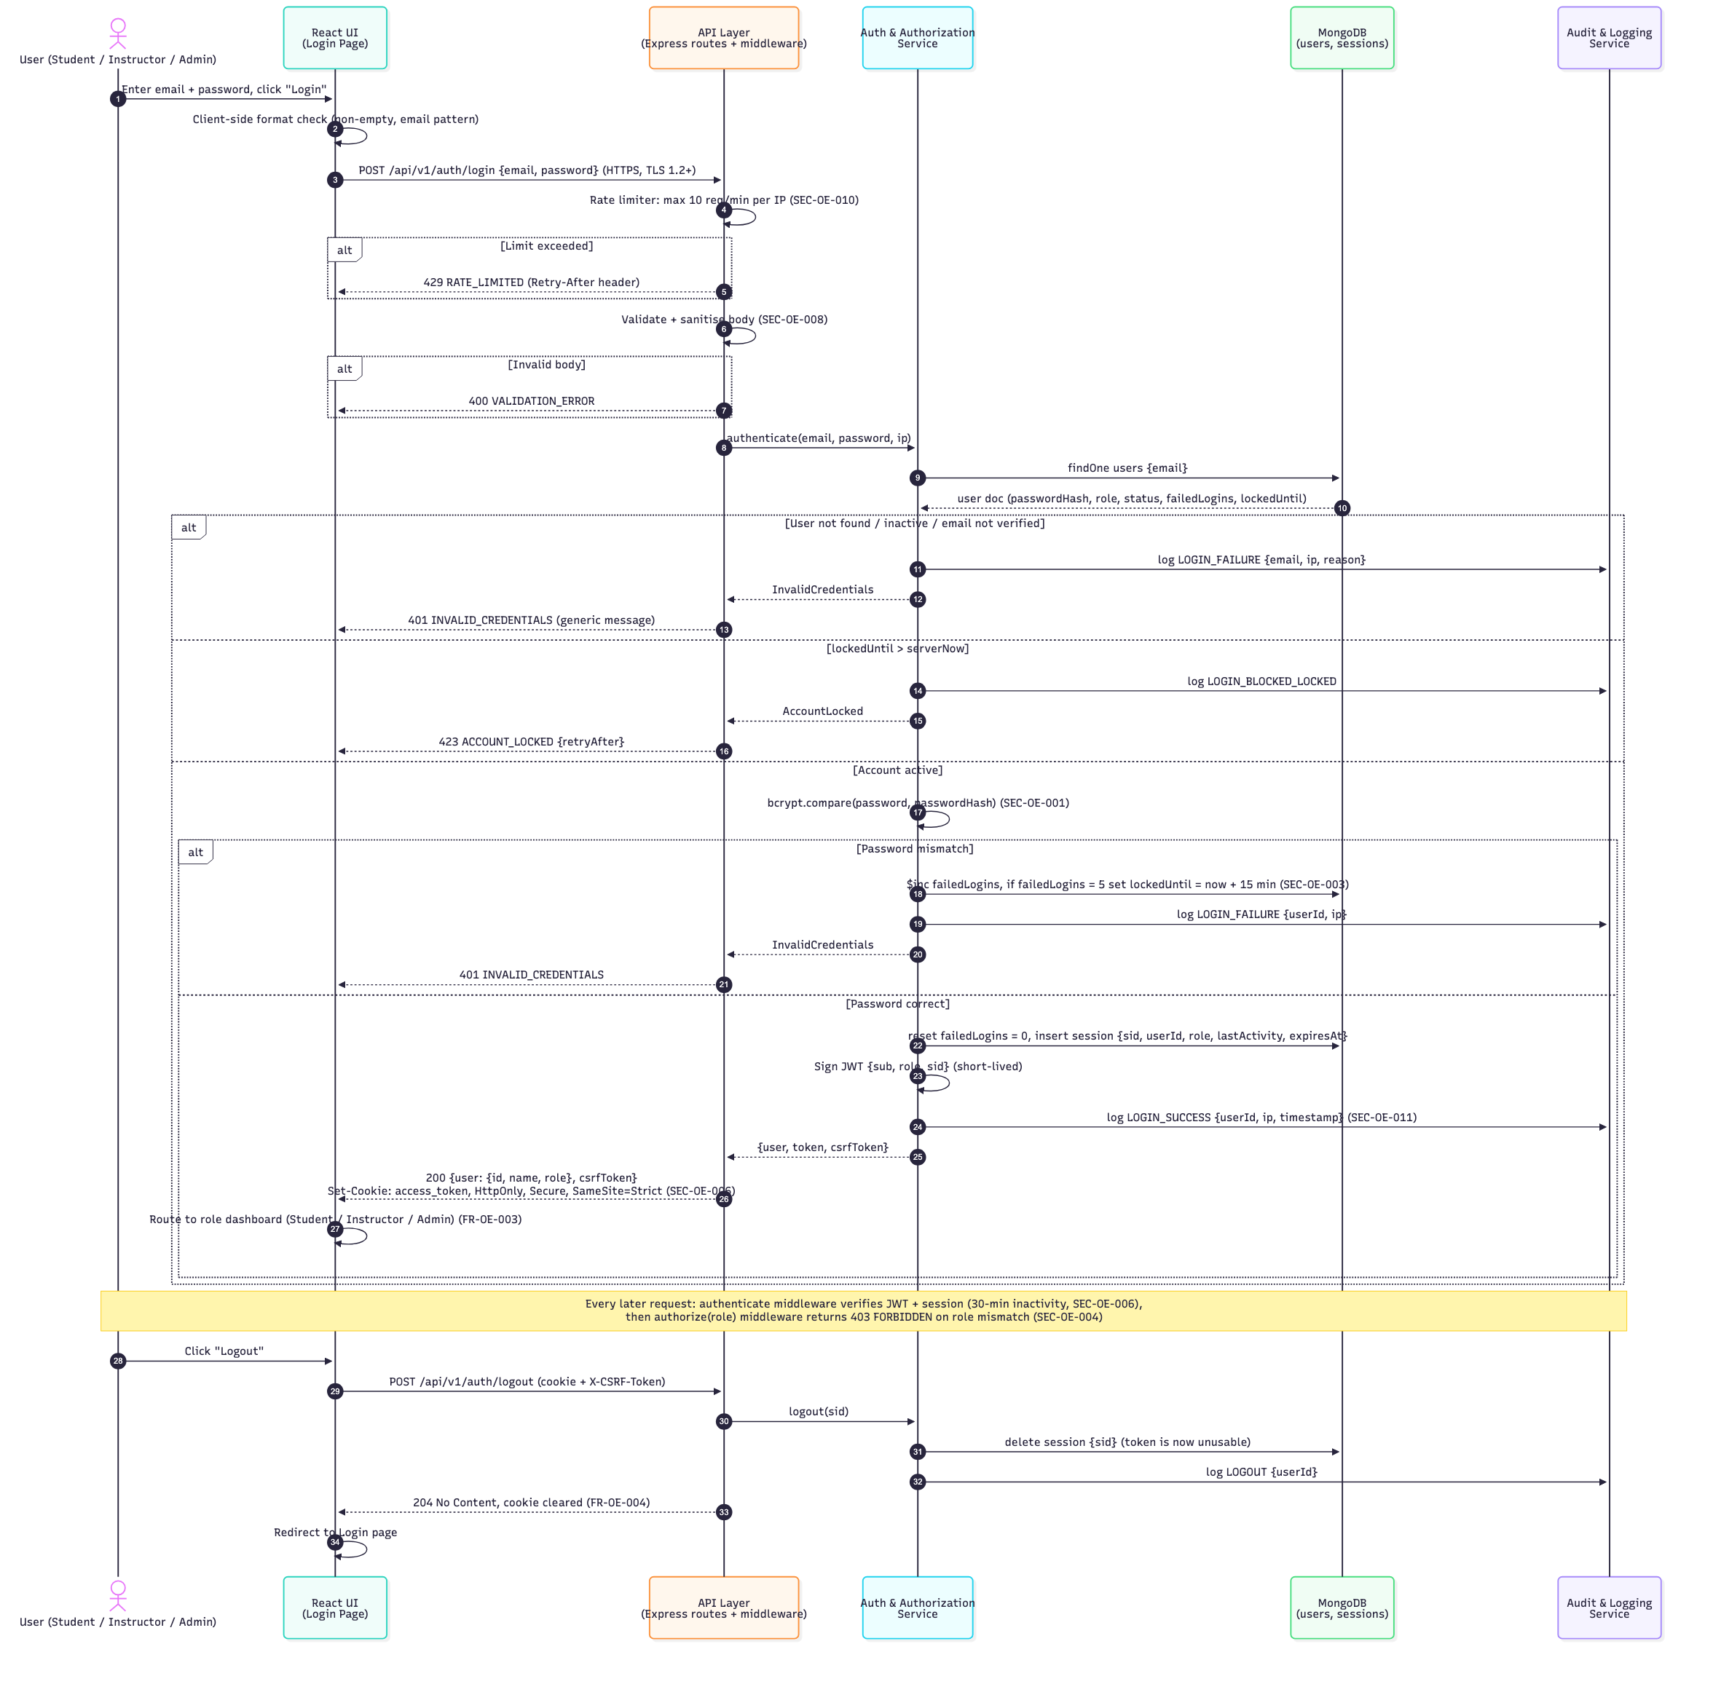
Figure 4.1 - SD-01 Login / Logout sequence diagram
Key design points:
- The rate limiter runs before any database access so brute-force traffic is rejected cheaply with HTTP 429 (SEC-OE-010).
- Unknown email, wrong password and unverified account all return the same generic 401 message to prevent account enumeration.
- The 5th consecutive failure sets lockedUntil = now + 15 min; while locked, login returns 423 without checking the password (SEC-OE-003).
- The JWT is delivered only in an HttpOnly, Secure, SameSite=Strict cookie and is bound to a server-side session (sid), so logout and inactivity expiry invalidate it immediately (FR-OE-004, SEC-OE-006).

4.2.2 SD-02: Attempt Exam (UC-09)
Requirements covered: FR-OE-012 to FR-OE-018, FR-OE-021, NFR-OE-002, NFR-OE-010, SEC-OE-004, SEC-OE-007, SEC-OE-009.
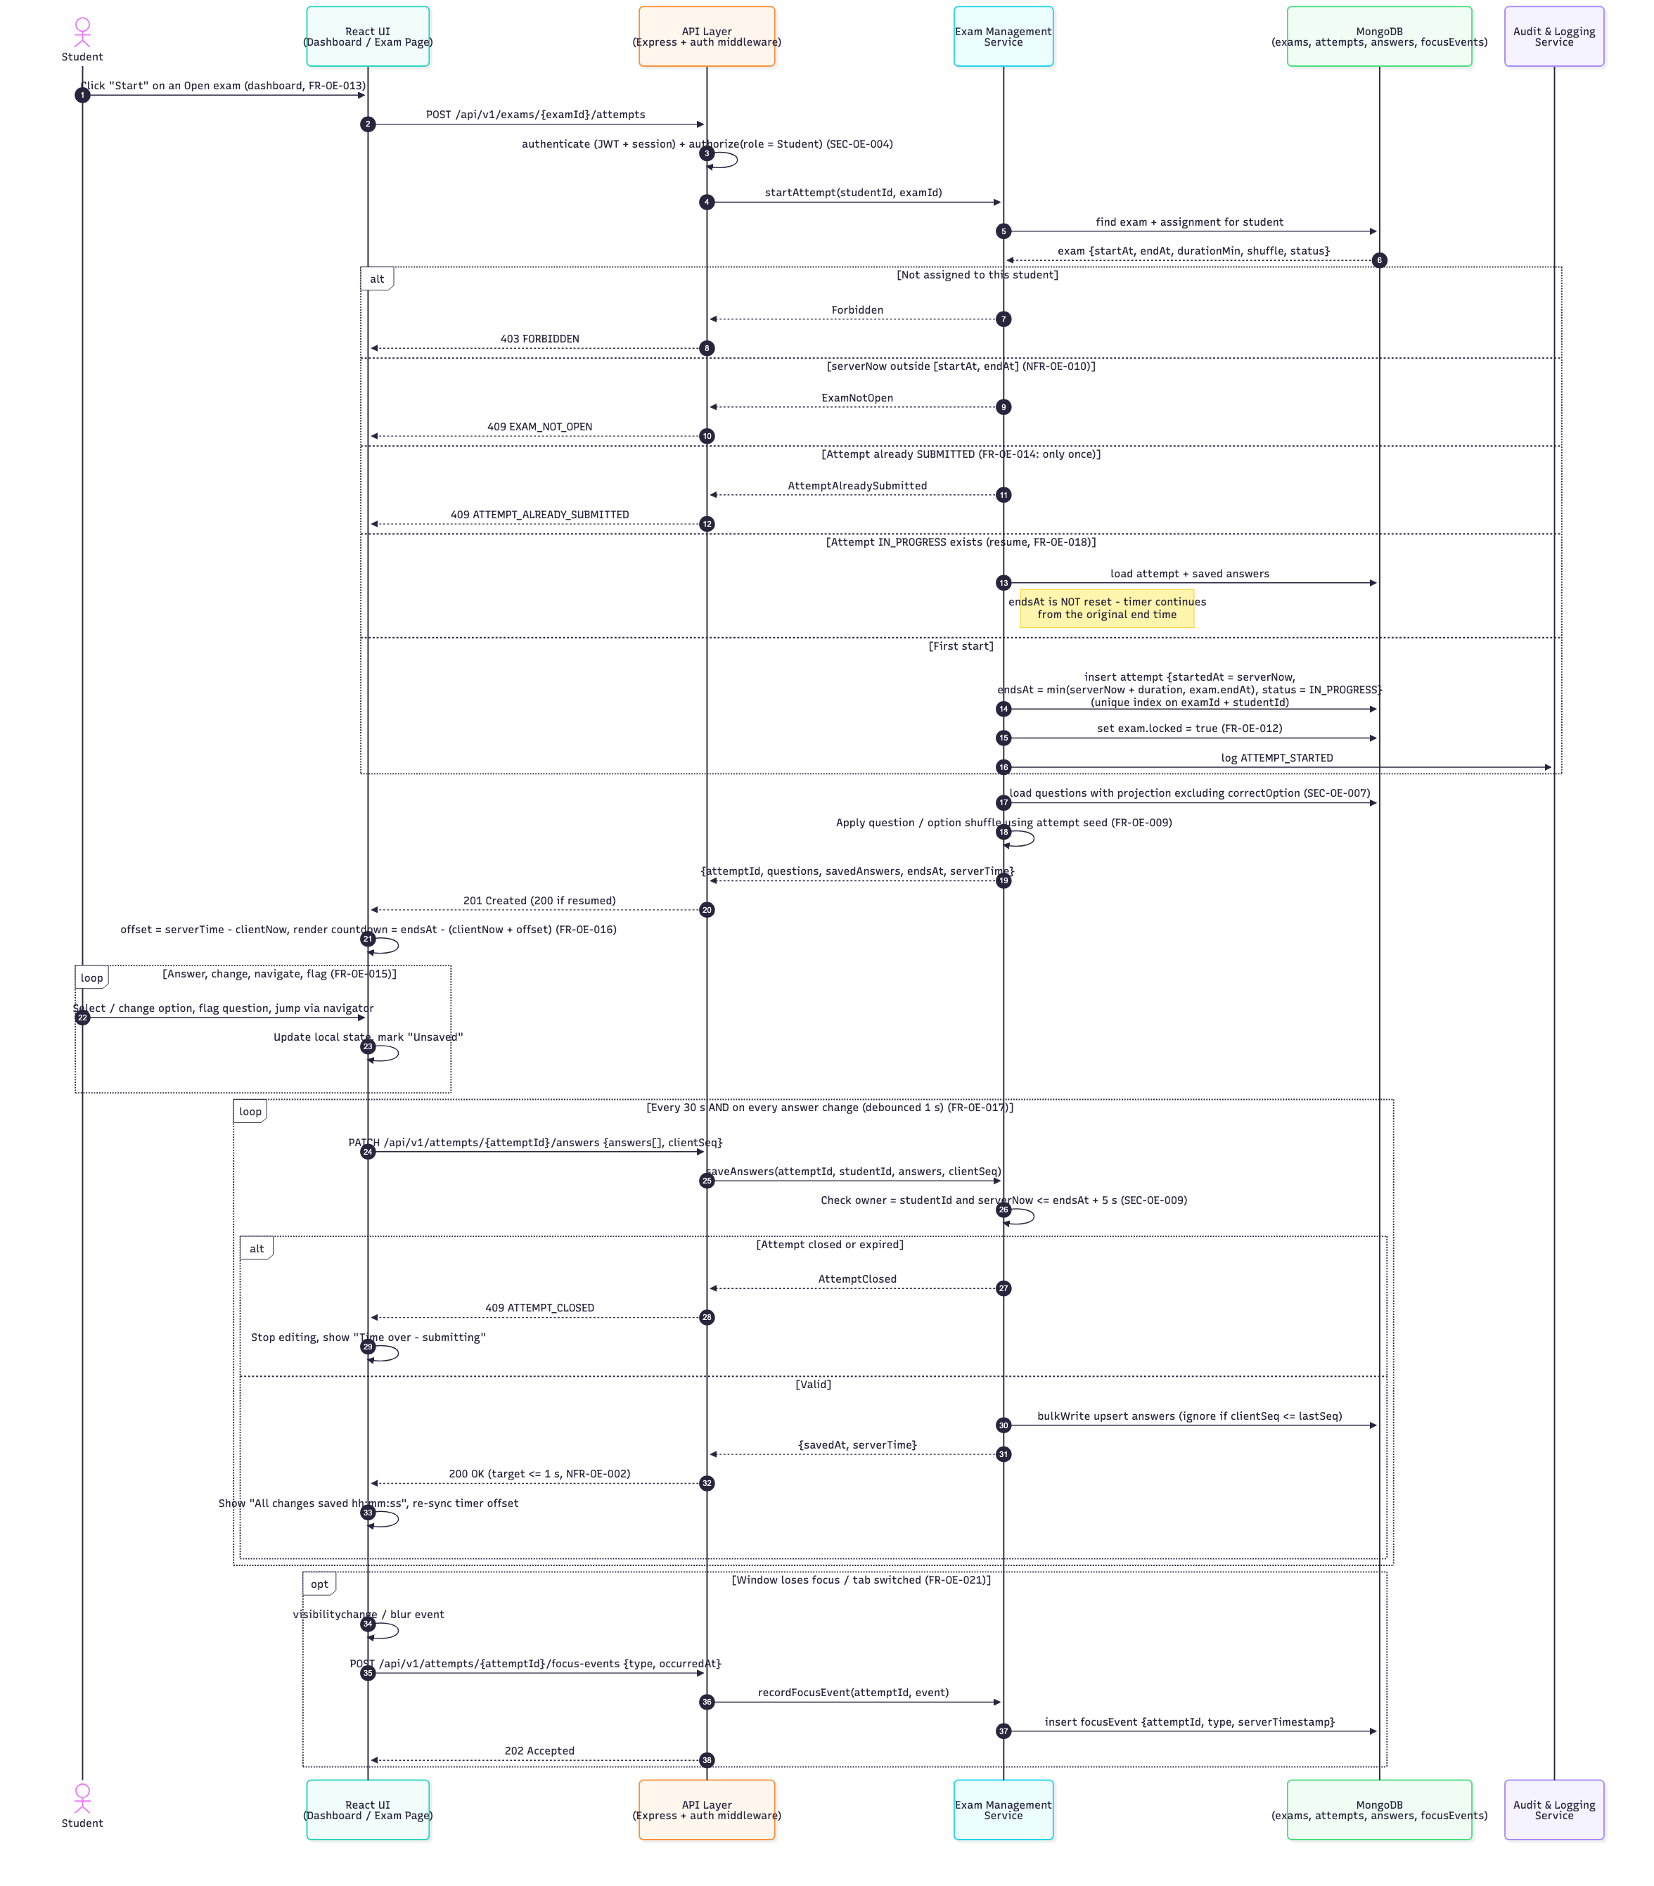
Figure 4.2 - SD-02 Attempt Exam sequence diagram
Key design points:
- endsAt is computed once on the server at first start as min(startedAt + duration, exam.endAt) and is never reset on resume (FR-OE-016, FR-OE-018).
- The client never trusts its own clock: it computes an offset from serverTime in every response and re-syncs on every auto-save, keeping deviation within 2 s (NFR-OE-010).
- A unique index on (examId, studentId) in attempts guarantees a single attempt even under concurrent "Start" clicks (FR-OE-014).
- Auto-save sends only changed answers with a monotonically increasing clientSeq; stale or out-of-order saves are ignored (FR-OE-017, NFR-OE-005).
- Focus-loss events are fire-and-forget (202 Accepted) so they never block answering (FR-OE-021).

4.2.3 SD-03: Submit Exam (UC-10)
Requirements covered: FR-OE-019, FR-OE-020, FR-OE-022, FR-OE-023, FR-OE-026, NFR-OE-003, NFR-OE-005, SEC-OE-009, SEC-OE-011.
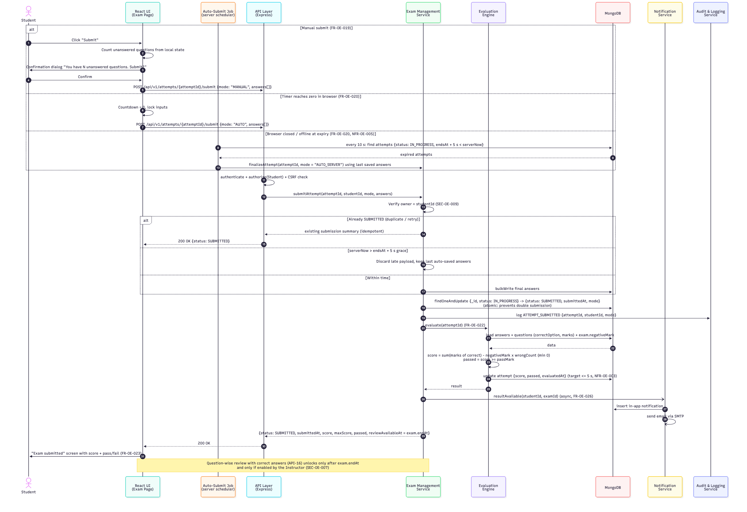
Figure 4.3 - SD-03 Submit Exam sequence diagram
Key design points:
- Three entry points converge on one submitAttempt() service: manual submit, client auto-submit at 00:00, and the server Auto-Submit Job for students who closed the browser (FR-OE-019, FR-OE-020).
- The status change IN_PROGRESS -> SUBMITTED is a single conditional findOneAndUpdate, so duplicate requests cannot double-submit or double-score; repeats return the existing summary.
- Payloads arriving after endsAt + 5 s are discarded and the last auto-saved answers are used (SEC-OE-009).
- Result release policy: the score and pass/fail are returned in the submit response; correct answers stay on the server until the exam end time has passed, so no student can leak them to others still writing (SEC-OE-007).
- Evaluation runs synchronously inside the submit request (MCQ scoring is O(number of questions)), so the score and pass/fail are shown immediately, within 5 s (NFR-OE-003). Notifications are sent asynchronously so SMTP latency never delays the response.

4.3 API Design

4.3.1 Conventions
- Base URL: https://<host>/api/v1 - HTTPS only, plain HTTP is redirected/rejected (SEC-OE-005).
- Format: JSON (Content-Type: application/json); timestamps in ISO 8601 UTC; IDs are MongoDB ObjectId strings.
- Authentication: access_token cookie (HttpOnly, Secure, SameSite=Strict). State-changing requests also send the X-CSRF-Token header (SEC-OE-008).
- Authorisation: every route declares its allowed roles; the authorize middleware returns 403 FORBIDDEN otherwise (SEC-OE-004).
- Validation: every request body/query is validated against a schema (Joi / express-validator) and sanitised (express-mongo-sanitize) before reaching a controller (SEC-OE-008).
- Errors: all errors use the standard envelope defined in Section 4.4. Every response carries an X-Request-Id header for log correlation.

4.3.2 Endpoint Catalogue
API ID | Method & Path | Role | Purpose | Req IDs
API-01 | POST /auth/register | Public | Register Student account | FR-OE-001, SEC-OE-002
API-02 | GET /auth/verify-email?token= | Public | Verify email (24 h link) | FR-OE-002
API-03 | POST /auth/login | Public | Authenticate, start session | FR-OE-003, SEC-OE-001/003/006/010
API-04 | POST /auth/logout | Any | End session | FR-OE-004
API-05 | POST /auth/password-reset/request | Public | Email one-time reset link | FR-OE-005, SEC-OE-010
API-06 | POST /auth/password-reset/confirm | Public | Set new password (30 min link) | FR-OE-005, SEC-OE-002
API-07 | GET | POST | PATCH /users[/:id] | Admin | Manage users and roles | FR-OE-006, NFR-OE-014*
API-08 | GET | POST | PUT | DELETE /questions[/:id] | Instructor | Question bank CRUD | FR-OE-007
API-09 | POST | PUT /exams[/:id] | Instructor | Create / configure exam (409 EXAM_LOCKED after first attempt) | FR-OE-008, 009, 010, 012
API-10 | POST /exams/:examId/publish | Instructor | Publish and assign to students | FR-OE-011, FR-OE-026
API-11 | GET /me/exams | Student | List assigned exams with status | FR-OE-013
API-12 | POST /exams/:examId/attempts | Student | Start or resume attempt | FR-OE-014, 016, 018, SEC-OE-007
API-13 | PATCH /attempts/:attemptId/answers | Student | Auto-save answers | FR-OE-015, FR-OE-017, NFR-OE-002
API-14 | POST /attempts/:attemptId/focus-events | Student | Record focus loss | FR-OE-021
API-15 | POST /attempts/:attemptId/submit | Student | Manual / auto submit + evaluate | FR-OE-019, 020, 022
API-16 | GET /attempts/:attemptId/result | Student | Own score; question-wise review only after exam end time | FR-OE-023, SEC-OE-007
API-17 | GET /exams/:examId/results | Instructor | Attempts, statistics, focus-loss counts | FR-OE-024, FR-OE-021
API-18 | GET /exams/:examId/results/export | Instructor | CSV download | FR-OE-025
API-19 | GET /notifications | Any | In-app notifications | FR-OE-026
API-20 | GET /audit-logs?from&to&userId | Admin | Filtered audit log | FR-OE-027, SEC-OE-011
API-21 | GET /health | Public | Liveness / DB readiness probe | NFR-OE-004

* API-07 also covers the Administrator deleting data of a deactivated user (NFR-OE-014).

4.3.3 Detailed Endpoint Specifications
The four endpoints below are fully specified because they implement the critical exam and login flows (FR-OE-003, FR-OE-017, FR-OE-019, FR-OE-020) and are the primary targets for API test cases in the Test Plan (P2).

API-03 POST /api/v1/auth/login
Component | Authentication & Authorization Service
Requirements | FR-OE-003, SEC-OE-001, SEC-OE-003, SEC-OE-006, SEC-OE-008, SEC-OE-010, SEC-OE-011
Auth | None (public). Rate limited: 10 requests / minute / IP.
Request body | {  "email": "student1@pes.edu", // required, valid email, max 254  "password": "Secret123" // required, 8-128 chars  }
Success 200 | {  "user": { "id": "66f1...a2", "name": "Asha R", "role": "STUDENT" },  "csrfToken": "b9c1...",  "sessionExpiresInSec": 1800  }  Set-Cookie: access_token=<JWT>; HttpOnly; Secure; SameSite=Strict; Path=/
Errors | 400 VALIDATION_ERROR - missing/malformed field  401 INVALID_CREDENTIALS - wrong email/password or unverified account (generic)  423 ACCOUNT_LOCKED - 5 failed attempts, details.retryAfterSec  429 RATE_LIMITED - more than 10 req/min from this IP
Side effects | Resets or increments failedLogins; creates session; writes LOGIN_SUCCESS / LOGIN_FAILURE audit entry with userId, IP, timestamp.

API-12 POST /api/v1/exams/{examId}/attempts
Component | Exam Management Service
Requirements | FR-OE-012, FR-OE-014, FR-OE-016, FR-OE-018, NFR-OE-010, SEC-OE-004, SEC-OE-007
Auth | Cookie + X-CSRF-Token. Role: STUDENT; student must be assigned to examId.
Request body | (empty)
Success 201 / 200 | 201 = new attempt, 200 = resumed attempt  {  "attemptId": "6700...9c",  "status": "IN_PROGRESS",  "startedAt": "2026-10-10T04:30:02Z",  "endsAt": "2026-10-10T05:30:02Z",  "serverTime": "2026-10-10T04:30:02Z",  "questions": [  { "questionId": "q1", "text": "...", "marks": 2,  "options": [ {"id": "a", "text": "..."}, {"id": "b", "text": "..."} ] }  ], // never contains correctOption  "savedAnswers": [ { "questionId": "q1", "selectedOption": "b", "flagged": false } ]  }
Errors | 401 UNAUTHENTICATED - no/expired session  403 FORBIDDEN - not a Student or not assigned  404 NOT_FOUND - examId does not exist  409 EXAM_NOT_OPEN - server time outside start/end window  409 ATTEMPT_ALREADY_SUBMITTED - attempt already used
Side effects | First start: inserts attempt, sets exam.locked = true, audit ATTEMPT_STARTED.

API-13 PATCH /api/v1/attempts/{attemptId}/answers (auto-save)
Component | Exam Management Service
Requirements | FR-OE-015, FR-OE-017, NFR-OE-002, NFR-OE-005, SEC-OE-009
Auth | Cookie + X-CSRF-Token. Role: STUDENT and owner of the attempt.
Trigger | Every 30 s and on every answer change (debounced 1 s).
Request body | {  "clientSeq": 42, // increasing per attempt  "answers": [  { "questionId": "q1", "selectedOption": "c", "flagged": false },  { "questionId": "q7", "selectedOption": null, "flagged": true }  ] // only changed answers, max 200  }
Success 200 | { "savedAt": "2026-10-10T04:41:30Z", "serverTime": "2026-10-10T04:41:30Z", "savedCount": 2 }
Errors | 400 VALIDATION_ERROR - unknown questionId / optionId  403 FORBIDDEN - not the owner  409 ATTEMPT_CLOSED - attempt SUBMITTED or serverTime > endsAt + 5 s  429 RATE_LIMITED - more than 30 saves/min for this attempt
Performance | p95 <= 1 s at 500 concurrent users (NFR-OE-002): single bulkWrite on the indexed answers collection.

API-15 POST /api/v1/attempts/{attemptId}/submit
Component | Exam Management Service -> Evaluation Engine
Requirements | FR-OE-019, FR-OE-020, FR-OE-022, NFR-OE-003, SEC-OE-009, SEC-OE-011
Auth | Cookie + X-CSRF-Token. Role: STUDENT and owner. (Server Auto-Submit Job calls the same service directly.)
Request body | {  "mode": "MANUAL", // MANUAL | AUTO  "clientSeq": 57,  "answers": [ { "questionId": "q3", "selectedOption": "a", "flagged": false } ]  }
Success 200 | {  "attemptId": "6700...9c",  "status": "SUBMITTED",  "submitMode": "MANUAL",  "submittedAt": "2026-10-10T05:12:44Z",  "score": 34, "maxScore": 40, "passed": true,  "reviewAvailableAt": "2026-10-10T06:00:00Z" // = exam endAt  }
Errors | 401 UNAUTHENTICATED  403 FORBIDDEN - not the owner  404 NOT_FOUND - attemptId does not exist  Note: a repeated submit returns 200 with the existing summary (idempotent); a late submit (> endsAt + 5 s) is accepted but its answers are ignored.
Side effects | Attempt status -> SUBMITTED, score computed, audit ATTEMPT_SUBMITTED, result notification queued (FR-OE-026).

4.4 Error Handling, Logging & Monitoring

4.4.1 Error Handling Strategy
- Services throw typed AppError objects (code, httpStatus, message, details). A single Express errorHandler middleware converts them into the standard envelope; unknown errors become 500 INTERNAL_ERROR with no stack trace in the response.
- Validation errors are returned with field-level details so the React forms can highlight the exact field.
- Authentication failures use generic messages (no hint whether the email exists).
- Async route handlers are wrapped so that rejected promises always reach the errorHandler; process-level unhandledRejection is logged and the process is restarted by PM2 / Docker.
Standard error envelope:
{
"error": {
"code": "ATTEMPT_CLOSED",
"message": "This attempt has ended and can no longer be changed.",
"details": { "endsAt": "2026-10-10T05:30:02Z" },
"requestId": "c0a8-4f1e-91d2"
}
}

Error code catalogue:
HTTP | Code | Raised when | Client (React) behaviour
400 | VALIDATION_ERROR | Body/query fails schema validation | Show inline field errors
401 | INVALID_CREDENTIALS | Login with wrong email/password | Generic "Email or password is incorrect"
401 | UNAUTHENTICATED | Missing / expired session (30 min idle) | Redirect to login; resume attempt after re-login (FR-OE-018)
403 | FORBIDDEN | Role or ownership check fails (SEC-OE-004) | Show "Not permitted" page
403 | CSRF_INVALID | Missing / wrong X-CSRF-Token | Refresh token and retry once
404 | NOT_FOUND | Resource id does not exist | Show not-found message
409 | EXAM_NOT_OPEN | Start outside exam window | Show window times
409 | ATTEMPT_ALREADY_SUBMITTED | Second start of same exam | Go to result / status page
409 | ATTEMPT_CLOSED | Save after submit or after endsAt + 5 s | Lock UI, show "Submitted" screen
409 | EXAM_LOCKED | Editing exam after first attempt (FR-OE-012) | Disable edit form, show reason
423 | ACCOUNT_LOCKED | 5 consecutive failed logins (SEC-OE-003) | Show unlock time
429 | RATE_LIMITED | Rate limit exceeded (SEC-OE-010) | Wait Retry-After seconds
500 | INTERNAL_ERROR | Unexpected server error | Generic message with requestId
503 | SERVICE_UNAVAILABLE | Database unreachable / maintenance | Retry with back-off

Exam-page resilience (NFR-OE-005): if an auto-save fails with a network error or 5xx, the React client keeps the unsaved answers in a local queue (memory + localStorage), retries with exponential back-off (1, 2, 4, 8, max 15 s) and shows an "Offline - answers will be saved when connection returns" banner. Because the server saves at least every 30 s, at most 30 s of answers can be lost in a server failure.

4.4.2 Logging
Log type | Content | Storage & retention
Application log | Structured JSON (pino/winston): timestamp, level, requestId, userId, route, status, latencyMs | stdout -> file / log service, 30 days
Audit log | LOGIN_SUCCESS / FAILURE, LOGOUT, ROLE_CHANGED, EXAM_CREATED, EXAM_PUBLISHED, ATTEMPT_STARTED, ATTEMPT_SUBMITTED, RESULT_VIEWED with userId, IP, timestamp | auditLogs collection, append-only, >= 12 months (SEC-OE-011, FR-OE-027)
Security events | Lockouts, 403s, 429s, CSRF failures | Application log at WARN level + audit log

- Never logged: passwords, password hashes, JWT / session / CSRF tokens, reset and verification tokens, correct options, full request bodies of auth routes (SEC-OE-001, SEC-OE-007). A redaction list is configured in the logger.
- Levels: ERROR (5xx, job failures), WARN (security events, retries), INFO (one line per request), DEBUG disabled in production.
- Every log line carries the requestId so a client error report can be traced end to end.

4.4.3 Monitoring & Alerting
ID | Metric | Target | Alert when | Req ID
M-01 | p95 API / page response time | <= 2 s | > 1.5 s for 5 min | NFR-OE-001
M-02 | p95 auto-save latency (API-13) | <= 1 s | > 0.8 s for 5 min | NFR-OE-002
M-03 | Submit-to-score time | <= 5 s | any > 5 s | NFR-OE-003
M-04 | Uptime of GET /health (1-min external ping) | >= 99.5 % in exam windows | 2 consecutive failures | NFR-OE-004
M-05 | 5xx error rate | < 1 % | > 1 % for 5 min | NFR-OE-004
M-06 | Expired attempts still IN_PROGRESS | 0 | > 0 for 30 s (auto-submit job stalled) | FR-OE-020
M-07 | Failed logins / 429s per minute | baseline | > 5x baseline | SEC-OE-003, SEC-OE-010
M-08 | Daily backup job result | success | failure or missing | NFR-OE-006

Implementation: prom-client exposes metrics from Express; Grafana dashboards display them; an external uptime monitor pings /health. Alerts go to the team by email.

4.5 UX Design
The UX goal is a calm, distraction-free exam experience that works for first-time users without training (NFR-OE-007).
Screen / element | Design decision | Req ID
Student dashboard | Exam cards grouped by status chip (Upcoming, Open, Attempted, Missed). The "Start" button is on the card: Dashboard -> Start -> Confirm instructions = 3 clicks. | FR-OE-013, NFR-OE-007
Exam page header | Exam title, countdown timer (hh:mm:ss) and save status ("All changes saved 10:41:30" / "Saving..." / "Offline"). | FR-OE-016, FR-OE-017
Timer | Turns amber at 5 min and red at 1 min; screen-reader announcements at 5 and 1 min via aria-live. At 00:00 inputs lock and auto-submit runs. | FR-OE-016, FR-OE-020
Question panel | One question at a time; options are native radio buttons; Previous / Next / Flag for review buttons. | FR-OE-015
Question navigator | Grid of numbered buttons showing answered, unanswered and flagged state with icon + colour (never colour only). Collapses to a drawer below 768 px. | FR-OE-015, NFR-OE-008, NFR-OE-009
Submit dialog | Modal shows "N unanswered, M flagged" with Go back / Submit; focus is trapped in the modal. | FR-OE-019
Focus-loss notice | Student sees a short notice at exam start that tab switches are recorded. | FR-OE-021
Result page | Score and pass/fail badge shown immediately after submit. Question-wise review with correct answers unlocks after the exam end time, only if enabled by the Instructor; before that the page shows "Review available at <time>". | FR-OE-023, SEC-OE-007
Instructor results | Attempts table with score, submit mode and focus-loss count; statistics cards; "Export CSV" button. | FR-OE-024, FR-OE-025, FR-OE-021
Errors & forms | Plain-language messages, inline field errors, no stack traces or internal codes shown to users. | Section 4.4

Accessibility and compatibility:
- WCAG 2.1 AA on exam pages: text contrast >= 4.5:1, visible focus ring, all actions reachable by keyboard (Tab order, 1-6 to choose option, N / P for next / previous, F to flag) (NFR-OE-008).
- Responsive layout from 360 px width; tested on the latest two versions of Chrome, Firefox and Edge (NFR-OE-009).
- Minimum 16 px body text, large tap targets (44 x 44 px) for options on mobile.

4.6 Design Traceability to Requirements
Design references for the "Design / API ref - P4" column of the RTM. SD = sequence diagram (4.2), API = endpoint (4.3), M = monitoring metric (4.4.3).
Req ID | Design reference
FR-OE-001, FR-OE-002 | API-01, API-02; services/auth
FR-OE-003 | SD-01; API-03
FR-OE-004 | SD-01; API-04
FR-OE-005 | API-05, API-06
FR-OE-006 | API-07
FR-OE-007 | API-08; questions collection
FR-OE-008, 009, 010 | API-09; exams collection
FR-OE-011 | API-10
FR-OE-012 | SD-02 (exam.locked); API-09 (409 EXAM_LOCKED)
FR-OE-013 | API-11; 4.5 Student dashboard
FR-OE-014, 016, 018 | SD-02; API-12
FR-OE-015, 017 | SD-02; API-13; 4.5 Question panel / navigator
FR-OE-019, 020 | SD-03; API-15; jobs/autoSubmit; M-06
FR-OE-021 | SD-02; API-14; API-17
FR-OE-022 | SD-03; services/evaluation
FR-OE-023 | API-16; 4.5 Result page
FR-OE-024, 025 | API-17, API-18
FR-OE-026 | SD-03; API-10; API-19
FR-OE-027 | API-20; 4.4.2 Audit log
NFR-OE-001 to 004 | M-01 to M-05; API-21
NFR-OE-005 | SD-02, SD-03; 4.4.1 exam-page resilience
NFR-OE-006 | jobs/backup; M-08
NFR-OE-007 to 009 | 4.5 UX Design
NFR-OE-010 | SD-02 (serverTime offset); API-12
NFR-OE-011 | 4.1 indexes
NFR-OE-012 | 4.1 module structure (services unit-testable)
NFR-OE-013 | 4.7 next steps (Docker Compose)
NFR-OE-014 | API-07; 4.1 data entities
SEC-OE-001 to 004, 006, 010 | SD-01; API-03
SEC-OE-005, 008 | 4.3.1 conventions
SEC-OE-007 | SD-02; API-12, API-16
SEC-OE-009 | SD-02, SD-03; API-13, API-15
SEC-OE-011 | 4.4.2 Logging; API-20
SEC-OE-012 | 4.1 data entities (encrypted fields)

4.7 Open Issues & Next Steps
# | Item | Type | Owner
1 | RESOLVED (05-10-2026): score and pass/fail are shown immediately after submit; question-wise review with correct answers is available only after the exam end time. Reflected in SD-03, API-15, API-16 and 4.5; SRS update by P1. | Closed | P1 / P4
2 | Choose token transport for mobile-width clients: cookie only (current design) vs. Authorization header. | Open issue | P3 / P4
3 | Map API-03, API-12, API-13, API-15 error codes to TC-OE test cases in the Test Plan. | Next step | P2 / P4
4 | Publish an OpenAPI 3.0 (Swagger) file generated from the endpoint specs in 4.3. | Next step | P4
5 | Docker Compose file (React, Node, MongoDB) with a one-page setup guide (NFR-OE-013). | Next step | P3 / P4
6 | Load-test auto-save and submit with JMeter / k6 at 500 virtual users (NFR-OE-001 to 003). | Next step | P2
7 | Future enhancements: webcam proctoring, descriptive answers, randomised question pools. | Future | -

5. Appendices

5.1 Glossary
MERN, MCQ, JWT, RBAC, STRIDE, TLS, SRS, STP, RTM, API, UI, ODM; CSRF – Cross-Site Request Forgery; TTL – Time-To-Live index; p95 – 95th-percentile latency; SD – Sequence Diagram; WCAG – Web Content Accessibility Guidelines.

5.2 References
IEEE 42010, IEEE 1016 (Software Design Descriptions), OWASP Top 10, OWASP ASVS, NIST SP 800-160, RFC 9110 (HTTP Semantics), WCAG 2.1, Official SRS v1.2, ID Cheat Sheet, RTM spreadsheet.

5.3 Tools
draw.io / diagrams.net, Mermaid (sequence diagrams), PlantUML, Postman / Swagger (OpenAPI 3.0), MongoDB Compass, Git.

