UML Diagram (Before Refactoring):

We represent this entire game using UML diagram (before refactoring), into different functionality.

Different relationships that differnt classes have in this game are:

(i) Association : It shows the relationship between the two classes. One of the classes may have objects of another class being used within it.

(ii) Dependency : Any changes made to one class may cause changes in the other class that is dependent on it.

(iii) Composition: It shows the relationship between two classes where one class is entirely made up of another class, which means one of the classes cannot exist if the parent/main class object doesn't exist.

(iv) Aggregation : It shows the part of relationship between 2 classes, which means one class is a part of another class.

(v) Generalization : In this one class generalises the functionalities of all its subclasses.

(vi) Specialisation : In a specialised class, a subclass inherits all properties from its parent class and also adds certain specific properties that are unique to it.

Functionality 1:

This UML diagram contains functionality to create new party and the assign a particular lane for the same. The player/bowler can choose from an existing list provided or can add a new patron.

Classes which are involved in this are:

AddPartyView, Alley, Bowler, ControlDesk, ControlDeskObserver (Interface), ControlDeskEvent, ControlDeskView, Drive, EndGamePrompt, EndGameReport, Lane, NewPatronView, Party

- The create written above the arrows indicates the parent-child relationship i.e. which class is created from which parent class.
- The ControlDeskObserver class is an interface class. It is shown with pink color.
- The interface class serves as an interface between two or more classes that may not be able to interact. Example: the ControlDeskView and ControlDeskEvent classes are interfaced to be able to share infromation and perform functions.
- The drive class is the driver module to start the game, which is linked to the ControlDesk class that carries out all the functions that control game.
- The private attributes and methods are represented by - and the public ones are represented by +.

Associations and Dependencies :
- There is association between AddPartyView and Bowler class. The AddPartyView class has a list of all the Bowlers and hence depends on the Bowler class in order to obtain details of the bowler.
- There is association between the ControlDesk and ControlDeskView class, as the ControlDeskView class uses an object of the ControlDesk class.
- Similarly there is an association between AddPartyView and NewPatronView, ControlDeskView and AddPartyView.
- The dotted arrow shows dependencies. It shows that a change in the class to which the arrow head points can cause a change to the dependent class.

Composition:
- The NewPatronView class composes the AddPartyView class. Here a main functionality is supported by the AddPartyView i.e. to add a patron to
the list of existing bolwers.
- The AddPartyView class composes the ControlDeskView class. The main functionality of the ControlDesk is to enable the players to add/create a party with a set of members/patrons and play the game, which is done through AddPartyView class's members and functions.
- The ControlDeskView class composes ControlDesk class since without the View provided by the GUI there would be no interface to support the ControlDeskclass.
- The Bowler object is a composition of the Lane class. It indicates that if there exists an object of the Bowler class then it must definitely belong to some Lane object and cannot exist alone.
- There exists a 1:n cardinality indicating that for a particular Lane there can be multiple Bowlers associated to it and a Bowler can be associated to only 1 lane.
- There is composition between Alley and ControlDesk classes. If there exists an object of the ControlDesk then it must have at least one object of Alley linked to it. It cannot exists standalone.

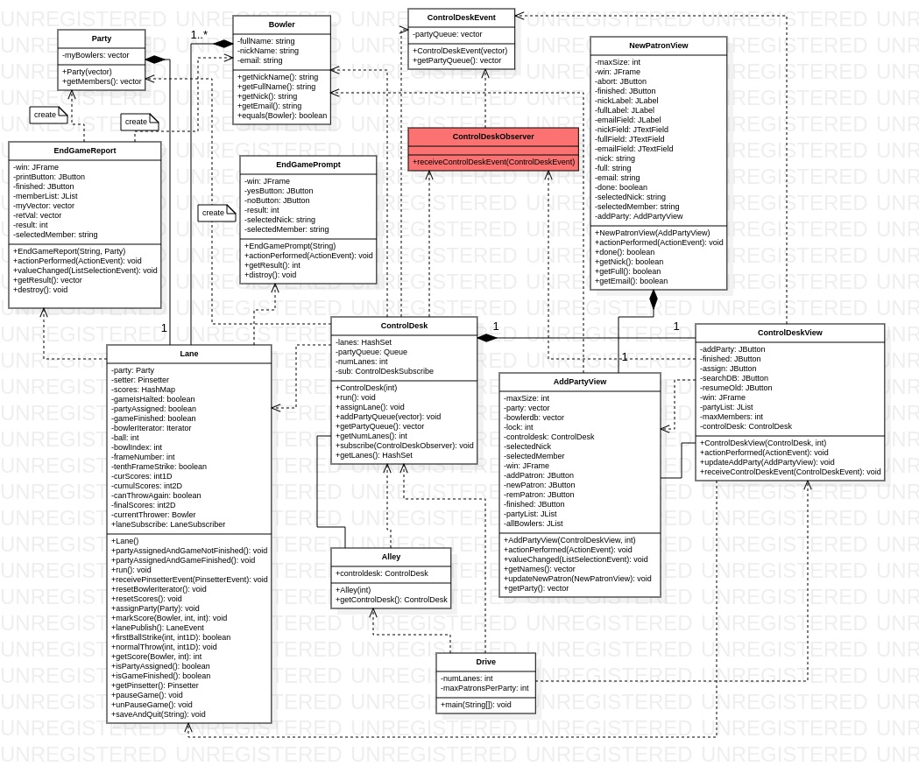

Functionality 2:

This UML diagram contains functionality to simulate a Ballthrow and observe the corresponding changes in the Score and PinsetterView.

Classes which are involved in this are:

Pinsetter, PinsetterEvent, PinsetterObserver (interface), PinSetterView, Lane, LaneEvent, LaneObserver, LaneServer, LaneStatusView, LaneView

- The create written above the arrows indicates the parent-child relationship i.e. which class is created from which parent class.
- The interface classes are PinsetterObserver, LaneObserver, LaneServer. It is shown with pink color.
- The interface class serves as an interface between two or more classes that may not be able to interact. Example: PinSetterView and Pinsetter classes are interfaced to be able to share infromation and perform different functions.
- The private attributes and methods are represented by - and the public ones are represented by +.

Associations and Dependencies :
- There is an association between Pinsetter and Lane, also between PinsetterView and LaneStatusViewclasses.
- The dotted arrow shows dependencies. It shows that a change in the class to which the arrow head points can cause a change to the dependent class.

Compositions:
- The LaneStatusView class composes The LaneView and Lane classes, and thry exist only if the LaneStatusView class object exists. Because for every Lane there must be a UI view and and status view linked to it.
- The LaneStatusView class composes the PinsetterView class indicating that if there exists a PinsetterView object then it must be the view of the pins belonging to some LaneStatusView object.
- And Lane class also composes the Pinsetter class.

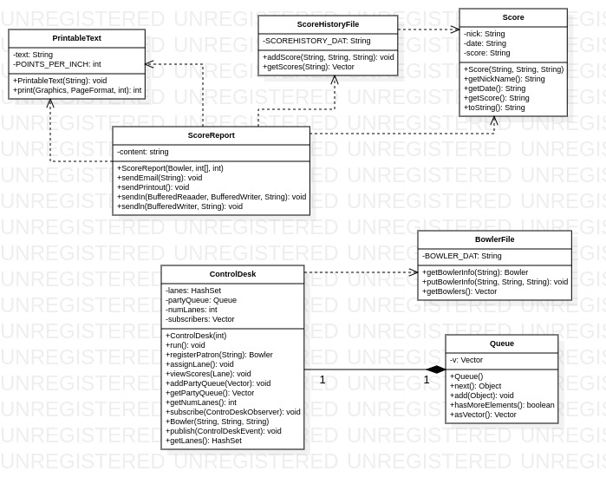

Functionality 3: This UML diagram contains functionality for scoring the game and also to maintain a queue of different class.

Classes which are involved in this are:

BowlerFile, ControlDesk, PrintableText, Queue, Score, ScoreHistoryFile, ScoreReport

- The create written above the arrows indicates the parent-child relationship i.e. which class is created from which parent class.
- In this UML class diagram there are two disjoint sets of classes. But all classes are required to implement it.

Associations and Dependencies :
- There is dependency between below shown classes which shows that they have objects shared between them.
- Score and ScoreHistoryFile
- Score and ScoreReport
- ScoreReport and ScoreHistoryFile

Composition:
- The ControlDesk class composes the Queue class, which indicates that if there exists a Queue object comprising the list of all the parties in the queue, then it must be managed by some ControlDesk object.

