Software Architecture and Design Specification
Project: Hostel Management System
Version: 1.0
Authors: R Agilesh, R G Nithik, R Muralidharan, R Pooja (Team 5)
Date: 28-09-2026
Status: Draft

Revision History
Version | Date | Author | Change Summary
1.0 | 28-09-2026 | Team 5 | Initial SAD derived from SRS v1.0 (03-09-2026) and STP v1.0 (17-09-2026)

Approvals
Role | Name | Signature/Date
Course Coordinator | Prof. Asha Kumari
Developer | R Agilesh
Developer | R G Nithik
Developer | R Muralidharan
Developer | R Pooja

1. Introduction

1.1 Purpose
This document specifies the architecture and design of the Hostel Management System (HMS). It translates the requirements in the HMS Software Requirements Specification (SRS) v1.0 into a structural and behavioural design, and aligns that design with the verification approach in the HMS Software Test Plan (STP) v1.0.

1.2 Scope
Covers student hostel records, hostel/block/room management, room allocation, occupancy tracking, check-in/check-out, room transfer requests, complaint management, occupancy and vacancy reporting, search, and audit logging. Excludes university-wide academic administration and payment processing beyond possible future APIs, as stated in the SRS.

1.3 Audience
Developers, QA engineers, hostel administrators, wardens, system integrators, security reviewers, instructors and assessment evaluators, and maintenance teams.

1.4 Definitions
HMS (Hostel Management System), UI (User Interface), API (Application Programming Interface), DB (Database), RBAC (Role-Based Access Control), NFR (Non-Functional Requirement), RTM (Requirements Traceability Matrix), ADR (Architecture Decision Record), HTTPS, TLS, ORM (Object-Relational Mapping), STRIDE (Spoofing, Tampering, Repudiation, Information disclosure, Denial of service, Elevation of privilege).

2. Document Overview

2.1 How to use this document
Provides the architectural deliverables for HMS: the component diagram, component descriptions, the chosen architecture pattern and rationale, technology stack, risks, security architecture (STRIDE), UML sequence diagrams, API design, error handling, logging and monitoring, and UX design. Section 3 describes the structure of the system; Section 4 describes its detailed behaviour.

2.2 Related Documents
- Software Requirements Specification (SRS) - Team 5, v1.0, 03-09-2026
- Software Test Plan (STP) - Team 5, v1.0, 17-09-2026
- Requirements Traceability Matrix (RTM) - SRS Section 8 and STP Section 13

3. Architecture

3.1 Goals & Constraints
Goals: secure handling of student data; consistent allocation and occupancy data (room capacity never exceeded); 99% monthly availability excluding scheduled maintenance (HMS-NF-002); 90% of common operations complete within 3 seconds under normal load (HMS-NF-001); responsive desktop and mobile web UI (HMS-NF-004); recoverable data through backup and restoration (HMS-NF-005).
Constraints: unique student and room identifiers; room capacity rules; role-based access restrictions; secure handling of student information; support for future integration through authenticated, documented APIs; web application on a Python (Django/Flask) or PHP (Laravel) server with a MySQL relational database; HTTPS/TLS for production communication.

3.2 Stakeholders & Concerns
Stakeholder | Concerns
Students | Easy access to hostel details, simple transfer and complaint submission, privacy of personal data
Wardens | Accurate occupancy monitoring, timely complaint handling, pending request visibility
Hostel Administrators | Correct allocation, capacity enforcement, approvals, reliable reports
System Administrator | Account and role management, backup and recovery, maintainability
QA / Test team | Testability of each requirement, traceable test cases (STP), stable environments
Evaluators / Coordinator | Compliance with SRS, traceability, quality of design artefacts
Developers | Modularity, clear interfaces, low coupling between modules

3.3 Component (UML) Diagram
The diagram shows the four layers of HMS, the cross-cutting security services, and the dependencies between modules. Dashed arrows show audit logging calls; the dashed external box is an optional future integration.
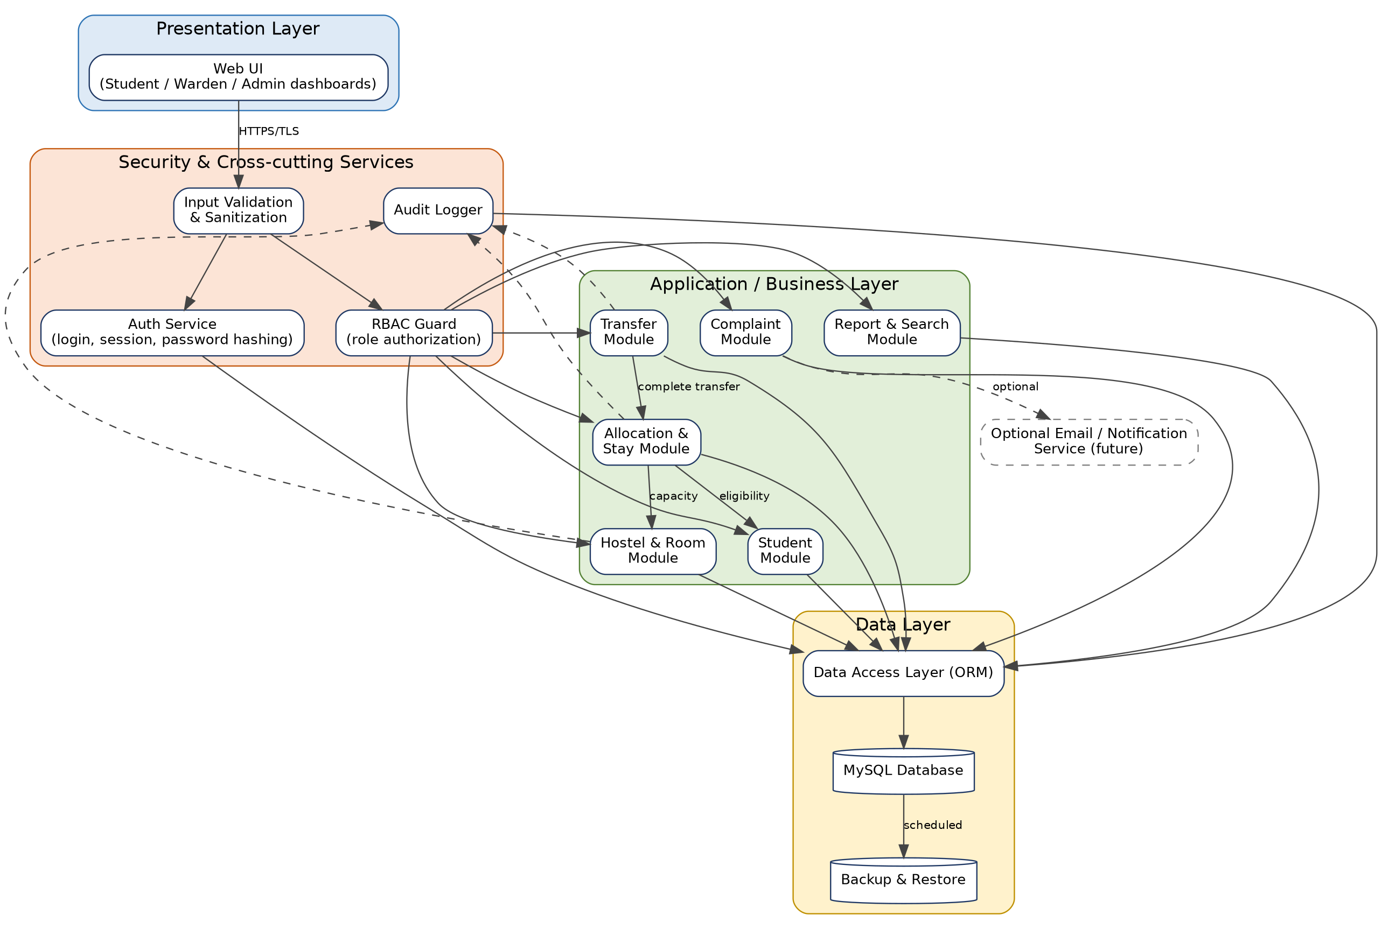
Figure 1: HMS Component Diagram

3.4 Component Descriptions
Component | Responsibility | SRS Requirements
Web UI | Role-specific dashboards (Student, Warden, Administrator): login, records, allocation, occupancy, requests, complaints, reports. Responsive on desktop and mobile browsers. | HMS-NF-004, Sec. 3.1
Input Validation & Sanitization | Validates and sanitizes all inputs before they reach business modules to reduce injection and malformed-input risk. | HMS-SR-005
Auth Service | Authenticates users, creates and ends sessions, verifies passwords against one-way hashes. | HMS-F-001, F-002, SR-001, SR-003
RBAC Guard | Checks the session and role on every protected request; blocks unauthorized role access. | HMS-F-003, SR-002
Student Module | Create and maintain student hostel records with unique student ID; duplicate ID rejected. | HMS-F-010
Hostel & Room Module | Maintain hostel, block and room records, capacity and availability. | HMS-F-011
Allocation & Stay Module | Allocate rooms, record date and status, enforce capacity and one-active-allocation rule, check-in and check-out, update occupancy. | HMS-F-020 to F-025
Transfer Module | Transfer request with reason, approve/reject workflow, atomic update of allocation and both room occupancies. | HMS-F-030 to F-032
Complaint Module | Complaint submission with unique reference, status and resolution remarks updates. | HMS-F-033, F-034
Report & Search Module | Occupancy/vacancy summaries, pending transfers and unresolved complaints, search and record retrieval. | HMS-F-040, F-041
Audit Logger | Records user, action and timestamp for important administrative actions. | HMS-F-042
Data Access Layer (ORM) | Single point of database access; parameterized queries; transaction management. | HMS-NF-003, SR-005
MySQL Database | Persistent storage of users, students, hostels, rooms, allocations, transfers, complaints and audit records. | Sec. 2.4, 3.3
Backup & Restore | Scheduled backups and verified restoration. | HMS-NF-005
Notification Service (optional) | Future email/notification integration; not part of the v1.0 test scope. | SRS 3.3, STP Sec. 4

3.5 Chosen Architecture Pattern and Rationale
Decision (ADR-01): a layered (presentation, application, data) monolithic web architecture with cross-cutting security services, organized as modular business components.
- Why layered: gives clear separation of concerns, matches the SRS description of a centralized web application, and lets each module map directly to an SRS feature group and an STP test suite (unit, integration, system).
- Why a single database transaction boundary: allocation, check-out and transfer must update the allocation record and room occupancy together (HMS-F-025, F-032, NF-003); a single relational database with ACID transactions provides this directly.
- Rejected - microservices: unnecessary operational complexity for a single-hostel-scale system, and distributed transactions would make occupancy consistency harder.
- Rejected - client-heavy single-page app with separate backend: more moving parts than the project needs; server-rendered responsive pages are sufficient for HMS-NF-004.

3.6 Technology Stack & Data Stores
Area | Choice
Application framework | Python with Django (selected from the SRS options Django/Flask/Laravel). Django provides built-in authentication, password hashing, ORM, CSRF and input-escaping support.
Database | MySQL relational database
Frontend | Server-rendered HTML with responsive CSS (mobile and desktop browsers)
Transport security | HTTPS/TLS for all production client-server communication
Sessions | Authenticated server-side sessions or signed tokens
Password storage | Salted one-way hashing (Django PBKDF2/Argon2 hasher); no plaintext passwords
Testing tools (from STP) | Selenium / browser dev tools (UI), Postman (APIs), JMeter (performance)
Design tools | draw.io / PlantUML / Graphviz for diagrams; Swagger/OpenAPI for API documentation
Primary data stores (MySQL tables): User, Student, Hostel, Block, Room, Allocation (date, status, check-in/out), TransferRequest (reason, status), Complaint (reference, status, remarks), AuditLog (user, action, timestamp). Constraints: unique Student ID, unique Room ID, capacity >= occupancy, and at most one Active allocation per student.

3.7 Risks & Mitigations
Risk | Mitigation
Occupancy exceeds capacity or becomes inconsistent after concurrent allocations/transfers | Wrap allocation, check-out and transfer in database transactions with row locking; database CHECK/unique constraints; TC-DATA-01, TC-AL-03/04
Unauthorized access to student data or admin functions | Central RBAC guard on every request; deny by default; TC-SEC-01/02
Injection or malformed input | Validation layer plus ORM parameterized queries; TC-SEC-05
Database downtime affects availability target | Backups, monitoring, documented restart procedure; record downtime for TC-REL-01
Backup cannot be restored | Scheduled restoration drills before acceptance; TC-REC-01
Slow reports/search under load | Indexes on student ID, room ID, status; pagination; profile using JMeter; TC-Perf-01
Changes to allocation logic break transfers and reports | Keep allocation rules in one module; run regression suites (STP 5.2)

3.8 Traceability to Requirements
Requirement | Description | Design element / Test case
HMS-F-001, F-002 | Login, reject invalid credentials | Auth Service; Seq. 3 / TC-Auth-01, 02
HMS-F-003, SR-002 | Role-based access | RBAC Guard; Seq. 3 / TC-Auth-03, TC-SEC-02
HMS-F-010 | Student records, unique ID | Student Module / TC-STU-01
HMS-F-011 | Hostel and room records | Hostel & Room Module / TC-RM-01
HMS-F-020 to F-023 | Allocation, date/status, capacity, single active allocation | Allocation Module; Seq. 1 / TC-AL-01 to 04
HMS-F-024, F-025 | Check-in, check-out, occupancy update | Allocation Module / TC-AL-05, 06
HMS-F-030 to F-032 | Transfer request, decision, atomic update | Transfer Module; Seq. 2 / TC-TR-01 to 03
HMS-F-033, F-034 | Complaints and status updates | Complaint Module / TC-CMP-01, 02
HMS-F-040, F-041 | Reports and pending views | Report & Search Module / TC-RPT-01, 02
HMS-F-042 | Audit records | Audit Logger / TC-AUD-01
HMS-NF-001 | Response time | Indexing, pagination / TC-Perf-01
HMS-NF-002 | Availability | Monitoring, restart procedure / TC-REL-01
HMS-NF-003 | Data integrity | DB constraints, transactions / TC-DATA-01
HMS-NF-004 | Responsive UI | Web UI / TC-UX-01
HMS-NF-005 | Backup and restore | Backup & Restore / TC-REC-01
HMS-SR-001, SR-003, SR-004, SR-005 | Authentication, hashing, TLS, input validation | Auth, Validation, TLS / TC-SEC-01, 03, 04, 05

3.9 Security Architecture
Security objectives (SRS 5.1.1): protect student and hostel data from unauthorized access and ensure important administrative actions are authorized and auditable. Threat model using STRIDE:
Threat | Scenario | Mitigation
Spoofing | Attacker logs in as a student or staff member | Credential verification against salted password hashes; session tokens; HMS-F-001/002, SR-003
Tampering | Modify allocation or occupancy data, or alter input in transit | Server-side RBAC, input validation, parameterized queries, HTTPS/TLS; SR-002/004/005
Repudiation | Admin denies changing an allocation or room | Audit log with user, action, timestamp; HMS-F-042
Information disclosure | Student records seen by wrong role, or intercepted | RBAC, TLS, no plaintext passwords, no sensitive data in logs
Denial of service | Flood of requests degrades service | Rate limiting on login and heavy endpoints, pagination, monitoring; HMS-NF-001/002
Elevation of privilege | Student calls warden/admin function | Deny-by-default RBAC guard on every endpoint; TC-Auth-03, TC-SEC-02

4. Design

4.1 Design Overview
HMS is designed as layered modules. Every request passes through the UI, input validation, authentication/RBAC, and then the responsible business module, which reads and writes through the data access layer. Business rules live in the modules, not the UI: capacity check and single-active-allocation check in the Allocation module, transfer completion as one transaction, and audit logging for allocation, room and transfer changes. Roles: Student, Warden, Hostel Administrator, System Administrator.

4.2 UML Sequence Diagrams
Three flows specific to HMS are shown: room allocation, room transfer approval, and login with role-based access.
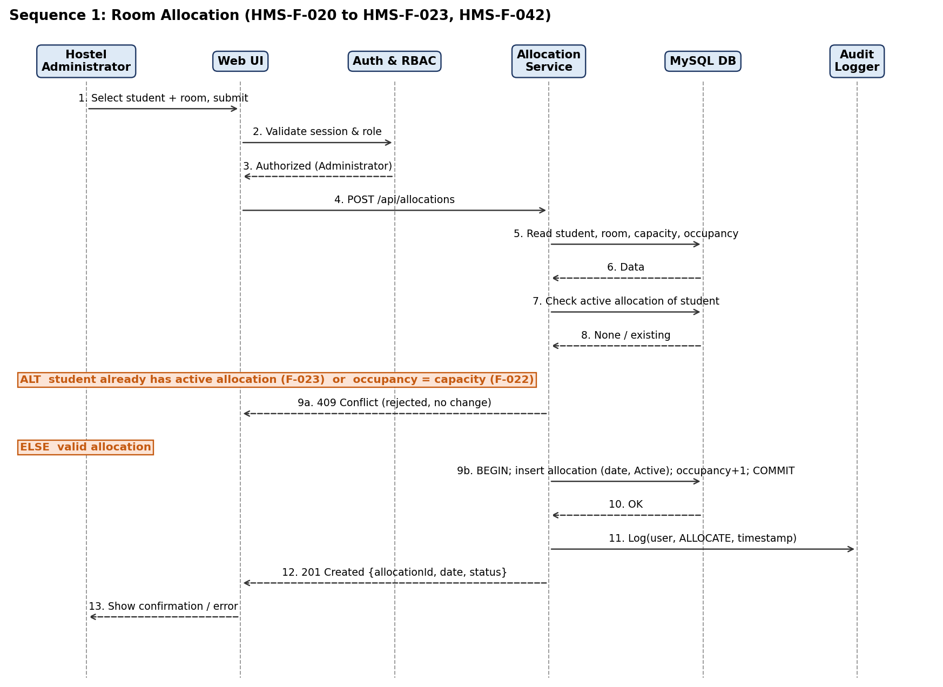
Figure 2: Sequence diagram - Room Allocation
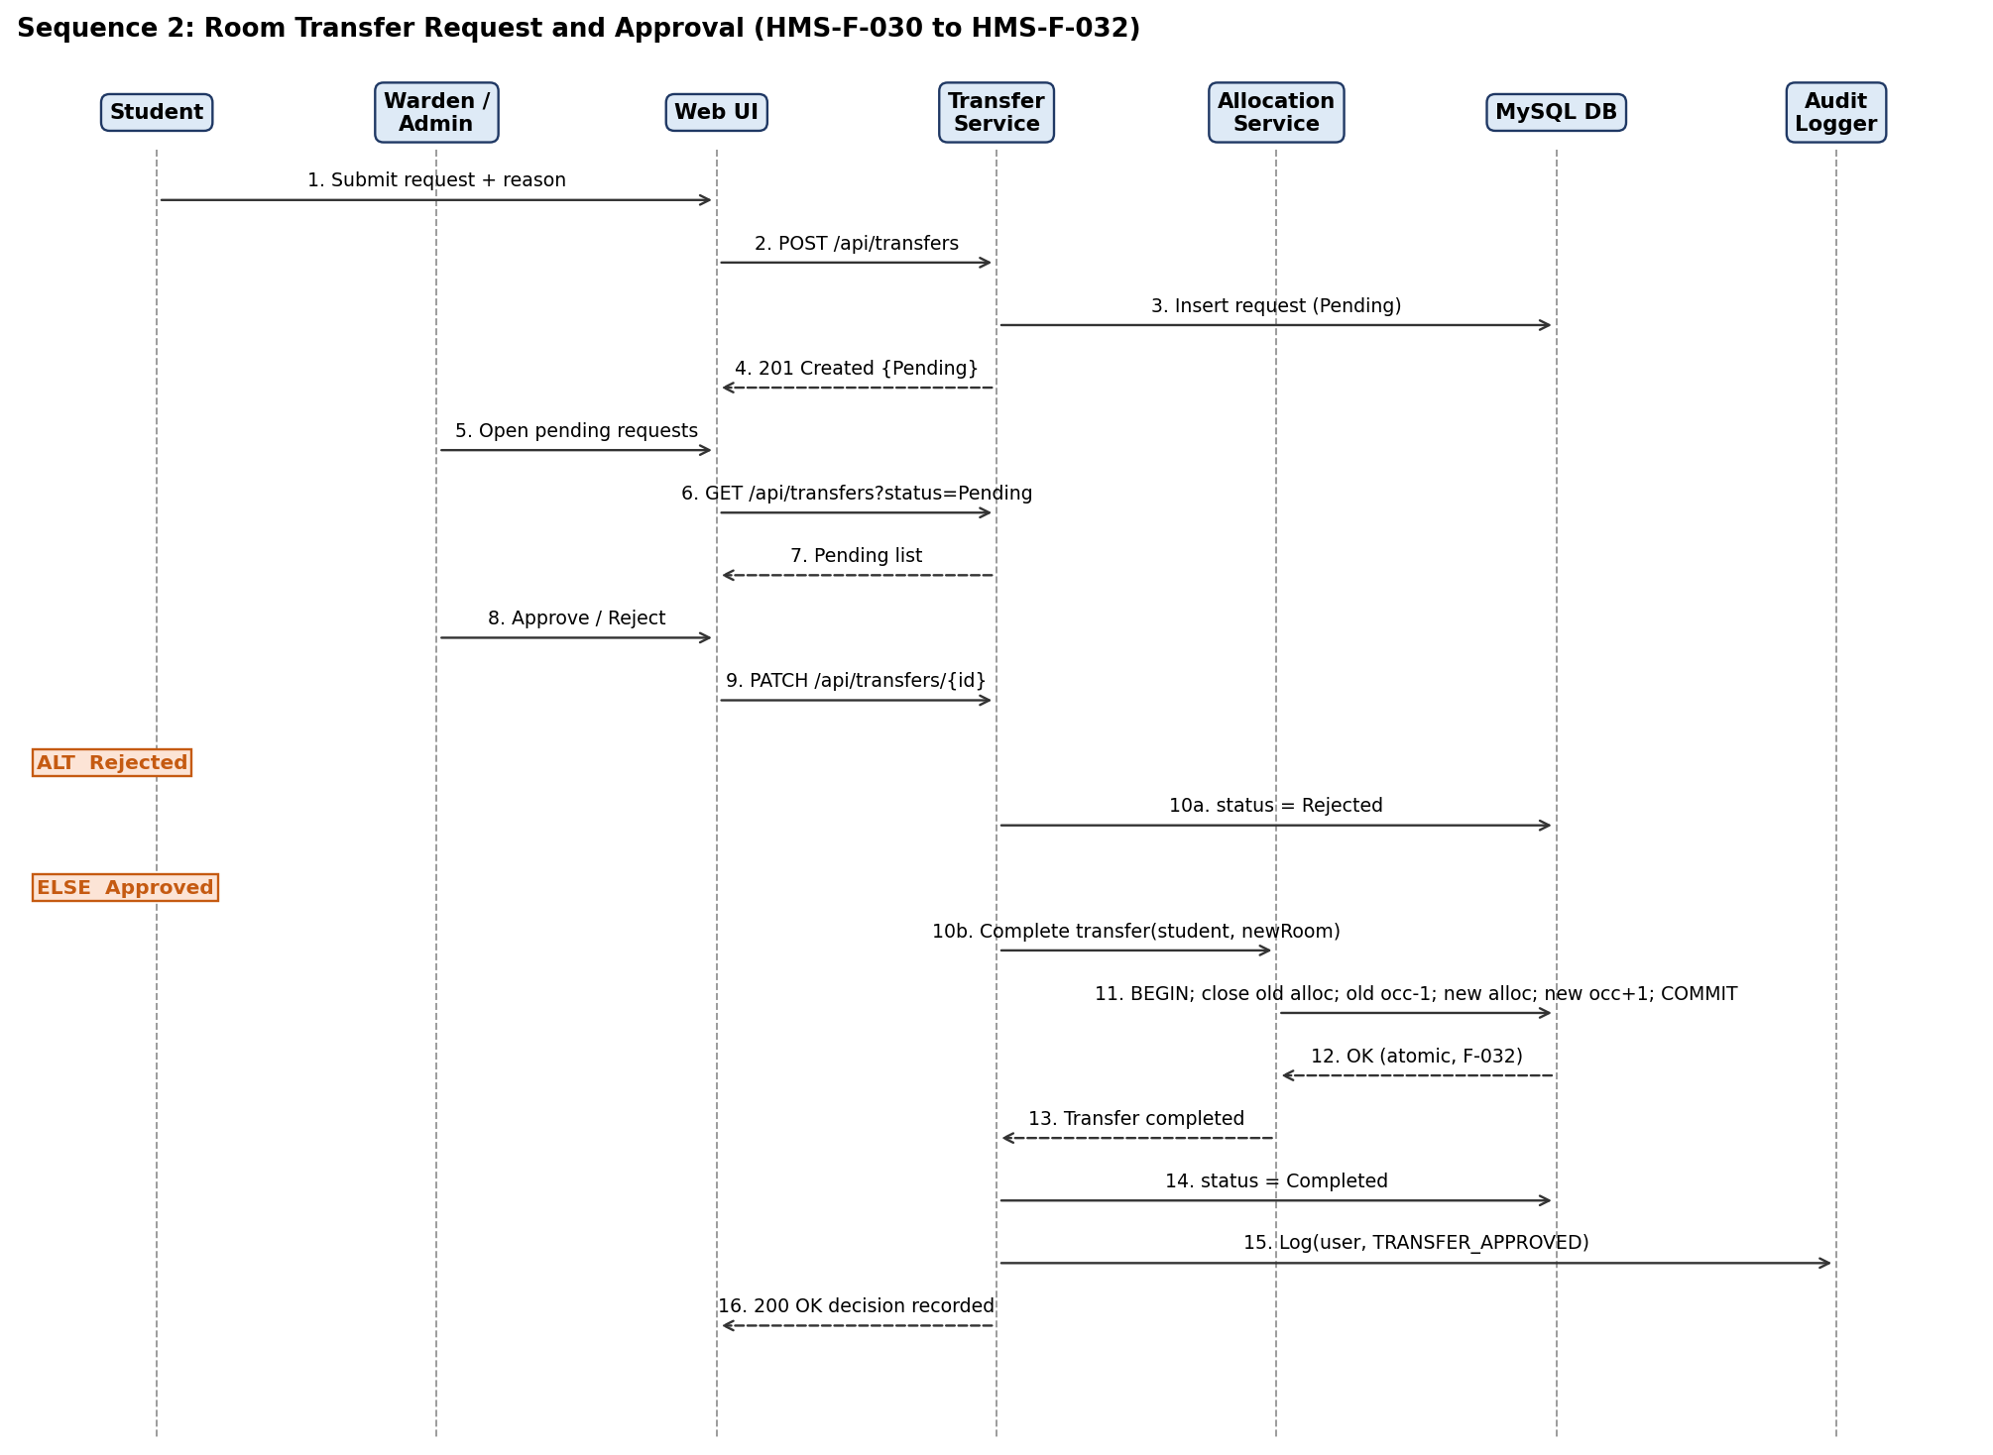
Figure 3: Sequence diagram - Room Transfer Request and Approval
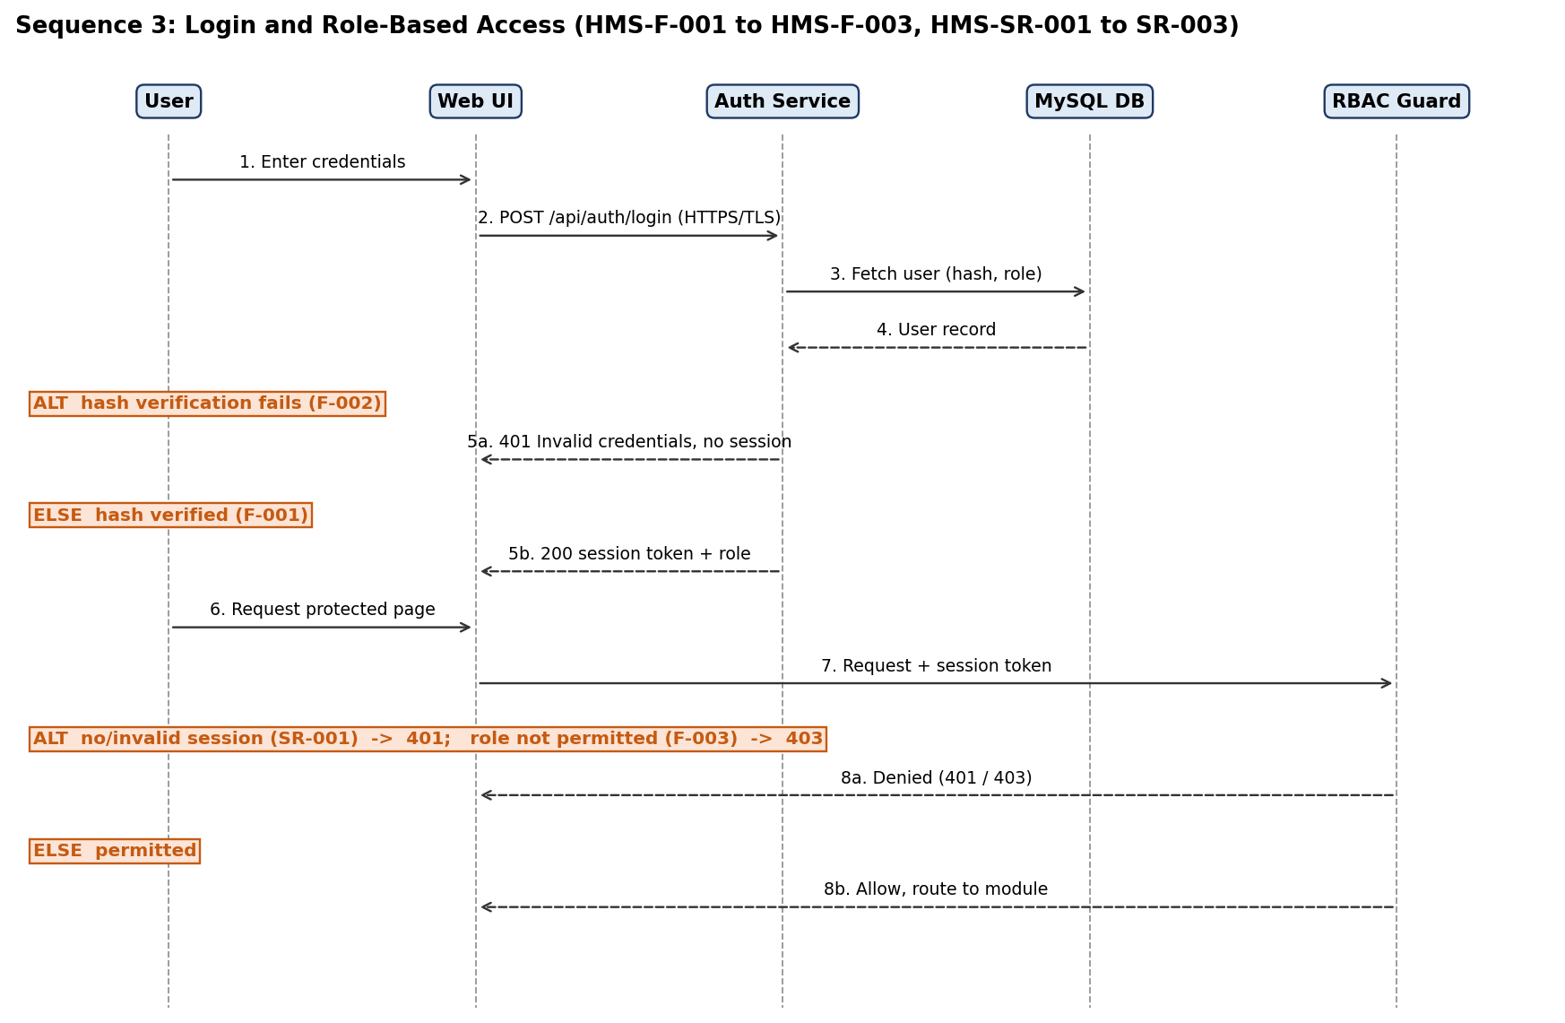
Figure 4: Sequence diagram - Login and Role-Based Access

4.3 API Design
Interfaces are defined for the Allocation, Transfer and Auth components. All endpoints require HTTPS and (except login) a valid session token. Final paths and payloads will be documented in Swagger/OpenAPI.
Component: Auth Service
Item | Definition
Endpoint | /api/auth/login
Method | POST
Request | {username, password}
Response | {status, token, role}
Errors | 401 Invalid credentials; 429 Too many attempts

Component: Allocation Service
Item | Definition
Endpoint | /api/allocations
Method | POST (Administrator only)
Request | {studentId, roomId}
Response | {allocationId, studentId, roomId, allocationDate, status}
Errors | 400 Invalid input; 401 Unauthenticated; 403 Forbidden role; 404 Student/room not found; 409 Room at capacity; 409 Student already has active allocation

Item | Definition
Endpoint | /api/allocations/{id}/checkin and /checkout
Method | POST (Warden or Administrator)
Request | {date}
Response | {allocationId, stayStatus, roomOccupancy}
Errors | 401, 403, 404, 409 No active allocation / stay

Component: Transfer Service
Item | Definition
Endpoint | /api/transfers
Method | POST (Student) - submit; GET (Warden/Admin) - list by status
Request | {reason, requestedRoomId (optional)}
Response | {requestId, status: Pending}
Errors | 400 Missing reason; 401; 403

Item | Definition
Endpoint | /api/transfers/{id}
Method | PATCH (Warden/Admin)
Request | {decision: Approved | Rejected, newRoomId}
Response | {requestId, status, oldRoomOccupancy, newRoomOccupancy}
Errors | 401; 403; 404 Request not found; 409 New room at capacity or request already decided

Component: Complaint Service
Item | Definition
Endpoint | /api/complaints (POST by Student; GET, PATCH /{id} by Warden/Admin)
Request | POST {category, description}; PATCH {status, remarks}
Response | {complaintRef, status, remarks}
Errors | 400; 401; 403; 404

4.4 Error Handling, Logging & Monitoring
- Error handling: standardized JSON error body {code, message, field} with consistent HTTP codes (400 validation, 401 unauthenticated, 403 forbidden, 404 not found, 409 business-rule conflict, 500 server). Messages are user-friendly and never expose stack traces or SQL.
- Logging: application logs for errors and security events (failed logins, denied access). Audit log records user, action and timestamp for allocation changes, room updates and transfer decisions (HMS-F-042). No passwords, tokens or unnecessary personal data in logs.
- Monitoring: uptime (target >= 99% monthly), 90th-percentile response time (target <= 3 s), error rate, failed-login count, backup job success. These feed the STP metrics for TC-REL-01, TC-Perf-01 and TC-REC-01.

4.5 UX Design
- Role-specific dashboards with clear navigation: Students see hostel details, transfer and complaint forms; Wardens see occupancy, pending transfers and complaints; Administrators see records, allocation, approvals and reports.
- Responsive layout that works on desktop and mobile browsers (HMS-NF-004, TC-UX-01).
- Readable font sizes, sufficient contrast, labelled form fields, inline validation messages, and confirmation before irreversible actions such as approving a transfer or checking out.
- Status labels (Pending, Approved, Rejected, Active, Resolved) shown consistently across lists.

4.6 Open Issues & Next Steps
- Final framework decision (Django selected here; Flask or Laravel remain SRS alternatives) to be confirmed by the team.
- Define eligibility rules for room allocation (HMS-F-020) in detail.
- Confirm the backup schedule and retention period for HMS-NF-005.
- Future enhancements: ID-card or biometric check-in, email/notification service, external APIs, payment integration.

5. Appendices
5.1 Glossary: HMS, UI, API, DB, RBAC, NFR, RTM, ADR, HTTPS, TLS, ORM, STRIDE, TC (Test Case), UAT.
5.2 References: IEEE 42010, OWASP, NIST SP 800-160, HMS SRS v1.0, HMS STP v1.0.
5.3 Tools: Graphviz, draw.io, PlantUML, Swagger/OpenAPI, Selenium, Postman, JMeter.

