1. Requirement

REQ-1: Activity Switching: Clicking on an activity card can end the current activity and start the activity of the card. Clicking on the title bar can end the current activity and set it to no activity status.

REQ-2: Start/End Activity: If there is an activity in the current activity tag bar, the user can start or end the activity by clicking the start button or long pressing the proceed button.

REQ-3: If the current activity is in progress, a secondary confirmation pop-up will appear when clicking on the activity tag bar or the activity card to switch or end the task.

REQ-4: If the current activity has not started, then clicking on the activity tag bar or the activity card to switch activities will switch the activity name displayed in the activity tag bar.

1. Use Case Diagram

|  |  |  |  |
| --- | --- | --- | --- |
| **Use Case:** | | | **Start Activity** |
| **Related Requirements:** | | REQ2 | |
| **Initiating Actor:** | | User | |
| **Actor’s Goal:** | | Start the selected activity | |
| **Participating Actors:** | | Layout, ActivityHelper | |
| **Preconditions:** | | * Has selected the activity. * No activity is currently in progress. * The button status is not started * Activity title shows "[Activity name](not start)" | |
| **Postconditions:** | | * The activity is in progress * The button status is in progress * The activity title shows "[activity name](playing)" | |
| **Flow of Events for Main Success Scenario:** | | | |
| → | 1. The user clicks the **Start button** | | |
| ← | 1. The system determines there is a selected activity, and **set the current activity to start** | | |
| **Flow of Events for Extensions (Alternate Scenarios):** | | | |
| → | 1.The user clicks the **Start button** | | |
| ← | 2.The system determines there isn’t a selected activity, and **pop up the window to prompt information** | | |

1. Acceptance Test Case

|  |  |  |
| --- | --- | --- |
| **Test-case Identifier:** | TC-1 | |
| **Use Case Tested:** | UC-1 | |
| **Pass/fail Criteria:** | The test passes if: when the user clicks the Start button when there is a selected activity, the activity will proceed. When the user clicks the Start button when there is no selected activity, the window will pop up to prompt information | |
| **Input Data:** | Mobile devices identifier | |
| **Test Procedure:** | | **Expected Result:** |
| Step 1. clicks the Start button | | The activity will proceed. |
| Step 2. clicks the Start button | | The window will pop up to prompt information. |

1. System Sequence Diagram

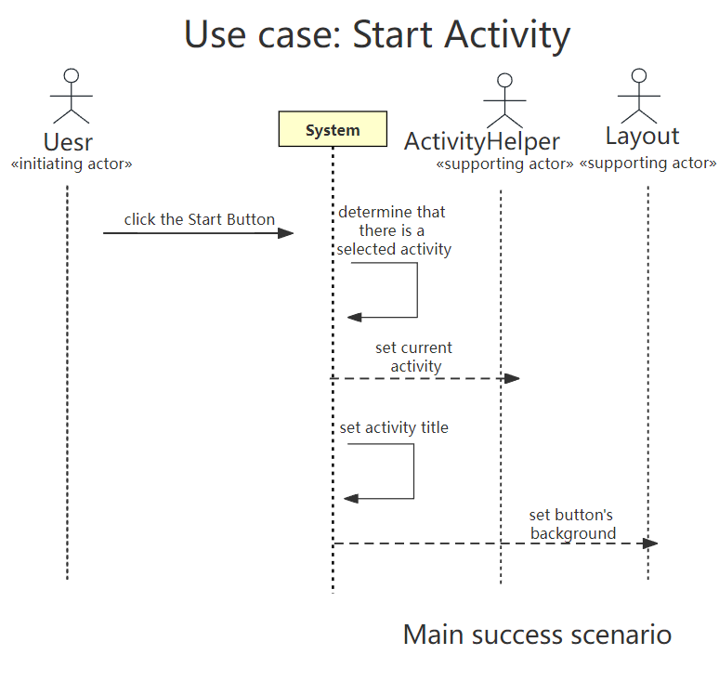

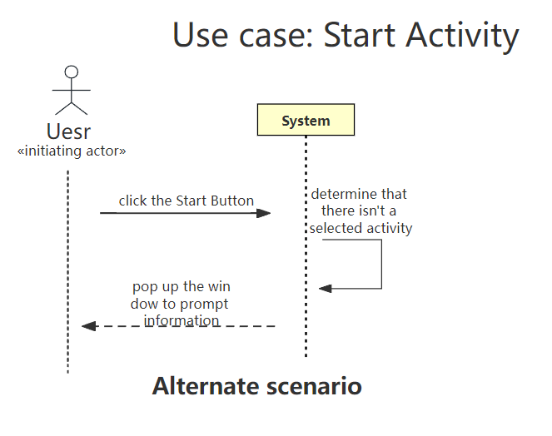

1. Activity Diagram

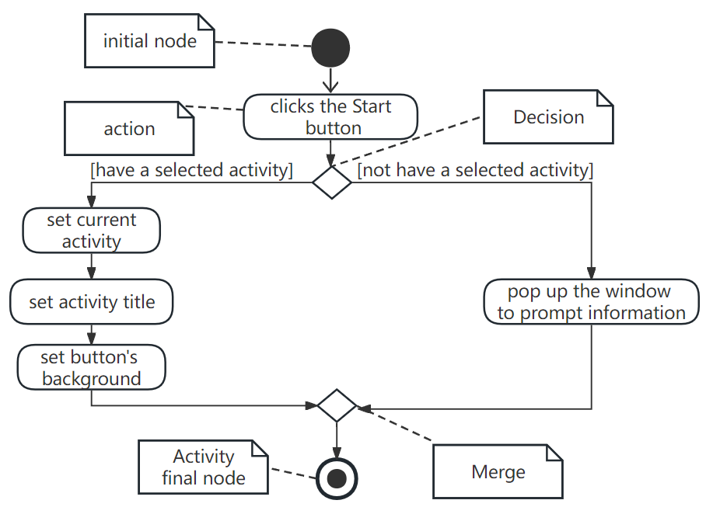

1. design sequence diagram

