Software Architecture and Design Specification
Project: Railway Reservation System
Version: 1.0
Authors:
- Tanisha Mathur — PES1UG24CS491
- Urav B S — PES1UG24CS507
- Vennela Shakthi V P — PES1UG24CS525
- Yashas Shivarajappa — PES1UG24CS545
Date: 12-10-2026
Status: Draft

Revision History
Version | Date | Author | Change Summary

Approvals
Role | Name | Signature/Date

1. Introduction
1.1 Purpose
This Software Architecture and Design Specification (SAD) describes the architecture and design of the Railway Reservation System. It identifies the major software components, their responsibilities, interactions, interfaces, security measures, and design decisions. This document serves as a reference for implementation, testing, maintenance, and evaluation.
1.2 Scope
The Railway Reservation System is a Python-based application intended to support passenger registration and login, train search, seat availability checking, ticket booking, PNR generation, ticket viewing, ticket cancellation, simulated refund calculation, and administrative train management. The system is designed for local execution with persistent storage. Payment and refund operations are simulated, and no external railway or banking system is involved.

1.3 Audience
The intended audience includes the student development team, software testers, project mentor, course instructor, and assessment evaluators.
1.4 Definitions
- SAD: Software Architecture and Design Specification.
- SRS: Software Requirements Specification.
- PNR: Passenger Name Record, a unique booking reference.
- FR: Functional Requirement.
- NFR: Non-Functional Requirement.
- RBAC: Role-Based Access Control.
- CI: Continuous Integration.
- API: Application Programming Interface.

2. Document Overview
2.1 How to use this document
This document describes the architecture and design of the Railway Reservation System. Section 3 explains the system architecture, its major components, architectural pattern, technology choices, risks, requirements traceability, and security architecture. Section 4 describes the design of the system, including UML sequence diagrams, component interfaces, error handling, logging, monitoring, and user experience. Section 5 contains the glossary and references.

2.2 Related Documents
The following documents are related to this specification:
- Software Requirements Specification (SRS) for the Railway Reservation System.
- Software Test Plan (STP) for the Railway Reservation System.
- Requirements document (requirements.md).
- User stories document (user-stories.md).
- Relevant source code and unit tests in the project repository.

3. Architecture
3.1 Goals & Constraints
Architecture Goals
- Modularity: Organise the system into separate feature modules for authentication, train search, booking, cancellation, and administration.
- Data integrity: Ensure that seat availability and booking records remain consistent during booking and cancellation operations.
- Security: Protect passenger information, validate user inputs, and restrict administrative operations to authorised users.
- Maintainability: Keep the code organised so that individual modules can be developed, tested, and modified independently.
- Testability: Support automated unit testing using pytest and continuous integration through GitHub Actions.
- Usability: Provide clear prompts, useful error messages, and a straightforward reservation workflow.
Constraints
- The application shall be developed using Python 3.10 or later.
- The baseline system shall run locally without requiring an external network connection.
- Persistent storage shall be used for user, train, seat, and booking information; the final storage technology must be confirmed.
- Payment and refund operations shall be simulated.
- The project shall use GitHub for source control and pull-request-based collaboration.
- Automated tests and continuous integration shall be used to verify code changes

3.2 Stakeholders & Concerns
1. Passengers
Passengers use the system to register, log in, search for trains, check seat availability, book tickets, view PNR details, and cancel bookings. Their main concerns are accurate train information, correct seat availability, protection of personal information, and clear confirmation and error messages.
2. Administrators
Administrators manage train information and view passenger bookings. Their main concerns are authorised access, accurate train schedules and fares, reliable updates, and correct booking information.
3. Developers
Developers are responsible for implementing and maintaining the application. Their main concerns are modular code organisation, maintainability, readability, automated testing, and reliable collaboration through GitHub.
4. Testers
Testers verify that the application meets the functional and non-functional requirements. Their main concerns are requirement coverage, correct booking and cancellation behaviour, data integrity, security validation, and successful automated test execution.
5. Project Mentor and Course Instructor
The mentor and instructor evaluate the system design, implementation, documentation, and testing. Their main concerns are compliance with the project requirements, consistency between the SRS and SAD, and demonstration of a working software product.

3.3 Component (UML) Diagram
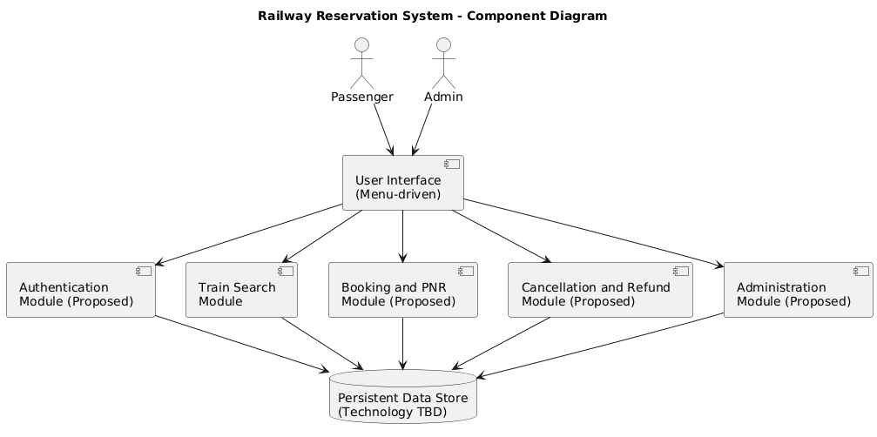
Figure 1: Proposed component architecture of the Railway Reservation System.

3.4 Component Descriptions
1. User Interface
Provides the interaction between passengers, administrators, and the application. The SRS specifies a menu-driven interface; the final interface implementation remains to be confirmed.
2. Authentication Module (Proposed)
Handles passenger registration, login, credential validation, and role-based access. It is responsible for enforcing authentication-related security requirements.
3. Train Search Module (Implemented)
Supports train searching and input validation. The current repository contains the src/railway/search.py module. This component is responsible for the train-search functionality implemented in the current codebase.
4. Booking and PNR Module (Proposed)
Handles seat selection, passenger details, booking confirmation, PNR generation, and ticket display, as specified in the SRS.
5. Cancellation and Refund Module (Proposed)
Handles ticket cancellation, simulated refund calculation, cancellation validation, and the release of cancelled seats.
6. Administration Module (Proposed)
Provides authorised administrators with functions to add, update, or deactivate train information and view passenger bookings.
7. Persistent Data Store (Technology TBD)
Stores user, train, seat, and booking information across application restarts. The final choice between SQLite and file-based storage must be confirmed before the design is finalised.

3.5 Chosen Architecture Pattern and Rationale
The proposed architecture follows a modular, layered approach. The system is divided into separate functional components, with each component responsible for a specific set of operations.
The user interface handles user interaction and passes requests to the relevant functional modules. These modules process operations such as authentication, train search, booking, cancellation, and administration. A persistent data store maintains the information required by the application.
Rationale for the Chosen Pattern
- Separation of concerns: Each component has a clearly defined responsibility, making the system easier to understand and maintain.
- Modularity: Features can be developed and tested independently, reducing the impact of changes to other components.
- Testability: Individual modules can be tested using automated unit tests, while integration tests can verify interactions between components.
- Maintainability: Separating application logic from user interaction and data storage makes future modifications easier.
- Suitability for the project: A modular, layered design is appropriate for a local Python application with a limited number of functional areas.
A microservices architecture is not proposed because the system is intended to run locally as a small application and does not require independently deployed network services.
The architecture described here is the proposed design. The final implementation structure should be verified against the source code as development progresses.

3.6 Technology Stack & Data Stores
Programming Language: Python 3.10 or later, as specified in the SRS.
Testing Framework: pytest for automated unit testing.
Version Control: Git and GitHub for source control, branch management, and pull-request-based collaboration.
Continuous Integration: GitHub Actions for automated test execution on relevant repository changes.
Data Storage: The system requires persistent storage for passenger accounts, train information, seats, and bookings. The final choice between SQLite and file-based storage has not yet been confirmed.
Application Interface: The system shall use a menu-driven interface, as specified in the SRS. The interface shall provide clear options for passenger and administrator operations.
External Services: Payment and refund operations are simulated. The baseline application does not require external railway or banking integrations.
The final technology configuration must be confirmed against the implementation and project dependencies.

3.7 Risks & Mitigations
Risk 1: Inconsistent Seat Availability
Concurrent booking attempts may result in the same seat being allocated more than once.
Mitigation: Validate seat availability immediately before confirming a booking and ensure booking operations are performed atomically.
Risk 2: Data Loss
Application data may be lost if persistent storage is not handled correctly.
Mitigation: Use reliable persistent storage, validate data before updates, and provide appropriate backup or recovery procedures where applicable.
Risk 3: Unauthorised Access
Unauthorised users may attempt to access passenger information or administrative functionality.
Mitigation: Enforce authentication, role-based access control, secure password storage, and ownership checks for passenger bookings.
Risk 4: Invalid User Input
Incorrect or malformed inputs may cause failures or inconsistent application behaviour.
Mitigation: Validate inputs before processing them and provide clear error messages without exposing sensitive information.
Risk 5: Incomplete Feature Implementation
Some features specified in the SRS may not yet be implemented in the application.
Mitigation: Track implementation progress against the SRS, develop and test each module incrementally, and document any deviations between the proposed design and the final implementation.

3.8 Traceability to Requirements

The following table maps the functional and non-functional requirements in the Software Requirements Specification (SRS) to their corresponding architectural components.
SRS Requirement IDs | Corresponding Component
RRS-F-001 to RRS-F-004 | Authentication Module
RRS-F-005 to RRS-F-008 | Train Search Module
RRS-F-009 to RRS-F-014 | Booking and PNR Module
RRS-F-015 to RRS-F-018 | Cancellation and Refund Module
RRS-F-019 to RRS-F-022 | Administration Module
RRS-NF-001 | Train Search Module
RRS-NF-002 | Booking Module and Persistent Data Store
RRS-NF-003 | Authentication Module and Persistent Data Store
RRS-NF-004 | Persistent Data Store and Logging
RRS-SR-001 to RRS-SR-007 | Authentication, relevant functional modules, and security controls
These mappings represent the proposed architecture. They should be verified against the final implementation and the detailed requirement descriptions in the SRS.

3.9 Security Architecture
The proposed security architecture aims to protect passenger information, maintain the integrity of train and booking records, and ensure that security-relevant activities can be traced.
1. Authentication and Password Protection
The Authentication Module shall validate user credentials and protect stored passwords using salted cryptographic hashes, as specified in RRS-SR-001. Passwords shall not be stored, displayed, or logged in plaintext.
2. Role-Based Access Control
Administrative operations shall be restricted to authenticated administrators. Passenger accounts shall not be permitted to access administrative functions, as specified in RRS-SR-002.
3. Booking Ownership Validation
Passengers shall be permitted to view and cancel only their own bookings. The system shall verify booking ownership before performing these operations, as specified in RRS-SR-003.
4. Input Validation
All user inputs shall be validated and sanitised. Data-store queries shall be parameterised where applicable, and invalid input shall be rejected without crashing the application, as specified in RRS-SR-004.
5. Security Logging
Login successes and failures, account lockouts, bookings, cancellations, and administrative changes shall be recorded in timestamped audit logs. Logs shall not contain passwords or other prohibited credentials, as specified in RRS-SR-005.
6. Session Management
Logged-in sessions shall expire after 15 minutes of inactivity, as specified in RRS-SR-006.
7. Network Security
If a network-based front end is introduced, communication shall use TLS 1.2 or higher, as specified in RRS-SR-007. This requirement applies conditionally because the baseline system is designed to run locally.
These measures describe the required security design. Their implementation and effectiveness must be verified through code inspection and security testing.

4. Design

4.1 Design Overview
The proposed design of the Railway Reservation System follows a modular approach in which each functional component is responsible for a specific set of operations.
The system is intended to provide separate functionality for passenger authentication, train search and seat availability, booking and PNR generation, cancellation and refund calculation, and administration. These components share persistent data relating to passengers, trains, seats, and bookings.
The design aims to maintain data consistency during booking and cancellation, validate user input, restrict access to authorised operations, and provide clear feedback when an operation succeeds or fails.
The train-search functionality has an implementation present in the current repository. The remaining components are described according to the SRS and must be verified against the final implementation before the design is considered complete.

4.2 UML Sequence Diagrams
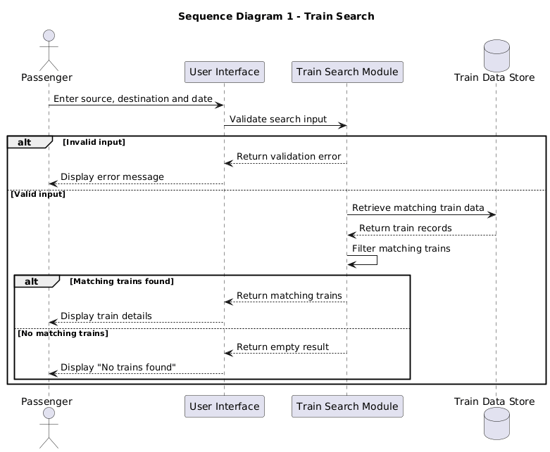
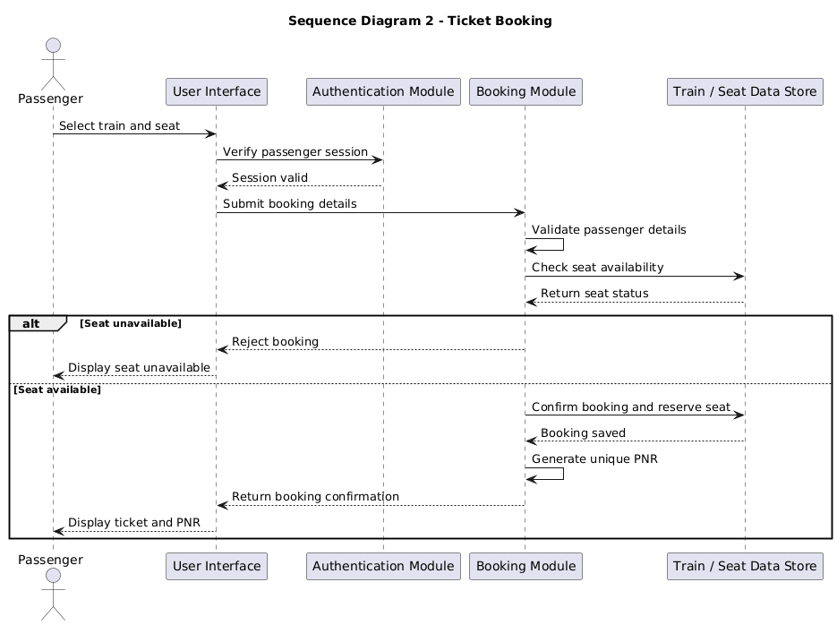

4.3 API Design
The Railway Reservation System is designed as a local Python application. Its component interfaces are therefore described as internal function or module interfaces rather than mandatory HTTP endpoints. The exact function signatures shall be confirmed against the implementation.
Interface 1: Train Search
- Component: Train Search Module
- Purpose: Find trains matching the passenger's source, destination, and travel date.
- Inputs: Source station, destination station, and travel date.
- Processing: Validate the inputs and identify matching train records.
- Output: Matching train details or an empty result if no trains match.
- Error handling: Invalid search inputs shall be rejected with a clear error message.
Interface 2: Ticket Booking (Proposed)
- Component: Booking and PNR Module
- Purpose: Create a confirmed booking for an available seat.
- Inputs: Authenticated passenger information, selected train, travel date, seat selection, and passenger details.
- Processing: Validate the booking details, recheck seat availability, save the booking, and generate a unique PNR.
- Output: Booking confirmation containing the PNR and ticket details.
- Error handling: Reject invalid passenger details and unavailable seats without creating an invalid booking.
These interfaces represent the intended design. The actual function names, parameter types, return values, and exceptions must be documented after inspecting the corresponding source code.

4.4 Error Handling, Logging & Monitoring
Error Handling
The system shall validate user inputs before processing requests. Invalid registration details, incorrect login credentials, invalid train search criteria, unavailable seats, and invalid booking or cancellation requests shall be rejected with clear error messages.
Booking and cancellation operations shall preserve data consistency. If an operation fails, the system shall avoid leaving incomplete or inconsistent booking records.
Logging
The system shall maintain timestamped records of important events, including successful and failed login attempts, account lockouts, bookings, cancellations, and administrative changes.
Passwords and other sensitive credentials shall not be included in log messages. Logs should contain sufficient information to support troubleshooting and security auditing without exposing confidential data.
Monitoring
During development and testing, the team shall monitor automated test results, test coverage, application errors, and failures in important operations. GitHub Actions shall be used to run automated tests on relevant repository changes.
The final implementation shall be checked to ensure that the logging and error-handling behaviour satisfies the requirements in the SRS.

4.5 UX Design
The Railway Reservation System is intended to provide a straightforward interface for passengers and administrators.
Passenger Interface
The passenger interface shall provide clear options for registration, login, train search, seat availability, ticket booking, PNR viewing, and ticket cancellation. Input prompts shall identify the information required from the user, and confirmation messages shall be displayed after successful operations.
Administrator Interface
The administrator interface shall provide authorised users with options to add, update, or deactivate train information and view passenger bookings.
Usability and Error Feedback
The system shall provide readable text, consistent navigation, meaningful error messages, and confirmation before ticket cancellation. The booking process should be simple enough for a first-time passenger to complete within the usability target specified in the SRS.
The system shall use a menu-driven interface, as specified in the SRS. The final implementation shall provide clear navigation and meaningful feedback for passenger and administrator operations.

4.6 Open Issues & Next Steps
The following items require confirmation or further work:
- Persistent Storage: Finalise the choice between SQLite and file-based storage.
- User Interface: Ensure that the final implementation follows the menu-driven interface specified in the SRS.
- Feature Implementation: Verify the implementation status of authentication, booking, PNR generation, cancellation, refund calculation, and administration.
- Refund Rules: Finalise the simulated refund percentages for different periods before departure.
- Security Controls: Verify password hashing, role-based access control, booking ownership checks, audit logging, and session expiry.
- Testing: Ensure that the implemented components are covered by automated tests and that the required test coverage is achieved.
- Documentation Consistency: Update the SAD if the final implementation differs from the SRS or the proposed architecture.
These items shall be reviewed during development and testing. Any deviations from the submitted design shall be documented and explained during the final project demonstration.

5. Appendices

5.1 Glossary
- SAD: Software Architecture and Design Specification.
- SRS: Software Requirements Specification.
- PNR: Passenger Name Record, a unique booking reference.
- FR: Functional Requirement.
- NFR: Non-Functional Requirement.
- RBAC: Role-Based Access Control.
- CI: Continuous Integration.
- API: Application Programming Interface.
- UML: Unified Modeling Language.

5.2 References
- Railway Reservation System — Software Requirements Specification, Version 1.0, dated 12 October 2026.
- Railway Reservation System — Software Test Plan, when finalised.
- Project requirements and user stories maintained in the GitHub repository.
- Python documentation: https://docs.python.org/3/
- pytest documentation: https://docs.pytest.org/

5.3 Tools
- Microsoft Word for preparing the SAD document.
- PlantText for generating UML diagrams.
- Git and GitHub for source control and collaboration.
- pytest for automated testing.
- GitHub Actions for continuous integration.

