Software Requirements Specification

for

Hotel Easy

Version 1.2 approved

Prepared by Nguyen Ngoc Phuoc

SE1218, FPT University

4/10/2018

Table of Contents

Table of Contents

1. Introduction 1

1.1 Purpose 1

1.2 Document Conventions 1

1.3 Intended Audience and Reading Suggestions 1

1.4 Product Scope 1

1.5 References 1

2. Overall Description 2

2.1 Product Perspective 2

2.2 Product Functions 2

2.3 User Classes and Characteristics 2

2.4 Operating Environment 3

2.5 Design and Implementation Constraints 3

2.6 User Documentation 3

2.7 Assumptions and Dependencies 3

3. External Interface Requirements 4

3.1 User Interfaces 4

3.2 Hardware Interfaces 4

3.3 Software Interfaces 4

3.4 Communications Interfaces 4

4. System Features 4

4.1 Manage Account 4

4.1.1 Create Account 4

4.1.2 Login 6

4.1.3 Log out 7

4.1.4 Reset Password 8

4.1.5 Change Password 10

4.2 Manage Room 12

4.2.1 Insert a Room 12

4.2.2 Delete a Room 13

4.2.3 Edit a Room 15

4.3 Support staff of hotel choose room for customer 17

4.3.1 Finding a Room 17

4.3.2 Booking room for customer 19

4.4 View option 20

4.4.1 Grid View 20

4.4.2 List View 21

5. Other Nonfunctional Requirements 23

5.1 Performance Requirements 23

5.2 Safety Requirements 24

5.3 Security Requirements 24

5.4 Software Quality Attributes 24

5.5 Business Rules 24

6. Other Requirements 24

Appendix A: Glossary 25

Appendix B: Database 25

Revision History

|  |  |  |  |
| --- | --- | --- | --- |
| **Name** | **Date** | **Reason For Changes** | **Version** |
| Nguyen Ngoc Phuoc | 4/10/2018 | Began initial release. | 1.0 |
| Nguyen Ngoc Phuoc | 8/10/2018 | Add some user interface for Manage Account | 1.1 |
| Nguyen Ngoc Phuoc | 10/10/2018 | Add some user interface for Manage Room and View Option | 1.2 |
|  |  |  |  |
|  |  |  |  |
|  |  |  |  |
|  |  |  |  |
|  |  |  |  |
|  |  |  |  |
|  |  |  |  |

# Introduction

## Purpose

The purpose of this document is to give a detailed description of the requirements for the “Hotel Easy” (HE) software. It will illustrate the purpose and complete declaration for the development of system. It will also explain system constraints, interface and interactions with other external applications. This document is primarily intended to be proposed to a customer for its approval and a reference for developing the first version of the system for the development team.

## Document Conventions

No document conventions are being used at this time.

## Intended Audience and Reading Suggestions

This document is intended to be used by members of the project team that will implement and verify the correct functioning of the system.

## Product Scope

The software is an web application to assist hotel reservation reception for guests:

+ Check the status of rooms such as: Expected arrival room, Departure room, Vacant ready room, Occupied room, Vacant dirty, House use room, Out of used room, Stay over room. All this information will be stored in the database.

+ Make your booking easier by the customer's preference because of the search filter. For example, a customer who wants to have a Deluxe Twin or Standard Single or more room types, the staff can easily find.

+ Accurately calculate the cost of the customer based on the factors: room type, booking time (weekdays, holidays or weekends), time to stay.

+ Save your customer's booking history to calculate revenue

## References

[1] IEEE Software Engineering Standards Committee, “IEEE Std 830-1998, IEEE Recommended Practice for Software Requirements Specifications”, October 20, 1998.

[2] Michael J. O'Fallon, Denney G. Rutherford, “Hotel Management and Operations”, 5th Edition, January, 2010

[3] Ian Sommerville, “Software Engineering”, 9th Edition, Pearson, 2010

# Overall Description

## Product Perspective

Currently, many hotels are established. In particular, there are still many hotels, especially small hotels, staff still use paper records to make reservations for customers. This will cause employees to spend a lot of time finding rooms and making reservations for their customers, sometimes with some confusion. This software is designed to assist in making reservations for customers.

HE is a web-based app. It should run on any OS with a web browser and Internet supported. The Manager can easily update content, review feedbacks of user, etc.

HE is intended to be a stand-alone product and should not depend on the availability of other software.

## Product Functions

The users (staffs of hotel) will be able to search for rooms. The result will be based on the criteria the user inputs. There are several search criteria and it will be possible for the administrator of the system to manage the options for those criteria that have that.

The result of the search will be viewed either in a Grid Layout view (some what like table view). Each cell display Room Number, Room Type and other properties. When user click on a cell, the screen will display detail information of this room.

The web portal will provide functionality to manage the system and the room information. It will also provide information about the system, for example show when there is a new update.

## User Classes and Characteristics

There are two types of users that interact with the system: Staffs of Hotel and Administrators. Each of these two types of users has different use of the system so each of them has their own requirements.

+ Staffs of Hotel can search the room base on some properties like Room Type, Price, Status of Room, etc. Besides, they can edit some dynamic information such as Status of Rooms.

+ Administrators can edit all information (dynamic and fixed) of a Room such as Room Number, Price.

## Operating Environment

|  |  |
| --- | --- |
| OE-1 | System is not dependent on geographical areas. |
| OE-2 | The application can operate on Windows, Linux, Android, iOS and some operation system have support web browsers. |
| OE-3 | System shall operate in newest versions of all web browsers. |
| OE-4 | There should be no constraint on users being able to access the system at a given time. |
| OE-5 | Continuous service is preferred, but as long as there is no data loss, mino service interruptions can be tolerated. |
| OE-6 | jQuery javascript library will be needed to create the user interface for th system. |

## Design and Implementation Constraints

Language requirement: English

The Internet connection is also a constraint for the application. Since the application fetches data from the database over the Internet, it is crucial that there is an Internet connection for the application to function.

The application will be constrained by the capacity of the database. Since the database is shared between applications on different devices it may be forced to queue incoming requests and therefor increase the time it takes to fetch data.

## User Documentation

User Manuals: help.docx

## Assumptions and Dependencies

|  |  |  |
| --- | --- | --- |
| Asspumptions | AS-1 | Have more than 400 MB in hard drive on server. |
| AS-2 | Users have any Web brower in their device. |
| AS-3 | Users have javascript enabled. |
| Dependencies | DE-1 | jQuery javascript library (for user interface). |

# External Interface Requirements

## User Interfaces

A graphic user interface will be available in all workflow scenarios to allow easy to access to all features of the system. The navigation options in every screen will be similar in order to help user can reduce the time learning and using system. All error occurring and exception handling will be catch and display for user with friendly messages.

## Hardware Interfaces

The prototype software (HE) will be implemented on Devices:

+ Safari 12.0, Macbook Pro 2016

+ Chrome 14, Dell XPS 15

## Software Interfaces

Any OS version with internet connection and internet browser.

## Communications Interfaces

|  |  |
| --- | --- |
| HE-01 | HTTP1.1 connection to communicate with server over the Internet. |
| HE-02 | PHP System (for all web interface and communication with MySQL database). |
| HE-03 | MySQL (for storing database). |
| HE-04 | Apache service (for HTTP protocol and PHP). |

# System Features

## Manage Account

### Create Account

|  |  |  |  |
| --- | --- | --- | --- |
| UC ID and Name: | MA01 – Create Account | | |
| Created By: | PhuocNN | Date Created: | 4/10/2018 |
| Primary Actor: | Staff | Secondary Actors: | N/A |
| Trigger: | Click “Create Account” on the home. | | |
| Description: | Create new account for user. | | |
| Preconditions: | The user has already access to the application. User had not logged in. | | |
| Postconditions: | User is navigated to Home | | |
| Normal Flow: | 1. Click <Sign In > button on the “Home”.  =>”Sign In” screen is displayed.  2. Fill information into all the required fields.  3. Click <Sign In> button. Successful message appear to user.  => A new account is added to the DB | | |
| Alternative Flows: | N/A | | |
| Exceptions: | - Invalid username  - Text in confirm field does not match with the original field  - Leave required fields blank  - User enter existed email address. | | |
| Priority: | Medium | | |
| Frequency of Use: | 1 – 2 times per month | | |
| Business Rules: | - Username must be greater than 4 characters and less than 10 characters.  - Username does not allow to contain special character such as { [ ] } \ | : ; “ ‘ < , > . ? / ! @ # $ % ^ & * ( ) _ - + =,…  - Password must be greater than 8 character and less than 20 characters.  - Age must be greater than 0 and less than 150 years old. | | |
| Other Information: | N/A | | |
| Assumptions: | User input correct all required fields. | | |

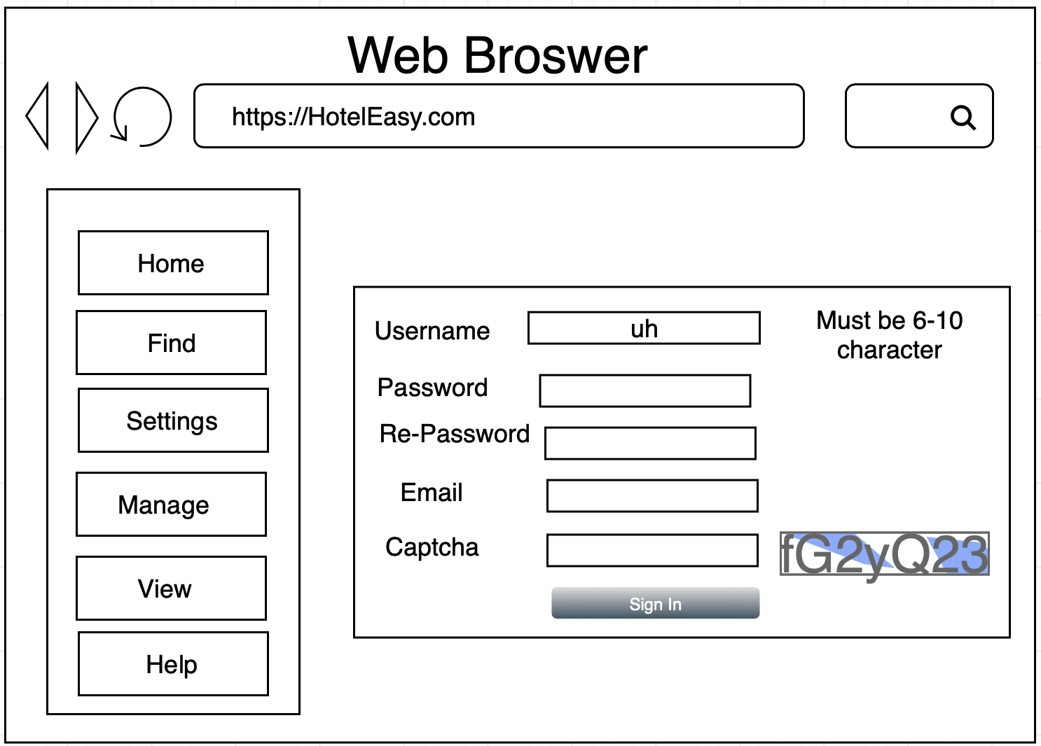

Figure 1.1a: Sign In

### Login

|  |  |  |  |
| --- | --- | --- | --- |
| UC ID and Name: | MA02 - Login | | |
| Created By: | PhuocNN | Date Created: | 4/10/2018 |
| Primary Actor: | Staff | Secondary Actors: | N/A |
| Trigger: | Click “Login” on the Home. | | |
| Description: | Login to the application. | | |
| Preconditions: | Opened application | | |
| Postconditions: | Remember username and password and type them into application | | |
| Normal Flow: | 1. Type the Username in Username textfield  2. Type the Password in Password textfield  3. Click on Login button  4. Login successfully | | |
| Alternative Flows: | N/A | | |
| Exceptions: | In step 3, if Username or Password incorrect, the application will move to HE02 – Create Account | | |
| Priority: | High | | |
| Frequency of Use: | 1-2 times used per day | | |
| Business Rules: | N/A | | |
| Other Information: | N/A | | |
| Assumptions: | User remember username and password. | | |

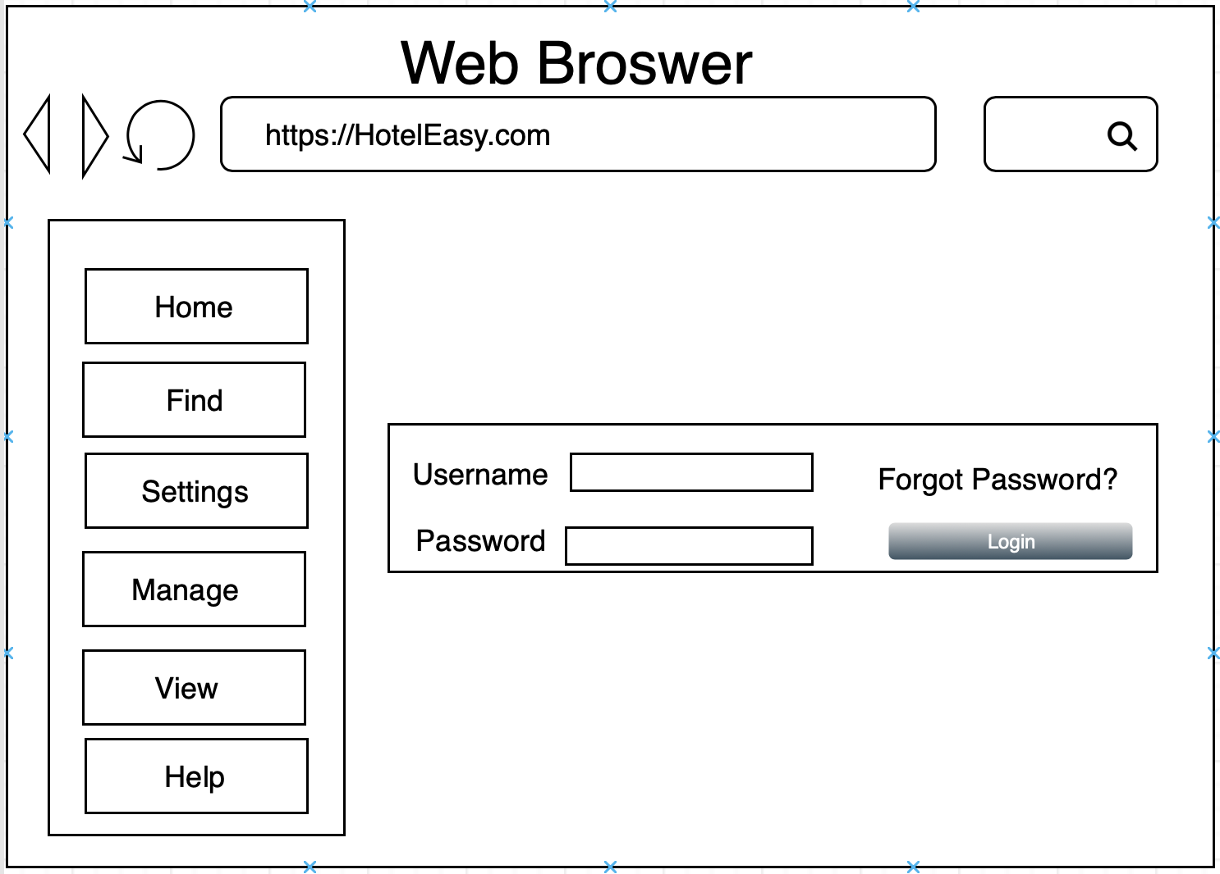

Figure 1.1b: Login

### Log out

|  |  |  |  |
| --- | --- | --- | --- |
| UC ID and Name: | MA03 – Logout | | |
| Created By: | PhuocNN | Date Created: | 4/10/2018 |
| Primary Actor: | Staff | Secondary Actors: | N/A |
| Trigger: | Click <Logout> button. | | |
| Description: | Allow user to log out the current account | | |
| Preconditions: | User is logging in | | |
| Postconditions: | “Home” is displayed with guest’s view | | |
| Normal Flow: | 1. Click “Settings” button  => “Settings” combo box will display.  2. Click “Log out” option  => System shows Confirm Message “Are you want to log out?”  3. Click “Yes”  =>”Login” screen will display | | |
| Alternative Flows: | N/A | | |
| Exceptions: | N/A | | |
| Priority: | Medium | | |
| Frequency of Use: | 1-2 times used per day | | |
| Business Rules: | N/A | | |
| Other Information: | N/A | | |
| Assumptions: | N/A | | |

### Reset Password

|  |  |  |  |
| --- | --- | --- | --- |
| UC ID and Name: | MA04 – Reset password | | |
| Created By: | PhuocNN | Date Created: | 4/10/2018 |
| Primary Actor: | Staff | Secondary Actors: | N/A |
| Trigger: | Click “Forgot Password” button. | | |
| Description: | Allow user to reset forgot password. | | |
| Preconditions: | N/A | | |
| Postconditions: | “Forgot Password” is displayed. | | |
| Normal Flow: | 1. Click “Forgot Password” button on “Home” screen.  =>”Forgot Password” screen is displayed.  2. Enter email address.  3. Click “Send” button  =>System show message “System had sent confirm code to your email, you can reset your password” | | |
| Alternative Flows: | N/A | | |
| Exceptions: | [1] a. Enter invalid email address.  b. Click “Send” button.  => System show message “Invalid email address”.  [2] a. Do not input <Email> field.  b. Click “Send” button.  => System show message “Please input your email address”. | | |
| Priority: | Medium | | |
| Frequency of Use: | Rarely. | | |
| Business Rules: | N/A | | |
| Other Information: | N/A | | |
| Assumptions: | N/A | | |

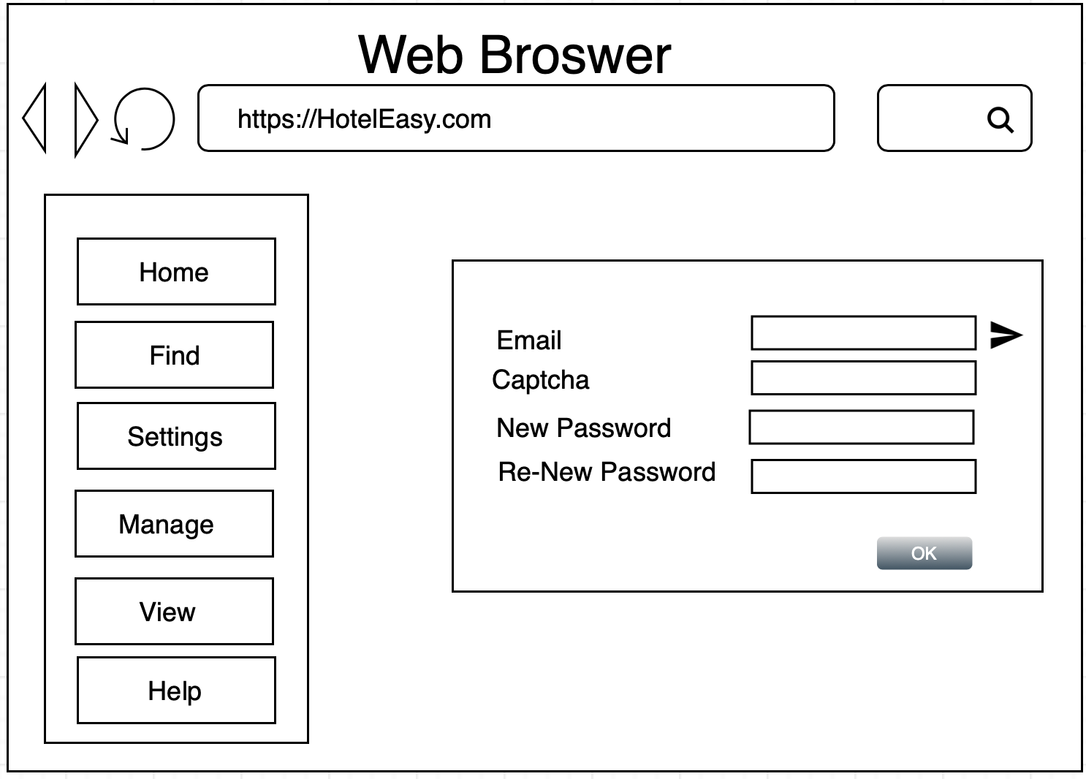

Figure 1.1c: Change Password

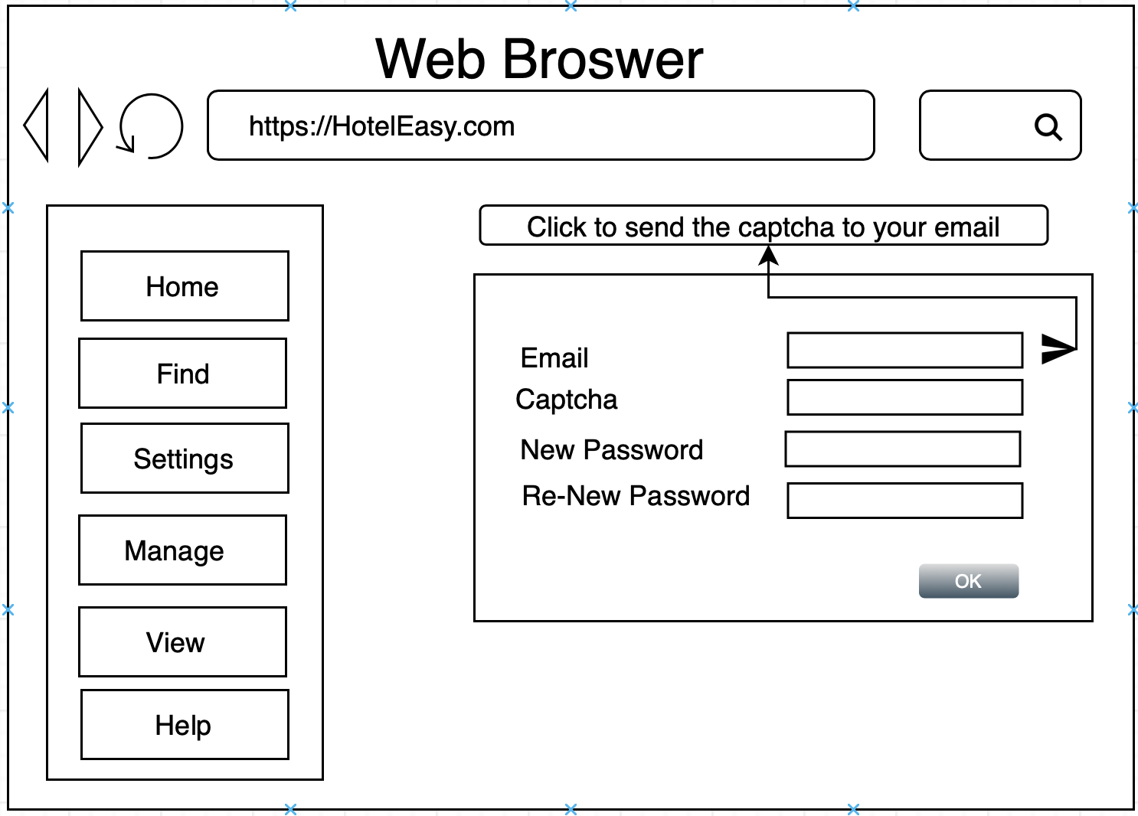

Figure 1.1d: Change Password | Mouse move to the trangle button

### Change Password

|  |  |  |  |
| --- | --- | --- | --- |
| UC ID and Name: | MA05 – Change password | | |
| Created By: | PhuocNN | Date Created: | 4/10/2018 |
| Primary Actor: | Staff | Secondary Actors: | N/A |
| Trigger: | Click “Forgot Password” button. | | |
| Description: | Allow user to change their password. | | |
| Preconditions: | User had logged in the application. | | |
| Postconditions: | “Change Password” is displayed. | | |
| Normal Flow: | 1. Click “Settings” menu.  => A drop down list will show.  2. Click “Account” option.  => “Account” screen will display.  3. Click “Change Password” option  => “Change Password” screen will display.  4. Enter old password, new password and confirm new password.  5. Click “Save” button.  => System show message “Your password have changed”. | | |
| Alternative Flows: | N/A | | |
| Exceptions: | [1] a. Do not enter into required fields.  b. Click “Save” button  => System show message “Please enter all field”.  [2] a. Enter old password incorrectly.  b. Click “Save” button  => System show message “Please input valid old password”.  [3] a. Enter new password and confirm password does not match.  b. Click “Save” button  => System show message “Confirm password incorrect”. | | |
| Priority: | Medium | | |
| Frequency of Use: | Rarely. | | |
| Business Rules: | Password must be greater than 8 character and less than 20 characters. | | |
| Other Information: | N/A | | |
| Assumptions: | N/A | | |

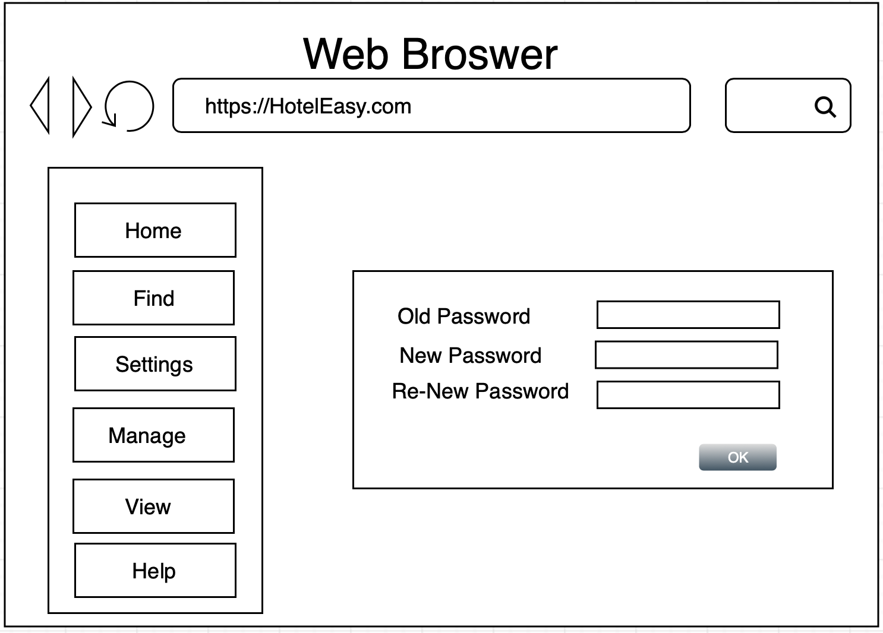

Figure 1.1c: Change Password

## Manage Room

### Insert a Room

|  |  |  |  |
| --- | --- | --- | --- |
| UC ID and Name: | MR01 – Insert a Room | | |
| Created By: | PhuocNN | Date Created: | 4/10/2018 |
| Primary Actor: | Administrators | Secondary Actors: | N/A |
| Trigger: | Click “Insert Room” option. | | |
| Description: | Allow user to add a Room of Hotel into application | | |
| Preconditions: | User had logged in the application with Administrators Account | | |
| Postconditions: | “Insert Room” screen had displayed. | | |
| Normal Flow: | 1. Click “Manage” menu.  => A drop down list will display.  2. Click “Insert Room” option.  => “Insert Room” screen will display.  3. Fill all the required fields.  4. Click “Insert” button. | | |
| Alternative Flows: | 1. Right click in any room in “Home” screen.  => A drop down list will display.  2. Click “Insert Room”. | | |
| Exceptions: | [1] a. Do not enter into required fields.  b. Click “Insert” button  => System show message “Please enter all field”.  [2] a. Enter duplicate Room Number.  b. Click “Insert” button  => System show message “The Room Number has existed. Please try again with another Room Number”. | | |
| Priority: | High | | |
| Frequency of Use: | Rarely. | | |
| Business Rules: | The Room Number should contain it’s floor. Example: 302 meaning the Room on 3rd floor. | | |
| Other Information: | N/A | | |
| Assumptions: | N/A | | |

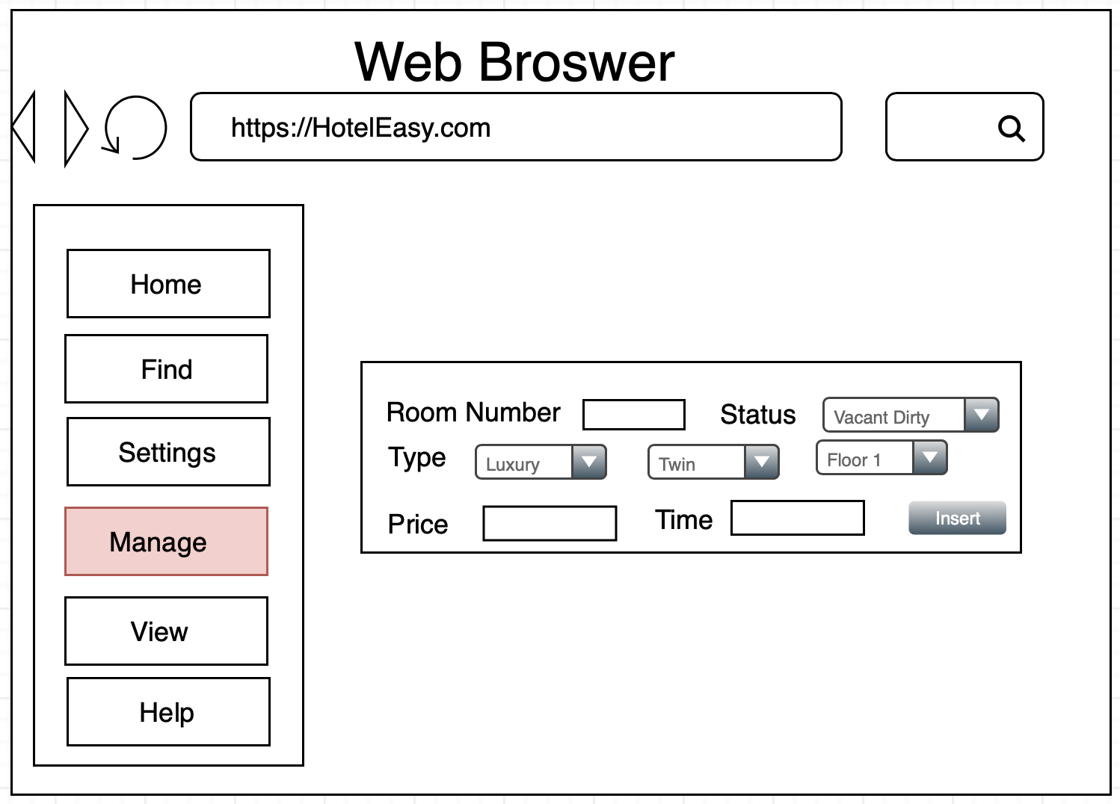

Figure 1.1: Insert Feature

### Delete a Room

|  |  |  |  |
| --- | --- | --- | --- |
| UC ID and Name: | MR02 – Delete a Room | | |
| Created By: | PhuocNN | Date Created: | 4/10/2018 |
| Primary Actor: | Administrators | Secondary Actors: | N/A |
| Trigger: | Click “Delete Room” option. | | |
| Description: | Allow user to delete a Room of Hotel into application | | |
| Preconditions: | User had logged in the application with Administrators Account | | |
| Postconditions: | “Insert Room” screen had displayed. | | |
| Normal Flow: | 1. Click “Manage” menu.  => A drop down list will display.  2. Click “Delete Room” option.  => “Delete Room” screen will display.  3. Choose the Room Number need to remove.  4. Click “Delete” button. | | |
| Alternative Flows: | 1. Right click in any room in “Home” screen.  => A drop down list will display.  2. Click “Delete this room”. | | |
| Exceptions: | [1] a. Do not click any room.  b. Click “Delete” button  => System show message “Please choose a Room”. | | |
| Priority: | High | | |
| Frequency of Use: | Rarely. | | |
| Business Rules: | N/A | | |
| Other Information: | N/A | | |
| Assumptions: | N/A | | |

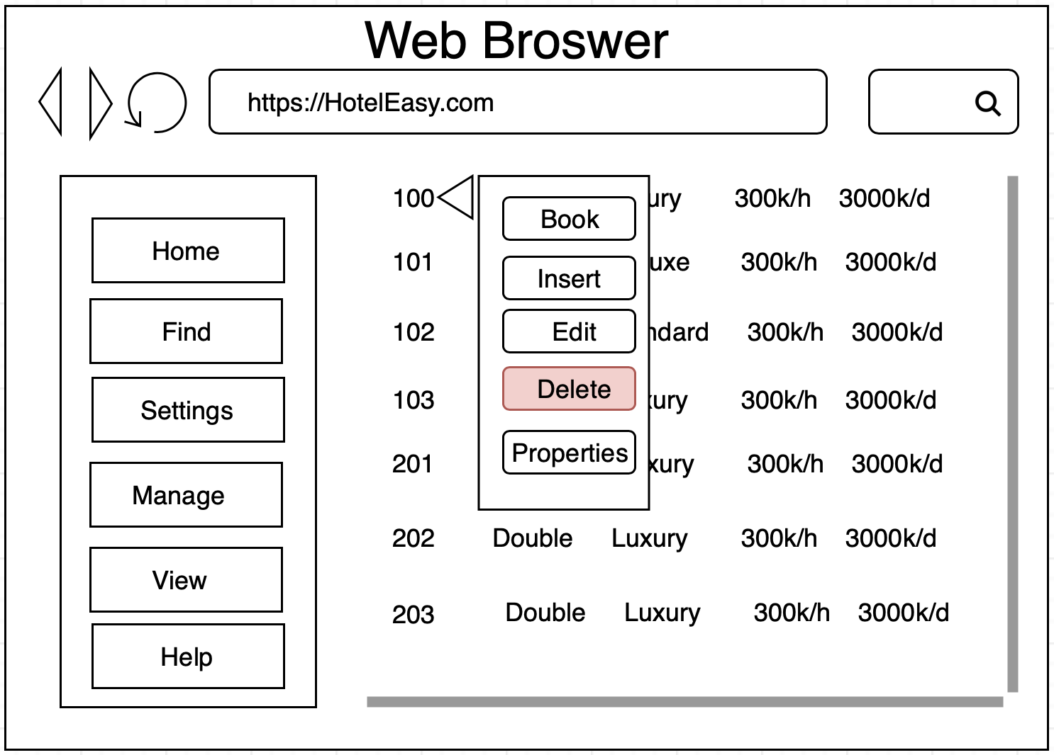

Figure 1.2a: Delete Option

### Edit a Room

|  |  |  |  |
| --- | --- | --- | --- |
| UC ID and Name: | MR03 – Insert a Room | | |
| Created By: | PhuocNN | Date Created: | 4/10/2018 |
| Primary Actor: | Administrators | Secondary Actors: | N/A |
| Trigger: | Click “Edit Room” option. | | |
| Description: | Allow user to edit a Room of Hotel into application | | |
| Preconditions: | User had logged in the application with Administrators Account | | |
| Postconditions: | “Edit Room” screen had displayed. | | |
| Normal Flow: | 1. Click “Manage” menu.  => A drop down list will display.  2. Click “Edit Room” option.  => “Edit Room” screen will display.  3. Choose the Room must be edit.  => “Edit Room” form will display  4. Fill all the required fields.  5.. Click “Edit” button. | | |
| Alternative Flows: | 1. Right click in any room in “Home” screen.  => A drop down list will display.  2. Click “Edit Room”. | | |
| Exceptions: | [1] a. Do not enter into required fields.  b. Click “Edit” button  => System show message “Please enter all field”.  [2] a. Enter Room Number which duplicate with another room.  b. Click “Edit” button  => System show message “The Room Number has existed. Please try again with another Room Number”. | | |
| Priority: | High | | |
| Frequency of Use: | Rarely. | | |
| Business Rules: | The Room Number should contain it’s floor. Example: 302 meaning the Room on 3rd floor. | | |
| Other Information: | N/A | | |
| Assumptions: | N/A | | |

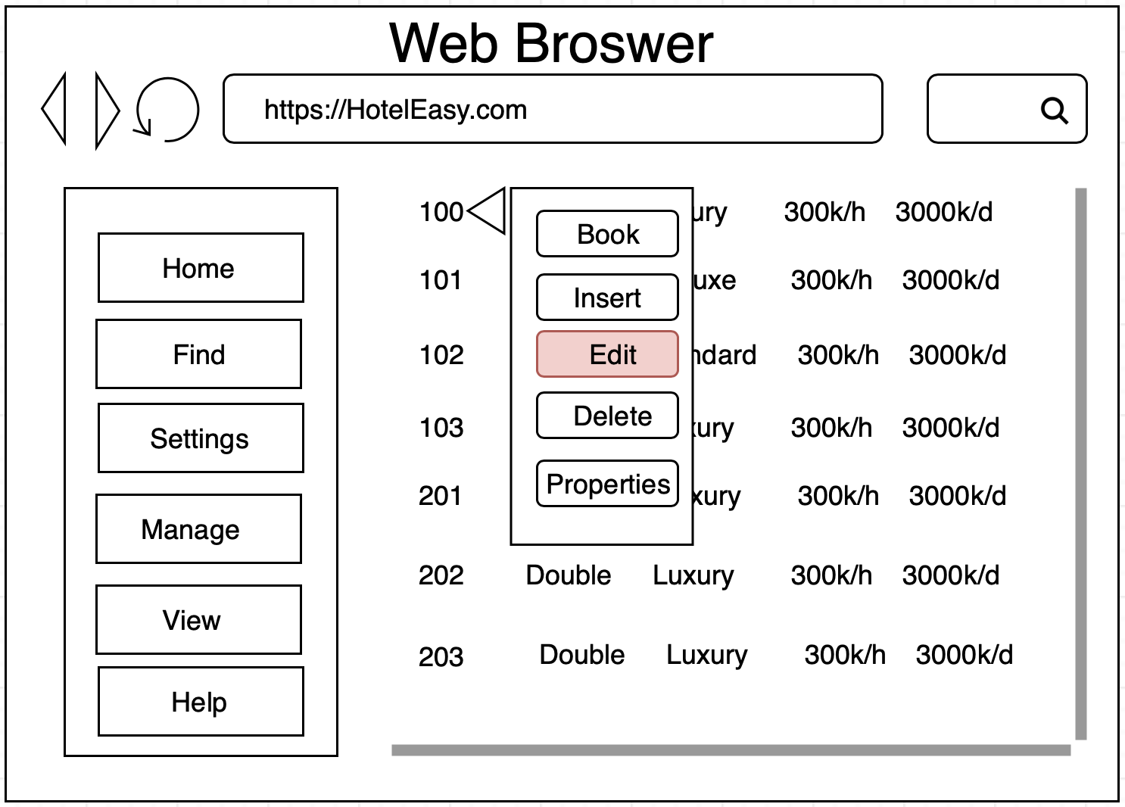

Figure 1.2: Edit Feature

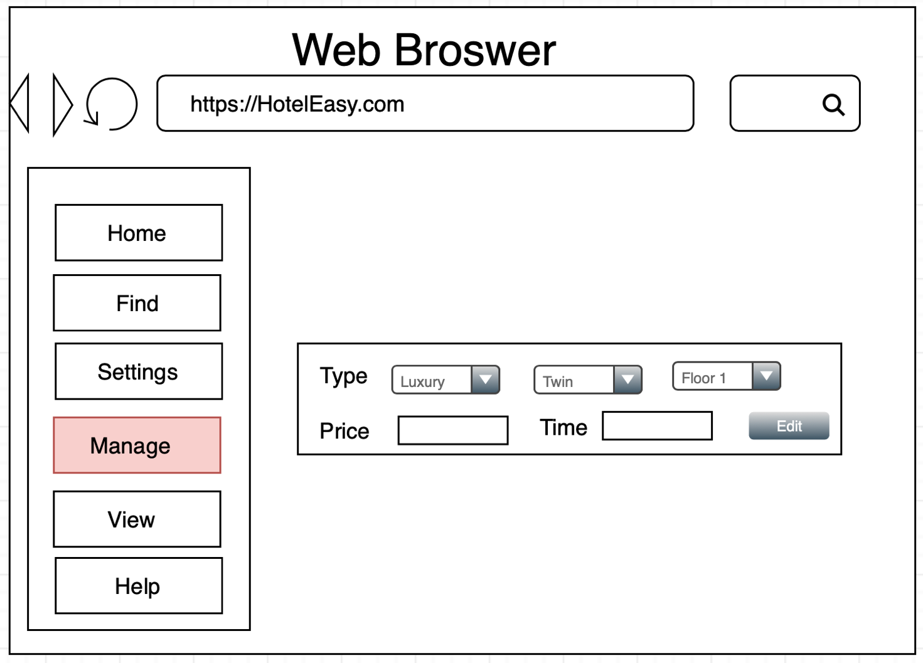

Figure 1.3: Edit Box Feature

## Support staff of hotel choose room for customer

### Finding a Room

|  |  |  |  |
| --- | --- | --- | --- |
| UC ID and Name: | MR03 – Insert a Room | | |
| Created By: | PhuocNN | Date Created: | 4/10/2018 |
| Primary Actor: | Administrators | Secondary Actors: | N/A |
| Trigger: | Click “Find” option. | | |
| Description: | Allow user to Find a Room of Hotel into application match request of customer. | | |
| Preconditions: | User had logged in the application | | |
| Postconditions: | N/A | | |
| Normal Flow: | 1. Click “Find” option.  => “Find” screen will display.  3. Choose properties suiable with request of customer.  4. Click “Find” button.  => A list of Room matched request of customer will display | | |
| Alternative Flows: | 1. Right click in any room in “Home” screen.  => A drop down list will display.  2. Click “Find”. | | |
| Exceptions: | N/A | | |
| Priority: | Medium | | |
| Frequency of Use: | Many times per day. | | |
| Business Rules: | N/A | | |
| Other Information: | N/A | | |
| Assumptions: | N/A | | |

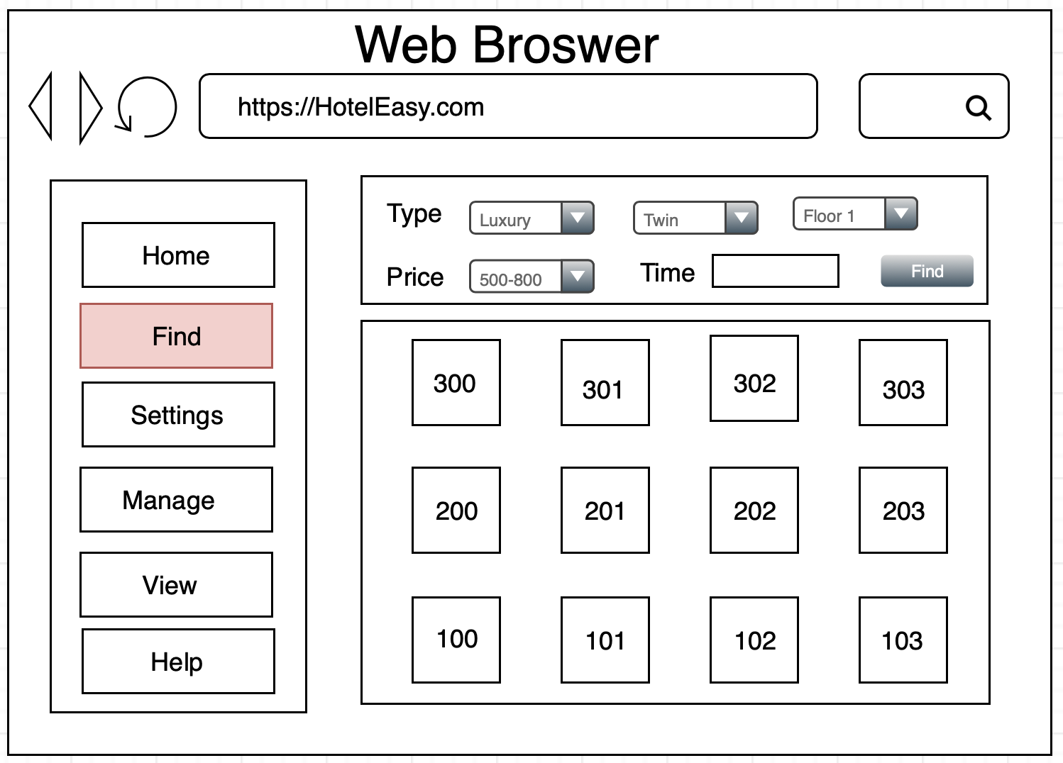

Figure 1.4: Find Option

### Booking room for customer

|  |  |  |  |
| --- | --- | --- | --- |
| UC ID and Name: | MR03 – Insert a Room | | |
| Created By: | PhuocNN | Date Created: | 4/10/2018 |
| Primary Actor: | Staff2 | Secondary Actors: | N/A |
| Trigger: | Click “Find” option. | | |
| Description: | Allow user to book a Room of Hotel into application | | |
| Preconditions: | User had logged in the application | | |
| Postconditions: | N/A | | |
| Normal Flow: | 1. Right click in any room in “Home” screen.  => A drop down list will display.  2. Click “Book”.  =>”Book” screen will display.  3. Fill in all required fields.  4. Click “OK”. | | |
| Alternative Flows: | N/A | | |
| Exceptions: | [1] a. Do not enter into required fields.  b. Click “OK” button  => System show message “Please enter all required fields”. | | |
| Priority: | High | | |
| Frequency of Use: | Many times per day. | | |
| Business Rules: | N/A | | |
| Other Information: | N/A | | |
| Assumptions: | N/A | | |

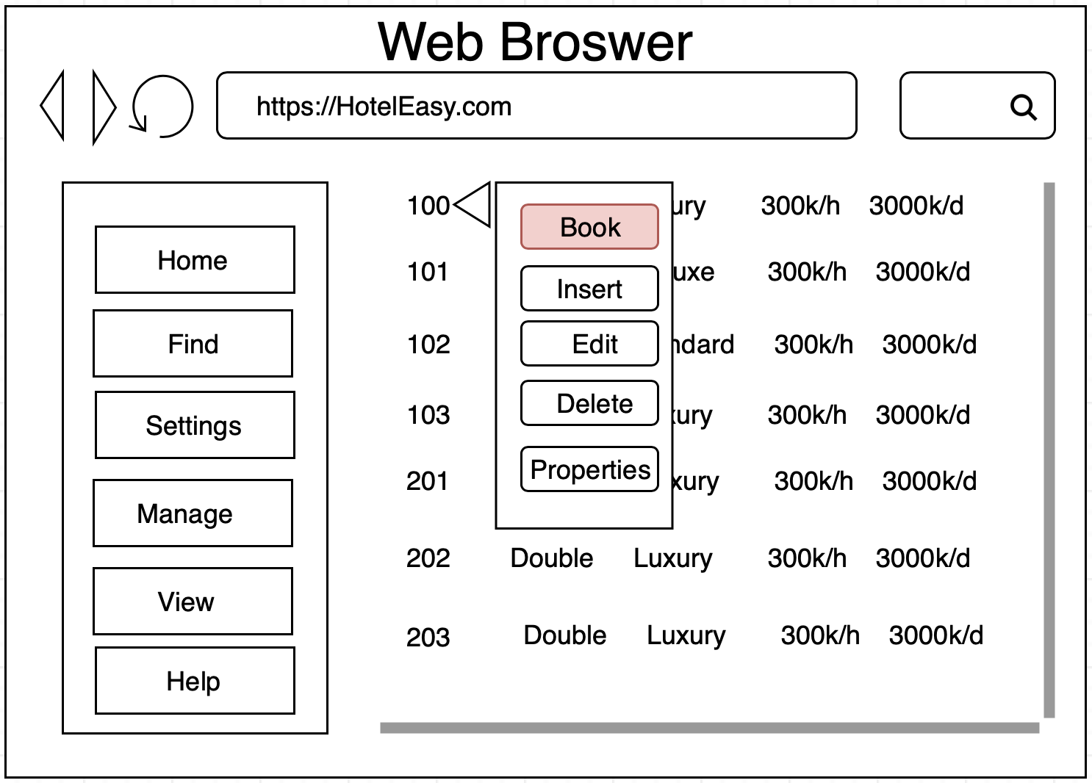

Figure 1.5: Book Feature

## View option

### Grid View

|  |  |  |  |
| --- | --- | --- | --- |
| UC ID and Name: | VI01 – Grid View | | |
| Created By: | PhuocNN | Date Created: | 4/10/2018 |
| Primary Actor: | Staff2 | Secondary Actors: | N/A |
| Trigger: | Click “Grid View” option. | | |
| Description: | Allow user to view Rooms of Hotel with Grid View | | |
| Preconditions: | User had logged in the application | | |
| Postconditions: | N/A | | |
| Normal Flow: | 1. Click “View” option  => A drop down list will display.  2. Click “Grid View” | | |
| Alternative Flows: | 1. Right click in any room in “Home” screen.  => A drop down list will display.  2. Click “View”.  =>”View” drop down list will display.  3. Click “Grid View”. | | |
| Exceptions: | N/A | | |
| Priority: | Low | | |
| Frequency of Use: | Any times per day. | | |
| Business Rules: | N/A | | |
| Other Information: | N/A | | |
| Assumptions: | N/A | | |

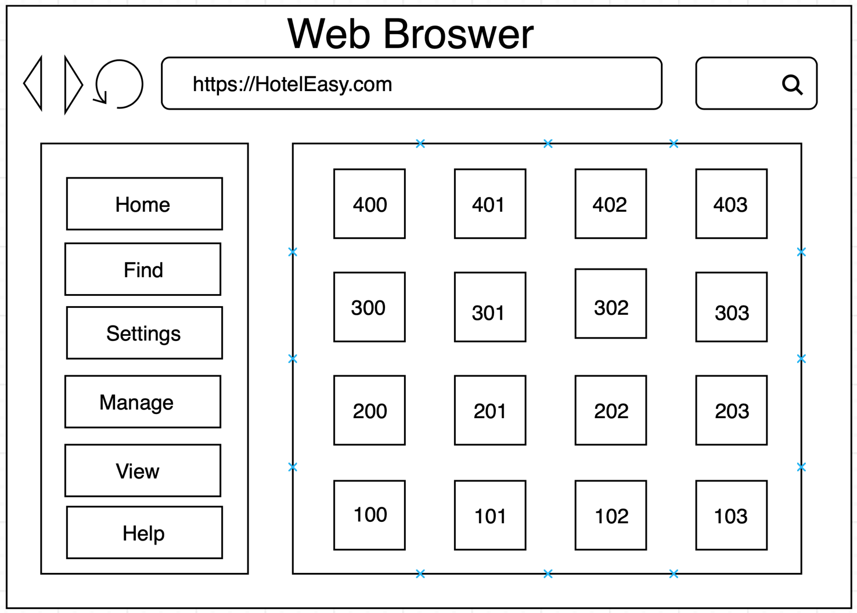

Figure 1.6: Main Screen

### List View

|  |  |  |  |
| --- | --- | --- | --- |
| UC ID and Name: | VI02 – Grid View | | |
| Created By: | PhuocNN | Date Created: | 4/10/2018 |
| Primary Actor: | Staff2 | Secondary Actors: | N/A |
| Trigger: | Click “List View” option. | | |
| Description: | Allow user to view Rooms of Hotel with Grid View | | |
| Preconditions: | User had logged in the application | | |
| Postconditions: | N/A | | |
| Normal Flow: | 1. Click “View” option  => A drop down list will display.  2. Click “List View” | | |
| Alternative Flows: | 1. Right click in any room in “Home” screen.  => A drop down list will display.  2. Click “View”.  =>”View” drop down list will display.  3. Click “Grid View”. | | |
| Exceptions: | N/A | | |
| Priority: | Low | | |
| Frequency of Use: | Any times per day. | | |
| Business Rules: | N/A | | |
| Other Information: | N/A | | |
| Assumptions: | N/A | | |

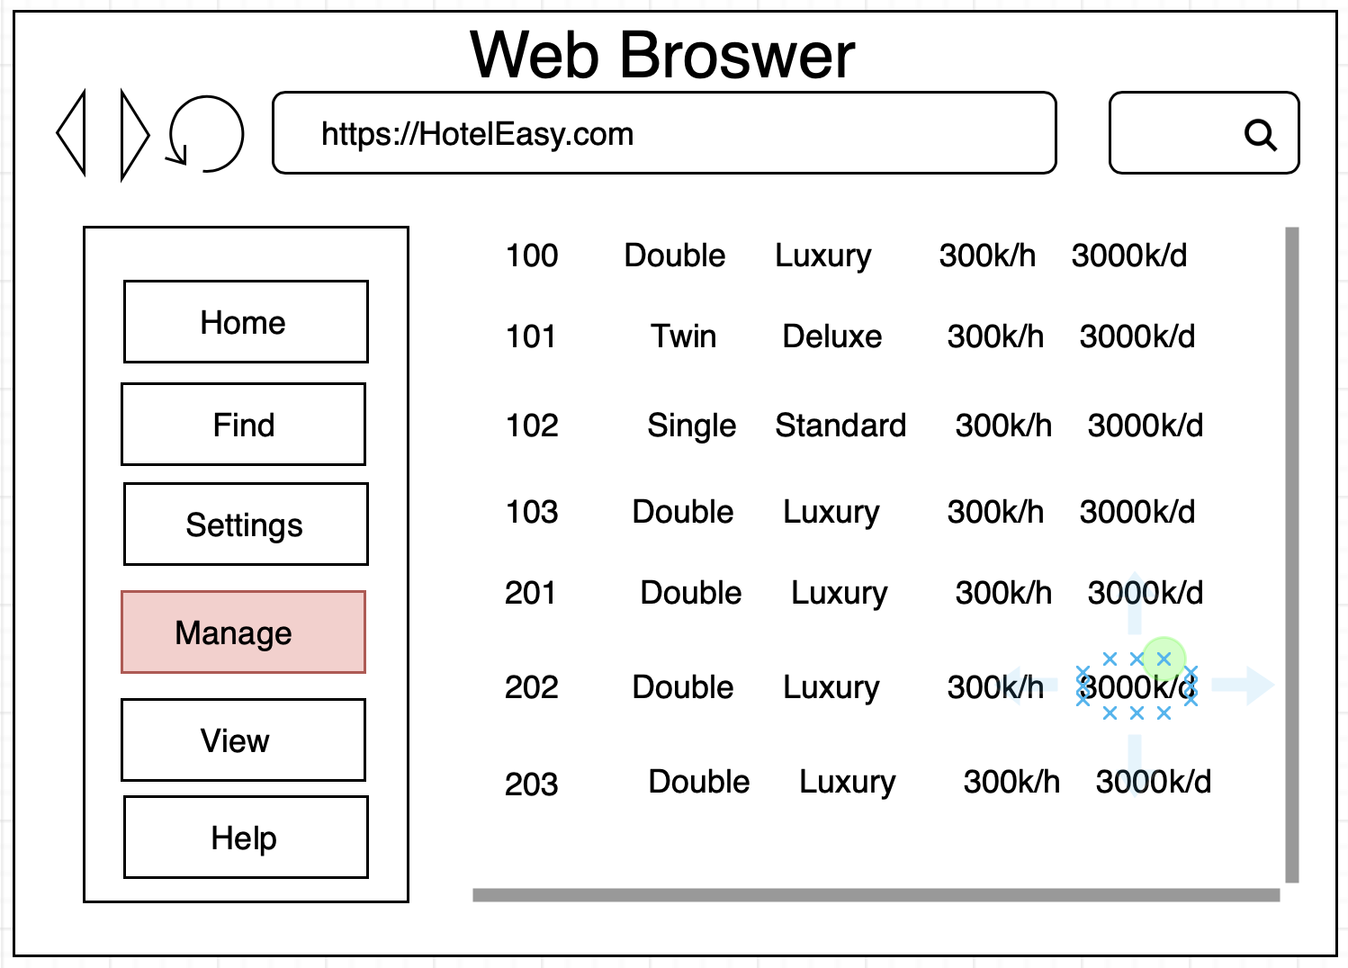

Figure 1.7: List Feature

# Other Nonfunctional Requirements

## Performance Requirements

|  |  |
| --- | --- |
| PR-01 | All Web pages generated by the system shall be fully downloadable in no more than 10 seconds over a 40KBps modem connection. |
| PR-02 | Responses to queries shall take no longer than 7 seconds to load onto the screen after the user submits the query. |

## Safety Requirements

No safety requirements have been identified.

## Security Requirements

|  |  |
| --- | --- |
| SE-1 | Users shall be required to log in to the system for all operations. |
| SE-2 | The system shall permit only staff members who are on the list of authorized  administrators to create or edit rooms. |
| SE-3 | The system shall permit users who are administrators to view only their own information, not the information of other users. |
| SE-4 | All network transactions that involve financial information or personally identifiable  information shall be encrypted. |

## Software Quality Attributes

No software quality attributes have been identified.

## Business Rules

|  |  |
| --- | --- |
| BR-01 | Username must be greater than 4 characters and less than 10 characters. |
| BR-02 | Username does not allow to contain special character such as { [ ] } \ | : ; “ ‘ < , > . ? / ! @ # $ % ^ & * ( ) _ - + =,… |
| BR-03 | Password must be greater than 8 character and less than 20 characters.  - Age must be greater than 0 and less than 150 years old. |
| BR-04 | Age must be greater than 0 and less than 150 years old. |
| BR-05 | The Room Number should contain it’s floor. Example: 302 meaning the Room on 3rd floor. |

# Other Requirements

No other requirements now.

# Appendix A: Glossary

|  |  |  |
| --- | --- | --- |
| ID | Acronym | Definition |
| 1 | Staff1 | Staff of Hotel, can book rooms for customers. |
| 2 | Staff2 | Staff of Hotel, only view Rooms, can’t book rooms for customers. |
| 3 | Administrators | Owner of Hotel / People who manager Hotel |
| 4 | HE | Hotel Easy |
| 5 | OS | Operating system |
| 6 | App | Application |

# Appendix B: Database

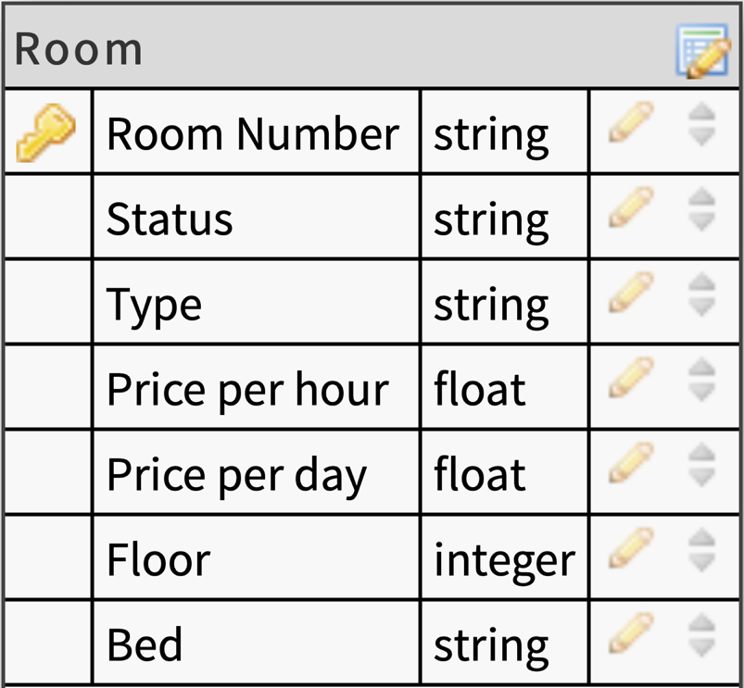

Figure 2.1: Room Database

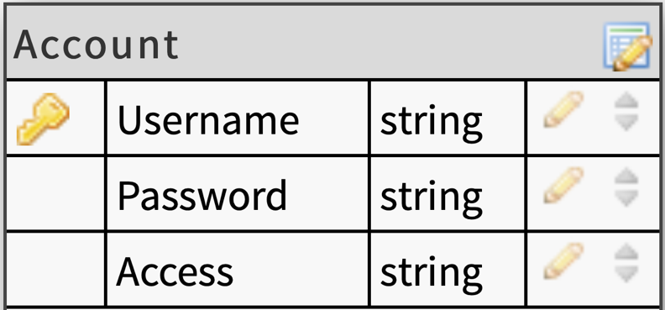

Figure 2.2: Account Database