

**FPT LOST & Found**

**Software Design Document**

– Ho Chi Minh, July 2022 –

**Table of Contents**

I. Overview 3

1. Code Packages 3

2. Database Schema 4

II. Code Designs 5

1.Create new post………………………………………………………………………………………………………………………………..5

- Sequence diagram(s)………………………………………………………………………………………………………………………5

2.View post………………………………………………………………………………………………………………………………………….6

- Sequence diagram(s)………………………………………………………………………………………………………………………6

3.Comment function……………………………………………………………………………………………………………………………7

- Sequence diagram(s)……………………………………………………………………………………………………………………..7

# I. Overview

## 1. Code Packages/Namespaces

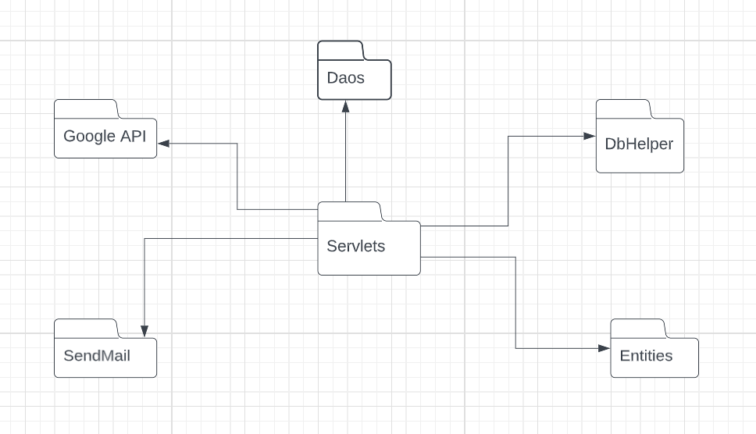

## Database Schema

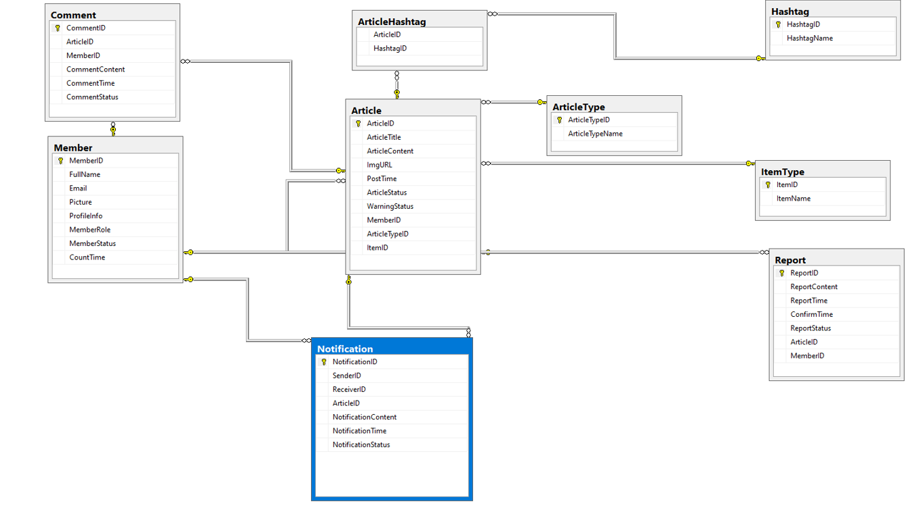

**II. Code Designs**

1. **Create new post**

* **Sequence diagram(s)**

1. **View post**

* **Sequence diagram(s)**

1. **Comment function**

* **Sequence diagram(s)**

# 