

**FPT LOst & Found**

**Software Requirement Specification**

– Ho Chi Minh, July 2022 –

**Table of Contents**

I. Overview 3

1. Introduction 3

2. System Functions 4

II. Software Requirements Specification 6

1.Use case diagram 6

2.Use case specification 6

# Overview

The document will detail all the functions and processes involved in developing the FPTU Lost & Found application. This document is intended for use by project team members who will be implementing and testing the functionality of the system. The objective of this document is to collect and analyze all the ideas presented to describe the system and its requirements for consumers. Furthermore, we anticipate and hope use this product to better understand the project, outline thoughts that may be generated later, and material ideas under consideration. In summary, the goal of this document is to provide a complete overview of our software product. This document covers the intended audience of the project, as well as the user interface and software needs. It defines our students and lecturer perceptions of the product and its capabilities.

## 1. Introduction

FPTU Lost & Found was created to make it easier for students and lecturer of FPT University to find and return items. The app is divided with many specific roles, users can access and use functions easily.

* The app can help users at FPTU without logging in can still view information on found and lost items.
* The problem is that the FPT university has a lot of students, and is currently preparing to welcome a large number of students as well. Therefore, the lost items as well as picking up other people's things but not knowing how to solve them also increased significantly, making many people feel uncomfortable.
* The system was born as a portal to help connect people who lost their things and those who returned them on FPT University campus. From now on, the app will help people found and lost items quickly and extremely conveniently.

## 2. System Functions

#### a. Screen Flow

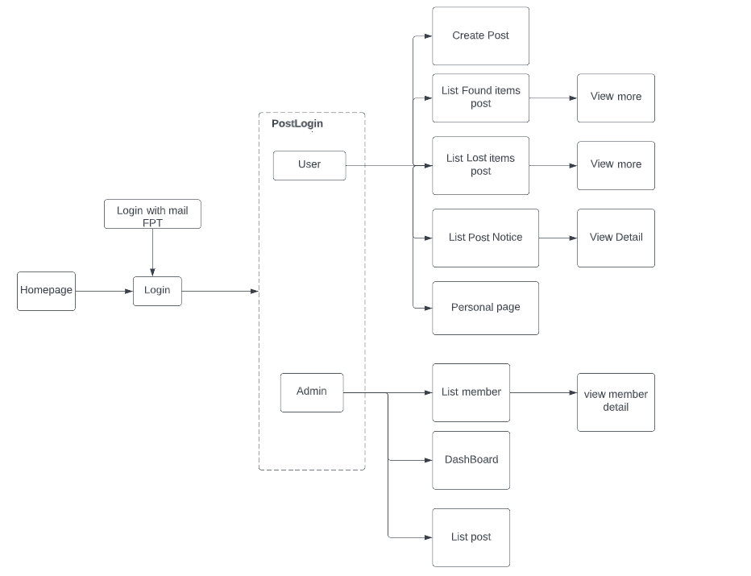

b. Screen Details

|  |  |  |  |
| --- | --- | --- | --- |
| **#** | **Feature** | **Screen** | **Description** |
| 1 | Display list post of the app | Homepage | Users can view post information without logging into the system |
| 2 | Login by mail FPT | Login | The login URL is generated for authentication and Google Sign-in button is shown to the user. |
| 3 | Display the general user’s information | User | Allow student to view generate the information and the screen to navigate. |
| 4 | Get user’s profile and display | Personal page | User can view information and edit their profiles. |
| 5 | Show a list post form for user | Create post | Displays the list of user posts that the user has posted on the system. The user can edit the state of the post. |
| 6 | Display the information of list Found item post | List Found item post | Displays a list of Found item information. User can use filter or search to easy find the post. |
| 7 | Show details for Found item list | View more | Show details for Found item list. Users can comment, report other people's posts, as well as update, delete, and update their own posts. |
| 8 | Display the information of list Lost item post | List Lost item post | Displays a list of Lost item information. User can use filter or search to easy find the post. |
| 9 | Show details for Lost item list | View more | Show details for Found item list. Users can comment, report other people's posts, as well as update, delete, and update their own posts. |
| 10 | Display the information from list post notice of admin. | List Post Notice | Displays a list post notice from Admin. User can use filter or search to easy find the post. |
| 11 | Show detail information from admin | View detail | Show detail notice from admin. User can remove the notice of Admin. |
| 12 | Display general the admin’s information | Admin | Allow the admin to view generate the information and the screen to navigate. |
| 13 | Show a list post of admin page | List post | Show all posts created by admin. |
| 14 | Show number of post | Dashboard | Displays the number of posts, the number of reported posts and the total number of posts. |
| 15 | Display list member | List member | Show all members of the app. Admin can ban and warn accounts that are reported many times. |
| 16 | Show list member detail | View member detail | Display details of members of the app. Admin can ban and warn reported accounts. |

c. User Authorization

|  |  |  |  |
| --- | --- | --- | --- |
| **Screen** | **Role1** | **Role2** | **Role3** |
| Homepage | X | X | X |
| Login |  | X | X |
| User |  | X |  |
| Create Post |  | X |  |
| List Found items post |  | X |  |
| View more (Found items) |  | X |  |
| List Lost items post |  | X |  |
| View more (Lost items) |  | X |  |
| List Post Notice |  | X |  |
| View detail |  | X |  |
| Personal page |  | X |  |
| Admin |  |  | X |
| List member |  |  | X |
| View member detail |  |  | X |
| Dashboard |  |  | X |
| List post |  |  | X |

In which:

* Role1: Guest
* Role2: User
* Role3: Admin

# II. Software Requirements Specifications.

## Use case diagram

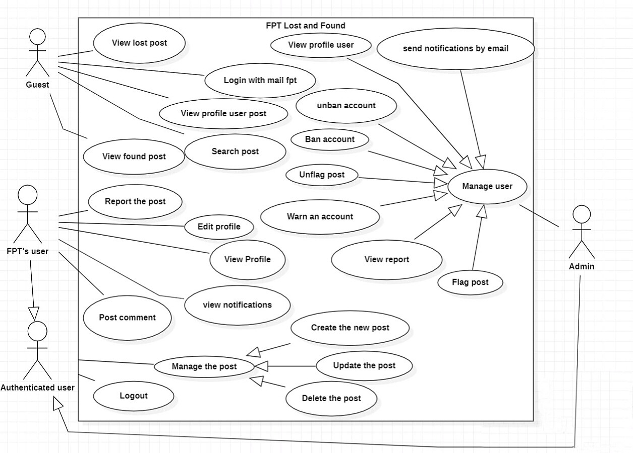

1. **Use case specification**

**Guest**

* Search Post
* view post
* view profile of user.

**User**

* view post
* search post
* comment post
* report post
* create post update post
* delete post
* Filter
* view profile
* edit profile

**Admin**

* create post
* update post
* delete post
* search post
* search member
* view detail member
* warn member
* ban/unban member
* flag/unflag post