

**Simple Merge**

**Software Requirement Specification**

Team number **#5**  
Team member 김성재, 박준영, 이현재, 주현준, 전진우

**1. Introduction**

This system is for text comparison and merging text-like files. Users can compare words between two different files, distinguishing similar part and merge, save, view and edit the files.

**2. Use Case Diagrams**

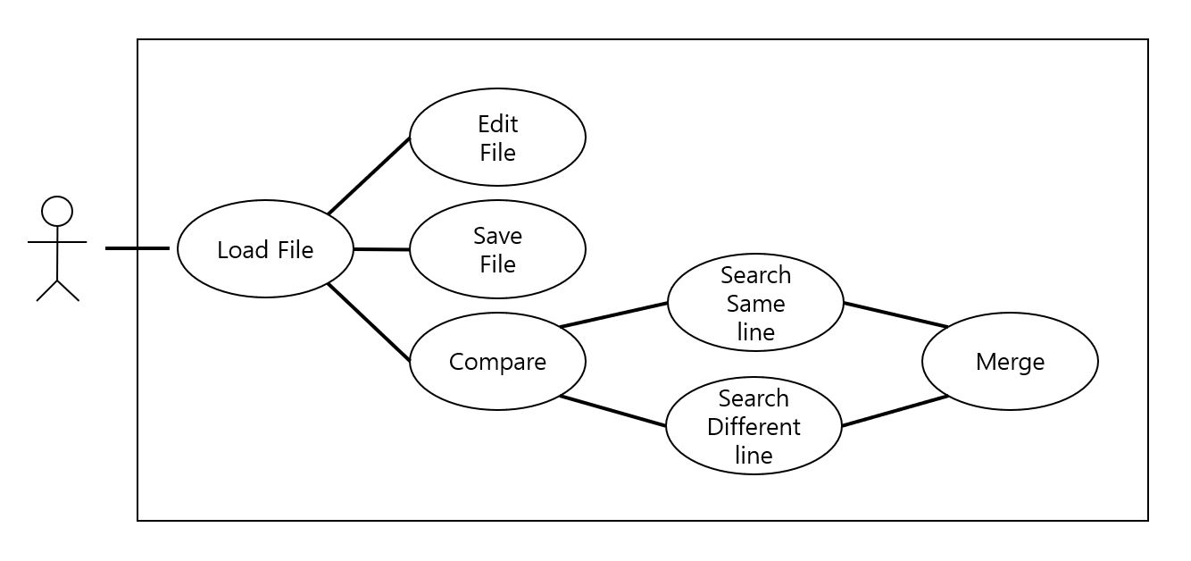

**3. Use Cases Descriptions**

1. **Load file.**

**1.1 Preconditions:**

At least two text files needed.

**1.2 Main Flow:**

Right after the program is started, the main window with two edit panels will be displayed.

On each edit panel: when “*Load*” button is clicked, then the program should allows user to choose a file in the file system in computer.

**1.3 Subflows:**

None.

**1.4 Alternative Flows:**

None.

1. **Edit file.**

**2.1 Preconditions:**

None.

**2.2 Main Flow:**

When user presses a “*Edit*” button, the program allows user to edit the content of file that shown in the edit panel **[E1]**.

**2.3 Subflows:**

None.

**2.4 Alternative Flows:**

**[E1]** When user clicked “*Edit*” again, the program disallow the user to edit the content.

1. **Save file.**

**3.1 Preconditions**

Load must be completed to execute Save.

Changes needed in loaded text files.

**3.2 Main Flow**

After loading files, user can save the file at anytime [S1].

**3.3 Subflows**

**[S1] ‘***Save as***’ :** Browse window / Save files at any directory and name that user sets.

**3.4 Alternative Flows**

Save cannot be executed before file loaded

1. **Compare two files.**

**4.1 Predictions**

Load must be completed to execute Compare.

Before two text files are loaded, the “*Comapre*” Button will be inactivated.

After two text files are successfully loaded, the “*Compare*” Button will be activated

**4.2 Main Flow**

This system provides Compare function that compares the files in both editing windows to highlight different parts. After user clicks “*Compare*” button, it shows different parts with highlighted background color [S1] in each edit window.

**4.3 Subflows**

**[S1]** If the two parts are the same, it will be displayed in white background; If the two parts are different, it will be displayed in red background.

**4.4 Alternative Flows**

Compare cannot be executed before file loaded.

1. **Merge two files.**

**5.a Up & Down**

**5.a.1 Preconditions**

Compare must be completed to activate “*Up & Down*” Buttons

**5.a.2 Main Flow**

After two files are compared successfully, different parts of each file will get highlighted background. If user presses the “*UP & Down*” button, the program will chanage the color of background of matching different part of each files. User can decide whether they merge file left to right or right to left.

**5.a.3 Subflows**

None

**5.a.4 Alternative Flows**

Before two text files are compared, the “*Up & Down*” button will be inactivated.

After two text files are successfully compared, the “*Up & Down*” button will be activated

**5.b Copy to Right**

**5.b.1 Preconditions**

Before two text files are loaded, the “*Copy to Right*” button will be inactivated.

After two text files are successfully loaded, the “*Copy to Right*” button will be activated

**5.b.2 Main Flow**

When the lines get colored, press “*Copy to Right*” button to merge left to right. The “*Copy to Right*” button works as copying the selected colored lines in the left panel to the colored lines in the right panel. When the user press the “*Copy to Right*” button again, the two colored parts in left and right will become same.

**5.b.3 Subflows**

None

**5.b.4 Alternative Flows**

Nothing will happen if the two colored lines are equal.

**5.c Copy to Left**

**5.c.1 Preconditions**

Before two text files are loaded, the “*Copy to Left*” button will be inactivated.

After two text files are successfully loaded, the “*Copy to Left*” button will be activated

**5.c.2 Main Flow**

When the lines get colored, press “*Copy to Left*” button to merge right to left. The “*Copy to Left*” button works as copying the selected colored lines in the right panel to the colored lines in the left panel. When the user press the “*Copy to Left*” button again, the two colored parts in left and right will become same.

**5.c.3 Subflows**

None

**5.c.4 Alternative Flows**

Nothing will happen if the two colored lines are equal.

**4. System Sequence Diagrams**

1. **Save File**

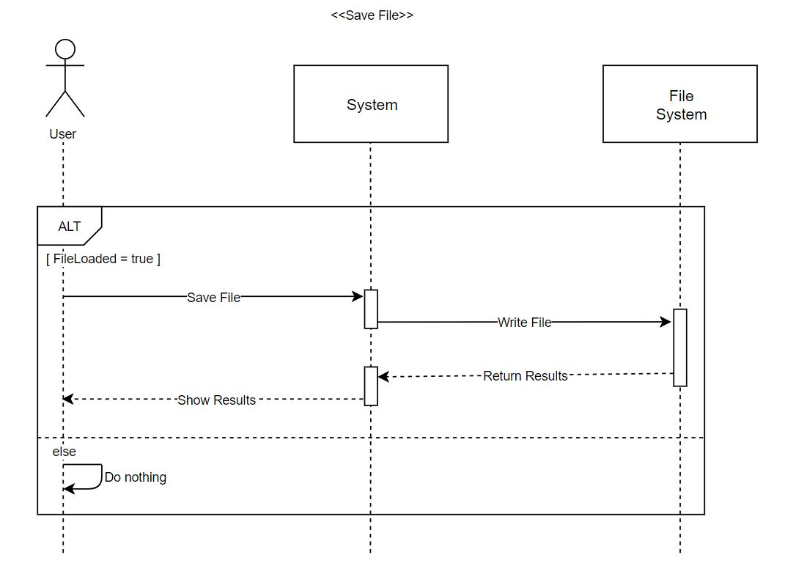

1. **Load File**

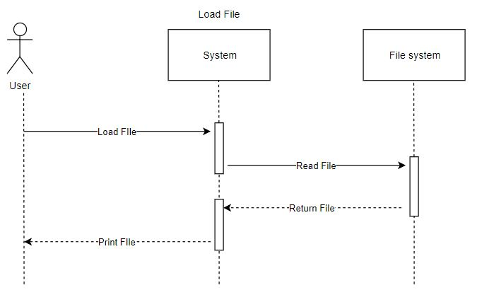

1. **Edit File**

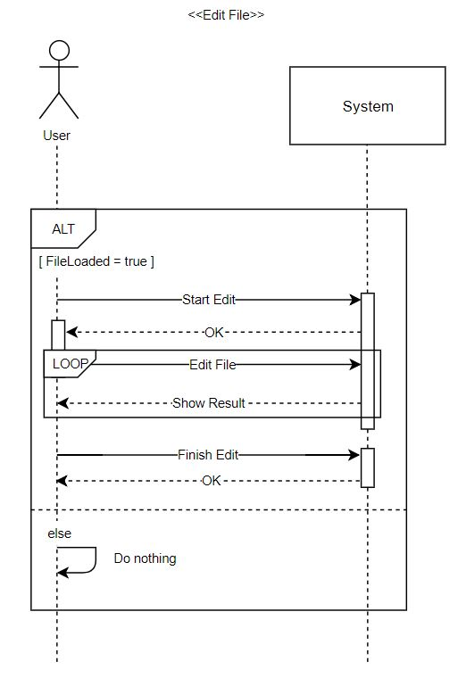

1. **Compare File**

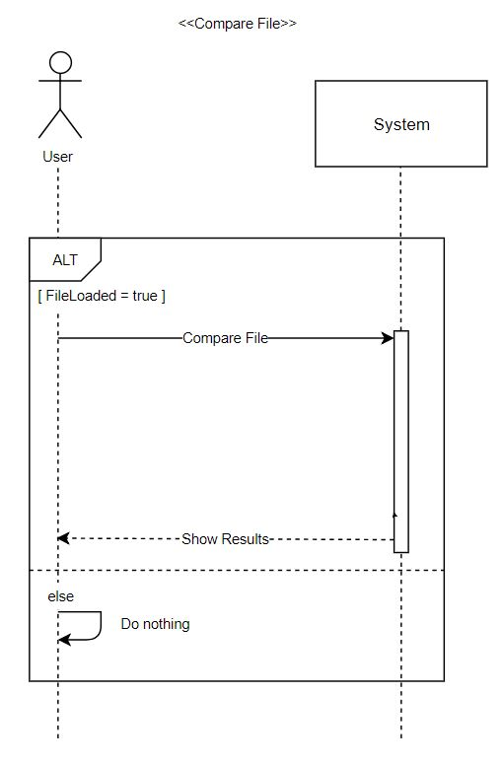

1. **Merge File**

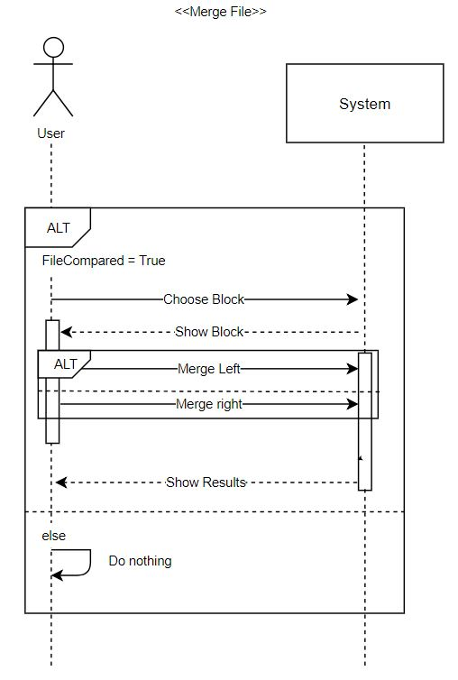

**5. Non-functional requirements**

**NR1. Performance**

The System shall wait for a user inputs and execute after user gives input to the system. Also, it should perform as moderate as there isn’t any error that can cause by user’s activities.

**NR2. Constraints**

All code development shall be done with the Java language.

**NR2.1 Time Constraints**

This system must be implemented until June 9.

**NR3. Usability**

**NR3.1 User Interface**

Implement like the WinMerge(http://www.winmerge.org) interface.

**6. Requirement Dependency Traceability**

|  |  |  |  |  |  |  |  |  |
| --- | --- | --- | --- | --- | --- | --- | --- | --- |
|  | **UC1** | **UC2** | **UC3** | **UC4** | **UC5** | **NR1** | **NR2** | **NR3** |
| **UC1** |  |  |  |  |  |  |  |  |
| **UC2** | **o** |  |  |  |  |  |  |  |
| **UC3** | **o** | **o** |  |  | **o** |  |  |  |
| **UC4** | **o** |  |  |  |  |  |  |  |
| **UC5** | **o** |  |  | **o** |  |  |  |  |
| **NR1** |  |  |  |  |  |  |  |  |
| **NR2** |  |  |  |  |  |  |  |  |
| **NR3** |  |  |  |  |  |  |  |  |

**7. Development and Target Platforms**

1. Windows 10 Operating System.
2. Intel i5 processors.
3. Eclipse Oxygen IDE.

**8. Project Glossary**

**Merge** : Compare two text blocks from left to right (or from right to left)

**9. Document Revision History**

|  |  |  |  |
| --- | --- | --- | --- |
| Version | 1.0 | 1.1 | 1.2 |
| Name(s) | J.Park, S.Kim, H.Lee, H.Joo,  J.Jeon | J.Park, S.Kim, H.Lee, H.Joo,  J.Jeon | J.Park, S.Kim, H.Lee, H.Joo,  J.Jeon |
| Date | May, 8, 2018 | May,13,2018 | June,06,2018 |
| Change Description | Introduction, UseCases | System Sequence Diagram, Requirement Dependency Traceability | Change in use case discription, System sequence diagram |