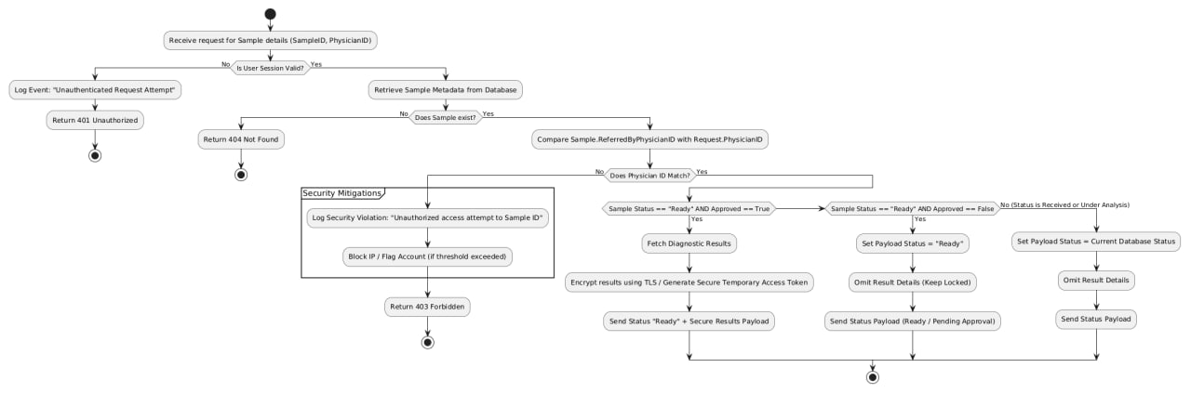

https://github.com/alsmaeelmay-pixel/medical_project/tree/main

