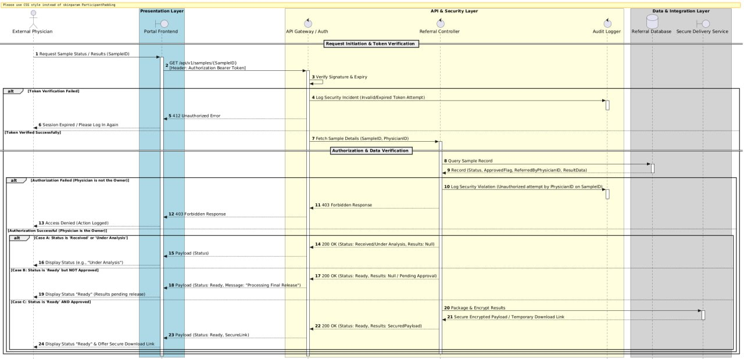

https://github.com/alsmaeelmay-pixel/medical_project/blob/main/sequence_diagram.uml

