Table: entity

Columns:

serial_id: Auto incremental serial ID. Not using entity ID as primary key because language is introduced.

entity_id: Eg. Q5, P110, Q123423

entity_language: Eg. Zh-cn, en, etc

entity_type: item or property

entity_text: item name due to its language

Table: description

Columns:

serial_id: as above

entity_id: as above

desc_language: as above

desc_text: as above

Table: mainsnak

Columns:

**snak**_**id**: An hash ID, not incremental

**entity_id**: ID of the entity this snak belongs to

**property_id:** Property ID of this snak

**serial**: It is the nth snak of the corresponding eid and pid

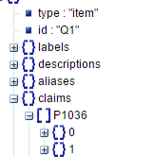eg. Here we have serial 0 and 1, two snaks

**Claimtype**:

This value:

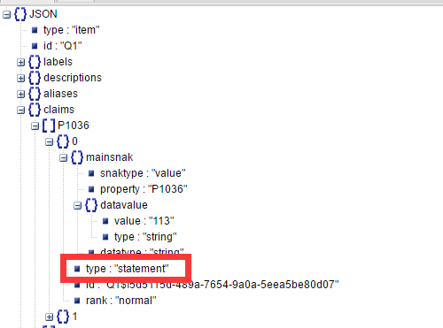

Value can be chose from “claim”and “statement”

**Snaktype**:

This value:

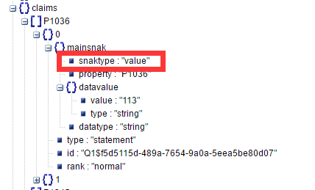

Can be chosen from “value””somevalue””nonvalue”

**Datatype**

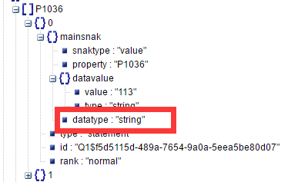

Can be chosen from https://www.wikidata.org/wiki/Special:ListDatatypes

**Rank**

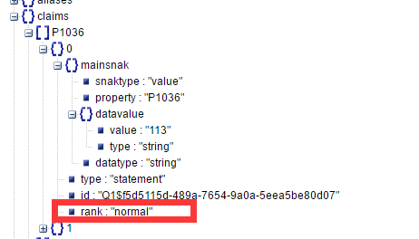

The rank expresses whether this value will be used in queries, and shown be visible per default on a client system. The value is either *preferred*, *normal* or *deprecated*.

Table: datavalue_XXX

Corresponding data.

According to its type it has some variants.

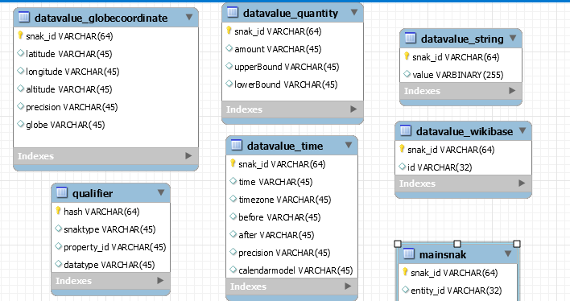

Table: qualifier

The qualifier to a snak. Eg. China has 1.2 billion people in 2000, in 2000 is a qualifier.

An row in datavalue can be either point to a snak or a qualifier.