|  |
| --- |
| **Modeling and Crowd Simulation Aircraft Evacuation Simulation** |
|  |
|  |
| In this project we will model the inside and outside environment of an aircraft, and simulate a crowd evacuation for an emergency situation. |
| COSC 729 Virtual Reality  Instructor: Dr Sharad Sharma |
| Stephen Otunba, Jingxin Han |
| **5/3/2011** |
|  |

Goal and Objectives

In this project, we will simulate an evacuation behavior in an aircraft using a crowd component. We will divide the application in two part, the inside and outside of an aircraft.

Outside Airplane: we will model the airport environment and the airplane. We will add the airport sound environment, such as the airplane take off or boarding sounds.

Inside Airplane: we will model the inside of airplane environment. We will model a typical airplane cabin including chairs and appropriate lighting for the environment.

MODELING

**Outer aircraft environment:**

1. Aircraft model, we will design a simple model in 3ds max, or use a model from internet
2. Airplane runway, planned geometry will be plane in 3ds max or a box in VRML, use of texture will be some grey color with some white lines
3. stairs

**Inner aircraft environment:**

1. Chair seat, will use a model from internet.
2. Passenger, use a model from internet but add biped inside of the model to perform avoid, seek, following path behavior,
3. Flight staff, will be waiting in the aircraft, when you enter the plane, you will see her/him.
4. Overhead bin will consist of a simple box, over the passenger seat. The box will open when clicked
5. Windows, next to the passenger seat.
6. Aircraft carpet.

**Models were found on the following sites:**

www.3dvia.com

<http://artist-3d.com/free_3d_models/>

**Planned geometry**: Box, cylinder, sphere, biped, dummy, plane, cone.

**Use of textures**: carpet color texture, and texture from mental ray Renderer

**Behavior and functionality:**

1. In the outer aircraft environment, the user will be able to click any of the plane doors to enter the aircraft.
2. In the inner aircraft environment, there is an emergency button that will be visible once you enter the plane. When the buttons color changes all passenger will move from their seat to nearest plane door (exit).

**Describe how the application will be used**

Upon entering the Virtual environment, the user will see an airplane and the runway, you can see the airplane using different viewpoints. The user can enter the aircraft by clicking any of the aircraft doors. Inside the aircraft, user can explore the interior of the airplane.

The application will redirect to another file, which is the interior of the airplane. In this environment, the passengers will be placed in front of the seats, and a timer will calculate elapsing time. A TV screen will display a safety video instructing passengers on what to do in case of an emergency. Once the emergency button is pressed the diffuse color on that button will change color and all the passengers will exit the aircraft. The exit paths of the passengers will be manually created using the built in 3ds Max function for creating biped footsteps. Once a passenger reaches an exit they will no longer be visible indicating that they have evacuated successfully . When all passengers leave the plane the evacuation completed.

VRML

* **VRML**: Add Functionality: [From Lecture 2 in VRML Lecture on Angel ] OR through VIRTOOLS

o    Lights: Outside the aircraft we will use point lights to represent light from the sun. In the aircraft we will use multiple spotlights, one for each passenger, and the default light will be disabled.

o    Interpolators:

1. Color interpolator : we will use when the user presses the emergency button, all items inside the plane will change color according to the light brightness change.
2. Coordinate interpolator: When user clicks the luggage bin above the passenger's seat, the luggage bin will open, we have to use the coordinate interpolator to perform this functionality.
3. Position interpolator: when the emergency button is pressed by user the animation will be implement by the position interpolator.

o    Sensors:.

1. Touch Sensor: we will place touch sensors on the emergency button, and the outer aircraft doors.
2. Time Sensor: the position interpolator comes with the time sensor to perform an animation period. This will be used to animate the depression of the emergency button and its recovery to its original position.
3. Visibility Sensor: When an avatar/passenger reaches a door they will disappear .

o    Routing: Anchor node, etc

We will set the time sensor to the emergency button position interpolation and to the passenger visibility sensor.

We incorporated a similar functionality by incorporating the VRML code. These functionalities will be mentioned in the presentation.

* + Latch / Switch
    - Will be used to indicate which avatar is selected. The user can click the switch to cycle through avatars in the scene a light source will illuminate the avatar indicating that it has been selected.
  + Time Counter
    - The time counter will be used to keep track of the elapsed time for an evacuation to take place. The time counter will be triggered at the start of the simulation and stop once the avatar(s) has reached a goal or exits the craft.
  + VCR
    - VCR will be used to pause, stop, and rewind the simulation so that the user can change the viewpoints if they wish and observe the evacuation from different angles.

Implementation

Due to the fact that modeling an airport from scratch tedious and time consuming, we decide to download one because the goal of our project is simulation not modeling. We downloaded an airport model, an airplane model, and a cross section of the interior of an airplane cabin from 3dviastudio.com, then we merge them together and resized them to the proper proportions. After importing all models, airport, airplane, airplane stairs, we created an anchor using a VRML helper in 3ds Max which directs the user to the interior environment. We created anchor nodes for all the doors on the exterior of the plane so that when the user clicks any of the doors the interior environment will load. We also created two viewpoint, one is a close up of the outside of the aircraft [Figure 1], and the other is a bird's eye view of the whole airport.

To create the plane cabin we had to use an FBX converter to convert the file from its .dae format to the FBX format because the original file was not usable in its initial format. We then used the FBX plugin in 3ds Max to import the file into 3ds Max and then saved it in the .3ds format. Once the file was converted we were able to edit it in 3ds Max to create our cabin. First we mirrored the cross section to create one complete section of the plane which included one row of chairs and a window on either side. We then created duplicates of the section and merged them together to create the cabin complete with many rows of chars and windows. We then placed cylinders at either end of the cabin and doors at either end of the rows to complete the cabin. We notice the environment was too dark when we entered the cabin so we placed a series of omni lights throughout the cabin. We found that although the scene looked good in 3ds Max, when converted to vrml it became too bright so we had to be careful to find the right balance between the number of lights and their placement.

After adding lights to the environment we then implemented some scripts in vrml. We added a timer and TV screen in back and front of the cabin. For the timer we used the example in the VRML lecture, but we change the timer to hour/minute/second pattern (Figure 2). For the TV screen we applied a video texture of a delta airlines safety video. We added a red and green button and applied touch sensors to them to turn the screen on and off. We also added an emissive property to the cylinders lining the aisles so that they would appear to glow.

The most difficult part of this project was rigging a character model and biped, and making the evacuation animation. In rigging the biped to the character model we initially followed the dinosaur example from assignment 2 as a way to merge the skin and biped, but unfortunately, this caused the skin or mesh to become deformed somehow. This proved to be a major problem that we struggled with for a long time. However, with the help of a YouTube video ([http://www.youtube.com/watch?v=kxTxAr9Jg84](http://www.youtube.com/watch?v=kxTxAr9Jg84%20)) we were able to find a solution. We were able to successfully finish the walking animation 3ds max but when we exported it to VRML, the biped and the skin became disassociated . This is a major problem in our project and we've yet to find a solution.

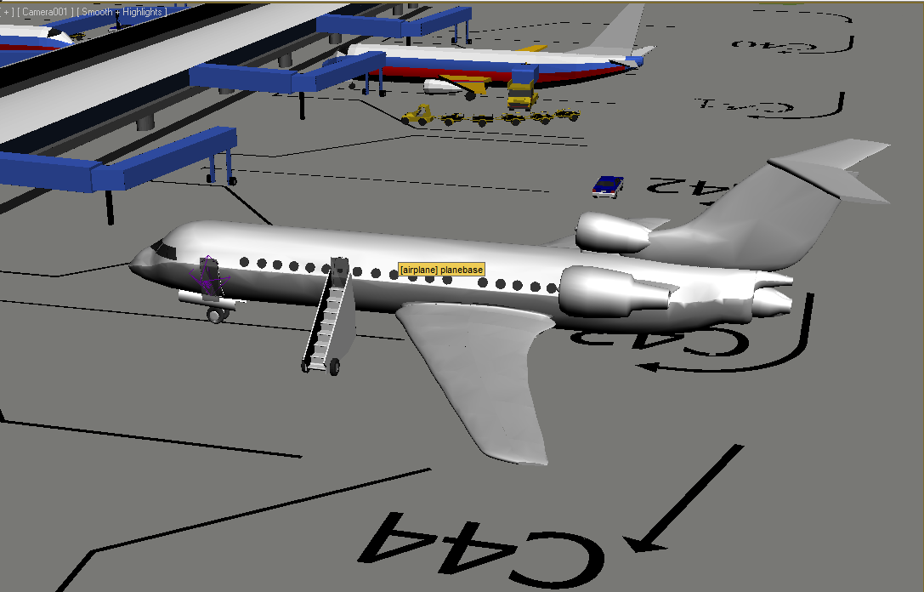

Figure 1 Airplane viewpoint

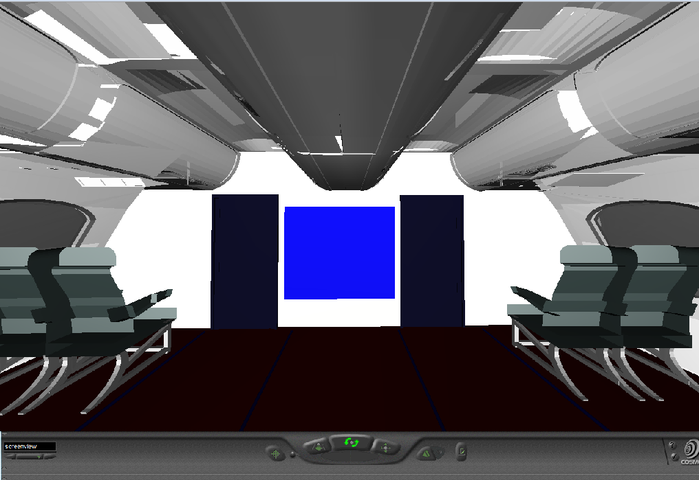

Figure 2 TV screen viewpoint

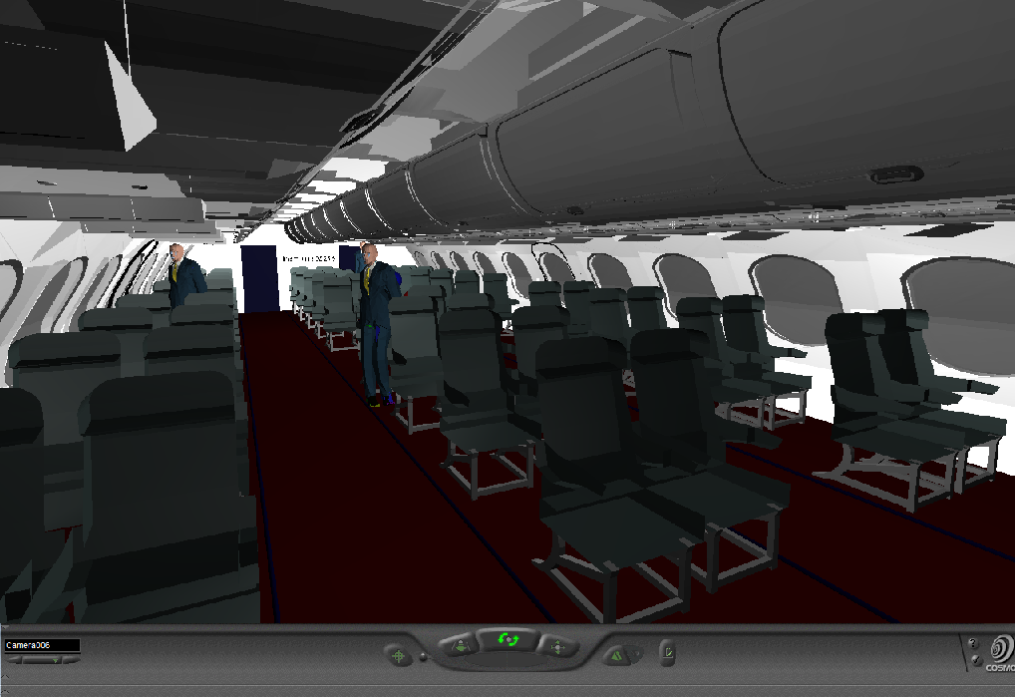

Figure 3 Interior environment viewpoint

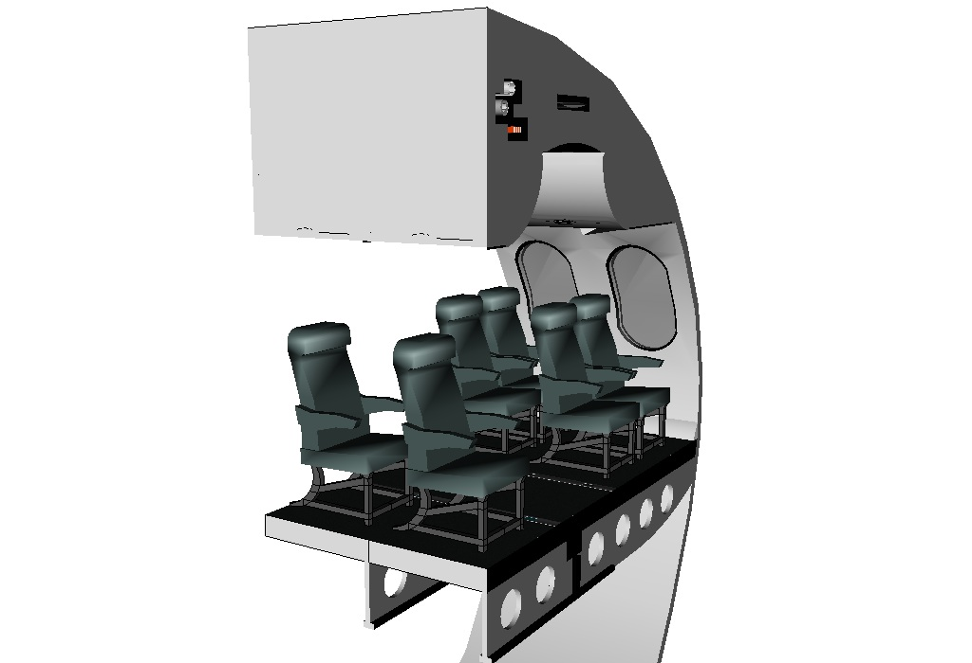

Figure 4 Interior cross section

Remaining shortcomings

One of the main shortcomings of the project is that the character model separates from the biped skeleton when exported to 3ds Max. We are currently searching for solutions to this problem. Another issue is that we were not able to implement the various behaviors we initially wanted to such as seek, panic, goal finding, helping, and path following behaviors because behaviors implemented in 3ds Max are exported to vrml as animations so new behaviors cannot be implemented in real time. They have to be exported a separate animations in multiple files. Due to time constraints were not able to add all of the interactivity that we had originally planned such as opening the overhead luggage bins, and the various additional light indicating that an avatar has been selected or color change of the environmental lights indicating an emergency evacuation was taking place.

The next step would be to find alternative software to run our environment in, which would allow us to implement different behaviors and alter the environment in real time. VIRtools is a possible program that we are considering which would add a lot more functionality to our environment as well as increased user interaction with the environment. 3dvia Studio is another possible application which would allow us to post our environment on the web. The only problem with that option is that a user would have to go to the 3dvia website to view the environment.

Conclusion

* Argue briefly **why this application is useful** and **why virtual reality is the appropriate technology** for this project.
  + In all passed years, there has only 2D simulation and this application can be used by airlines to simulate emergency scenarios without the use of live actors. This will allow airlines to run multiple simulation under a variety of conditions which will save time and lower costs. The application can also be adapted and expanded to other industries.
  + This application can also be used a training tool for airline staff and emergency personnel.
* List software and hardware equipment that is required or desired for the implementation.

  Software: Virtools, 3ds max, cosmo player, windows 7, Mac OS.