Traffic Intersection

Project Report

By: Blaine Menelik, Tori Garrick, and Ray Akinlosotu

Dr. Sharma

COSC 490

May 3, 2010

Goals and Objectives

The objective of our project was to create a realistic model of a traffic intersection. The environment allows the user to visualize how the busy traffic intersection works, traffic lights change colors and have cars moving throughout the city. As the traffic lights change, the cars will move to the users desired location; using the quickest route to that destination. Our intended goal was to implement a simulation that will let the user move the vehicle from point A to point B, throughout the environment.

Modeling

Our envisioned environment resembles a traffic intersection that’s in the city. We’ve included the following models:

Vehicles:

Buildings

Stoplights

Benches

People

Stop signs

Utility Pole

We used a texture to create the sidewalks throughout the environment. The animation also includes the people walking around the city on the sidewalks as the cars are moving to the selected locations. For the lighting in the environment we used the daylight system that’s used in 3ds max. The envisioned user should be able to visualize a simulated traffic intersection. As well as see the vehicles move through the environment based on the selected location by using the interpolators.

Models were found on the following sites:

[www.3dvia.com](http://www.3dvia.com)

[www.3dXtras.com](http://www.3dXtras.com)

[www.free3dstextures.com](http://www.free3dstextures.com)

[www.max-realms.com](http://www.max-realms.com)

Major Tools: VRML, 3ds max, models/textures

We used a couple of different VRML functionalities such as the lights, interpolators, touch sensors and routing. Point lights were used to give the illusion of rays of light coming from the sky in all directions. ColorInterpolators were used on the stoplights to change the colors from green to yellow, and yellow to red etc. With the sensors we could make the cars move down the road based on the color of the stoplight at the given time. When including the touch sensors you must put a timesensor in as well because it controls the animation.

Our designed environment consists of a number of traffic lights with about 8 intersections in the whole environment. There are sensors in various spots that will trigger the vehicles to automatically move based on the color the traffic light is showing at that time. The environment also consists of a park, buildings and many other vehicles. There are people on the sidewalks, and it gives the application the look of a city.

When creating our traffic intersection environment we did encounter a few problems. Finding the textures/models online was an issue because a lot of websites charged for downloading their files. So finding free websites was very hard but we found 3 websites that were very useful. It was also very hard to find the sidewalk and grass textures. Exporting some of our downloaded files was also an issue because they would not open up or once we opened them in 3ds max it wouldn’t ungroup. Making our road was also an issue for us because it was hard to make them with the box polygons, then putting the yellow lines in the middle and making it straight. There was also a hard time finding a curved road to connect our straight streets.

In order for us to create the streets and grass we had to download the textures. For our functionalities we used lights, interpolators and sensors. Virtual reality is the appropriate technology because it lets the user get to see how the application actually works without having to build one. When using the application all the user has to do is click on the sensor in order for the car to travel to that destination.

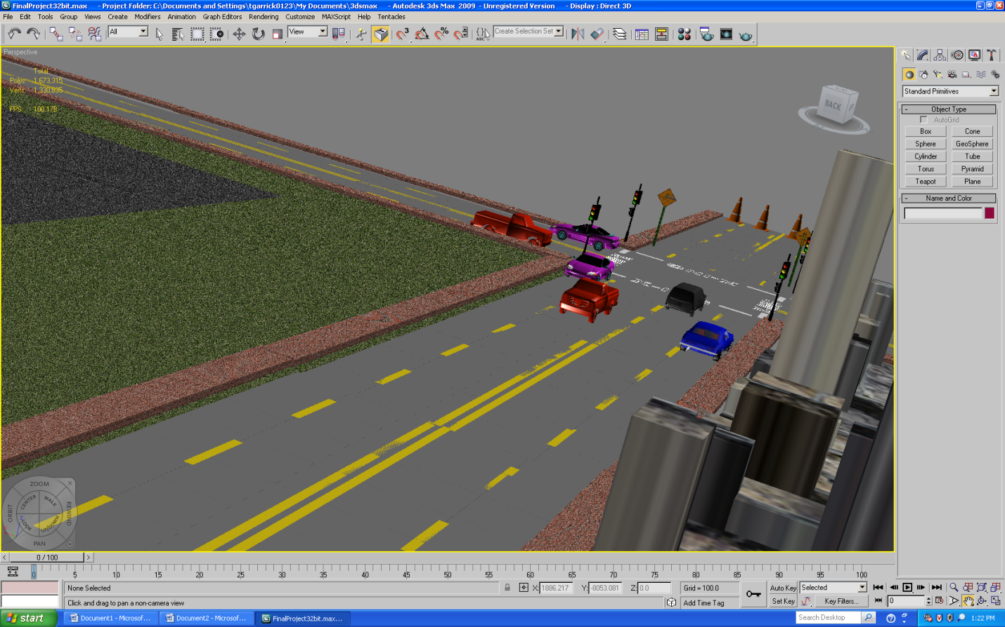

Snapshot of a traffic intersection

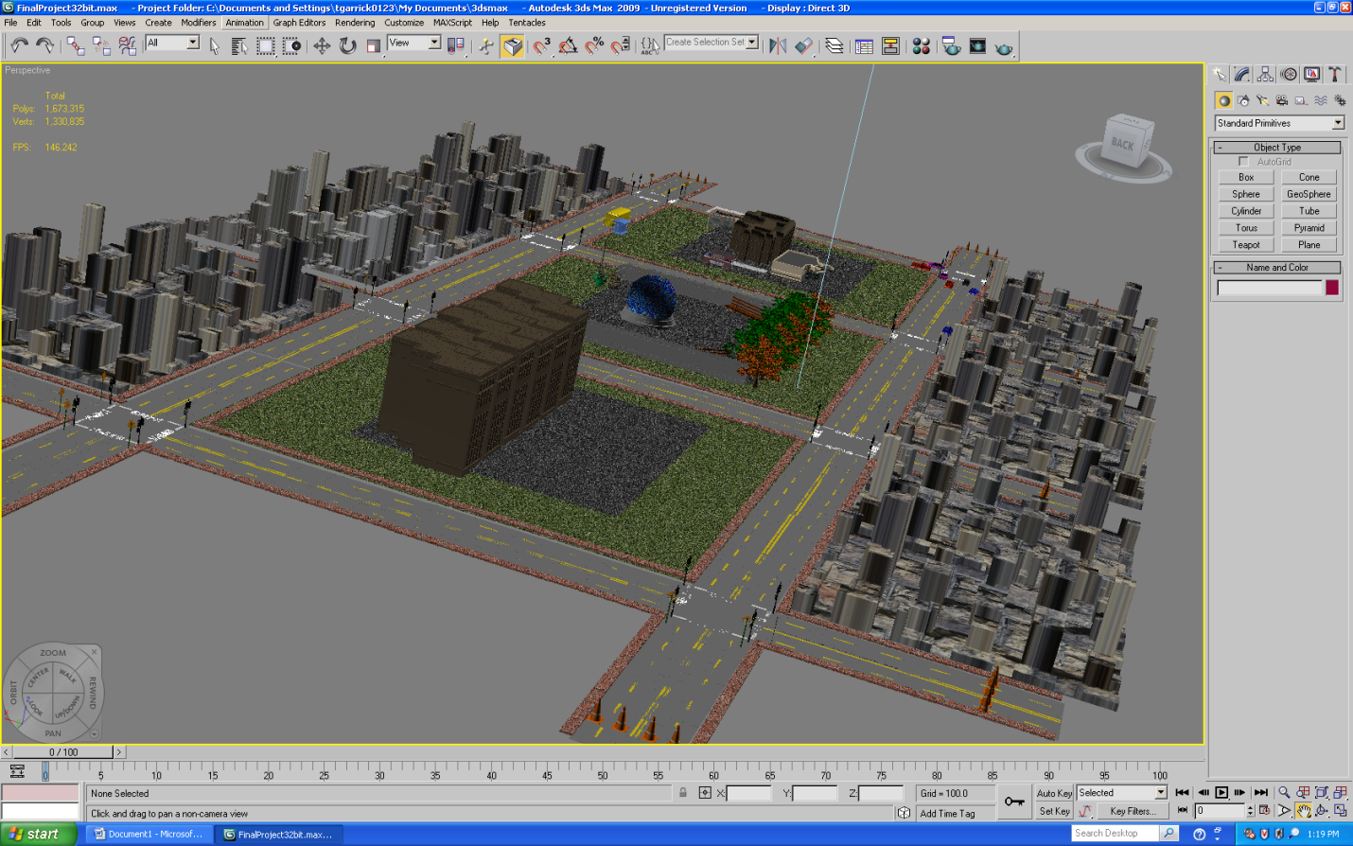

Snapshot of the entire environment

Sources for models/textures:

**Street sign**: <http://www.max-> realms.com/modules/wmpdownloads/viewcat.php?cid=7&min=10&orderby=titleA&show=5

**Stop sign:**  <http://www.max-realms.com/fullimage/stopsign.jpg>

**Grass**: <http://free3dstextures.com/texture/IMG_2165_JPG/450564313>

**Van**: <http://www.max-realms.com/fullimage/caravan_mrealms.jpg>

**Building**: <http://www.max-realms.com/fullimage/office_round_mrealms.jpg>

**Tree**: <http://www.max-realms.com/fullimage/elm1_full.jpg>

**Sidewalk:**  <http://free3dstextures.com/texture/Brick_Texture_-_Medium/453679147\>

**Skyscraper**: <http://www.max-realms.com/fullimage/skyscraper4_mrealms.jpg>

**Software/Hardware Used**

VRML

3ds Max 2009

Cosmo Player

Virtual Reality Lab

Microsoft Word