Bowie state university

2011

Our Solar System:

COSC 729 Final Project

By Ruth Agada & Michelle Snowden

Bowie state university

**Goal and Objective:**

The goal of our project is to create a semi realistic virtual model of our solar system that gives the user the opportunity to explore the different planets in our system. There are 2 main parts to the solar system project: nine planetary bodies (we still consider Pluto a planet) as well as the major moons associated with them, a futuristic model of a space station. Additional objects may be added to project to include the different satellite missions that have been sent into the solar system.

**Textures/Sensor/Light:**

The project is using a variety of textures, sensors, and lights to enhance the user’s experience as they wonder through the solar system and the space station.

Lighting:

While the solar system view the light source is simulating the sun as a point as a point light. As for the space station model, headlight serves as the main light source to illuminate the environment.

Sensors:

Anchor nodes and touch sensors are added to allow the user to navigate the different scene.

Textures:

We used the texture maps for all the planets, including those for the moons that we could find. Note: only textures for moons that were available were modeled. Textures for the different environments were included in the package for the different scenes that were modeled. (links available in the reference page).

**Software/Hardware Used:**

Software:

* 3D Studio Max 2011
* VRMLPAD 3.0
* Cortona 3D
* Windows 7

Hardware:

* HP pavilion dv6 notebook
* Dual core processor
* 4GB RAM
* 500 GB HDD

**Modeling:**

Solar System:

The solar system model consists of all eight planets including Pluto and the Sun. Each planet model and orbits are an approximation; they are not done to any scale. Each planet has a set orbit path that they follow due to their respect rotation, as well as their respective moons in their corresponding orbit. Different cameras are added to allow the user to move through the system with relative ease. Touch sensors on different objects will allow the user to interact with their environment and anchor nodes allowed for ease of movement between scenes.

Futuristic International Space Station:

The model of the futuristic international space station is a model of a space station from the Star Trek universe. Three rooms have been modeled, the main bridge, the engine room, and the conference room. For ease of transition, a corridor model was added to the list. Again, anchor and touch sensors were added to increase interactivity in the environment.

Problems Encountered:

Several issues were encountered during this project mostly with the modeling of the solar system. Finding accurate textures for the planets and its moon proved difficult. In the case of the four largest planets in our solar system finding the correct textures for the rings, if the planet in question has a ring system as well as texture maps for their moon was extremely difficult the texture map for most of the moons were applied to the bump map of the material and not the diffuse property because of the incompleteness of the image. Another issue was the number of moons we had to model and their correct orbits. For most of them only the largest and more popular moons were modeled. Getting the correct orbit and path of the planets also proved difficult.

As for the futuristic space station, modeling the interior scene to the correct scale proved difficult. When trying to move through the environment it may seem to be slow.

**Screenshots:**

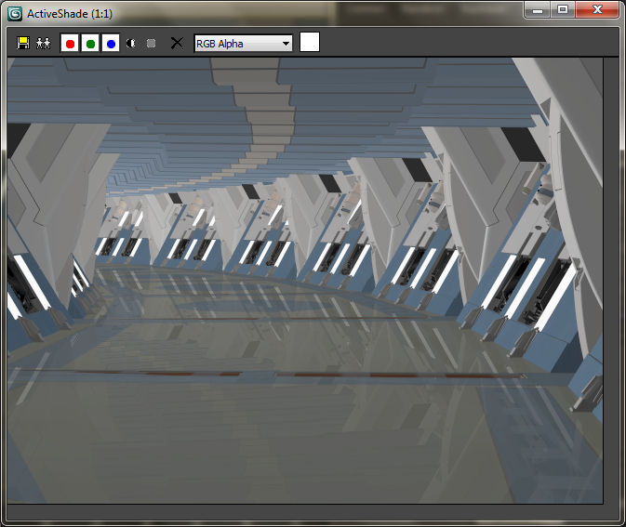

**Corridor to walk through to get to the different rooms**

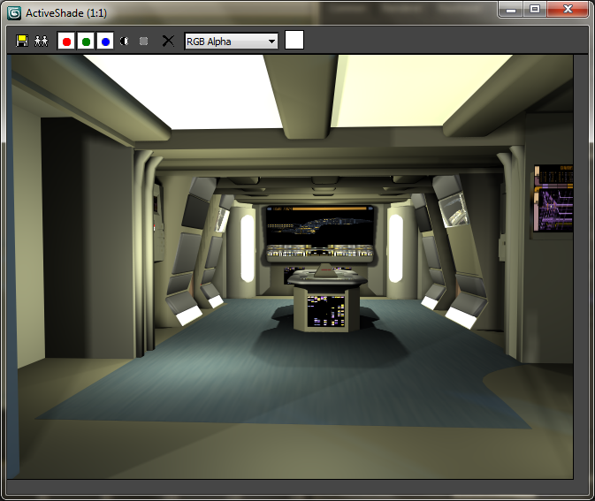

**Engine room**

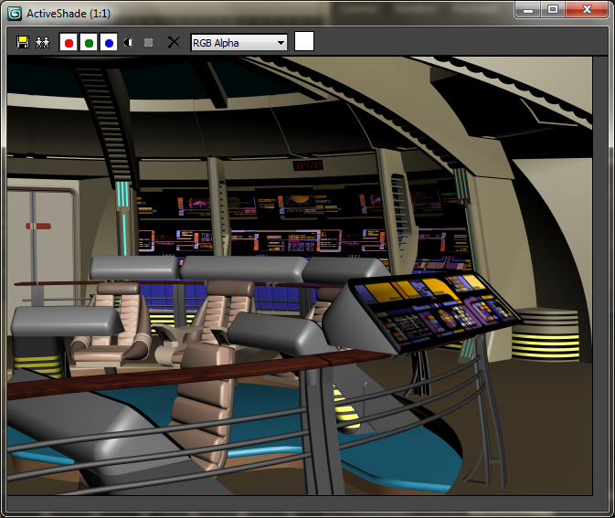

**Main bridge**

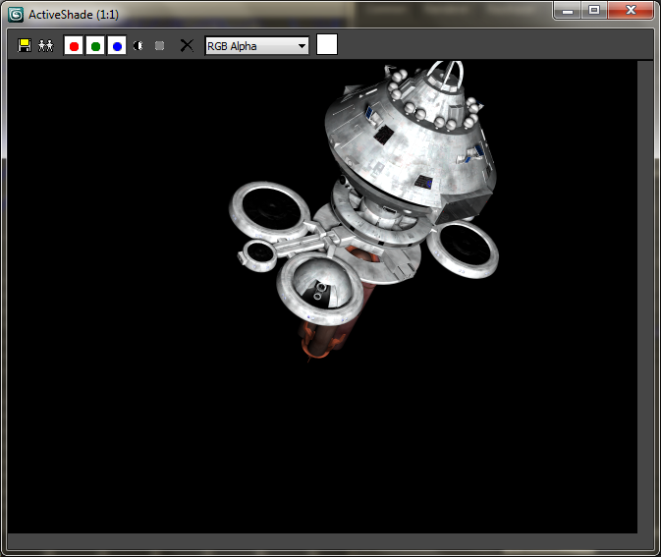

**Space Station**

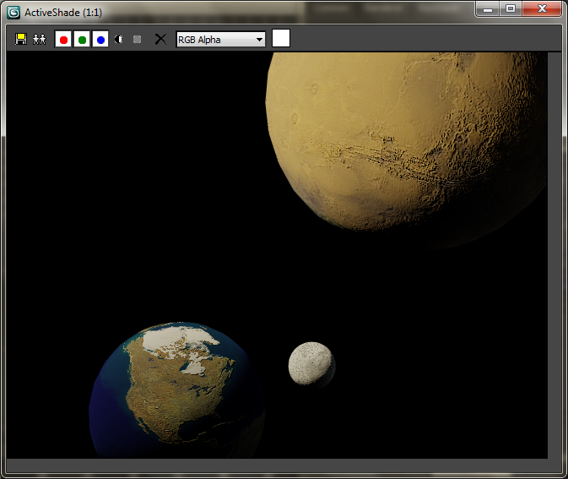

**Perspective view of the earth(**this view is subject to change)