|  |
| --- |
| **Hotel Simulation** |
| COSC 729 |
|  |
| Stacy Reddick |
| Dane Morgan |
|  |
| **5/5/2009** |
|  |

In the virtual environment, what is envisioned is a modern hotel that consists of 3-4 floors. Only one floor will be specific, because the user will only be simulated to enter a designated floor and room.

The landscape

The lobby will have a warm, elegant feeling with colors of red, brown, and orange. Chairs, tables, a television, and a clerk's desk will be the furniture. It will also contain an area where the user can use the elevator. Plants around the perimeter will also give the area a real feel. There will be other people venturing around the lobby to make it look vacant. Views of the outside will also be an option to the user as well. The elevator will consist of four floor buttons. Music will be an option to make it more enjoyable for the user as he/she continues to their floor. The hallway will piggyback off the lobby, but with white walls, red carpeting, and lights to light the hallways. The user’s room will be the most tedious as it will have a bathroom, bedroom, and a den area. It will contain a bed, televisions, tub, toilet, and etc.

The animation/interaction

The user is going to the hotel to make a reservation. The user enters the hotel. He/She will have the option to interact with the lobby, by sitting down on one of the couches or walking around to view the elegance of the hotel, or just going up to the counter to reserve a room. If he/she reserves a room, there will be a user ready to interact and give the user their key. The user will then go to their designated room by going straight toward the area of the elevator. They enter the elevator and push the floor of which the room is located. If time is available the user will be able to venture around on all four floors, but for now the elevator will just go up to the particular floor and go down back to the lobby. When the user arrives on the floor, he will be able to see the elegance of the hallways of the hotel. He/She will then find their room, and make an entrance with the key (if possible). As the user enters, there will be a lot of interaction areas in the room. The user can go to the den and watch television, he/she can go to their bedroom and go to sleep, or go to the bathroom to freshen up. Other interactions in this project may be added, but those three are the major ones to complete. If the user wants to go back down to the lobby area, he/she is able by exiting the room and entering the elevator down to the lobby. He/She then can exit the hotel.

For the user, they will be able to click on certain items and they will respond, i.e., if the user was in the elevator, the user can click in the elevator and music will come on. Also, in the hotel room, the user is able to turn the lights, television, electronics, and etc. off and on.

In order for the visions, functionalities, and elements of the project to all be incorporated, virtual reality is necessary. 3dsmax will help build the elements of the project, i.e., the user, building, elements in the building, and etc. VRML scripting will be useful to complete the projects functionalities. We want this to make the user seem as if there were really able to interact with different elements and objects in the hotel. VRML is what will do that. Virtual Reality is defined as a real-time simulation that is computer generated that uses senses. For this project to successfully complete its tasks, it needs to meet the requirements of what virtual reality is.

This simulation will be useful for any user that enjoys hotels, or just would like to have an entertaining, virtual experience in a hotel. For example, this simulation gives the user the ability to virtually cycle through various rooms (such as the lobby, bedrooms, etc), have interactions with various items, and seek through the beautiful scenery. Most people in this country would say they love traveling. Hotels play a big role in traveling and are usually the first place a user or group would lodge in. Hotels are used for its amenities, location, and its excellent service. This simulation should give someone who’s never had a traveling experience a close to ‘reality’ experience.

Accomplishing our goals and objectives were somewhat difficult. A few things were added, removed, or altered. These ‘things’ included creating a hotel simulation with detailed objects, efficient functionalities, and user interaction. Initially, there were many planned functionalities including entertainment, more objects in each of the given rooms to give the user a more realistic feeling. Due to time involved, it was only best to implement the necessary functionalities in the project. The addition of a bigger landscape gives the user a natural feeling of where he/she is. Being that there were limited amount of object and functionalities to make the experience more enjoyable for the user, our goal of creating user interaction in the hotel simulation still succeeds.

One recommendation for further improvement of a hotel simulation in virtual reality would be time. Without conflicting schedules, time could have paved a way for more implementation of functions and given the user a more in depth experience in the hotel simulation.

Hardware/software needed:

3dsmax 2008

Desktop

VRML application

Screenshots:

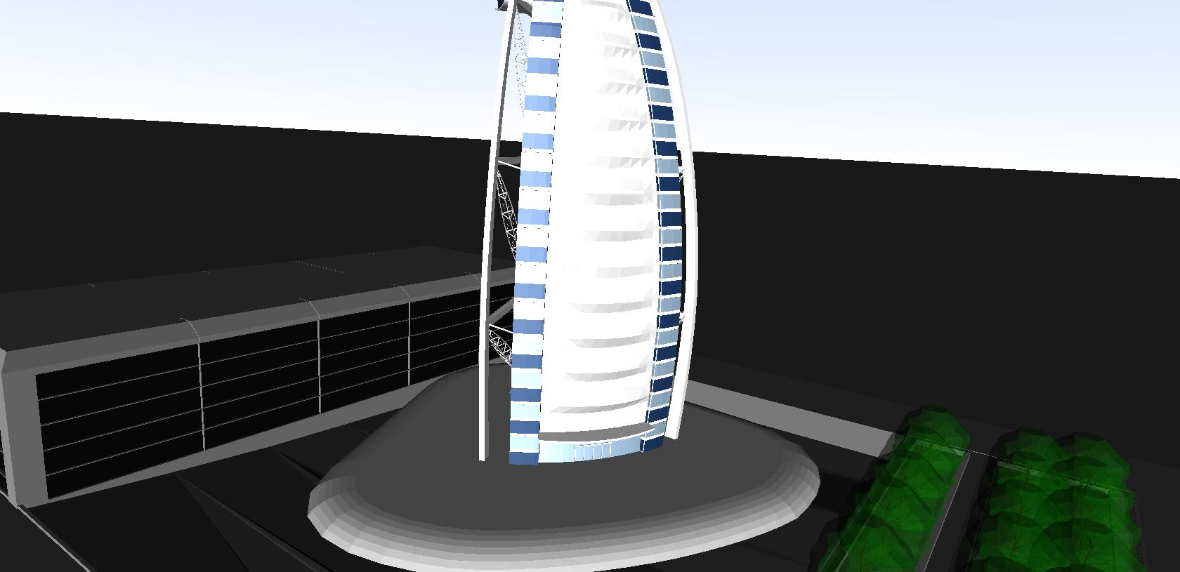

Hotel Outside View

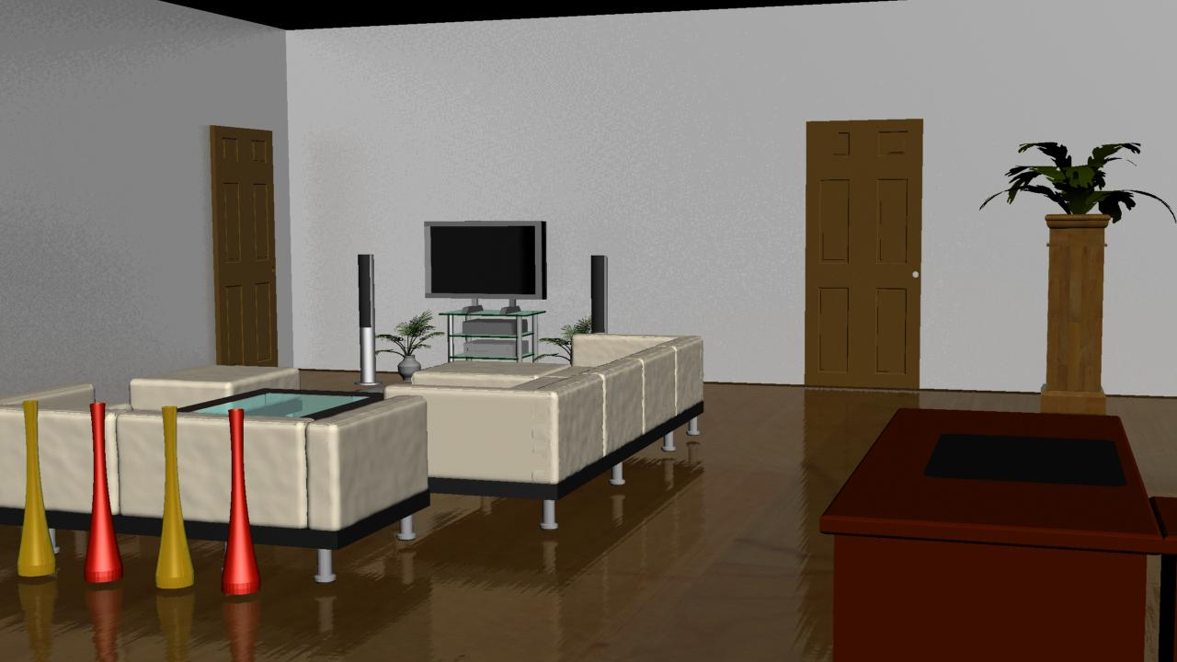

Lobby View