Comparative Study between SSD and HDD

In partial fulfillment of requirements for CPE355 – Microprocessor Systems

Members:

ACULA, John Kenneth

SANTOS, Sebastian

3-ECE

Professor:

Engr. R. Stephen L. Ruiz

# Table of Contents

# Introduction

# Discussion

## Hard Disk Drive

### Parts

### How memory is accessed

### Performance (Speed and Capacity)

## Solid State Drive

### Parts

### How memory is accessed

### Speed

### Performance (Speed and Capacity)

# Comparison

## Performance

## Capacity

## Reliability

# Conclusion

# References

# Introduction

With today’s technology, informations and data has become more abundant than it was years ago and still growing. The advancements of human information have evolves from written, vocal to recorded copy of videos or voices that comes in every devices available nowadays. This kind of elevation requires a kind storage as most thing that exist, a device that can store more information than its size. This is the innovation of the tool, hard drive comes into play with the idea of storing large amount of information in a manner where it can easily be accessed the user.

Hard drive was first introduced as a stack of high-speed spinning disks, with a recording/reading head over each surface. The idea of compact disk and floppy disk is one of the later devices used for storage that involve spinning disk storage. Unlike floppy and compact disk, hard drive is a stack of disk wherein it allows a higher amount of storage and accessibility to multiple information. It was abundantly used since it was the only type of high amount of storage at point in time, but as the time progress, technology does as well. The spinning type of hard drive is not keeping up with most of the software that needs a powerful processor also needs a fast and huge amount of storage. But having both a fast and large storage comes at a hefty price and it isn’t even guaranteed to last a very long time.

Smartphones’ existence is the proof of humanities continues advances on telecommunication and media manipulation. Where the media exist, the storage is needed. Solid State drives are the next innovation of data storage which allows performances a spinning storage have it difficult. SSD doesn’t use spinning components since it all happens in a microchip. Despite the difference of storing techniques, this study will classify what will be advantage that comes with the usage of each of the hard drive.

# Discussion

## Hard Disk Drive (HDD)

Hard disk drive consists of moving pieces and parts that includes circular metal disc-shaped platters which store and retrieve the computer's data. HDD is the most common and inexpensive form of hard drive.

### Parts of the HDD

The HDD has moving parts and relies on magnets to store and retrieve data. It composed of four key components inside its casing, such as, the platter for storing data, the spindle for spinning the platters, the read/write arm for reading and writing data and the actuator for controlling the actions of the read/write arm. The head connected to the actuator arm is the one in charge in reading/writing data, which is directly contact with the disk.

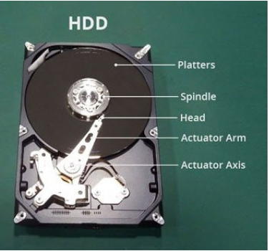

Also, the number of platter is an indication of how much storage capacity it can take, which correlate to the weight of the hard drive.

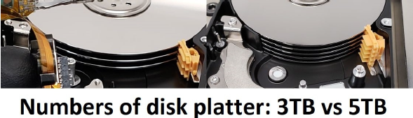

### How Data is Stored in an HDD

The traditional spinning hard drive is the basic storage on a computer. The spinning platters is the disk storage while, the head and actuator which controls the computer’s data. This is technology is relatively ancient and common storage for most of the existing devices.

### Performance (Speed and Capacity)

Consumers may choose an HDD because of its massive storage capacity and it is relatively inexpensive. However, HDD is not known for its processing speed, it has a read/write speed of 160 MB/s.

## Solid State Drive (SSD)

An SSD is a type of non-volatile memory, meaning it maintains its memory even if the system isn’t powered.

### Parts of the SSD

The main components that make-up the SSD is the flash memory, which stores the data through logic gates like NOR and NAND, the flash controller, which manages the data stored and communicates between the computer and the flash memory, the addressing, which is responsible for the selection function across the flash memory components, the data buffer or cache, which is used to cache frequently accessed data for faster reading, and the error correction, which detects and corrects errors. Unlike the traditional logic gates, when the system isn’t driven with power, they lose their capacity to hold data, meaning they are volatile, the logic gates used for SSD’s are floating gate transistors (FGRs) which holds electric charge unlike that of the traditional logic gates.

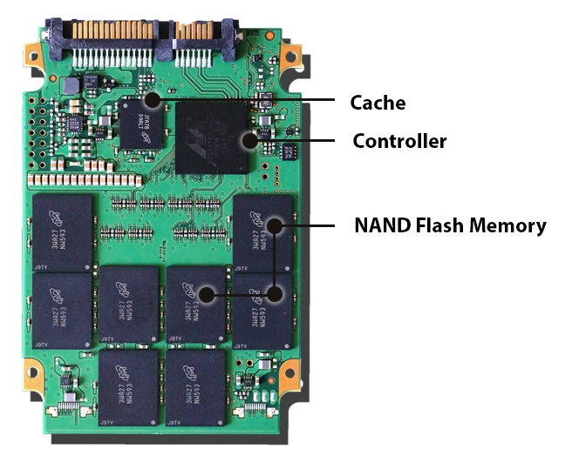

### How Data is Stored in an SSD

Unlike Hard Disk Drives which stores the data into rotating disks called platter, SSD’s store the data into arrays of NAND chips, which can retain their charge without being driven by a power source. These NAND Chips are made up of a floating gate transistors which hold charge when supplied power is removed.

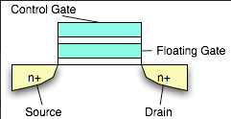

Unlike traditional MOSFETs, floating-gate transistors have an additional electrode between the gate and the semiconductor. By running high currents through the device, electrons can be forcibly directed through the insulating layer and gets retained in the floating gate. Thus connecting to the gate and drain parts of the semiconductor, which acts like a normal MOSFET. But unlike normal MOSFETs, when the supplied power is removed, the floating gate retains its charge because it is insulated from the control gate as well as the source and drain.

### Performance (Speed and Capacity)

The typical read and write speeds of an SSD is around 550MB/s and 520MB/s, respectively. But that depends on factors such as the size of the data being read or written, the randomness of the data being read or written, mixture of reads and writes, and other factors. But typically the speed is greater than that of the HDD. The capacity of an SSD is determined by how many NAND chips it contains. Which makes it more expensive per GB compared to the HDD. Typical SSD capacity can range from 120GB to 4TB.

# Comparison

## Performance

|  |  |  |
| --- | --- | --- |
| Factors | Samsung 860 EVO SATA 2.5” SSD 1TB | Typical 1TB Hard Disk Drive |
| Sequential Read Speed | Up to 550MB/s | 147 MB/s |
| Random Read Speed | Up to 10,000 IOPS | 0.77 MB/s or 190 IOPS |
| Sequential Write Speed | Up to 520MB/s | 147 MB/s |
| Random Write Speed | Up to 42,000 IOPS* | 1.53 MB/s or 380 IOPS |

A typical NAND flash drives’ file copy and write speeds are typically around 200 to 550 Mbps while typical HDDs are at around 50 to 120 Mbps.

*IOPS – Input/Output Operations per second

HDD’s speed is dependent on the rotations per minute (rpm) of the platters. The fastest rpm is up to 10,000 rpm, further research to increase that speed is not feasible because SSDs would be the next standard external memory storage that will phase out the HDD.

## Capacity

The maximum capacity that an HDD can have is 18 TB but SSD can only have 4TB. But with the trend called the Moore’s law which states that the number of transistors per silicon chip doubles every year, it is only a matter of time until the SSD can catch up to the capacity which the HDDs are popular for.

## Reliability

SSDs tend to be more reliable due to it having no mechanical parts moving. HDDs, meanwhile, having moving parts can be heavily affected by external forces. Forces such as shock and vibrations can cause the physical moving parts of the HDD to be misaligned, damaged, or cause the platter to scratch up. Magnetism is also a major vulnerability of the HDD due to data being stored magnetically in the platter. Although SSDs are, in general, more reliable than HDDs, SSD’s UBER (Unrecoverable Bit Error Rate) rate is higher than that of the HDDs meaning frequent backups are needed in an event of data loss.

# Conclusion

HDDs uses mechanical means to locate the data, by the means of spinning disks and a spindle, while SSDs uses logic gates to read data. The physical limitation of the speed of an HDD hinders the performance of the external storage device. HDDs are also notorious for their reliability because there are moving parts in an HDD, external forces such as shock and vibration can break the HDD, magnets can also be detrimental to the data that is contained in the platters. But the reason people are still buying HDDs is because it is cheaper in terms of GB per unit of currency. Large servers that requires massive storages uses HDDs because the reliability issues that the HDD have is avoided due to the nature of servers, which is stationary.

The prices of SSDs are becoming more and more competitive due to the continuous advancement in technologies and research in making it more efficient. High IOPS, durability, longer lifespan, lower power consumption, quitter due to absence of moving mechanical parts, are the reasons why SSDs are becoming more and more competitive.

It’s only a matter of time until the HDDs are phased out similar to its predecessors like floppy disks. But the advantage of massive capacities of the HDDs are still valuable to the masses as well as the companies.

# References

Bednar, L. (2019, August 2). "Pros and Cons to Using a Hard Drive vs. Solid State Drive," Secure Data, [Online]. Retrieved April 28, 2021, from: <https://www.securedatarecovery.com/blog/pros-cons-hard-drive-vs-solidstatedrive>

Data Recovery Specialists (2018, June 15). How do SSDs Store Data. Retrieved April 22, 2021, from <http://www.datarecoveryspecialists.co.uk/blog/how-do-ssds-store-data>

Harris, R. (2016, February 25). “SSD reliability in the real world: Google's experience”. Retrieved May 5, 2021, from <https://www.zdnet.com/article/ssd-reliability-in-the-real-world-googles-experience/>

Kranz, G. (2019, July 18). What is SSD (solid-state drive)? A definition from WhatIs.com. Retrieved April 22, 2021, from https://searchstorage.techtarget.com/definition/SSD-solid-state-drive

Markman, M. (2015, April 1). "What are the Functions of a Hard Drive?," Techwalla, [Online]. Retrieved April 28, 2021, from: <https://www.techwalla.com/articles/what-arethe-functions-of-a-hard-drive>

Nield, D. (2013, May 24). "The Four Major Component of a Hard Drive," Chron [Online]. Retrieved April 28, 2021, from: <https://smallbusiness.chron.com/four-majorcomponents-hard-drive-70821.html>

Owen, J. (2015, May 3). "What’s inside of a hard drive?," YouTube [Online]. Retrieved from May 5, 2021, from: https://www.youtube.com/watch?v=n6uPALWAyxc

Senanan, K. (2015, October 21). "How do hard drive work?," TEDEd [Online]. Retrieved from May 2, 2021, from: https://ed.ted.com/lessons/how-do-hard-drives-work-kanawat-senanan#review

Tablante, T. (2020, May 9). How do SSDs Work? | How does Smartphone store data? | Complex nanoscopic Structures!, YouTube. Retrieved May 5, 2021, from https://www.youtube.com/watch?v=5Mh3o886qpg

Yeh, A. (2011, November 28). How does a floating-gate transistor work? Retrieved April 22, 2021, from <https://www.quora.com/How-does-a-floating-gate-transistor-work>

526christian (2019, May 31). Understanding SSD Speed Specifications and their Relevance. Retrieved April 22, 2021, from http://blog.logicalincrements.com/2019/05/understanding-ssd-speed-specifications