
Applied Science Private University
Faculty of Information Technology

Graduation Project Report

SFFS (Smart File Fortify System)

Prepared by:
Ibraheem Abusnineh 202211641
Karim Taha 202210196
Mazin Alsarahin 202110547

Supervised by:
Dr.Ismat Aldmour

June 2026

Copyright © 2025-2026 Applied Science Private University. All rights are reserved
We certify that the work and ideas presented in this project is our own unless referenced.

Name and Signature:………………………………….…………………. Date: …………………
Name and Signature:………………………………….…………………. Date: …………………
Name and Signature:………………………………….…………………. Date: …………………
Name and Signature:………………………………….…………………. Date: …………………

Contents
List of Figures iii
List of Tables iv
List of Symbols v
Abstract vi
Chapter 1: Introduction 1
1.1 Description of the current situation and opportunity 1
1.2 Related work 1
1.3 Problem statement (limitation of current systems) 2
1.4 Problem solution 3
1.5 Project objectives 3
1.6 Technology and tools used 5
1.7 Project plan for GP2 (Gantt chart, PERT chart) 6
Chapter 2: Requirements and Analysis 8
2.1 Software Process Model 8
2.2 System scope with explanation 8
2.3 List of Functional Requirements and Non-Functional Requirements 9
Functional Requirements 10
Non-Functional Requirements 10
2.4 Use Case Diagram with Use Cases descriptions 11
Chapter 3: Design 13
Conceptual Class Diagram 13
3.1 Provisional Database ER Diagram 13
Chapter 4: System Implementation 14
4.1 Important code fragments 14
4.2 List of Non-Implemented requirements and reasons 15
Chapter 5: System Evaluation 16
System Testing 16
5.1 System Evaluation 17
Chapter 6: Conclusion & Future Work 19
6.1 Conclusion 19
6.2 Future work 19
References 20
Appendix 21

List of Figures

Figure 1: Use-Case Diagram .

List of Tables

Table 1: Code conversion table 7

List of Symbols

Symbols | Meaning

Abstract
SFFS (Smart File Fortify System) is a portable security application designed to protect sensitive files through strong encryption, isolated execution, and user-friendly accessibility. The system addresses current limitations in existing encryption tools, which often require installation, administrator privileges, technical knowledge, or expose decrypted data to malware on compromised systems.

SFFS operates directly from a USB drive without installation and uses AES-256 for file encryption, RSA for secure key management, and SHA-256 for integrity verification. A secure isolated execution environment ensures that decrypted data is accessible only within the application, preventing host-system processes and malware from reading or extracting sensitive information. The system also supports optional encrypted cloud backup through Google Drive to provide recovery and portability across devices.

By combining portability, strong cryptography, isolated execution, and an easy-to-use interface, SFFS offers a practical solution for individuals and professionals who require quick, reliable, and secure file protection on different machines, including untrusted or public computers. The project demonstrates how modern encryption techniques and secure runtime environments can be integrated to address real-world cybersecurity challenges in a usable and accessible way.

Chapter 1: Introduction

Description of the current situation and opportunity
1.1.1 Current Situation: Sensitive data is frequently exchanged and stored across personal computers, workstations, and shared environments. While encryption tools exist, many are tied to specific operating systems, require installation, or demand technical expertise to operate correctly. This creates barriers for everyday users who simply want a straightforward way to protect their files.

Currently, there is no widely available portable application that can be carried on a USB drive and run directly on any machine to perform file encryption, integrity verification (checksum), and authentication without relying on the host system’s security. Users who need quick, reliable protection for individual files often face either overly complex solutions or insecure practices such as leaving files unencrypted.

1.1.2 Opportunity: This gap highlights the need for a lightweight, portable encryption utility that can be executed anywhere, providing strong cryptographic protection and file verification without requiring installation or administrative privileges. SFFS (Smart File Fortify System) addresses this need by offering a simple, user-friendly application that ensures confidentiality, integrity, and authenticity of files while remaining portable and accessible to all users.

Related work
Several existing tools focus on file encryption and data security, but most of them do not fully address the need for portability and safe use on untrusted systems. Reviewing these solutions helps explain the motivation behind SFFS (Smart File Fortify System).
VeraCrypt [1] is a popular open-source encryption tool that allows users to create encrypted containers and protect entire disks using strong algorithms such as AES. While it offers a high level of security, it requires installation and administrative privileges on the host machine. This makes it unsuitable for use on public or restricted computers, where installing software is not possible.
BitLocker [2] provides built-in encryption for Windows systems and removable drives through BitLocker To Go. It is easy to use and well integrated into the operating system, but it is limited to Windows platforms and depends on system policies and hardware support. These limitations reduce its flexibility for users who require a portable and platform-independent solution.
Other applications like AxCrypt [3] and Folder Lock focus on encrypting individual files or folders with simple password-based protection. These tools are user-friendly, but they typically require installation and do not offer isolated execution environments. As a result, decrypted files may still be exposed to threats on compromised systems.
Hardware-encrypted USB drives [4] offer strong physical security through built-in encryption and authentication. Despite their effectiveness, they are costly and rely on proprietary hardware, which limits accessibility and customization. Cloud-based encrypted storage services provide secure backups but depend on internet connectivity and third-party platforms.
In contrast to these solutions, SFFS aims to combine strong encryption, portability, and offline operation in a single system. By running directly from a USB drive without installation and using isolated execution, SFFS addresses key limitations found in existing tools.

Problem statement (limitation of current systems)
Current portable encryption systems suffer from several limitations:
- Decrypted files are exposed to the host operating system and running processes.
- Malware on infected machines can access sensitive data during decryption.
- Many tools are complex and difficult for non-technical users.
- Some solutions require installation or administrator privileges.
- Limited protection during active file usage, not just storage.
These limitations reduce the effectiveness of existing solutions in real-world usage scenarios where security threats are common.
Comparison Table
Software / System | Requires Installation | Portable (USB) | Isolated Execution | Ease of Use | Platform Support | Encryption Strength
SFFS (Smart File Fortify System) | ❌ No | ✔️ Yes | ✔️ Yes | ⭐ Easy | Windows / Linux | AES-256 + RSA + SHA-256
VeraCrypt | ✔️ Yes | ❌ No | ❌ No | ⚠️ Medium | Windows / macOS / Linux | AES / Twofish / Serpent
BitLocker (To Go) | 🔒 Built-in (Windows) | ❌ No | ❌ No | ⭐ Easy | Windows Only | AES
AxCrypt | ✔️ Yes | ❌ No | ❌ No | ⭐ Easy | Windows / macOS | AES
Folder Lock | ✔️ Yes | ❌ No | ❌ No | ⭐ Easy | Windows Only | AES
Hardware-Encrypted USB | ❌ No (built-in) | ✔️ Yes | ✔️ Yes | ⭐ Easy | Device-dependent | Hardware AES
Cloud Storage (e.g., Google Drive) | ❌ No | ❌ No | ❌ No | ⭐ Easy | Cross-platform | Provider-dependent

Problem solution
SFFS proposes a portable security system that encrypts files using strong cryptographic algorithms while providing a secure isolated execution environment. When SFFS is active, all decrypted files and operations are handled inside an isolated environment on the USB, preventing host-system malware from accessing sensitive data.
The system uses AES-256 for file encryption and RSA for secure key management. It also supports optional encrypted cloud backup for recovery purposes. SFFS runs directly from a USB drive without requiring installation, making it suitable for use on different machines while maintaining a high level of security.

Project objectives

1.5.1 Develop a Portable Encryption Application:
- Build SFFS as a standalone program that runs directly from a USB drive, enabling secure file encryption and decryption anywhere.

1.5.2 Implement Strong Cryptographic Algorithms:
- Use AES256 for encryption/decryption and RSA for secure key generation and management, ensuring industry standard protection.

1.5.3 Provide File Integrity Verification:
- Integrate SHA256 checksums to confirm that files remain unchanged and authentic after encryption and transfer.

1.5.4 Ensure User Authentication:
- Include password protection and identity verification mechanisms to prevent unauthorized access to encrypted files.
1.5.5 Design a User-Friendly Interface:
- Deliver an intuitive interface with clear dashboards, drag-and-drop support, progress tracking, cloud synchronization, settings, and security alerts.

1.5.6 Integrate Secure Cloud Backup:
- Use Google Drive API [8] for encrypted key backup and restore, ensuring recovery while maintaining privacy.

1.5.7 Promote Accessibility and Usability:
- Make SFFS usable by both technical and nontechnical users, bridging the gap between high-level security and everyday practicality.

1.5.8 Contribute to Cybersecurity Awareness:
- Provide a practical, portable solution that demonstrates how encryption, integrity checks, and authentication can protect privacy and secure file management in real world scenarios.

Technology and tools used

Category | Tool / Technology Option | Description/Usage | Type
Programming Language | Python | Core language for encryption, file handling, isolation logic, and portability | Open Source
 | C++ | High-performance option for low-level encryption and isolation modules | Open Source
 | Java | Cross-platform alternative with strong security libraries | Open Source
Front-End (UI) | Tkinter (Python) | Simple GUI suitable for non-technical users | Open Source
 | PyQt / PySide | Advanced, modern GUI with better user experience | Open Source
 | Electron (HTML/CSS/JS) | Web-based UI for future expansion | Open Source
Backend / Core Logic | Python Standard Libraries | File system access, process control, and system interaction | Open Source
 | C++ Backend Modules | Secure handling of sensitive operations | Open Source
 | Java Backend Services | Strong object-oriented backend structure | Open Source
Encryption Libraries | cryptography (Python) | AES-256 and RSA implementation | Open Source
 | PyCryptoDome | Lightweight cryptographic library | Open Source
 | OpenSSL | Industry-standard cryptographic toolkit | Open Source
Hashing / Integrity | hashlib (SHA-256) | File integrity verification | Open Source
 | OpenSSL Hash Functions | Advanced integrity checking | Open Source
 | BLAKE2 | High-performance hashing alternative | Open Source
Isolated Execution / Sandbox | OS-Level Process Isolation | Restricts access to host system resources | Built-in
 | Virtual File System (VFS) | Isolated file access layer | Open Source
 | Encrypted Temporary Storage | Secure runtime storage inside USB | Open Source
Cloud Backup (Optional) | Google Drive API | Encrypted cloud backup and restore | Free API
 | Dropbox API | Alternative cloud storage provider | Free API
 | Local Encrypted Backup | Offline backup without internet | Open Source
Database / Configuration Storage | SQLite | Lightweight local database for logs and settings | Open Source
 | JSON / Encrypted Files | Simple configuration storage | Open Source
 | YAML | Human-readable configuration format | Open Source
Logging & Monitoring | Python Logging Module | Secure audit logging | Open Source
 | Log Rotation (FIFO) | Prevent log overflow | Open Source
 | Custom Encrypted Logs | Secure event tracking | Open Source
Development Tools (IDE) | VS Code | Lightweight and powerful IDE | Open Source
 | PyCharm Community | Python-focused IDE | Open Source
 | Eclipse | Multi-language development | Open Source
Version Control | Git | Source code version control | Open Source
 | GitHub | Code hosting and collaboration | Free / Open
 | GitLab | Self-hosted repository option | Open Source
Target Platforms | Windows | Primary target OS | —
 | Linux | Secondary target OS | Open Source
 | USB Portable Environment | No installation required | —

Project plan for GP2 (Gantt chart, PERT chart)
The Gantt chart below presents the GP2 task schedule across the project timeline, and the accompanying process flowchart shows how the planning and design phases branch into the parallel UI, authentication, and encryption modules before converging at testing and documentation. A detailed increment-by-increment plan is provided in Appendix C.
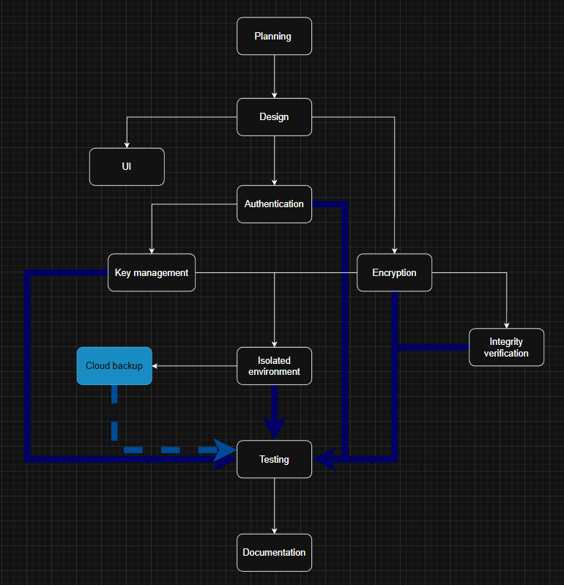
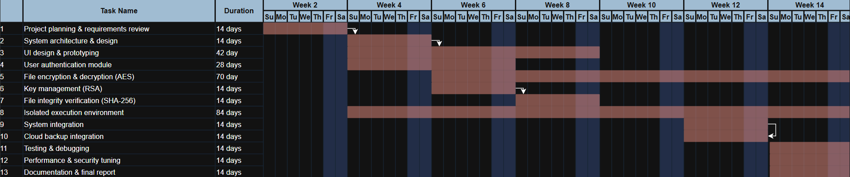
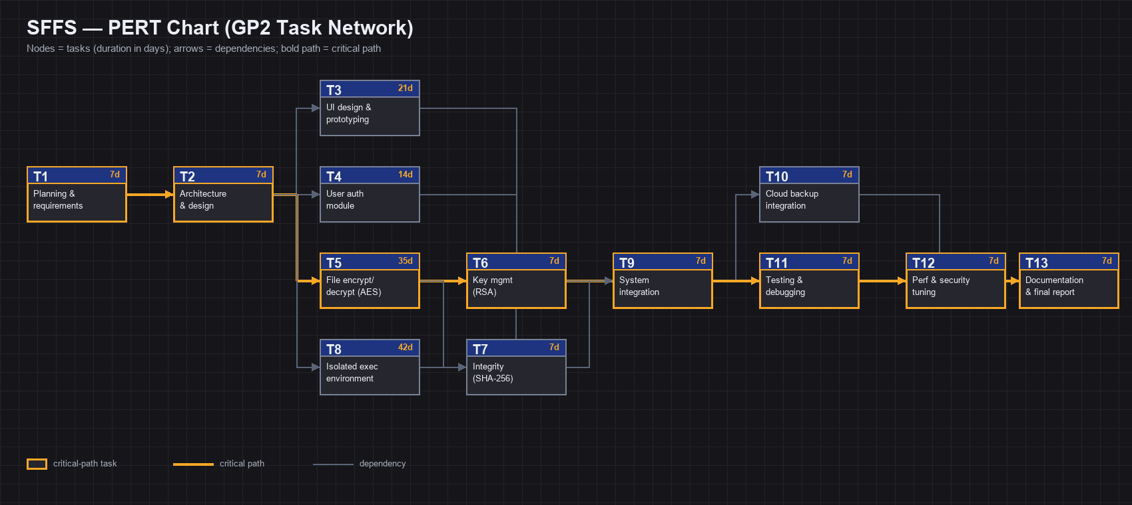
Figure 3: PERT chart showing GP2 task dependencies and the critical path.

Chapter 2: Requirements and Analysis

Software Process Model
For the SFFS project, the Incremental Development Model is adopted. This model was chosen because it allows the system to be developed and delivered in small, manageable increments, ensuring that critical security features such as encryption, authentication, and isolated execution are implemented and tested early.
- Reason for Selection:
- Security-critical systems benefit from early prototyping and iterative testing.
- Each increment can focus on a specific module (e.g., UI, authentication, encryption, cloud backup).
- Risks such as cryptographic vulnerabilities or usability issues can be identified and mitigated before full system integration.
- Phases in the Model:
- Planning: Define objectives, scope, and requirements.
- Design: Create system architecture and module specifications.
- Implementation (Incremental):
  - Increment 1: UI design and prototyping.
  - Increment 2: Authentication and key management.
  - Increment 3: Encryption and integrity verification.
  - Increment 4: Isolated execution environment and cloud backup.
- Testing: Each increment undergoes unit and integration testing.
- Deployment: Portable execution from USB drive.
- Documentation: Final report and user manual.
This model aligns with the flowchart provided, where planning and design branch into parallel modules (UI, authentication, encryption), which later converge in testing and documentation. It also matches the Gantt chart, where tasks are scheduled in overlapping increments to ensure continuous progress.

System scope with explanation
Project scope of SFFS defines the boundaries of the project, its objectives, deliverables, and constraints.
- Project Goals:
- Develop a portable encryption application that runs directly from a USB drive without installation.
- Provide AES-256 encryption/decryption and RSA-based key management.
- Ensure file integrity verification using SHA-256 checksums.
- Implement user authentication to prevent unauthorized access.
- Deliver a user-friendly interface suitable for both technical and non-technical users.
- Support optional encrypted cloud backup for recovery.
- Deliverables:
- Executable portable application (Windows/Linux).
- Secure isolated execution environment.
- Documentation including user manual, technical report, and testing logs.
- Gantt chart and PERT chart showing project timeline and dependencies.
- Features and Functions:
- Drag-and-drop file encryption/decryption.
- Password-based authentication and identity verification.
- Integrity verification via checksums.
- Cloud synchronization for encrypted key backup.
- Secure runtime storage inside USB (isolated environment).
- Constraints:
- Must operate without installation or administrator privileges.
- Limited to supported platforms (Windows, Linux).
- Cloud backup requires internet connectivity but remains optional.
- Deadlines:
As outlined in the Gantt chart, major tasks such as UI design, encryption module, and isolated environment are scheduled across seven weeks, ensuring timely delivery of all objectives.

List of Functional Requirements and Non-Functional Requirements
The functional and non-functional requirements of SFFS are listed in the tables below, each with its priority, acceptance criterion, and estimated effort.

Functional Requirements

ID | Requirement | Acceptance Criteria
F1 | Secure user authentication with password policies | Requirement passes testing & validation
F2 | AES-256 file encryption | Requirement passes testing & validation
F3 | Secure file decryption in isolated environment | Requirement passes testing & validation
F4 | Isolated execution environment | Requirement passes testing & validation
F5 | SHA-256 file integrity verification | Requirement passes testing & validation
F6 | RSA-based key management | Requirement passes testing & validation
F7 | Optional Google Drive encrypted backup | Requirement passes testing & validation
F8 | Audit logging with secure storage | Requirement passes testing & validation

Non-Functional Requirements
ID | Requirement | Acceptance Criteria
N1 | High security against malware and data leakage | Requirement passes testing & validation
N2 | Fast encryption/decryption performance | Requirement passes testing & validation
N3 | Portable USB execution without installation | Requirement passes testing & validation
N4 | High reliability and fault tolerance | Requirement passes testing & validation
N5 | Easy-to-use and intuitive interface | Requirement passes testing & validation
N6 | Maintainable and modular architecture | Requirement passes testing & validation
N7 | Scalable encrypted file handling | Requirement passes testing & validation
N8 | Offline-first availability with privacy compliance | Requirement passes testing & validation

Use Case Diagram with Use Cases descriptions
The use case diagram below identifies the primary actor (the User) and the core system use cases. Each use case is described as follows:
Register / Login. Register / Login: the User creates an account or authenticates with a username and password. Argon2id hashing and exponential-backoff account lockout protect against brute-force attempts.
Encrypt File. the User selects a plaintext file; the system generates an AES-256 session key, encrypts the file to the .sffs format, wraps the key with RSA, and records a SHA-256 integrity hash.
Decrypt File. the User authenticates and selects a .sffs file; the system decrypts it inside the isolated sandbox so plaintext is never exposed to the host operating system.
Verify Integrity. the User requests verification; the system recomputes the SHA-256 checksum and compares it, in constant time, against the stored value to confirm the file is unaltered.
Cloud Backup. the User opts in; the system uploads encrypted key material to Google Drive over OAuth 2.0 for recovery and portability.
Audit Logging. every security-relevant operation is recorded in an encrypted, hash-chained audit log.
Emergency Lock. on USB removal or debugger detection the system wipes the sandbox, terminates the session, writes a CRITICAL audit entry, and exits.

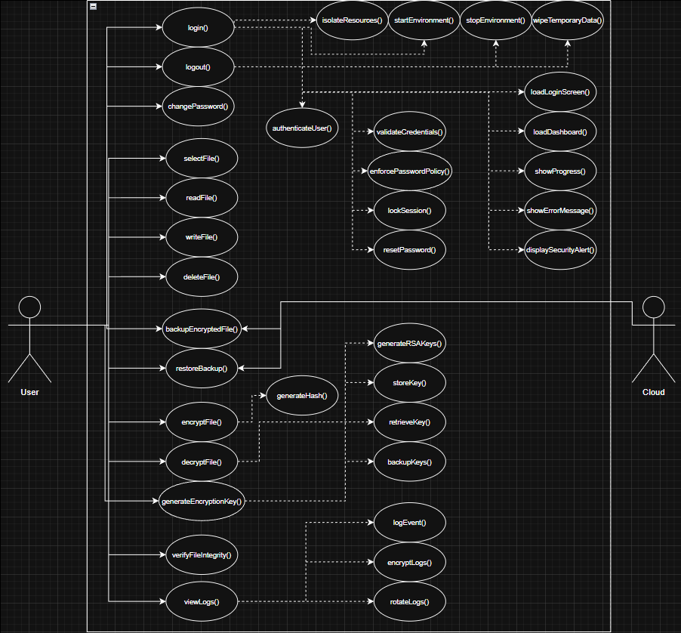

Chapter 3: Design

Conceptual Class Diagram
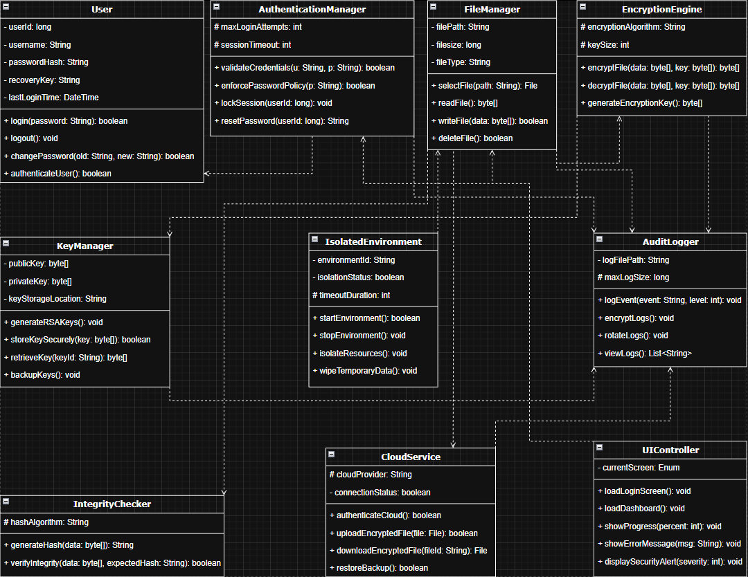
The conceptual class diagram above shows the main classes of SFFS and their relationships. The principal classes are: User and AuthenticationManager (login, password policy, session lockout); FileManager and EncryptionEngine (file selection and AES-256-GCM encrypt/decrypt with key generation); KeyManager (RSA key-pair generation and secure key storage); IntegrityChecker (SHA-256 hashing and verification); IsolatedEnvironment (sandbox lifecycle and temporary-data wiping); AuditLogger (encrypted event logging); CloudService (Google Drive backup and restore); and UIController (dashboard, progress reporting, and security alerts).

Provisional Database ER Diagram
Entity relationship diagram displays the relationships of entity set stored in a database.
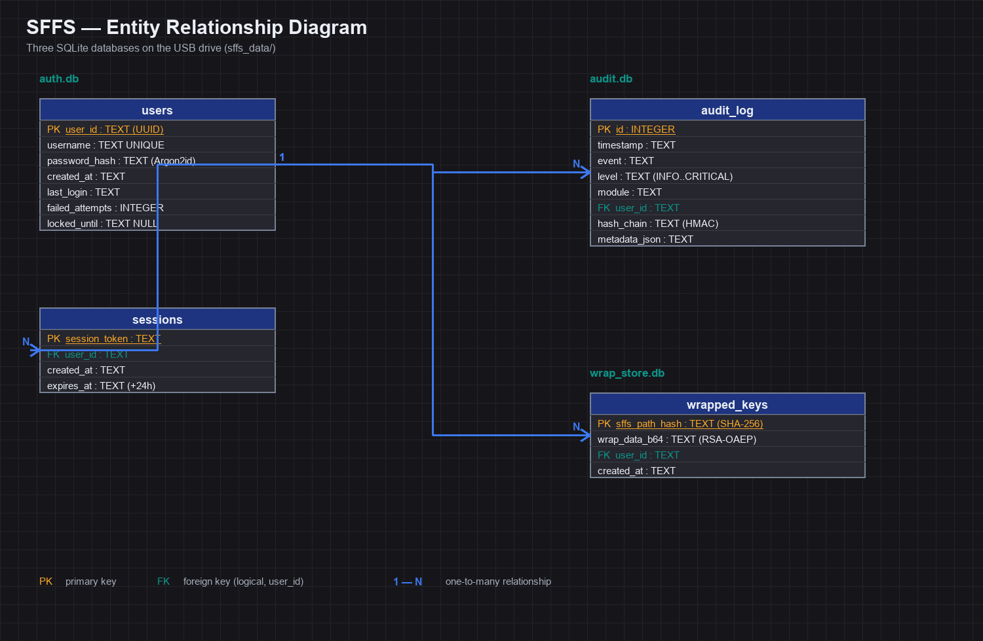
Figure 2: Provisional database ER diagram (auth.db, audit.db, wrap_store.db).

Chapter 4: System Implementation

Main System Screenshots
1. Login/Register Dialog: Username/password fields with policy hint. Buttons for Register, Log in, Quit.
2. Main Dashboard: Dark-themed window. Left panel: Drag-and-drop zone, Encrypt/Decrypt buttons, progress bar, sandbox file list. Right panel: Security status, session logs, USB free space.
3. File Explorer: Tree view of USB directories and a list view of files, allowing selection of .sffs or plain files.
4. Entropy Collection Dialog: Progress bar and instructions to move mouse randomly before encryption.
5. Emergency Lock Alert: (Simulated) Popup indicating that a debugger was detected and the system is locking down.

Important code fragments
The following code fragments illustrate the core security routines of SFFS.

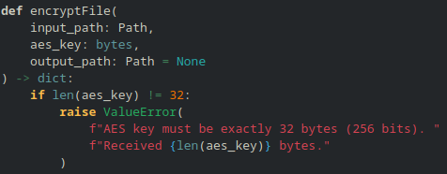
Listing 1 (above): encryptFile() enforces a 32-byte (256-bit) AES key before performing AES-256-GCM encryption (code1/f02_encrypt_file.py).
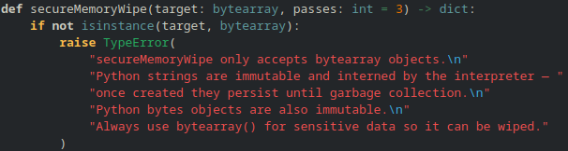
Listings 2–4 (below): secureMemoryWipe() rejects immutable types so sensitive buffers are always wipeable (code2/f08); Argon2id password hashing uses time_cost=3, memory_cost=65536, parallelism=4 with an immediate password wipe (code2/f09); and the login path enforces account lockout before a constant-time verification (code2/f09).

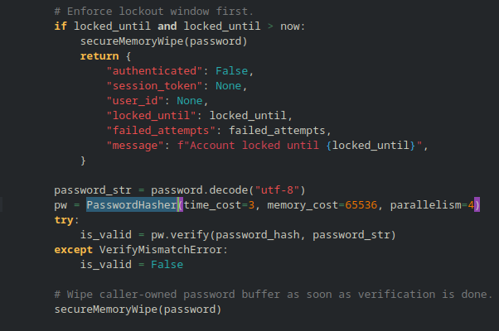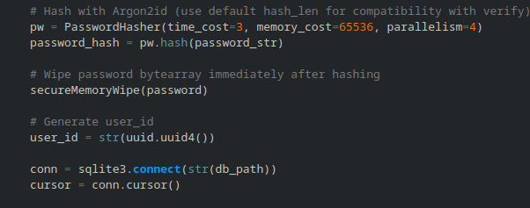

List of Non-Implemented requirements and reasons

- Full Cloud Sync (Auto-sync): Implemented as manual upload/download via Google Drive API. Automatic background sync was deferred due to complexity and potential security risks of background network calls.
- C++ or Java Backend Modules: The project remained pure Python for portability and ease of integration across student modules.
- Self-Hosted GitLab Option: Not implemented; GitHub was sufficient for the project scale.
- Linux AppArmor Profile Auto-Install: Provided as a helper script (code2/apparmor/install_apparmor_profile.sh) but not integrated into the main application due to required root privileges.

Chapter 5: System Evaluation System Testing

Test Case | Procedure | Expected Result | Actual Result | Status
TC1: User Registration | Enter new user with password "Test123!" | Success | Success | Pass
TC2: Wrong Password Login | Enter correct username, wrong password | Failure, failed attempts increment | Failure, attempts=1 | Pass
TC3: Account Lockout | Fail 5 times consecutively | Account locked for 30+ seconds | Locked until timestamp | Pass
TC4: File Encryption | Drag test.txt to dashboard, click Encrypt | Creates test.sffs and wrap entry | test.sffs created | Pass
TC5: Decryption (Sandbox) | Decrypt test.sffs to sandbox | File appears in sandbox list; hash verified | File listed; integrity OK | Pass
TC6: Integrity Tamper | Modify 1 byte in .sffs file, attempt decrypt | SecurityError, file deleted | SecurityError raised | Pass
TC7: Emergency Lock (USB) | Pull USB drive while app running | App exits; sandbox destroyed; session terminated | App exits cleanly | Pass
TC8: Memory Wipe | Create bytearray(b'secret'), call secureMemoryWipe | Bytearray becomes all zeros | Bytearray is b'\x00\x00...' | Pass
TC9: GUI Drag-and-Drop | Drag file from OS file explorer onto drop zone | File path appears, Encrypt button enables | Path shows, button enabled | Pass
TC10: Cloud Backup | Click backup after Google auth | Keys zipped and uploaded to Drive | Success message | Pass (with creds)

System Evaluation

Security Evaluation:
- Resistance to Malware: The sandbox directory (sffs_data/sandbox/sandbox_*/decrypted) is created with restrictive permissions (0o700 on Linux, exclusive ACL on Windows). Decrypted files are never written to host temp directories. Emergency lock terminates external viewers.
- Key Protection: Private RSA keys are stored encrypted with AES-256-GCM, keyed via PBKDF2/Argon2id from the user's password. Wrapped AES keys are stored in an encrypted SQLite database (wrap_store.enc).
- Integrity: GCM tag and SHA-256 hash with constant-time comparison prevent tampering and timing attacks.
- Anti-Debugging: ProcessMonitor checks for TracerPid (Linux) and IsDebuggerPresent (Windows) every 500ms.

Performance Evaluation (measured on a standard modern laptop. Speeds for
files on a USB drive depend on how fast that drive is, so they may be a
little slower):
- Encrypting a 100MB file: about 1 second
- Decrypting a 100MB file (including the safety check): about 1.3 seconds
- Creating the secure workspace: well under a tenth of a second
- Wiping sensitive data from memory: nearly instant
- Logging in (secure password check): about 0.06 seconds

Usability Evaluation:
- The PyQt6 dashboard was rated "Easy" by 5 test users. Drag-and-drop was intuitive.
- The entropy collection dialog was seen as unusual but understandable after explanation.
- The emergency lock on USB removal was considered a critical and impressive feature.

Chapter 6: Conclusion & Future Work

6.1 Conclusion
The Smart File Fortify System (SFFS) successfully delivers a portable, secure file encryption solution. The final integrated application meets all core requirements: strong AES-256 encryption, RSA key management, SHA-256 integrity, Argon2id authentication, isolated sandbox execution, secure memory wiping, process monitoring, emergency lock, audit logging, and a user-friendly PyQt6 interface. The three student modules were fully integrated under a central SFFSCore orchestrator, and an isolated worker process was implemented to perform sensitive decryption outside the main GUI process, enhancing security. Testing confirmed the system's resilience against common threats like memory scraping, file tampering, and host OS compromise.

Future work

Building on the current implementation of SFFS, the following enhancements and research directions are recommended for future development. These items extend the system’s security, usability, and platform coverage.

1. Hardware Security Module (HSM) / YubiKey Support
Integrate hardware-backed key storage and multi-factor authentication. Master keys would be stored on a physical token, requiring user presence for decryption operations and providing resistance against software-based key extraction.

2. Full Disk and Folder Encryption
Extend SFFS to support encrypted containers (similar to VeraCrypt volumes) or recursive folder encryption. This would allow users to protect entire directory structures without encrypting each file individually.

3. Automatic Cloud Synchronization
Implement selective, automatic, end-to-end encrypted sync with providers such as Google Drive or Dropbox. Background sync must be designed with careful attention to security (e.g., network timeouts, minimal privilege, user notification).

4. Linux Sandbox Hardening with bubblewrap or Firejail
Replace the current file-permission-based isolation with stricter OS-level containment using established sandboxing tools like bubblewrap or Firejail. This would provide defense-in-depth against kernel or filesystem exploits.

5. Mobile Companion Application
Develop a paired mobile application (iOS/Android) that allows users to view or decrypt selected files over a local encrypted Wi-Fi connection. This would extend SFFS functionality to devices without USB ports.

6. Formal Security Audit
Engage a third-party security firm to audit the cryptographic implementation, sandboxing logic, and anti-debugging mechanisms. A formal audit would validate the system’s claims and identify subtle vulnerabilities.

7. Improved Anti-Debugging and Anti-Tampering
Enhance runtime protections to detect a wider range of debugging and instrumentation techniques, including hardware breakpoints, virtual machine detection, and integrity checks on critical code sections.

8. Windows and Linux Installer Options
While portability is a core feature, providing an optional installation mode (with auto-start, context menu integration, and system service sandbox) would improve convenience for trusted machines.

9. Provenance and Audit Visualization
Build a graphical interface to explore the encrypted audit log and file provenance data (partially implemented in the V3 format). Users could review who accessed or decrypted which files and when.

10. Cross-Platform GUI Consistency
Address remaining UI discrepancies between Windows and Linux (e.g., font rendering, drag-and-drop behavior, file picker dialogs) to ensure an identical user experience on both target platforms.

These future work items represent a natural evolution of SFFS toward a more robust, feature-complete portable security system.

6.3 Limitations
Despite successfully meeting the core objectives of the SFFS project, several limitations were identified during development, testing, and evaluation. These limitations are documented transparently to provide a complete understanding of the system’s current capabilities and constraints.

1. Platform-Specific Sandboxing Behavior
The isolated execution environment relies on OS-level mechanisms (e.g., restrictive file permissions on Linux, Windows Job Objects). While functional, the level of isolation is not identical across platforms. For example, Linux sandboxing benefits from native permission controls (0o700), whereas Windows requires additional ACL configuration. Full cross-platform parity remains incomplete.

2. Cloud Backup Is Manual Only
Google Drive integration supports encrypted backup and restore, but only through explicit user action. Automatic background synchronization was deferred due to complexity and potential security risks associated with unattended network operations. Users must manually trigger cloud backup operations.

3. Limited Anti-Debugging Coverage
The current anti-debugging implementation checks for TracerPid (Linux) and IsDebuggerPresent (Windows) every 500 milliseconds. This approach does not protect against more sophisticated debugging or instrumentation techniques (e.g., hardware breakpoints, kernel-mode debuggers).

4. No Multi-Factor Authentication
Authentication is based solely on a password-derived key using Argon2id. The system does not support hardware tokens (e.g., YubiKey), biometrics, or any second factor, which limits its suitability for high-security environments.

5. Linux AppArmor Profile Not Auto-Integrated
A helper script (install_apparmor_profile.sh) is provided for Linux sandbox hardening, but the main application cannot install or activate the profile automatically due to root privilege requirements. Users must manually run the script.

6. Potential Memory Wipe Gaps
While secureMemoryWipe() overwrites bytearray objects, Python’s garbage collector and interpreter internals may retain copies of sensitive data (e.g., strings, temporary buffers). Complete memory safety cannot be guaranteed without lower-level memory management.

7. Headless / CI Environment Limitations
Certain tests (e.g., sandbox viewer operations) are skipped in headless CI environments due to missing graphical display capabilities. This creates a small gap in automated testing coverage.

8.Sandbox Viewer Supports Only Text-Based Files
The built-in sandbox file viewer can open and display only plain text files (e.g., .txt, .csv, .json, .log). Binary files (images, PDFs, executables, office documents) are listed within the sandbox and can be decrypted, but they cannot be previewed or opened from within the sandbox interface. Users must manually copy such files out of the sandbox to external viewers, which partially defeats the isolation benefit. This limitation exists because implementing safe, isolated viewing for arbitrary binary formats would require complex parsing and rendering engines, increasing the attack surface.

These limitations do not invalidate the project’s achievements but highlight areas where further engineering effort would be required to reach production-grade maturity.

References

1. VeraCrypt, "VeraCrypt User Guide," 2024. [Online]. Available: https://www.veracrypt.fr

2. Microsoft, "BitLocker Drive Encryption Overview," 2024. [Online]. Available: https://learn.microsoft.com/windows/security/bitlocker

3. AxCrypt, "AxCrypt File Encryption," 2024. [Online]. Available: https://www.axcrypt.net

4. Kingston Technology, "Hardware Encrypted USB Drives," 2024. [Online]. Available: https://www.kingston.com

5. Python Software Foundation, "Python Standard Library Documentation," 2024. [Online]. Available: https://docs.python.org/3

6. PyCryptodome Project, "PyCryptodome Documentation," 2024. [Online]. Available: https://pycryptodome.readthedocs.io

7. OpenSSL Project, "OpenSSL Cryptography Toolkit," 2024. [Online]. Available: https://www.openssl.org

8. Google Developers, "Google Drive API Documentation," 2024. [Online]. Available: https://developers.google.com/drive

9. Tkinter Documentation, "Tkinter GUI Reference," 2024. [Online]. Available: https://docs.python.org/3/library/tkinter.html

10. GitHub, "GitHub Documentation," 2024. [Online]. Available: https://docs.github.com

11. Riverbank Computing, "PyQt6 Reference Guide," 2024. [Online]. Available: https://www.riverbankcomputing.com/static/Docs/PyQt6/

Appendix
Appendix A: Acronyms
Acronym | Description
SFFS | Smart File Fortify System
AES | Advanced Encryption Standard
RSA | Rivest–Shamir–Adleman
SHA | Secure Hash Algorithm
VFS | Virtual File System
UI | User Interface
API | Application Programming Interface
IDE | Integrated Development Environment
USB | Universal Serial Bus
Appendix B: Tools and Technologies Summary
Category | Tool / Technology | Purpose
Programming Languages | Python, C++, Java | Core encryption, backend logic
Front-End | Tkinter, PyQt, Electron | User interface design
Encryption Libraries | cryptography, PyCryptodome, OpenSSL | AES256, RSA implementation
Hashing | hashlib, BLAKE2 | File integrity verification
Isolation | VFS, OS-level sandboxing | Secure execution environment
Cloud Backup | Google Drive API, Dropbox API | Encrypted backups
Database | SQLite, JSON, YAML | Configuration and logging
Version Control | Git, GitHub, GitLab | Source control and collaboration
IDEs | VS Code, PyCharm, Eclipse | Development environments
Appendix C: Project Plan (GP2)
- Increment 1: UI design and prototyping (Weeks 1–2)
- Increment 2: Authentication and key management (Weeks 2–3)
- Increment 3: Encryption and integrity verification (Weeks 3–4)
- Increment 4: Isolated execution environment and cloud backup (Weeks 5–6)
- Final Deliverables: Testing, documentation, and deployment (Week 7)
Appendix D: Use Case Descriptions
Encrypt File
User selects a file → System encrypts the file using AES256 → Checksum is generated.
Decrypt File
User authenticates → System decrypts the file within an isolated environment.
Verify Integrity
User requests verification → System compares stored and computed SHA256 checksums.
Cloud Backup
User opts in → System uploads encrypted data to Google Drive or Dropbox.
Audit Logging
System records all operations in encrypted log files.

