LAB 1: Docker Container Management

Aim
To study Docker fundamentals, manage Docker images and containers, and perform container lifecycle operations using various Docker commands.

┌──────────────────────────────────────────────────────────────────────┐
│ • MobaXterm Personal Edition v26.3 • │
│ (SSH client, X server and network tools) │
│ │
│ ⮞ SSH session to dharan@172.27.30.24 │
│ • Direct SSH : ✓ │
│ • SSH compression : ✓ │
│ • SSH-browser : ✓ │
│ • X11-forwarding : ✓ (remote display is forwarded through SSH) │
│ │
│ ⮞ For more info, ctrl+click on help or visit our website. │
└──────────────────────────────────────────────────────────────────────┘

Welcome to Ubuntu 22.04.5 LTS (GNU/Linux 5.15.0-179-generic aarch64)

* Documentation: https://help.ubuntu.com
* Management: https://landscape.canonical.com
* Support: https://ubuntu.com/pro

System information as of Thu May 28 01:30:00 PM UTC 2026

System load: 0.23 Processes: 107
Usage of /: 19.7% of 37.57GB Users logged in: 1
Memory usage: 8% IPv4 address for eth0: 172.27.30.24
Swap usage: 0%

* Strictly confined Kubernetes makes edge and IoT secure. Learn how MicroK8s
just raised the bar for easy, resilient and secure K8s cluster deployment.

https://ubuntu.com/engage/secure-kubernetes-at-the-edge

Expanded Security Maintenance for Applications is not enabled.

67 updates can be applied immediately.
To see these additional updates run: apt list --upgradable

2 additional security updates can be applied with ESM Apps.
Learn more about enabling ESM Apps service at https://ubuntu.com/esm

New release '24.04.4 LTS' available.
Run 'do-release-upgrade' to upgrade to it.

Step 1: Verify Docker Installation

Command
docker version
docker info

Working
- docker version displays Docker Client and Server versions.
- docker info provides detailed information about Docker Engine, storage driver, containers, images, networks, and system resources.

Screenshot
Screenshot 1: Docker Version Output
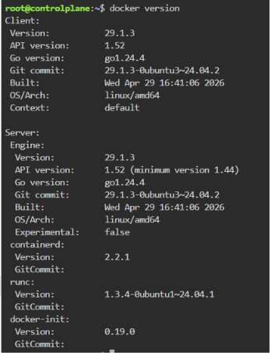
Screenshot 2: Docker Information Output
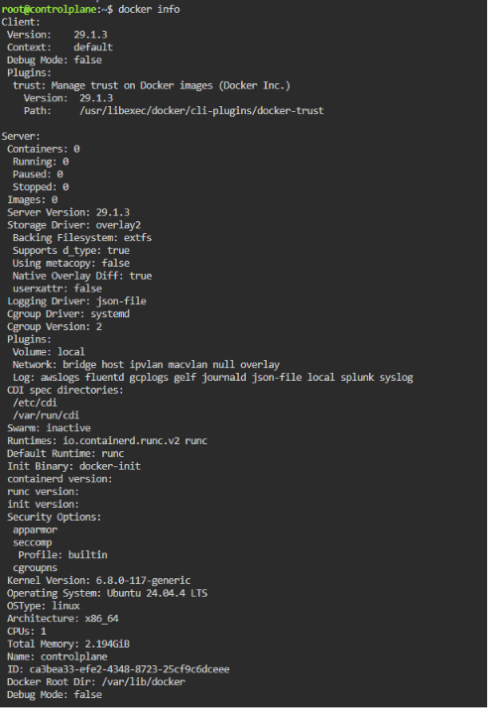


Step 2: Search Docker Images from Docker Hub

Command
docker search ubuntu

Working
This command searches Docker Hub repositories and displays available Ubuntu images along with descriptions and popularity ratings.

Screenshot
Screenshot 3: Docker Search Ubuntu
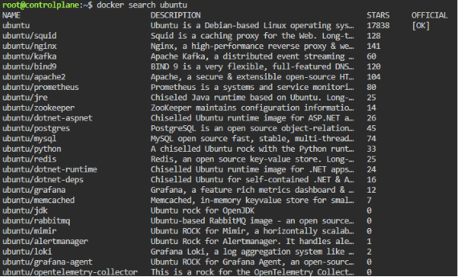

Step 3: Download Docker Images

Commands
docker pull ubuntu:22.04
docker pull centos:8
docker pull nginx
docker pull httpd
docker pull busybox
docker pull node
docker pull python
docker pull jenkins/jenkins:lts
docker pull mysql
docker pull phpmyadmin/phpmyadmin

Working
The docker pull command downloads images from Docker Hub to the local system.

Screenshot
Screenshot 4: Pull Ubuntu Image
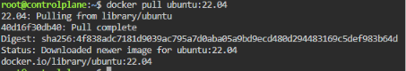
Screenshot 5: Pull CentOS Image
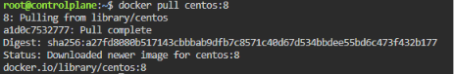
Screenshot 6: Pull Nginx Image
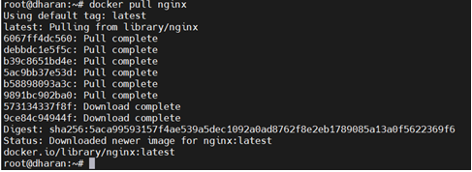

Screenshot 7: Pull HTTPD Image
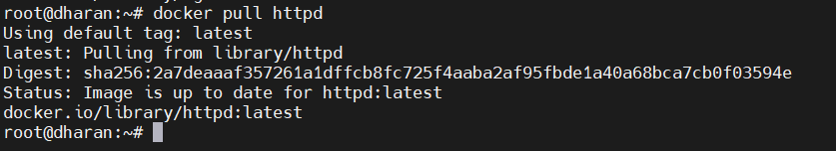
Screenshot 8: Pull BusyBox Image
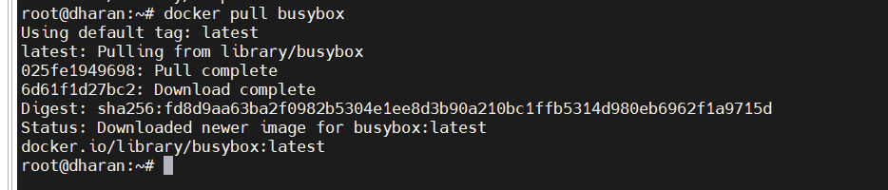
Screenshot 9: Pull Node Image
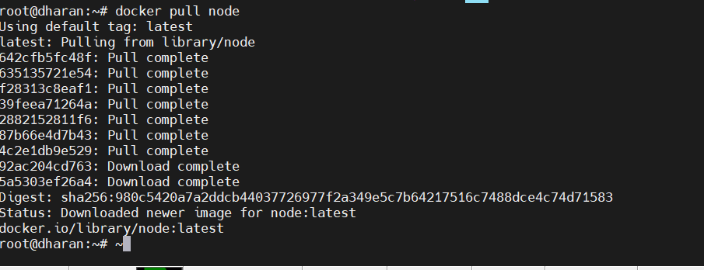
Screenshot 10: Pull Python Image
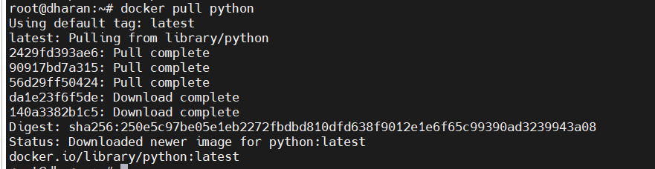

Screenshot 11: Pull Jenkins Image
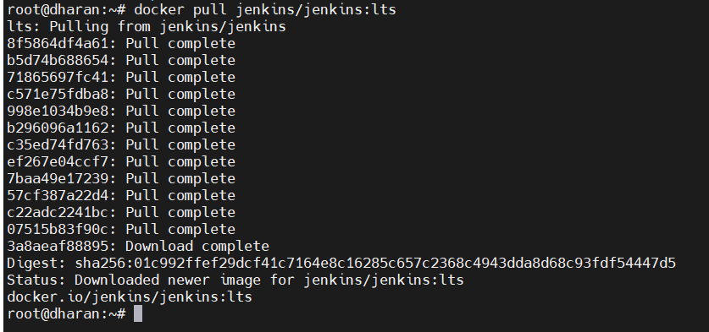
Screenshot 12: Pull MySQL Image
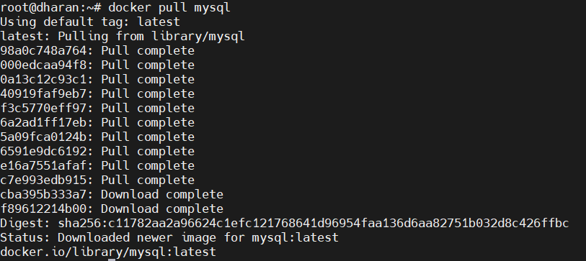
Screenshot 13: Pull phpMyAdmin Image
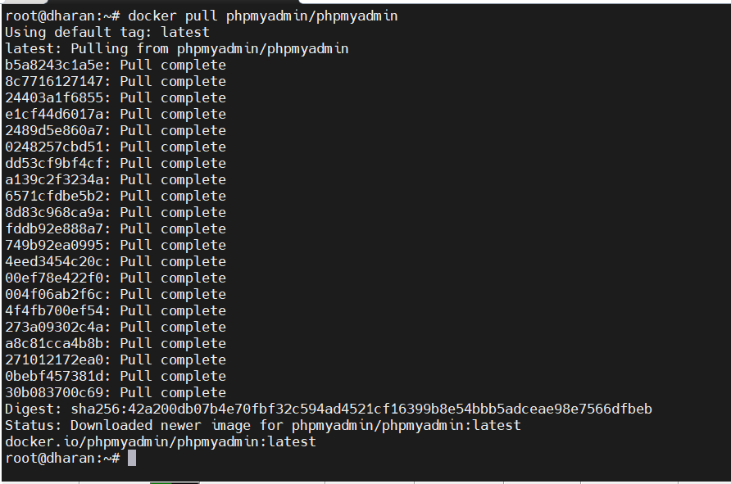

Step 4: View Downloaded Images

Command
docker images

Working
Displays all downloaded Docker images with Image ID, size, and repository details.

Screenshot
Screenshot 14: Docker Images List
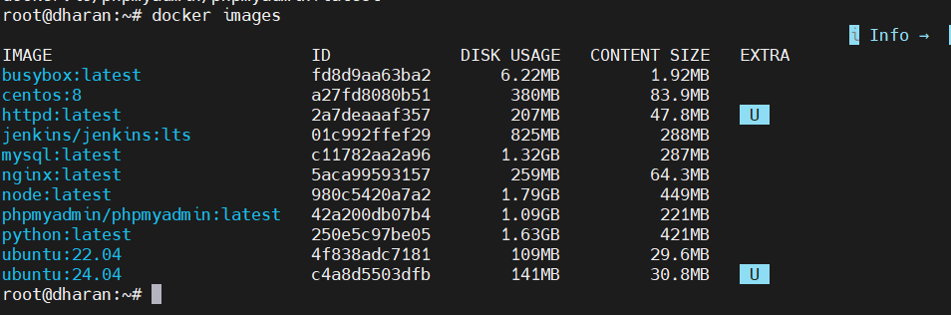

Step 5: Run an Nginx Container

Command
docker run -d --name nginx-container -p 8080:80 nginx

Working
- Creates a container named nginx-container.
- Maps host port 8080 to container port 80.
- Runs Nginx in detached mode.

Screenshot
Screenshot 15: Nginx Container Creation
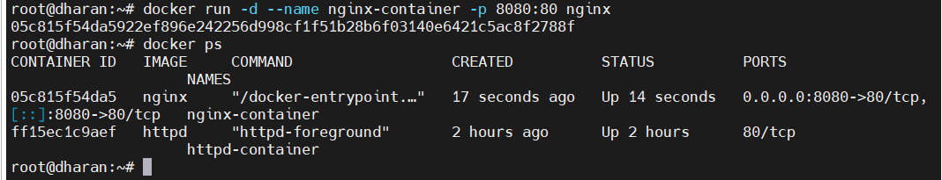

Step 6: Run an Apache HTTPD Container

Command
docker run -d --name httpd-container-new -p 8081:80 httpd

Working
Creates and runs an Apache HTTP Server container.

Screenshot
Screenshot 16: HTTPD Container Creation
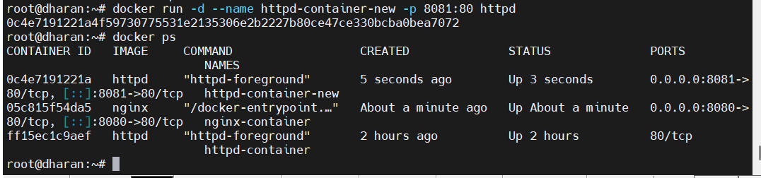

Step 7: Run a BusyBox Container

Command
docker run -dit --name busybox-container busybox

Working
Starts a lightweight Linux container in interactive detached mode.

Screenshot
Screenshot 17: BusyBox Container Creation
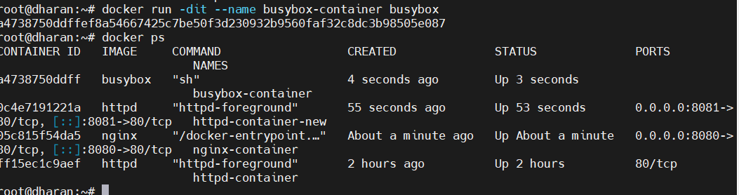

Step 8: Run a Node.js Container

Command
docker run -dit --name node-container node

Working
Creates a Node.js runtime container.

Screenshot
Screenshot 18: Node Container Creation
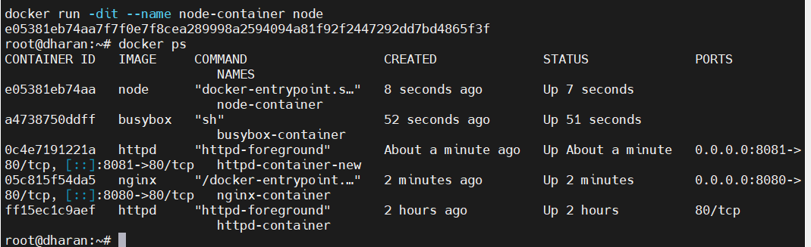

Step 9: Run a Python Container

Command
docker run -dit --name python-container python

Working
Creates a Python runtime container.

Screenshot
Screenshot 19: Python Container Creation
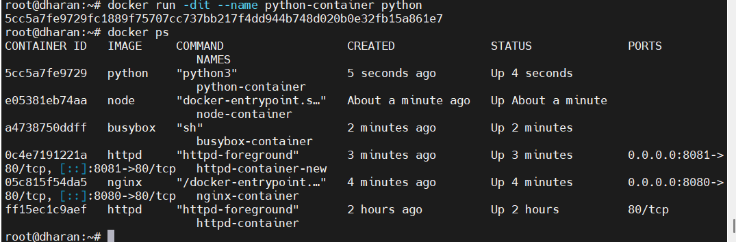

Step 10: Run Jenkins Container

Command
docker run -d --name jenkins-container -p 8082:8080 -p 50000:50000 jenkins/jenkins:lts

Working
Runs Jenkins CI/CD server with required port mappings.

Screenshot
Screenshot 20: Jenkins Container Creation
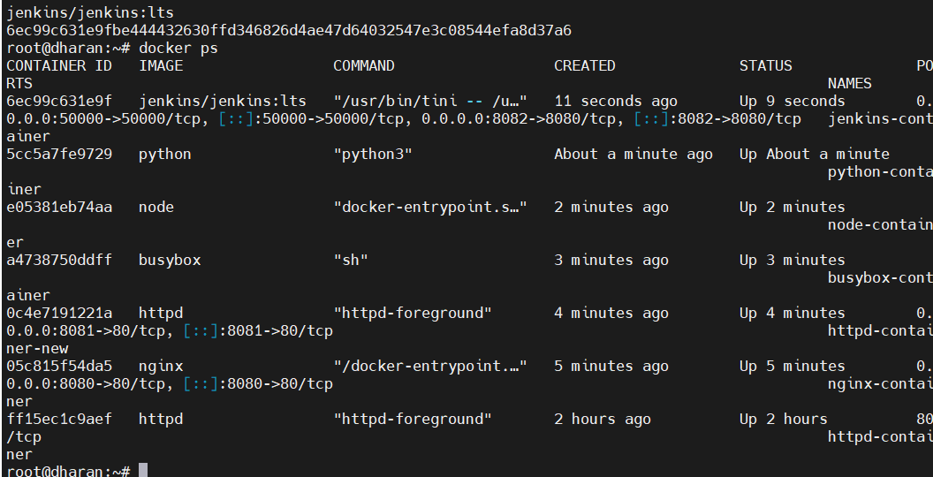

Step 11: Run MySQL Container

Command
docker run -d \
--name mysql-container \
-e MYSQL_ROOT_PASSWORD=root123 \
-p 3306:3306 \
mysql

Working
Creates a MySQL database server with root password configuration.

Screenshot
Screenshot 21: MySQL Container Creation
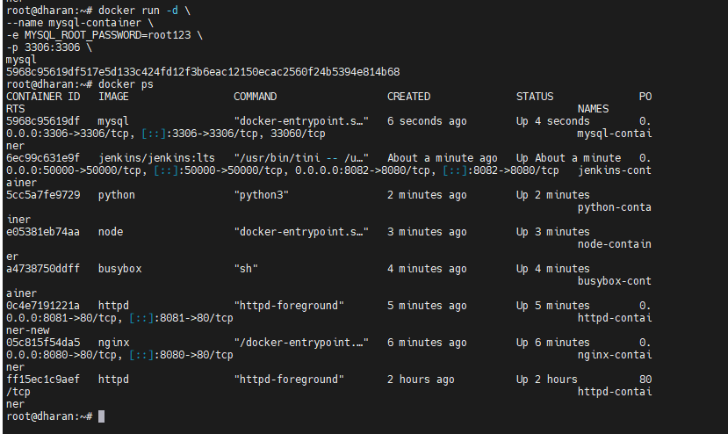

Step 12: Run phpMyAdmin Container

Command
docker run -d \
--name phpmyadmin-container \
--link mysql-container:db \
-p 8083:80 \
phpmyadmin/phpm yadmin

Working
Creates phpMyAdmin and connects it to the MySQL container.

Screenshot
Screenshot 22: phpMyAdmin Container Creation
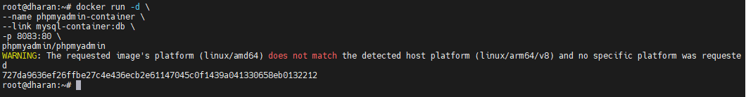

Step 13: View Running Containers

Commands
docker ps
docker ps -a
docker ps -l

Working
- docker ps → Running containers.
- docker ps -a → All containers.
- docker ps -l → Most recently created container.

Screenshot
Screenshot 23: Docker PS Output
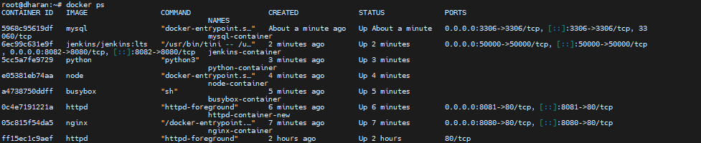
Screenshot 24: Docker PS -A Output
Screenshot 25: Docker PS -L Output

Step 14: Access Nginx Container

Command
docker exec -it nginx-container bash

Commands Executed Inside Container
hostname
pwd
ls
cat /etc/os-release
nginx -v

Working
Verifies:
- Container hostname
  - hostname
- Working directory
  - pwd
- File system
  - ls
- Operating System
  - cat /etc/os-release
- Nginx Version
  - Nginx -v

Screenshot
Screenshot 26: Nginx Container Inspection
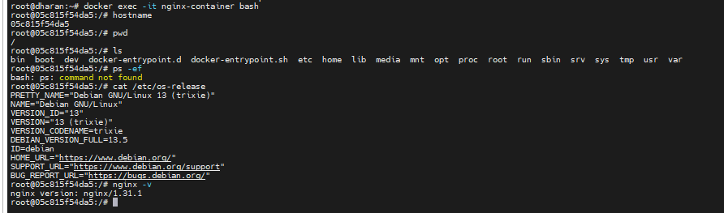

Step 15: Access Apache Container

Command
docker exec -it httpd-container-new bash

Commands Executed
hostname
httpd -v

Working
Checks Apache server details and container information.

Screenshot
Screenshot 27: Apache Container Inspection
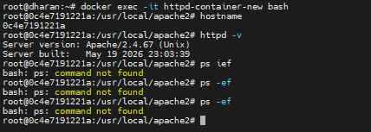

Step 16: Access BusyBox Container

Command
docker exec -it busybox-container sh

Commands Executed
hostname
pwd
ls
ps
date
uname -a
cat /etc/os-release

Working
Verifies BusyBox environment and system information.

Screenshot
Screenshot 28: BusyBox Container Inspection
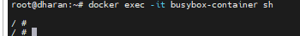
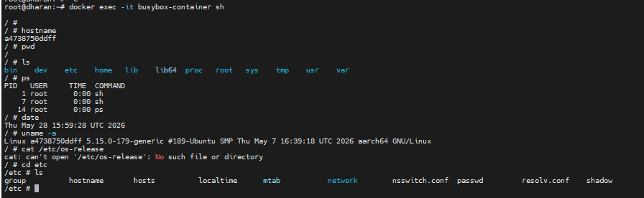

Step 17: Access Node Container

Command
docker exec -it node-container bash

Commands Executed
node -v
npm -v

Working
Checks installed Node.js and NPM versions.

Screenshot
Screenshot 29: Node Container Inspection
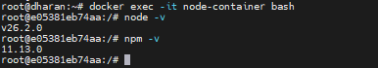

Step 18: Access Python Container

Command
docker exec -it python-container bash

Commands Executed
python --version
pip --version

Working
Verifies Python interpreter and package manager.

Screenshot
Screenshot 30: Python Container Inspection
root@dharan:~# docker exec -it python-container bash
root@5cc5a7fe9729:/#
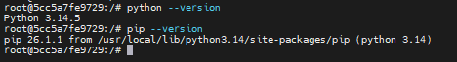

Step 19: Access Jenkins Container

Command
docker exec -it jenkins-container bash

Commands Executed
java -version
ps -ef

Working
Checks Java Runtime Environment and Jenkins process status.

Screenshot
Screenshot 31: Jenkins Container Inspection
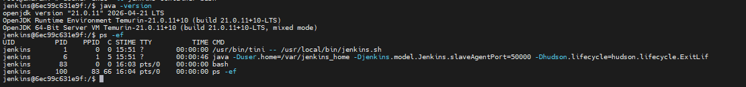

Step 20: Access MySQL Container

Command
docker exec -it mysql-container bash

Commands Executed
mysql -u root -p
show databases;

Working
Connects to MySQL server and displays available databases.

Screenshot
Screenshot 32: MySQL Login
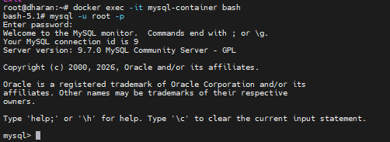
Screenshot 33: Show Databases Output
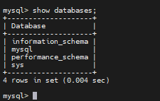
To Exit From mysql
Run:
exit
Then exit from the container also:
exit
After returning to:
root@dharan:~#
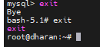

Step 21: View Container Logs

Commands
docker logs nginx-container
docker logs jenkins-container

Working
Displays application logs generated by containers.

Screenshot
Screenshot 34: Nginx Logs
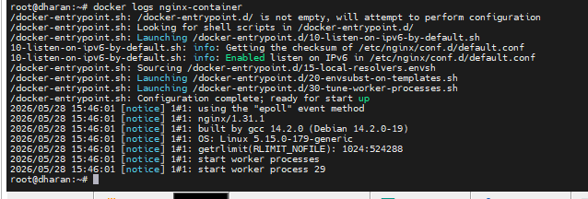

Screenshot 35: Jenkins Logs
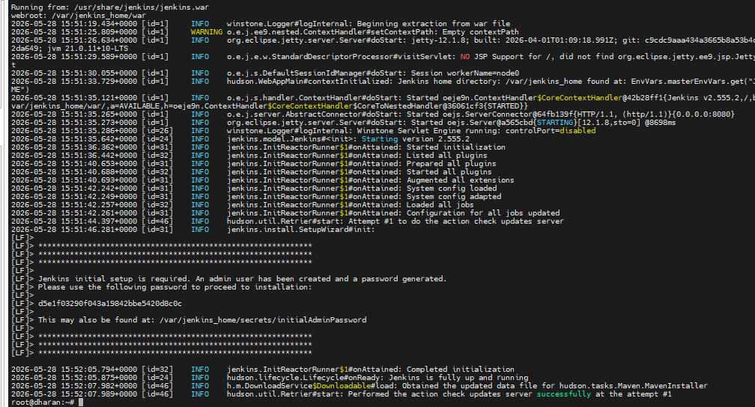

Step 22: Stop Containers

Commands
docker stop nginx-container
docker stop httpd-container-new

Working
Gracefully stops running containers.

Screenshot
Screenshot 36: Container Stop Operation
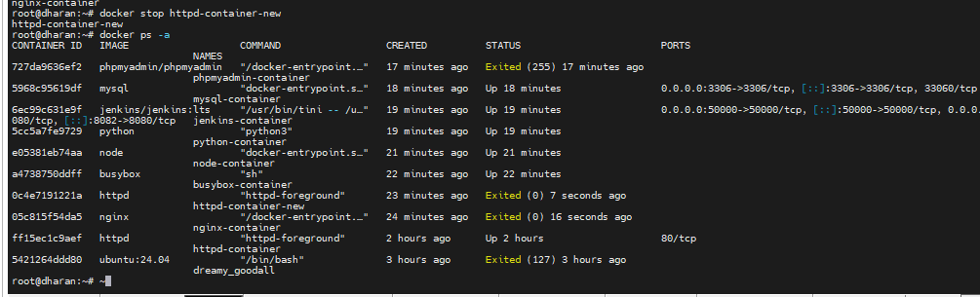

Step 23: Start Containers

Commands
docker start nginx-container
docker start httpd-container-new

Working
Restarts previously stopped containers.

Screenshot
Screenshot 37: Container Start Operation
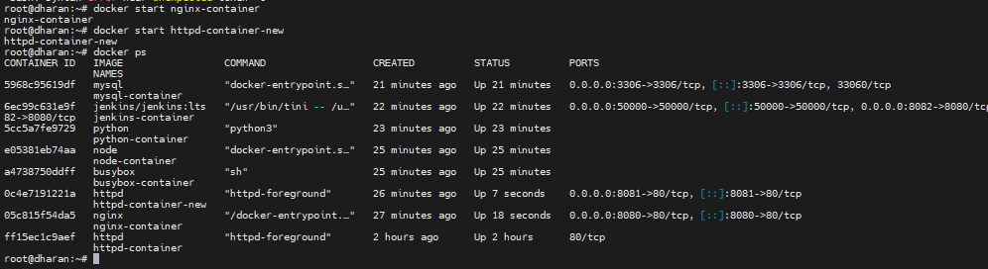

Step 24: Restart Container

Command
docker restart nginx-container

Working
Stops and starts the container in a single operation.

Screenshot
Screenshot 38: Container Restart Operation
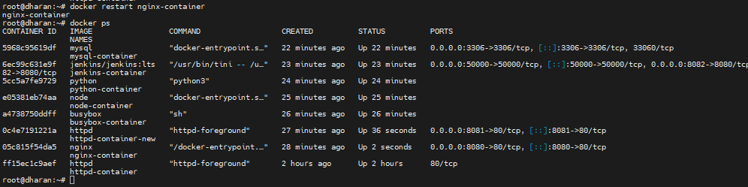

Step 25: Kill Container

Command
docker kill busybox-container

Working
Forcefully terminates the running container.

Screenshot
Screenshot 39: Container Kill Operation
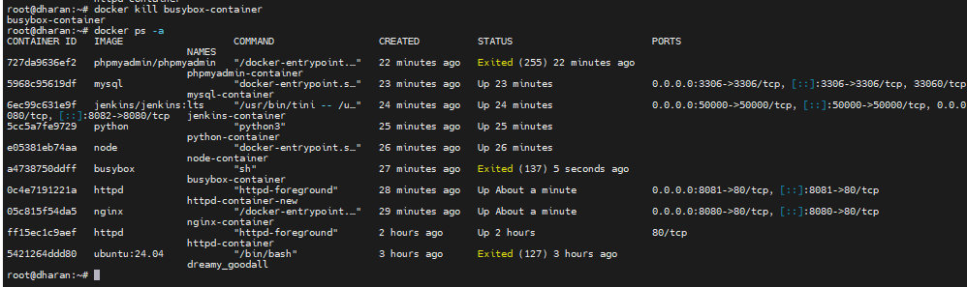

Step 26: Remove Containers

Commands
docker rm busybox-container
docker rm -f nginx-container httpd-container-new node-container
docker rm -f python-container

Working
Deletes containers from Docker host.

Screenshot
Screenshot 40: Remove Containers


Step 27: Remove Images

Commands
docker rmi nginx
docker rmi httpd busybox node python
docker rmi -f httpd

Working
Removes Docker images from local storage.

Screenshot
Screenshot 41: Remove Images
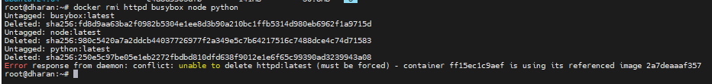
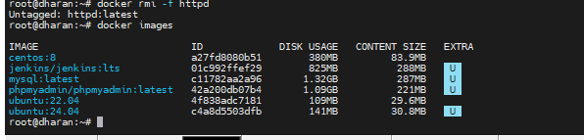

Step 28: Cleanup Docker Environment

Commands
docker container prune
docker image prune
docker system prune -a

Working
- Removes stopped containers.
- Removes unused images.
- Cleans Docker system resources.

Screenshot
Screenshot 42: Container Prune
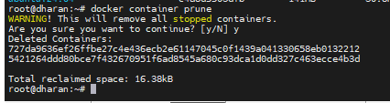
Screenshot 43: Image Prune
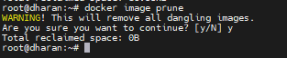
Screenshot 44: System Prune
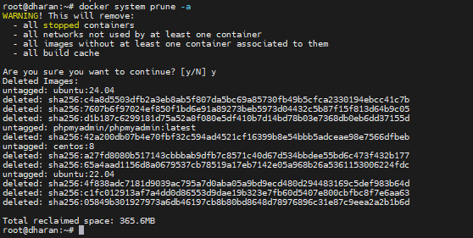

Result
Successfully performed Docker image management, container creation, execution, inspection, logging, lifecycle management, and Docker cleanup operations using various Docker commands on Ubuntu Linux.

