Port-mapping

- Nginx Website Deployment

docker run -d --name nginx-container -p 9090:80 nginx:latest

Open this url in browser
http:192.168.155.130:9090
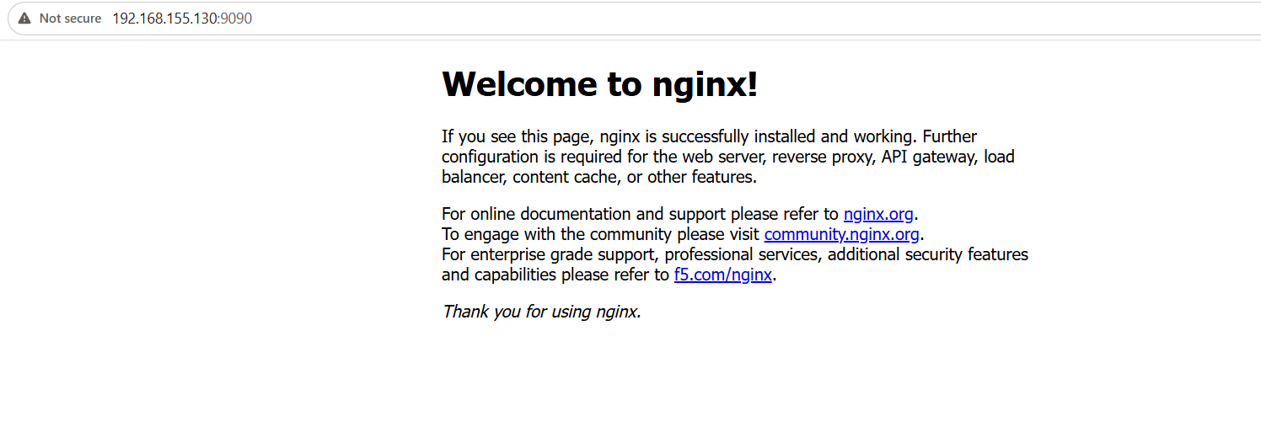

Login into Container Install Required Packages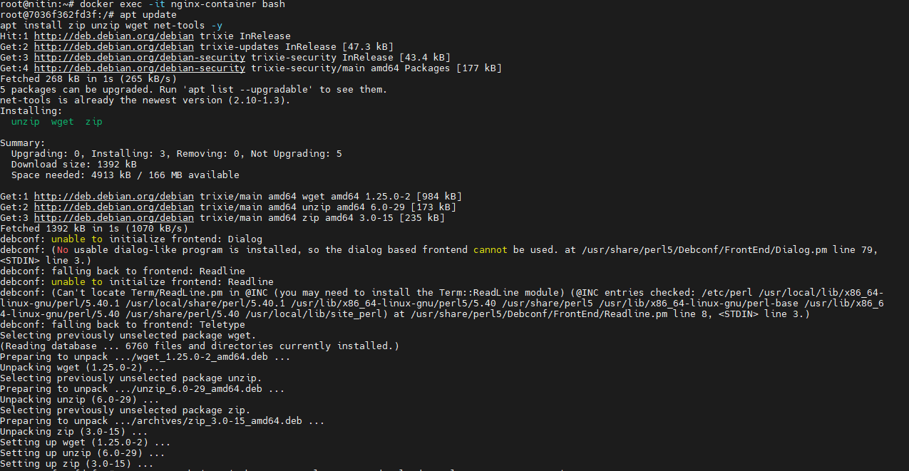
Download Frontend Website Template
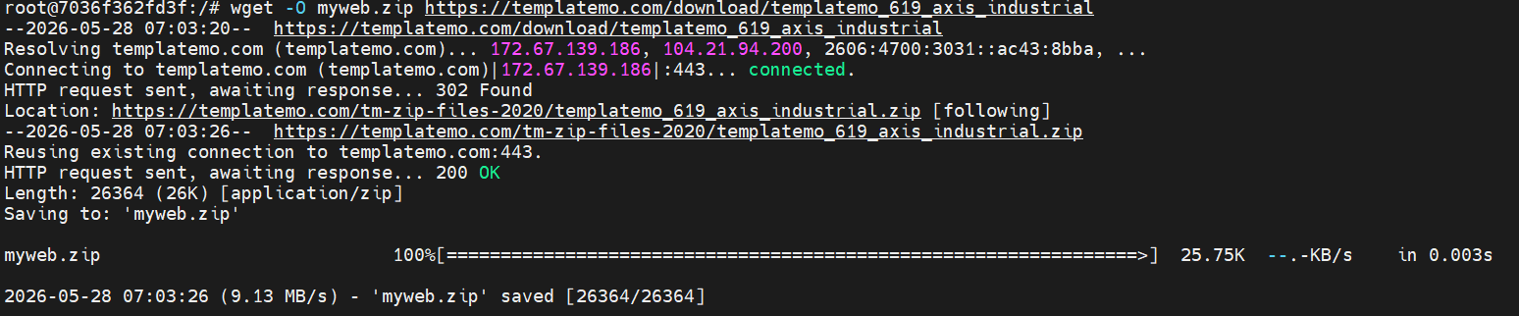

Unzip Website Files
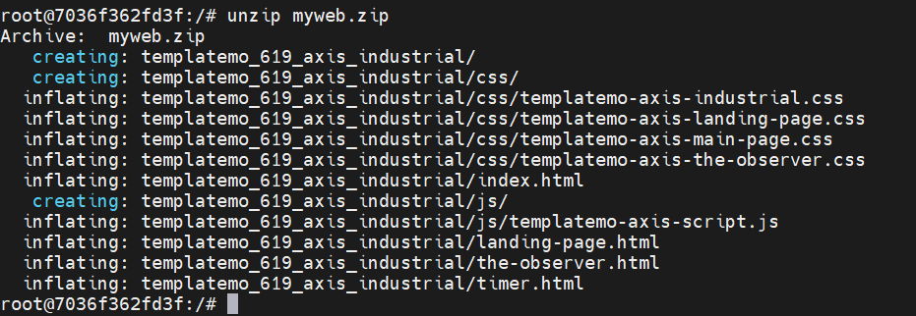

Verify Downloaded File

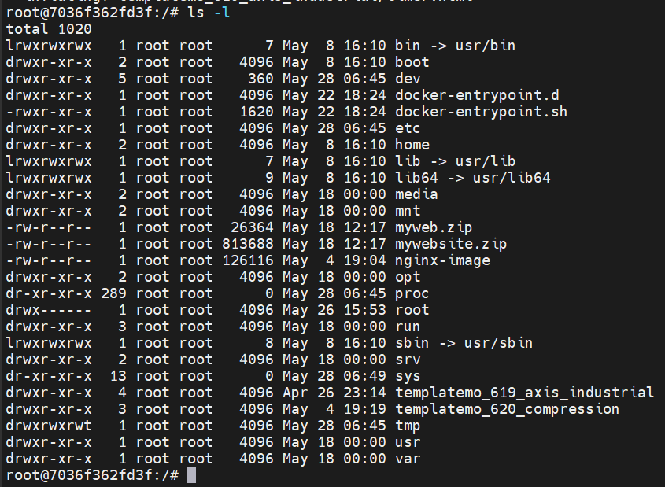

Copy Website Content to Nginx HTML Directory
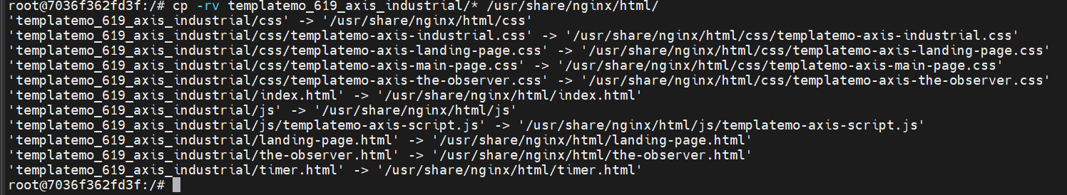

Exit container using exit command

Validate Website
Open browser:
http://<SERVER-IP>:8080


- Tomcat Application Deployment

Run Tomcat Container:
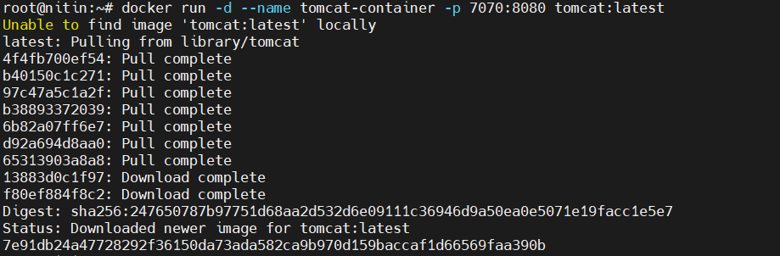

Verify

Access Tomcat
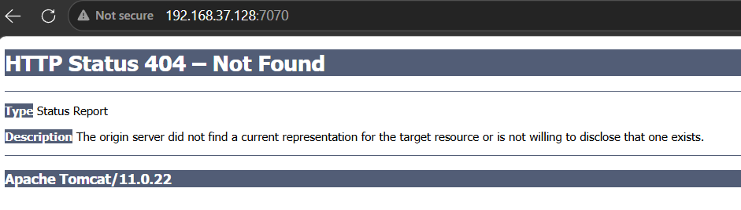

- PHP Website using PHP Apache Image

Run PHP Container
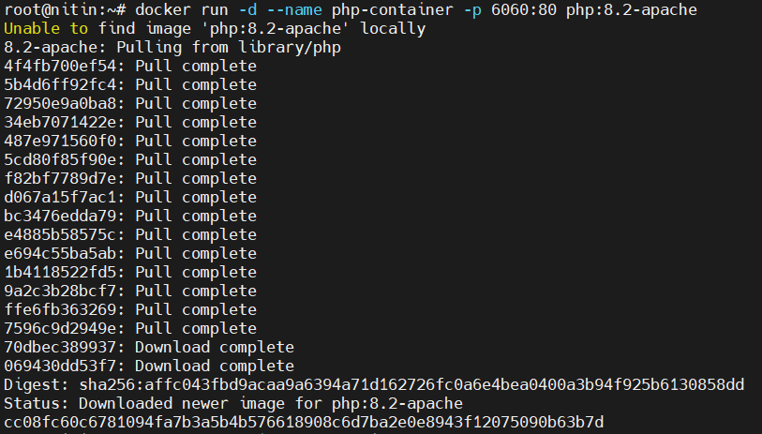
Login into Container
Create PHP File
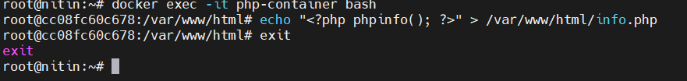

Access Browser
http://<SERVER-IP>:6060/info.php

