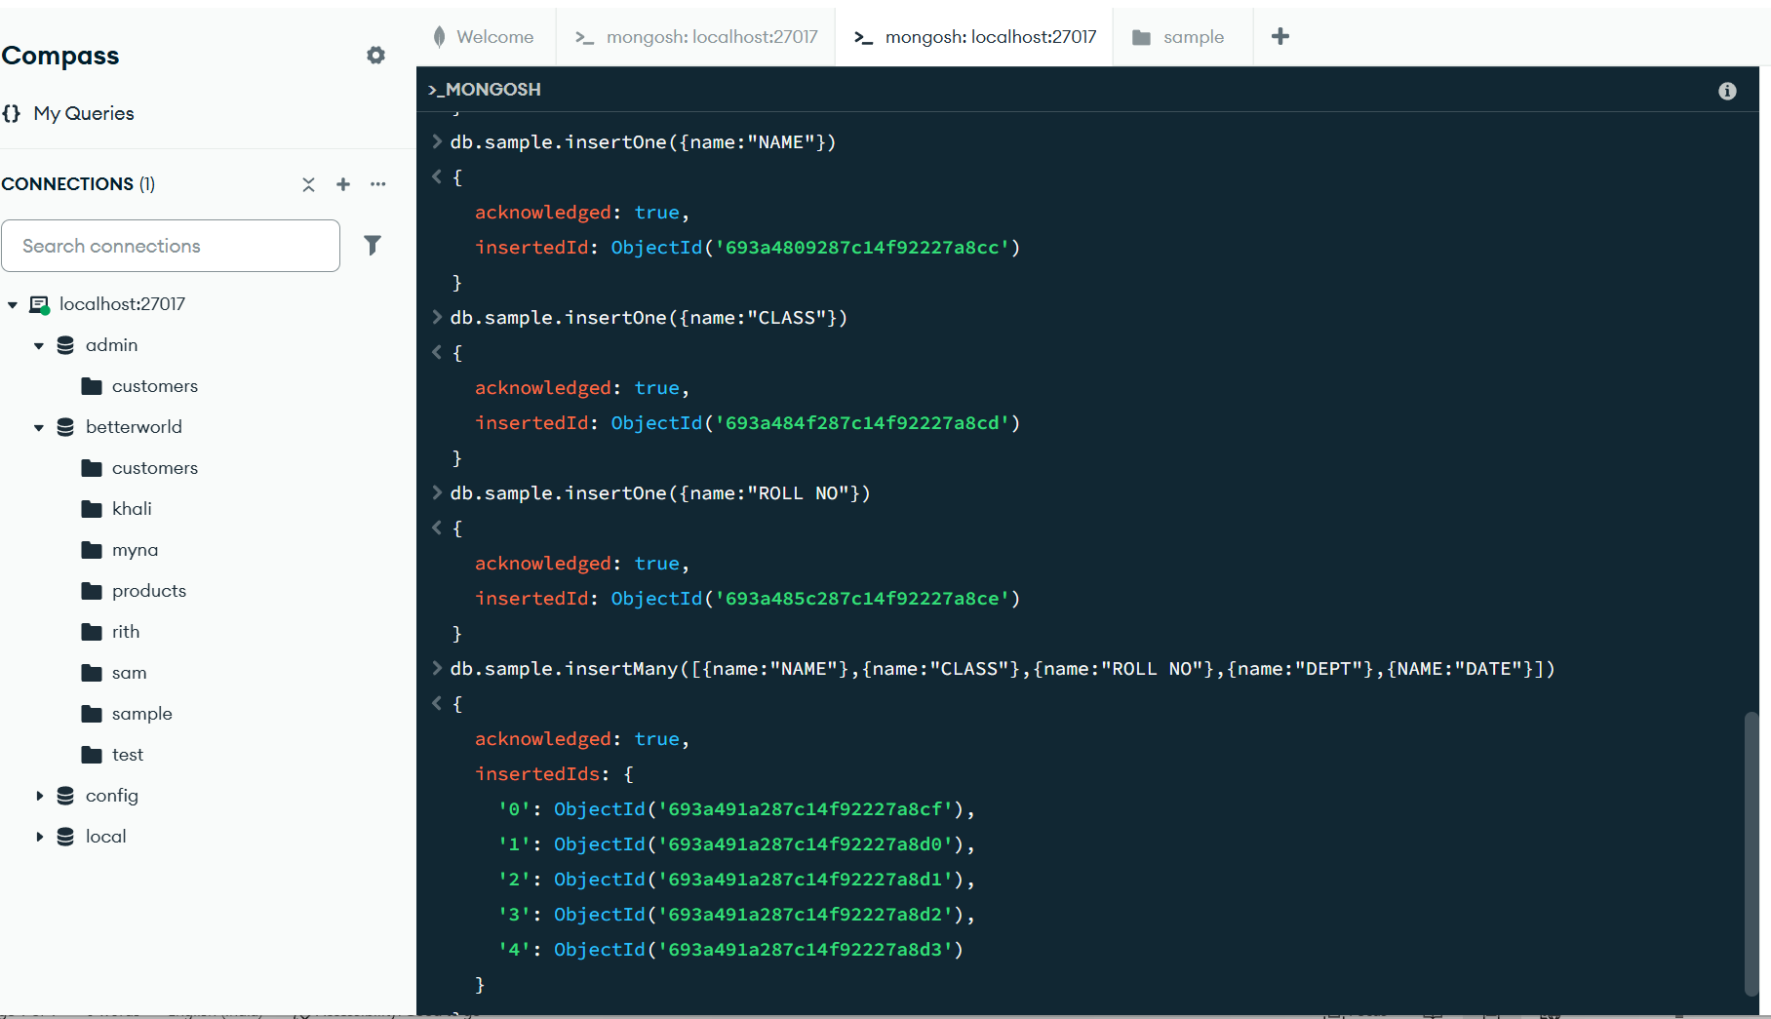

INSERT ONE- 3
INSERT MANY-5
db.sample.drop()-is use to delete the data base
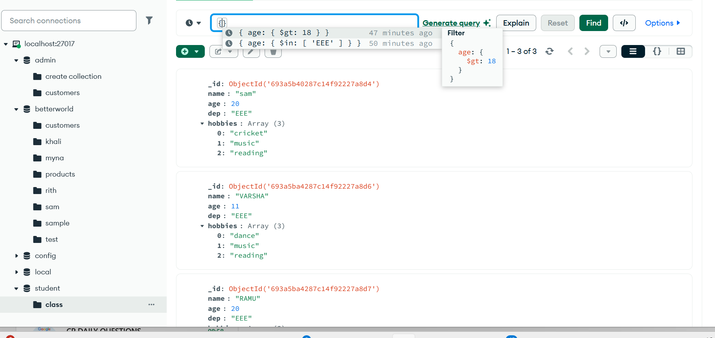
TAST 1

