MERN INTERNSHIP

MERN STANDS FOR:
M-MongoDb(To store the Data)
- Express.js(Backened usedfor the Server Side)
- React.js(forntened used for the client Side)
- Node.js(Running the js and it is the for the Backened)

MERN ARCHITECTURE:

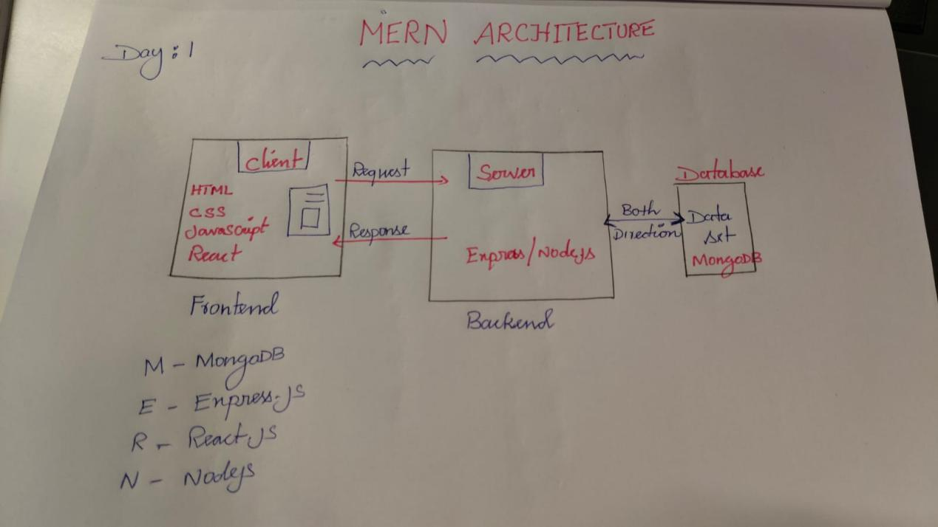

INSTALLATION:

- VS CODE(IDLE)
- MONGODB
- NODE.JS
- NPM
- VS EXTENTION-prettier code formatter,ESLint.

IN VS CODE :

Create folder :

Command:
npx create-react-app appname
(OR)
npm create vite

GIT HUB:
Git Push:
>>git init
>>git add .
>>git commit -m “First Commit”
>>git branch -M main
>>git remote add origin repo
>>git push -u origin main

