**SOFTWARE REQUIREMENTS SPECIFICATIONS**

**For**

**Car Rental System**

**Prepared by:-**

*Dharshini M V*

*Mageshwaran P*

*Mahima Tejeshwini R*

# Introduction

## Purpose

## The main objective of this document is to illustrate the requirements of the project Car Rental system. The document gives the detailed description of the both functional and non-functional requirements proposed by the client. The purpose of this project is to provide a friendly environment to maintain the details of books and library members. The main purpose of this project is to maintain easy circulation system using computers and to provide different reports. This project describes the hardware and software interface requirements using ER diagrams and UML diagrams.

## 1.2 Document Conventions

* + - Entire document should be justified.
    - Convention for Main title

Font face: Times New Roman Font style: Bold

Font Size: 14

* + - Convention for Sub title

Font face: Times New Roman Font style: Bold

Font Size: 12

* + - Convention for body

Font face: Times New Roman Font Size: 12

## Scope of Development Project

The Car Rental Management System, an advanced application designed to revolutionize traditional car rental processes into a web-based platform. This comprehensive system offers a user-friendly interface for both administrators and customers, facilitating efficient management of vehicle details, reservations, and billing. Users can easily reserve cars, access detailed vehicle information, and receive transparent invoices, all while having a clear overview of rental durations and pricing. Developed in Java, the system ensures cross-platform compatibility, cost-effectiveness, and a streamlined development process. Its modular and scalable design allows for easy customization and addition of new features, making it adaptable to various scenarios and environments. Ideal for car rental businesses, this system promotes user account management, enabling customers to monitor their accounts, track reservations, and view transaction history seamlessly.

## Definitions, Acronyms and Abbreviations

JAVA -> platform independence SQL-> Structured query Language ER-> Entity Relationship

UML -> Unified Modeling Language

IDE-> Integrated Development Environment SRS-> Software Requirement Specification

## References

* + - Books
    - Software Requirements and Specifications: A Lexicon of Practice, Principles and Prejudices (ACM Press) by Michael Jackson
    - Software Requirements (Microsoft) Second EditionBy Karl E. Wiegers
    - Software Engineering: A Practitioner’s Approach Fifth Edition By Roger S. Pressman
    - Websites
* **https://istatement.esqbs.ac.id/index.php/istatement/article/view/284**
* [jurnal.darmajaya.ac.id/index.php/icitb/article/viewFile/2502/1283](https://jurnal.darmajaya.ac.id/index.php/icitb/article/viewFile/2502/1283)

# Overall Descriptions

## Product Perspective

Use Case Diagram of Car Rental System.

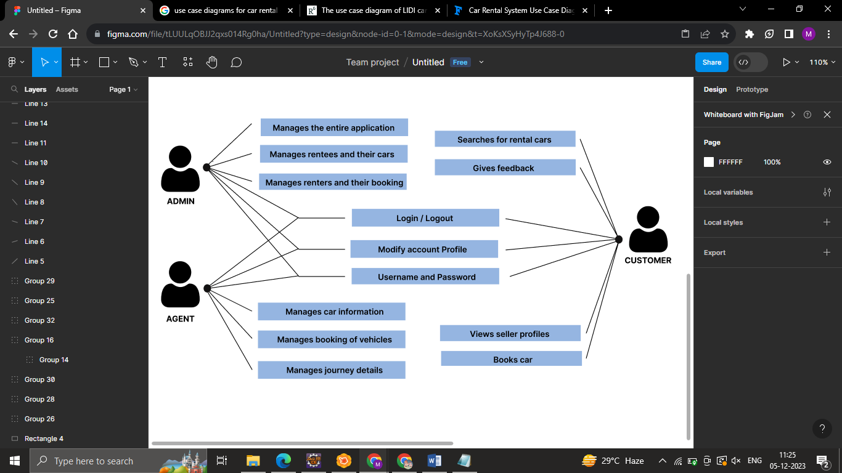

This is a broad level diagram of the project showing a basic overview. The users can be anyone who are willing to rent a car. This System will provide a search functionality to facilitate the search of resources. This search will be based on various categories viz pick up point, destination, date and day of requirement, etc. Further the admin can add/update the resources and the resource users from the system. The users of the system can book rental cars based on their needs, also owners of cars can rent their vehicles based on certain criteria.

## Product Function

Entity Relationship Diagram of Car Rental System

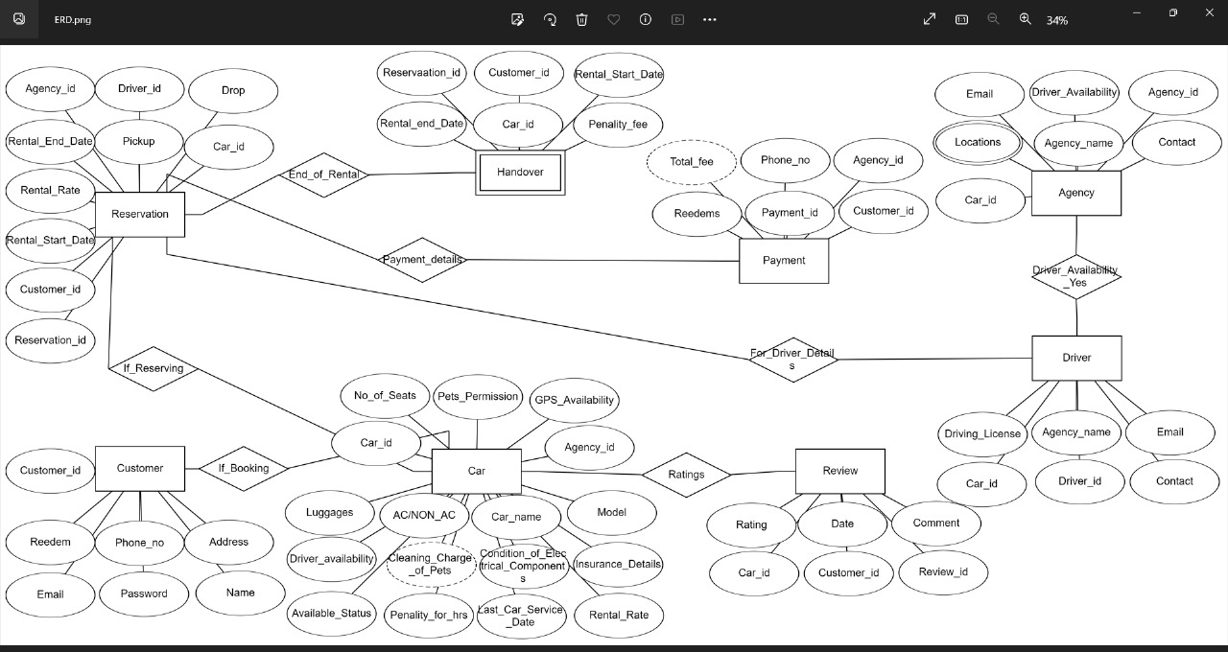

The Car Rental Management System offers real-time information on available cars and user details, streamlining manual processes. The primary goal is to enhance efficiency. The software efficiently handles Car Reservations, Returns, Fine Calculation/Management, and Report Generation to meet user needs. The system designates the Rental Administrator as the key authority, overseeing member activities and book management.

**Key features include:**

Car Reservation and Returns: Allows users to book and return cars seamlessly.

Fine Calculation/Management: Manages fines associated with late returns or damages.

Report Generation: Generates various reports for effective record-keeping.

Administrator Control: Empowers the rental administrator to manage both members and cars.

Database Maintenance: Records and maintains member's issue/return status.

Member Details Retrieval: Enables librarians to retrieve member details from the database as needed.

Member Account Viewing: Authorizes valid members to view their account information.

Permission for pets: Users can check for pet permission options too.

Redeem discounts: Implements attractive discounts and offers for customers.

## User Classes and Characteristics

The system provides different types of services based on the type of users [Renters/Rentees]. The Admin will be acting as the controller and he will have all the privileges of an administrator. The user can be either a renter or rentee, who will be accessing the car rental system.

The features that are available to the Admin are:-

* Can manage user accounts, both rentees and renters
* Can oversee and manage the listings of available vehicles
* Can monitor financial transactions related to rentals
* Can configure system settings and parameters
* Serve as a central communication hub, facilitating communication between rentees and renters
* Can verify the authenticity of vehicle listings and user accounts.
* Can implement promotions, discounts, or special offers to attract users
* Provide support and assistance to users

The features that are available to the Rentees are:-

* Can Specify Rental Terms
* Can View Renter Feedback
* Can List Available Vehicles
* Can Manage Rental Schedule
* Can Monitor Rental Transactions
* Can Communicate with Renters

The features that are available to the Renters are:-

* Can View Available Vehicle Categories
* Can Create and Manage an Account
* Can View Reserved Vehicles
* Can Provide Feedback and Reviews
* Can view rental history
* Can Search for a Specific Vehicle

## Operating Environment

The product will be operating in windows environment. The Library Management System is a website and shall operate in all famous browsers, for a model we are taking Microsoft Internet Explorer, Google Chrome, and Mozilla Firefox. Also it will be compatible with the IE 6.0. Most of the features will be compatible with the Mozilla Firefox & Opera 7.0 or higher version. The only requirement to use this online product would be the internet connection.

The hardware configuration include Hard Disk: 40 GB, Monitor: 15” Color monitor, Keyboard: 122 keys. The basic input devices required are keyboard, mouse and output devices are monitor, etc. If logged in with mobile, then that is enough.

## Assumptions and Dependencies

The assumptions are:-

* The coding should be error free
* The system should be user-friendly so that it is easy to use for the users
* The information of all users, renters and rentees, cars must be stored in a database that is accessible by the website
* The system should have more storage capacity and provide fast access to the database
* The system should provide search facility and support quick transactions
* The Car Rental System is running 24x7
* Users may access from any computer or mobile that has Internet browsing capabilities and an Internet connection
* Users must have their correct usernames and passwords to enter into their online accounts and do actions.

## Assumptions and Dependencies

The assumptions are:-

* The coding should be error free
* The system should be user-friendly so that it is easy to use for the users
* The information of all users, renters and rentees, cars must be stored in a database that is accessible by the website
* The system should have more storage capacity and provide fast access to the database
* The system should provide search facility and support quick transactions
* The Car Rental System is running 24x7
* Users may access from any computer or mobile that has Internet browsing capabilities and an Internet connection
* Users must have their correct usernames and passwords to enter into their online accounts and do actions

The dependencies are:-

* The specific hardware and software due to which the product will be run
* On the basis of listing requirements and specification the project will be developed and run
* The end users (renters/rentees) should have proper understanding of the product
* The system should have the general report stored
* The information of all the users must be stored in a database that is accessible by the Car Rental System
* Any update regarding the car from the rentee is to be recorded to the database by the admin and the data entered should be correct

## Requirement

Software Configuration:-

This software package is developed using java as front end which is supported by sun micro system. Microsoft SQL Server as the back end to store the database.

Operating System: Windows

Language: Java Runtime Environment (front end)

Database: MS SQL Server (back end)

Hardware Configuration:-

Processor: Intel Core

Hard Disk: 40GB or more

RAM: 16 GB or more

## Data Requirement

The inputs consist of the query to the database and the output consists of the solutions for the query. The output also includes the user receiving the details of their accounts. In this project the inputs will be the queries as fired by the users like create an account, selecting rental cars and booking them for renters while for rentees it will be uploading proper vehicle information, applying terms and conditions, etc. Now the output will be visible when the user requests the server to get details of their account in the form of time, date and their rental history.

# External Interface Requirement

## GUI

The software provides good graphical interface for the user and the administrator can operate on the system, performing the required task such as create, update, viewing the details of the rental cars.

* It allows user to view quick reports like Car booked/Returned in between particular time.
* It provides availability of cars and search facility based on different criteria.
* The user interface must be customizable by the administrator
* All the modules provided with the software must fit into this graphical user interface and accomplish to the standard defined
* The design should be simple and all the different interfaces should follow a standard template
* The user interface should be able to interact with the user management module and a part of the interface must be dedicated to the login/logout module

Login Interface:

In case the user (renter/rentee) is not yet registered, he can enter the details and register to create his account. Once his account is created he can ‘Login’ which asks the user to type his username and password. If the user entered either his username or password incorrectly then an error message appears.

Search and Categories View:

The renter can enter the pickup location, drop location and the time and date of requirement he is looking for. Categories view shows the categories of rental cars available and provides ability to the admin to add/edit or delete category from the list.

Admin’s Control Panel:

This control panel will allow admin to add/remove users, add, edit, or remove a resource. And manage lending options.

# System Features

The users of the system should be provided the surety that their account is secure. This is possible by providing:-

* User authentication and validation of members using their email and mobile number.
* Proper monitoring by the administrator which includes updating account status, showing a popup if the renter exceeds the limit provided by the rentee policy, assigning fine to renters who skip the date of return
* Proper accountability which includes not allowing a renter to see other renter’s account. Only administrator will see and manage all member accounts

# Other Non-functional Requirements

## Performance Requirement

The proposed system that we are going to develop will be used as the Chief performance system. Therefore, it is expected that the database would perform functionally all the requirements that are specified by the admin.

* The performance of the system should be fast and accurate
* Car Rental System shall handle expected and non-expected errors in ways that prevent loss in information and long downtime period. Thus it should have inbuilt error testing to identify invalid username/password
* The system should be able to handle large amount of data. Thus it should accommodate high number of renters and rentees without any fault.

**5.2 SafetyRequirements**

The database may get crashed at any certain time due to virus or operating system failure. Therefore, it is required to take the database backup so that the database is not lost. Proper UPS/inverter facility should be there in case of power supply failure.

## Security Requirement

* + - System will use secured database
    - Normal users can just read information but they cannot edit or modify anything except their personal and some other information.
    - System will have different types of users and every user has access constraints
    - Proper user authentication should be provided
    - No one should be able to hack users’ password
    - There should be separate accounts for admin and members such that no member can access the database and only admin has the rights to update the database.

## Requirement attributes

* There may be multiple admins creating the project, all of them will have the right to create changes to the system. But the members or other users cannot do changes
* The project should be open source
* The Quality of the database is maintained in such a way so that it can be very user friendly to all the users of the database
* The user be able to easily download and install the system

## Business Rules

A business rule is anything that captures and implements business policies and practices. A rule can enforce business policy, make a decision, or infer new data from existing data.This includes the rules and regulations that the System users should abide by. This includes the cost of the project and the discount offers provided. The users should avoid illegal rules and protocols. Neither admin nor member should cross the rules and regulations.

## User Requirement

The users of the system are customers (renters), vehicle owners (rentees) and admin who act as administrator to maintain the system. The renters and rentees are assumed to have basic knowledge of the computers and internet browsing. The administrators of the system should have more knowledge of the internals of the system and is able to rectify the small problems that may arise due to disk crashes, power failures and other catastrophes to maintain the system. The proper user interface, user manual, online help and the guide to install and maintain the system must be sufficient to educate the users on how to use the system without any problems.

The admin provides certain facilities to the users in the form of:-

* Forgot Password
* Data migration i.e. whenever user registers for the first time then the data is stored in the server
* Data replication i.e. if the data is lost in one branch, it is still stored with the server
* Maintaining files i.e. File Organization
* The server must be maintained regularly and it has to be updated from time to time

# Other Requirements

## Data and Category Requirement

There are different categories of users namely Admin, Renters, Rentees, etc. Depending upon the category of user the access rights are decided. It means if the user is an administrator then he can be able to modify the data, delete, append etc. All other users except the Admin only have the rights to retrieve the information about database. Similarly there will be different categories of rental cars available. According to the categories of cars their relevant data should be displayed. The categories and the data related to each category should be coded in the particular format.

## Appendix

A: Admin, Abbreviation, Acronym, Assumptions; B: Books, Business rules; C: Class, Client, Conventions; D: Data requirement, Dependencies; G: GUI; K: Key; L: Library, Librarian; M: Member; N: Non-functional Requirement; O: Operating environment; P: Performance, Perspective, Purpose; R: Requirement, Requirement attributes; S: Safety, Scope, Security, System features; U: User, User class and characteristics, User requirement;

## Glossary

The following are the list of conventions and acronyms used in this document and the project as well:

* Administrator: A login id representing a user with admin privileges to the software
* User: A general login id assigned to most users
* Client: Intended users for the software
* SQL: Structured Query Language; used to retrieve information from a database.
* SQL Server: A server used to store data in an organized format
* Layer: Represents a section of the project
* User Interface Layer: The section of the assignment referring to what the user interacts with directly
* Application Logic Layer: The section of the assignment referring to the Web Server. This is where all computations are completed
* Data Storage Layer: The section of the assignment referring to where all data is recorded
* Use Case: A broad level diagram of the project showing a basic overview
* Class diagram: It is a type of static structure diagram that describes the structure of a system by showing the system’s cases, their attributes, and the relationships between the classes
* Interface: Something used to communicate across different mediums
* Unique Key: Used to differentiate entries in a database

## Class Diagram

A class is an abstract, user-defined description of a type of data. It identifies the attributes of the data and the operations that can be performed on instances (i.e. objects) of the data. A class of data has a name, a set of attributes that describes its characteristics, and a set of operations that can be performed on the objects of that class. The classes’ structure and their relationships to each other frozen in time represent the static model. In this project there are certain main classes which are related to other classes required for their working. There are different kinds of relationships between the classes as shown in the diagram like normal association, aggregation, and generalization. The relationships are depicted using a role name and multiplicities. Here ‘Admin’, ‘Renters’ and ‘Rentees’ are the most important classes which are related to other classes.

