SOFTWARE REQUIREMENTS SPECIFICATION

**For**

**Event Management System**

**Prepared by:**

*Vishnu Ram M*

*Bharath S M*

*Darshan R A*

# Introduction

## Purpose

## The purpose of this Software Requirements Specification (SRS) document is to outline the requirements and specifications for the development of an Event Management System. The objective is to create a system that efficiently manages events, encompassing registrations, schedules, and ticket sales. The key users of this system comprise event organizers, attendees, check-in staff, and administrators. Furthermore, the system facilitates improved communication between organizers and attendees, enhancing the overall experience. Incorporating features such as data analysis and reporting, the EMS empowers organizers to make informed decisions and implement enhancements for future events.

## Document Conventions

* + - Entire document should be justified.
    - Convention for Main title

Font face: Times New Roman Font style: Bold

Font Size: 14

* + - Convention for Sub title

Font face: Times New Roman Font style: Bold

Font Size: 12

* + - Convention for body

Font face: Times New Roman Font Size: 12

## Scope of Development Project

## The goal of the Event Management System project is to establish an online platform facilitating smooth event planning and participation. This platform will furnish event organizers with tools for creating, scheduling, and promoting events, while enabling attendees to register and buy tickets. The system will incorporate functionalities like ticket scanning, check-in, and reporting. Notably, it is crafted to be flexible, allowing for easy modifications and future enhancements. The development will leverage Java due to its benefits in performance, cross-platform compatibility, and development tools.

## Definitions, Acronyms and Abbreviations

JAVA -> platform independence SQL-> Structured query Language ER-> Entity Relationship

UML -> Unified Modeling Language

IDE-> Integrated Development Environment SRS-> Software Requirement Specification

## References

* + - Books

 Software Requirements and Specifications: A Lexicon of Practice, Principles and Prejudices (ACM Press) by Michael Jackson

Software Requirements (Microsoft) Second Edition By Karl E. Wiegers

Software Engineering: A Practitioner’s Approach Fifth Edition By Roger S. Pressman

* + - Websites

[**http://www.slideshare.net/**](http://www.slideshare.net/)

[**http://ebookily.net/doc/srs-Event-management-system**](http://ebookily.net/doc/srs-library-management-system)

# Overall Descriptions

## Product Perspective

Use Case Diagram of Event Management System

This is a high-level diagram of the event management system, offering a foundational overview. Users can fall into categories such as staff or attendees. The system incorporates a search functionality to simplify the exploration of events. The search criteria encompass various categories, including event names or specific identifiers. Additionally, event organizers can add/update events and manage attendees through the system. System users have the capability to request event registration, renewal, or withdrawal, subject to specific criteria.

## Product Function

Entity Relationship Diagram of Event Management System

The Event Management System provides instant access to real-time information regarding available events and user details, with the core objective of minimizing manual efforts. This software is proficient in handling event registrations, participant attendance, fee calculations, and generating reports tailored to user specifications. The Event Organizer functions as the administrator, overseeing participants and managing event logistics. The system records the status of participant registrations and attendance, allowing the Organizer to retrieve information as required. Furthermore, authorized participants have the capability to view their account information within the system.

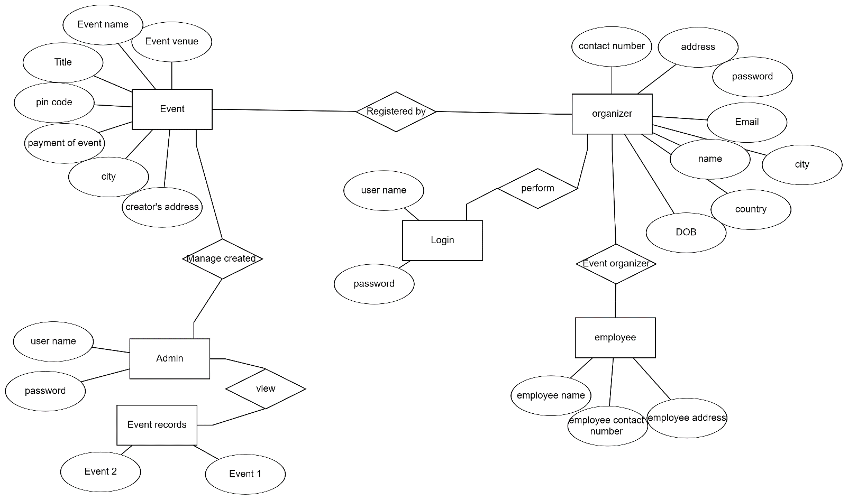

## User Classes and Characteristics

The Event Management System provides distinct services based on user types [Organizer/Attendee]. Organizers, functioning as controllers, have administrator privileges, while attendees, who can be participants or staff involved in event planning, access the system online.

Features available to Organizers include:

* Issuing invitations to attendees
* Viewing different event categories
* Accessing the list of events within each category
* Managing returned resources from attendees
* Adding events and related information to the database
* Editing details of existing events
* Generating reports on existing events
* Checking reports on issued tickets
* Accessing all attendee accounts

Features available to Attendees include:

* Viewing different event categories
* Accessing the list of events within each category
* Creating an account in the event system
* Viewing the events, they have registered for
* Requesting participation in new events
* Reviewing the history of past event participations
* Searching for specific events

## Operating Environment

The product will be operating in windows environment. The Event Management System is a website and shall operate in all famous browsers, for a model we are taking Microsoft Internet Explorer, Google Chrome, and Mozilla Firefox. Also it will be compatible with the IE 6.0. Most of the features will be compatible with the Mozilla Firefox & Opera 7.0 or higher version. The only requirement to use this online product would be the internet connection.

The hardware configuration includes Hard Disk: 40 GB, Monitor: 15” Color monitor, Keyboard: 122 keys. The basic input devices required are keyboard, mouse and output devices are monitor, printer etc.

## Assumptions and Dependencies

The assumptions are:

* + - The coding should be error free
    - The system should be user-friendly so that it is easy to use for the users
    - The system should have more storage capacity and provide fast access to the database
    - The system should provide search facility and support quick transactions
    - The Event System is running 24 hours a day
    - Users may access from any computer that has Internet browsing capabilities and an Internet connection
    - Users must have their correct usernames and passwords to enter into their online accounts and do actions

The dependencies are:

* + - The specific hardware and software due to which the product will be run
    - On the basis of listing requirements and specification the project will be developed and run
    - The end users (admin) should have proper understanding of the product
    - The system should have the general report stored
    - The information of all the users must be stored in a database that is accessible by the Event System
    - Any update regarding the booking from the Event is to be recorded to the database and the data entered should be correct

## Requirement

Software Configuration:

This software package is developed using java as front end which is supported by sun micro system. Microsoft SQL Server as the back end to store the database.

Operating System: Windows NT, windows 98, Windows XP Language: Java Runtime Environment, Net beans 7.0.1 (front end) Database: MS SQL Server (back end)

Hardware Configuration:

Processor: Pentium(R)Dual-core CPU Hard Disk: 40GB

RAM: 256 MB or more

## Data Requirement

## The Event Management system incorporates vital event details, such as names, descriptions, dates, and locations. Seamless attendee management relies on essential attendee data, encompassing names, contact information, preferences, and registration history. For secure and transparent financial processes, the system manages financial transactions data, including payment information, transaction history, and receipts. Effective event promotion is supported through promotional data, integrating social media, discounts, and marketing campaign details. Additionally, the system prioritizes security data, covering user authentication, access logs, and encryption keys, to safeguard sensitive information. Collectively, these data elements constitute the foundation of the system, empowering organizers to create, manage, and promote events while ensuring the security and privacy of all stakeholders involved.

# External Interface Requirement

## GUI

## A robust graphical user interface (GUI) is crucial for both users and administrators, ensuring a seamless experience. Users, including event organizers and attendees, can perform essential tasks such as event creation, updates, and detailed event viewing through an intuitive GUI. Key features of the GUI include the ability for users to generate quick reports, such as attendance metrics within specific time frames, facilitating real-time insights.

* + - The GUI is designed with customizability in mind, allowing administrators to tailor the interface to their preferences
    - The user interface must be customizable by the administrator
    - All the modules provided with the software must fit into this graphical user interface and accomplish to the standard defined.
    - The design should be simple and all the different interfaces should follow a standard

template

* + - The user interface should be able to interact with the user management module and a part of the interface must be dedicated to the login/logout module

Login Interface:

The login interface for the Event Management System is designed to be user-friendly, enabling unregistered users to create accounts and prompting login credentials thereafter. Error messages are incorporated for incorrect entries, enhancing the security of the access process.

Event Search:

Users, whether members or organizers, can input the type of event they are seeking and specify the event title for targeted searches, streamlining the process of finding the desired event.

Event Categories View:

The Categories view displays various event categories and grants administrators the ability to add, edit, or delete event categories from the list.

Event Control Panel:

The Event Control Panel empowers administrators to manage users by adding or removing them. Additionally, administrators can add, edit, or remove event resources and oversee lending options for enhanced event management.

# System Features

Ensuring the security of user accounts is paramount in the event management system, achieved through the following measures:

* + - User authentication and validation of organizers using their unique organizer ID
    - Administrator oversight, involving updating organizer account status, issuing warnings if organizers attempt to schedule events beyond the policy limit, and applying penalties for organizers who exceed specified deadlines
    - Ensuring accountability by restricting access to an organizer's own event information, with only the administrator having visibility and control over all organizer accounts

# Other Non-functional Requirements

## Performance Requirement

The envisioned event management system, slated for development, is intended to serve as the primary performance tool across various university campuses, interacting with university staff and students. Therefore, it is imperative that the database efficiently fulfills all the specified requirements outlined by the organizer.

* The system's performance should prioritize speed and accuracy.
* The Event Management System must adeptly manage both anticipated and unforeseen errors to prevent information loss and minimize downtime. It should include built-in error testing to identify issues such as invalid credentials.
* The system should be capable of handling a substantial volume of data, accommodating a high number of events and users without encountering faults.

## Safety Requirement

The database may get crashed at any certain time due to virus or operating system failure. Therefore, it is required to take the database backup so that the database is not lost. Proper UPS/inverter facility should be there in case of power supply failure.

## Security Requirement

* + - System will use secured database
    - Normal users can just read information but they cannot edit or modify anything except their personal and some other information.
    - System will have different types of users and every user has access constraints
    - Proper user authentication should be provided
    - No one should be able to hack users’ password
    - There should be separate accounts for admin and members such that no member can access the database and only admin has the rights to update the database.

## Requirement attributes

* + - There may be multiple admins creating the project, all of them will have the right to create changes to the system. But the members or other users cannot do changes
    - The project should be open source
    - The Quality of the database is maintained in such a way so that it can be very user friendly to all the users of the database
    - The user be able to easily download and install the system

## Business Rules

## Within the Event Management System, critical business rules are in place to ensure both secure and efficient operation. Solely authenticated event organizers possess the authority to create, modify, or delete events. Attendee registrations mandate accurate information tied to unique identifiers. Financial transactions, including ticket sales, strictly adhere to industry-standard security protocols. All events and ticketing processes are required to comply with legal and regulatory standards. Access controls are rigorously implemented to manage user permissions, mitigating unauthorized access. To uphold system integrity, every user interaction is logged for auditing purposes, and routine security audits are conducted. Collectively, these business rules safeguard the reliability, security, and compliance of the Event Management System.

## User Requirement

## Users of the Event Management System necessitate an intuitive platform equipped with tools for effortless event creation, seamless attendee registration management, and a comprehensive ticketing system. Event organizers specifically require promotional tools, analytics for attendee insights, and robust security controls. Attendees are looking for a user-friendly registration process, transparent ticket purchasing, and mobile accessibility. System administrators, on the other hand, require user management tools, robust security measures, regular data backups, compliance checks, and responsive support services. The system must effectively facilitate event promotion, streamline attendee interactions, and ensure secure and user-friendly experiences for all stakeholders.

## The admin provides certain facilities to the users in the form of:-

* + - Backup and Recovery
    - Forgot Password
    - Data migration i.e., whenever user registers for the first time then the data is stored in the server
    - Data replication i.e., if the data is lost in one branch, it is still stored with the server
    - Auto Recovery i.e., frequently auto saving the information
    - Maintaining files i.e., File Organization
    - The server must be maintained regularly and it has to be updated from time to time

# Other Requirements

## Data and Category Requirement

## The Event Management System requires a robust set of data and category specifications. Vital data components encompass comprehensive event details, including names, descriptions, dates, and venue information, as well as attendee data for registrations and secure financial transaction handling. Promotional data, incorporating social media integration and discounts, enhances marketing capabilities. Security data considerations encompass user authentication, access logs, and encryption keys. Key categories involve intuitive event creation and scheduling tools, user-friendly interfaces for attendee registration and ticket sales, efficient procedures for ticket scanning and check-in, robust user access controls, and secure authentication mechanisms. Additionally, features such as reporting and analytics, compliance with regulations, backup and recovery protocols, and comprehensive documentation and support contribute to the overall effectiveness, security, and user experience of the Event Management System.

## Appendix

A: Admin, Abbreviation, Acronym, Assumptions; B: Books, Business rules; C: Class, Client, Conventions; D: Data requirement, Dependencies; G: GUI; K: Key; L: Event, Librarian; M: Member; N: Non-functional Requirement; O: Operating environment; P: Performance, Perspective, Purpose; R: Requirement, Requirement attributes; S: Safety, Scope, Security, System features; U: User, User class and characteristics, User requirement;

## Glossary

The following are the list of conventions and acronyms used in this document and the project as well:

* + - Administrator: A login id representing a user with user administration privileges to the software
    - User: A general login id assigned to most users
    - Client: Intended users for the software
    - SQL: Structured Query Language; used to retrieve information from a database
    - SQL Server: A server used to store data in an organized format
    - Layer: Represents a section of the project
    - User Interface Layer: The section of the assignment referring to what the user interacts with directly
    - Application Logic Layer: The section of the assignment referring to the Web Server. This is where all computations are completed
    - Data Storage Layer: The section of the assignment referring to where all data is recorded
    - Use Case: A broad level diagram of the project showing a basic overview
    - Class diagram: It is a type of static structure diagram that describes the structure of a system by showing the system’s cases, their attributes, and the relationships between the classes
    - Interface: Something used to communicate across different mediums
    - Unique Key: Used to differentiate entries in a database

## Class Diagram

A class, in the context of the event management system, is an abstract, user-defined representation of a particular type of data. It defines the attributes of the data and specifies the operations that can be performed on instances, known as objects, of that data type. Each class in the system has a name, a set of attributes describing its characteristics, and a set of operations applicable to its objects.

The static model of the system is represented by the frozen structure of classes and their relationships. Within this project, there are key classes that play pivotal roles and are interconnected with other classes necessary for their functionality. Various types of relationships, such as normal association, aggregation, and generalization, exist between these classes, illustrated in the diagram. These relationships are depicted using role names and multiplicities. Notably, the most crucial classes in this context are 'Organizer,' 'Attendee,' and 'Events,' each having significant relationships with other classes.

