SOFTWARE REQUIREMENTS SPECIFICATION

**For**

**Customer Relationship Management System**

**Prepared by:-**

*Keran Loretta D*

*Jeevika G*

*Monisa RJ*

# Introduction

## Purpose

The purpose of the Customer Relationship Management (CRM) system project is to develop a sophisticated and user-eccentric platform that enables efficient management of customer interactions, data, and relationships. This initiative aims to create a centralized system capable of optimizing customer engagement, data analysis, and strategic decision-making within the organization. This CRM system seeks to revolutionize how the company interacts with its clientele, offering comprehensive tools to streamline communication, track interactions, and provide invaluable insights into customer behaviors and preferences..

## Document Conventions

* + - Entire document should be justified.
    - Convention for Main title

Font face: Times New Roman Font style: Bold

Font Size: 14

* + - Convention for Sub title

Font face: Times New Roman Font style: Bold

Font Size: 12

* + - Convention for body

Font face: Times New Roman Font Size: 12

## Scope of Development Project

The scope of the Customer Relationship Management (CRM) System project encompasses the design, development, and implementation of a comprehensive software solution aimed at transforming customer interactions and data management. This initiative focuses on creating a centralized platform to efficiently capture, organize, and utilize customer information across various touch points.

The CRM System aims to provide functionalities for interaction tracking, task management, communication tools, and insightful reporting, catering to the diverse needs of administrators, customer support representatives, and management teams. The project scope also involves ensuring regulatory compliance, scalability, and integration capabilities to adapt to evolving business requirements and technological advancements. Additionally, the system's scope extends to facilitating user-friendly interfaces and seamless interactions, ultimately enhancing customer engagement and enabling informed decision-making processes within the organization.

## Definitions, Acronyms and Abbreviations

JAVA -> platform independence SQL> Structured query Language ER-> Entity Relationship

UML -> Unified Modeling Language

IDE-> Integrated Development Environment SRS-> Software Requirement Specification

## References

* + - Books

 Software Requirements and Specifications: A Lexicon of Practice, Principles and Prejudices (ACM Press) by Michael Jackson

Software Requirements (Microsoft) Second EditionBy Karl E. Wiegers

Software Engineering: A Practitioner’s Approach Fifth Edition By Roger S. Pressman

* + - Websites

**<http://www.slideshare.net/>**

**<http://ebookily.net/doc/srs-library-management-system>**

# Overall Descriptions

## Product Perspective

Use Case Diagram of Library Management System

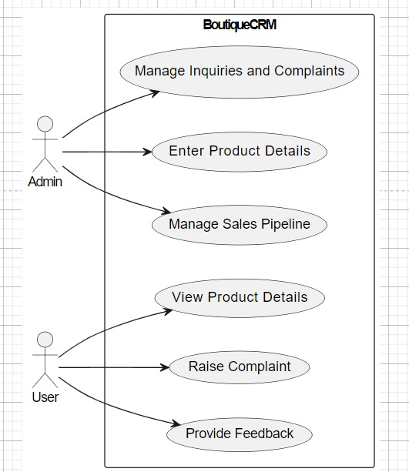

This diagram illustrates the Admin and User interacting with various functionalities within the CRM System, including managing inquiries/complaints, handling product details, managing the sales pipeline, and user activities such as viewing product details, raising complaints, and providing feedback

## Product Function

Entity Relationship Diagram of Customer Relationship Management System

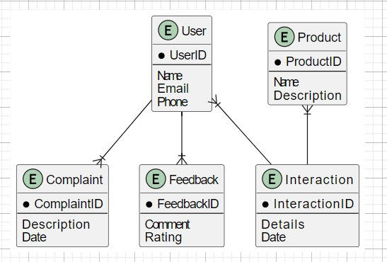

This ER diagram outlines the basic entities and their relationships within the CRM system. Users interact with Complaints, Feedback, and Product entities, while Interactions capture the engagement between Users and Products. Adjustments or additions to entities can be made based on the specific requirements or additional functionalities of the CRM system for the boutique.

## User Classes and Characteristics

The system provides different types of services based on the type of users [Administrator/User]. The Administrator will be acting as the controller and he will have all the privileges . The member can be the user interacting with the CRM system to facilitate various functions.

The features that are available to the Administrator are:-

* + - Assign or modify user roles and access permissions within the CRM system.
    - Configure system settings, including customization options, preferences, and system behavior
    - Access all features and functionalities within the CRM system for comprehensive control.
    - Generate and analyze comprehensive reports on customer engagement, sales performance, and interactions.
    - Monitor user activities, system usage, and data integrity within the CRM.
    - Regularly assess system security and take necessary measures to enhance protection.
    - Provide training to users, assist in issue resolution, and offer support for system-related queries.

The features that are available to the Users are:-

* + - View categorized products or services offered by the company through an intuitive interface.
    - Explore various categories to understand the range and diversity of offerings available.
    - Access specific lists or catalogs within each product or service category for detailed information.
    - Explore individual items, their descriptions, prices, and availability.
    - View specific lists or catalogs of available products or services within each category
    - Access categorized views of available products or services offered by the company.

## Operating Environment

The operational environment encompasses a Windows-based platform, operating seamlessly across popular web browsers such as Microsoft Internet Explorer, Google Chrome, and Mozilla Firefox. The system's model primarily aligns with compatibility standards set by IE 6.0, while also ensuring a functional scope within Mozilla Firefox and Opera 7.0 or higher versions. This web-based CRM solution is accessible via an internet connection, enabling users to interact with the system from various locations.In terms of hardware configuration, the system requirements include a minimum Hard Disk capacity of 40 GB, a 15” Color monitor, and a standard 122-key Keyboard. Basic input devices like keyboards and mice, along with output devices such as monitors and printers, facilitate user interaction and information display within the CRM environment. This setup ensures compatibility and accessibility across diverse hardware configurations, allowing users to engage with the CRM system efficiently and effectively.

## Assumptions and Dependencies

The assumptions are:-

* + - The coding should be error free
    - The system should be user-friendly so that it is easy to use for the users
    - The information of all users, sales record ,product details must be stored in a database that is accessible by the website
    - The system should have more storage capacity and provide fast access to the database
    - The system should provide search facility and support quick transactions
    - Users may access from any computer that has Internet browsing capabilities and an

Internet connection

* + - Users must have their correct usernames and passwords to enter into their online accounts and do actions

The dependencies are:-

* + - The specific hardware and software due to which the product will be run
    - On the basis of listing requirements and specification the project will be developed and run
    - The end users (admin) should have proper understanding of the product
    - The system should have the general report stored
    - The information of all the users must be stored in a database that is accessible by the Customer relationship System
    - Any update regarding the product from the company is to be recorded to the database and the data entered should be correct

## Requirement

Software Configuration:-

This software package is developed using java as front end which is supported by sun micro system. Microsoft SQL Server as the back end to store the database.

Operating System: Windows NT, windows 98, Windows XP Language: Java Runtime Environment, Net beans 7.0.1 (front end) Database: MS SQL Server (back end)

Hardware Configuration:- Processor: Pentium(R)Dual-core CPU Hard Disk: 40GB

RAM: 256 MB or more

## Data Requirement

Customer Relationship Management (CRM) system, data requirements involve user queries as inputs to the database, generating solutions and account details as outputs. Users initiate queries such as creating an account, selecting books, or managing their accounts. Upon user request, the system provides outputs in the form of account details, including the time and date stamp of the information retrieval and a comprehensive list of books associated with the user's account. This functionality allows users to receive real-time updates on their account status, enabling them to track which books are currently linked to their account at any given time. This data flow ensures seamless interaction between users and the system, facilitating efficient management of user accounts and providing immediate access to crucial account-related information.

# External Interface Requirement

## GUI

The software provides good graphical interface for the user and the administrator can operate on the system, performing the required task such as create, update, viewing the details of the book.

* + - It allows user to view quick reports like Book Issued/Returned in between particular time.
    - It provides stock verification and search facility based on different criteria.
    - The user interface must be customizable by the administrator
    - All the modules provided with the software must fit into this graphical user interface and accomplish to the standard defined
    - The design should be simple and all the different interfaces should follow a stand

template

* + - The user interface should be able to interact with the user management module and a part of the interface must be dedicated to the login/logout module

Login Interface:-

In case the user is not yet registered, he can enter the details and register to create his account. Once his account is created he can ‘Login’ which asks the user to type his username and password. If the user entered either his username or password incorrectly then an error message appears.

Search:-

The member or librarian can enter the type of book he is looking for and the title he is interested in,then he can search for the required book by entering the book name.

Categories View:-

Categories view shows the categories of books available and provides ability to the librarian to add/edit or delete category from the list.

Librarian’s Control Panel:-

This control panel will allow librarian to add/remove users; add, edit, or remove a resource. And manage lending options.

# System Features

The users of the system should be provided the surety that their account is secure. This is possible by providing:-

* A Customer Relationship Management (CRM) system is designed to help businesses

manage their interactions and relationships with customers.

* The features of a CRM system can vary based on the specific needs of a business
* Store and organize customer information, including names, addresses, phone numbers, and email addresses.
* Record interactions and communication history with each contact
* Capture and manage leads from various sources. Assign and track leads through the sales pipeline
* Monitor and manage sales opportunities and deals.Track the status and potential value of each opportunity

# Other Non-functional Requirements

## Performance Requirement

Performance requirements for a Customer Relationship Management (CRM) system project are crucial to ensure that the system meets the needs of users and performs efficiently. Here are some key performance requirements to consider:

* + - The performance of the system should be fast and accurate
    - Library Management System shall handle expected and non-expected errors in ways that prevent loss in information and long downtime period. Thus it should have inbuilt error testing to identify invalid username/password
    - The system should be able to handle large amount of data. Thus it should accommodate high number of books and users without any fault

## Safety Requirement

Safety requirements in the context of a Customer Relationship Management (CRM) system project may not be as direct as in fields like manufacturing or healthcare, but they are essential for ensuring the security, privacy, and reliability of customer data and system operations. Here are some safety requirements to consider:

Data Security:

Implement encryption mechanisms to secure sensitive customer data during storage and transmission.

Ensure compliance with data protection regulations such as GDPR, HIPAA, or other relevant standards depending on your industry.

Access Control:

Implement role-based access control (RBAC) to restrict access to customer data based on user roles and responsibilities.

Enforce strong authentication mechanisms, such as two-factor authentication, to prevent unauthorized access.

## 

Safety requirements in the context of a Customer Relationship Management (CRM) system project may not be as direct as in fields like manufacturing or healthcare, but they are essential for ensuring the security, privacy, and reliability of customer data and system operations. Here are some safety requirements to consider:

Data Security:

Implement encryption mechanisms to secure sensitive customer data during storage and transmission.

Ensure compliance with data protection regulations such as GDPR, HIPAA, or other relevant standards depending on your industry.

Access Control:

Implement role-based access control (RBAC) to restrict access to customer data based on user roles and responsibilities.

Enforce strong authentication mechanisms, such as two-factor authentication, to prevent unauthorized access.

## Security Requirement

Security is a critical aspect of a Customer Relationship Management (CRM) project, especially given the sensitive nature of customer data. Here are key security requirements that should be considered for a CRM system:

* + - All sensitive data, both in transit and at rest, should be encrypted using industry-standard encryption algorithms to prevent unauthorized access.
    - Implement robust access controls to ensure that only authorized users have access to specific functionalities and customer data. Use role-based access control (RBAC) to manage permissions.
    - Enforce strong authentication mechanisms, such as username/password combinations or multi-factor authentication, to verify the identity of users accessing the system.

## Requirement attributes

For a Customer Relationship Management (CRM) project, some common requirements attributes include

* + - A unique identifier for each requirement to facilitate tracking and referencing.
    - A brief and descriptive title or name for the requirement for easy identification.
    - A detailed explanation of the requirement, including its purpose, functionality, and any relevant context.
    - The level of importance or urgency assigned to the requirement, indicating its relative importance in the context of the overall project.
    - The origin or source of the requirement, whether it comes from stakeholders, regulatory bodies, business processes, or other sources.

## Business Rules

Business rules in a Customer Relationship Management (CRM) project define the operational, structural, and strategic guidelines that govern how the CRM system behaves in various scenarios. These rules help ensure consistency, compliance with business policies, and effective management of customer interactions.

## User Requirement

The users of the system are members and Librarian of the university who act as administrator to maintain the system. The members are assumed to have basic knowledge of the computers and internet browsing. The administrators of the system should have more knowledge of the internals of the system and is able to rectify the small problems that may arise due to disk crashes, power failures and other catastrophes to maintain the system. The proper user interface, user manual, online help and the guide to install and maintain the system must be sufficient to educate the users on how to use the system without any problems.

The admin provides certain facilities to the users in the form of:-

* + - Backup and Recovery
    - Forgot Password
    - Data migration i.e. whenever user registers for the first time then the data is stored in the server
    - Data replication i.e. if the data is lost in one branch, it is still stored with the server
    - Auto Recovery i.e. frequently auto saving the information
    - Maintaining files i.e. File Organization
    - The server must be maintained regularly and it has to be updated from time to time

# Other Requirements

## Data and Category Requirement

Designing a Customer Relationship Management (CRM) system involves defining the data and category requirements to effectively manage and analyze customer interactions. Here are some key data and category requirements for a CRM system:

Name: First name, last name, title, etc.

Contact Information: Email address, phone number, address.

Company Information: If applicable, company name, industry, size.

Interactions: Record of customer interactions, including emails, calls, meetings, support tickets.

Communication Preferences: Customer preferences for communication channels and frequency.

Sales Opportunities: Details on potential sales, including lead source, deal size, and stage.

Purchase History: Products or services purchased, transaction history.

## Appendix

A: Admin, Abbreviation, Acronym, Assumptions; B: Books, Business rules; C: Class, Client, Conventions; D: Data requirement, Dependencies; G: GUI; K: Key; L: Library, Librarian; M: Member; N: Non-functional Requirement; O: Operating environment; P: Performance,Perspective,Purpose; R: Requirement, Requirement attributes; S: Safety, Scope, Security, System features; U: User, User class and characteristics, User requirement;

## Glossary

Creating a glossary for your Customer Relationship Management (CRM) system project is essential for ensuring that all project stakeholders have a clear understanding of the key terms and acronyms used.

* + - Account: A record in the CRM system representing a company, organization, or individual with whom the business has a relationship.
    - CRM (Customer Relationship Management): A system or strategy for managing interactions with current and potential customers.
    - Data Migration: The process of transferring data from one system to another, often during CRM system implementation.
    - Dashboard: A visual representation of key performance indicators and data within the CRM system.
    - Entity: A distinct object or concept in the CRM system, such as a customer, lead, opportunity, or contact.
    - User Role: A predefined set of permissions and access levels assigned to users based on their responsibilities.
    - Workflow: The sequence of tasks and activities that need to be completed to achieve a specific outcome within the CRM system.

## Class Diagram

A class is an abstract, user-defined description of a type of data. It identifies the attributes of the data and the operations that can be performed on instances (i.e. objects) of the data. A class of data has a name, a set of attributes that describes its characteristics, and a set of operations that can be performed on the objects of that class. The classes’ structure and their relationships to each other frozen in time represent the static model. In this project there are certain main classes

which are related to other classes required for their working. There are different kinds of relationships between the classes as shown in the diagram like normal association, aggregation, and generalization. The relationships are depicted using a role name and multiplicities. Here ‘Librarian’, ‘Member’ and ‘Books’ are the most important classes which are related to other classes.

