ASSIGNMENT – 2

HOTEL RESERVATION SYSTEM

Submitted by:

Sivaranjani S

Sreenithi V

Sudharshana D

Varshini G M

________________________________________________________

1. To draw the ER Diagram for hotel reservation system:

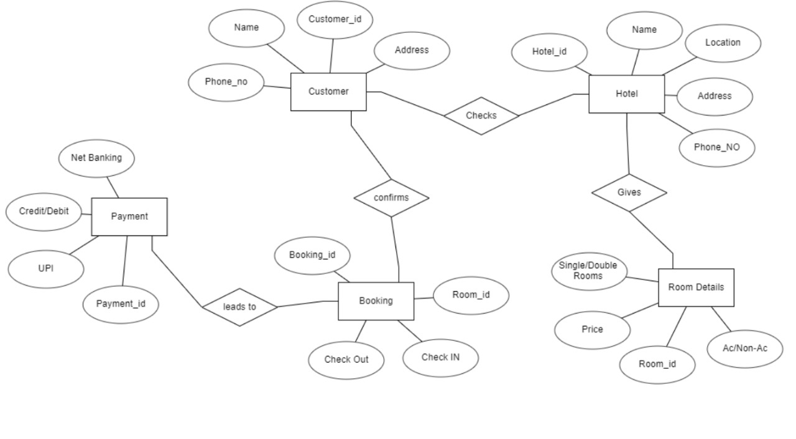

_____________________________________________

1. To create a class diagram for hotel reservation system:

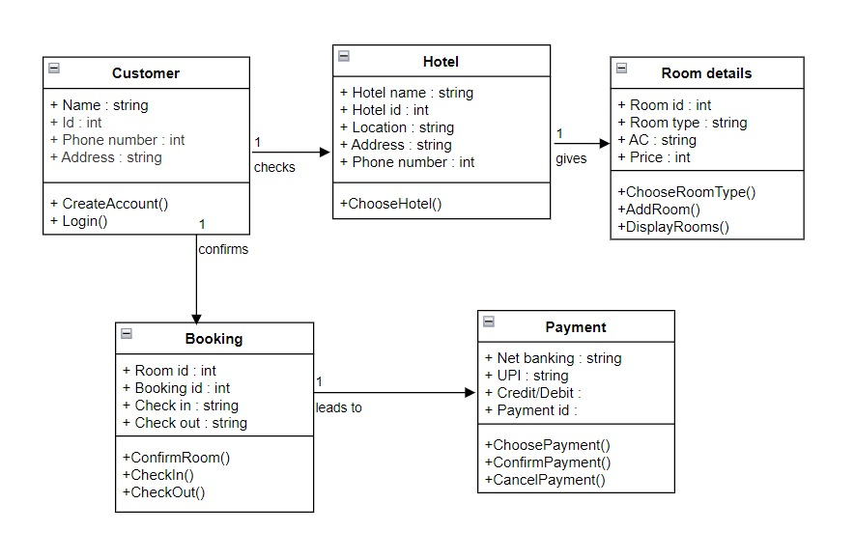

___________________________________________

1. To create the database for hotel reservation system:

Table Customer:

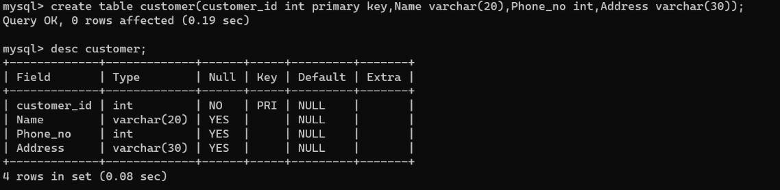

Table Hotel:

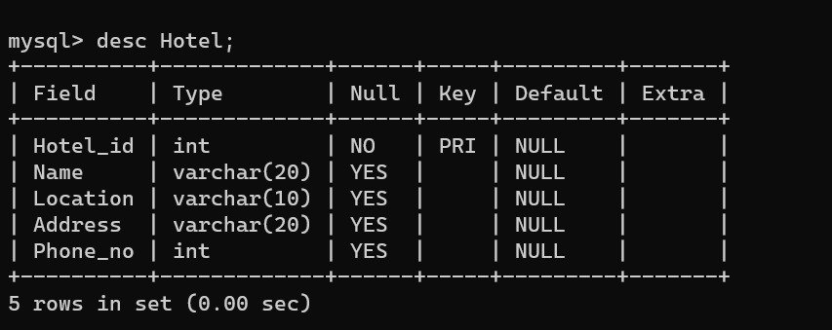

Table Room Details:

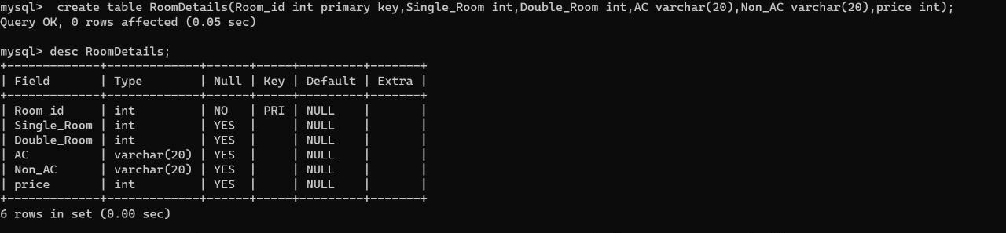

Table Booking:

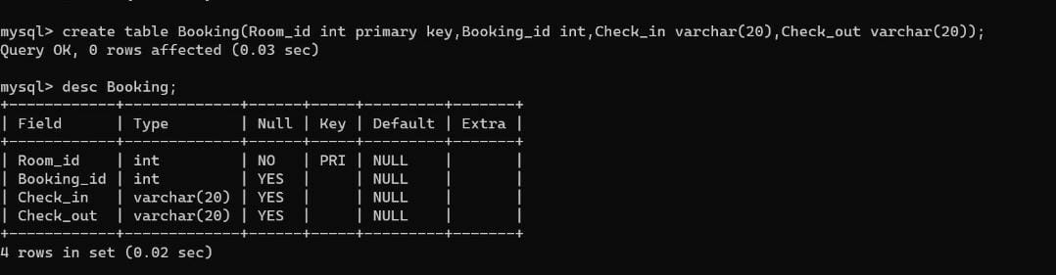

Table Payment:



