SOFTWARE REQUIREMENTS SPECIFICATION

**For**

**HOTEL RESERVATION SYSTEM**

**Prepared by :-**

**Sivaranjani S**

**Sreenithi V**

**Sudharshana D**

**Varshini G M**

# Introduction

## Purpose

The main objective of this document is to illustrate the requirements of the project Hotel Management system. The document gives the detailed description of the both functional and non-functional requirements proposed by the client.The purpose of this project is to provide a friendly environment to maintain the details of room reservation and management.The main purpose of this project is to maintain easy circulation system using computers and to provide different reports. This project describes the hardware and software interface requirements using ER diagrams and UML diagrams.

## Document Conventions

* + - Entire document should be justified.
    - Convention for Main title

Font face: Times New Roman Font style: Bold

Font Size: 14

* + - Convention for Sub title

Font face: Times New Roman Font style: Bold

Font Size: 12

* + - Convention for body

Font face: Times New Roman Font Size: 12

## Scope of Development Project

The Hotel Reservation System project is intended for the reservations for room that can be made through online. It will be able to automate the various operations of the Hotel. Our Hotel Reservation System will have three end users: Customer, Receptionist, and Hotel Manager. Hotel Reservation System will consists of Booking Management System, DBMS Server, and Report Generator. Customers will be able to check for room’s availability, select the rooms, and pay for the room. Receptionist will have access to update or modify booking details. Manager will able to view the financial report and able to update room information such as cost and category

The main goal of this introduced automated Hotel Reservation System software is to simplify every day process of hotel. Day to day Hotels are increasing and they need to automate to provide customer ease of access. It will be able to take care of services to customer in a quick manner. This automation will be able to replace the drawbacks of large customer information physical files which were difficult to handle. Secure Transaction, quick retrieval of information, ease of use, quick recovery of errors, fault tolerance are some of the benefits that development team will be working on to achieve end user satisfaction.

## Definitions, Acronyms and Abbreviations

JAVA -> platform independence SQL-> Structured query Language ER-> Entity Relationship

UML -> Unified Modeling Language

IDE-> Integrated Development Environment SRS-> Software Requirement Specification

## References

* + - Websites:
    - Hotel Reservation System: [Hotel Management System (wordpress.com)](https://dipeshagrawal.files.wordpress.com/2018/07/srs-hotel-management-system-ok.pdf)
    - Case Study : <https://www.scribd.com/doc/27927992/Hotel-Management-Case-Stud>
    - ER Diagram Tutorial: <https://www.tutorialspoint.com/dbms/er_diagram_representation.htm>
    - Fundamentals of database system,6Th edition,Ramez Elmasri,Shamkant B.Navathe

## Product Perspective

Use Case Diagram of Hotel Reservation System

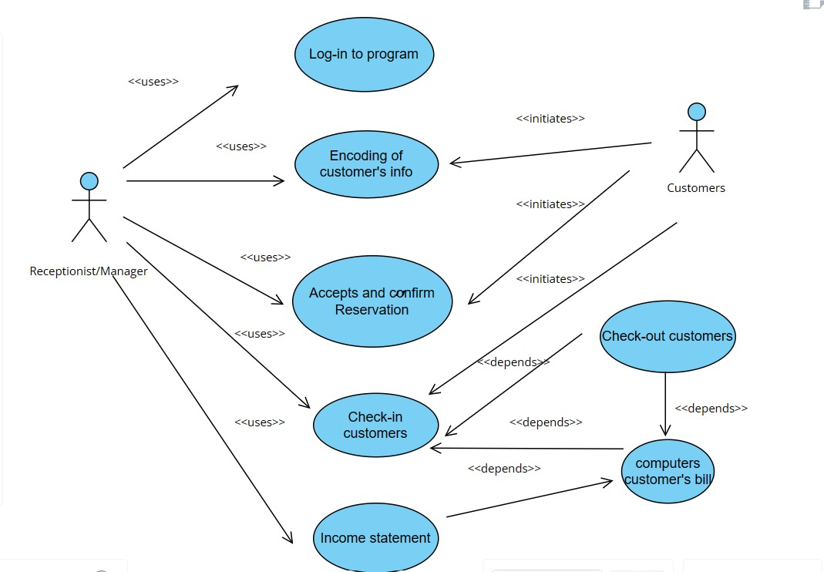

This is a broad level diagram of the project showing a basic overview. The users can be either staff or student.. This System will provide a search functionality to facilitate the search of resources. This search will be based on various categories viz. book name or the ISBN. Further the library staff personnel can add/update the resources and the resource users from the

system.The users of the system can request issue/renew/return of books for which they would have to follow certain criteria.

## Product Function

Entity Relationship Diagram of Hotel Reservation System

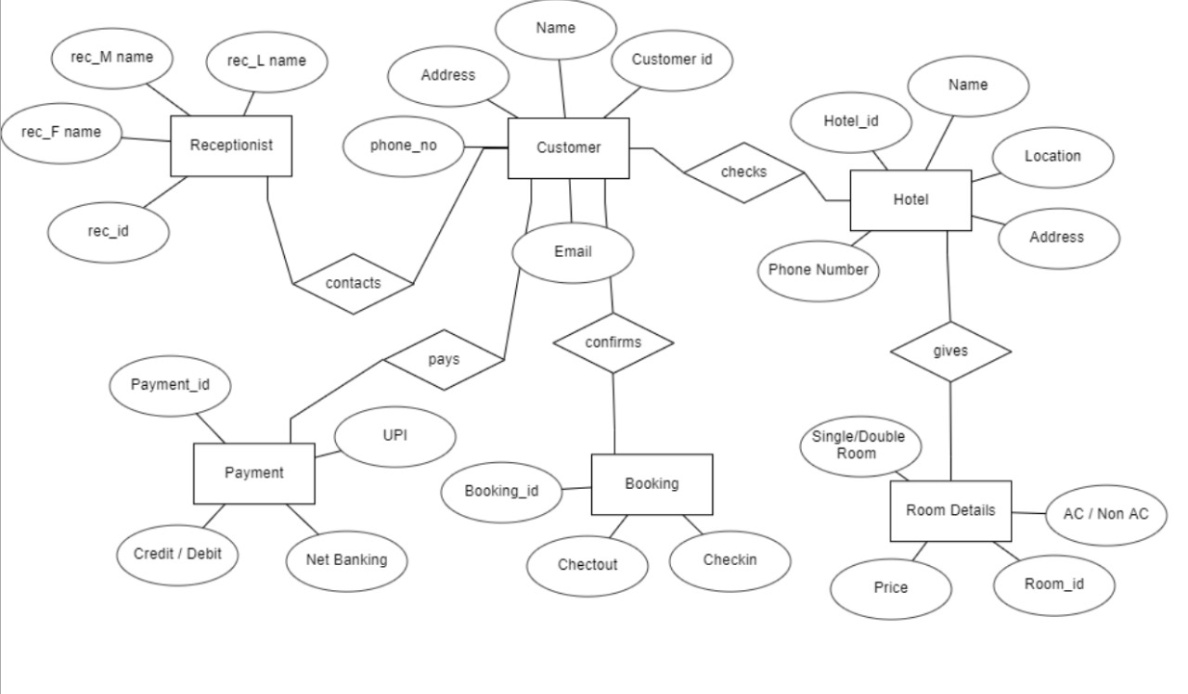

The Hotel Reservation System provides online real time information about the room available in the Hotel and the user information. The main purpose of this project is to reduce the manual work. This software is capable of managing Hotels,Room availability, Room type, Payment type,etc,.The Receptionist will act as the administrator to control customers and manage rooms. The customer’s status of booking is maintained in the reservation database. The user’s details can be fetched by the receptionist from the database as and when required.

## User Classes and Characteristics

The system provides different types of services based on the type of users [Customer/Receptionist]. The Receptionist will be acting as the controller and he will have all the privileges of an administrator.

The features that are available to the Receptionist are:-

* + - A receptionist can have least access than the manager.
    - A receptionist can manage the booking details.
    - A receptionist can search for availability of rooms.
    - A receptionist can add the customer.
    - A receptionist can confirm the booking, and update the booking details.

The features that are available to the Customers are:-

* + - Customer are vital part of the system.
    - Customer have access to view the vacant room information and price range.
    - Customers should be able to confirm the booking and cancel it if necessary.
    - Customers have access to customer service desk portal to forward their inquiry.
    - Customer should at least be capable to use the web UI interface.

## Operating Environment

The product will be operating in windows environment. The Library Management System is a website and shall operate in all famous browsers, for a model we are taking Microsoft Internet Explorer,Google Chrome,and Mozilla Firefox.Also it will be compatible with the IE 6.0. Most of the features will be compatible with the Mozilla Firefox & Opera 7.0 or higher version. The only requirement to use this online product would be the internet connection.

The hardware configuration include Hard Disk: 40 GB, Monitor: 15” Color monitor, Keyboard: 122 keys. The basic input devices required are keyboard, mouse and output devices are monitor, printer etc.

## Assumptions and Dependencies

The assumptions are:-

* + - The coding should be error free
    - The system should be user-friendly so that it is easy to use for the users
    - The information of all users, rooms and availabilities must be stored in a database that is accessible by the website
    - The system should have more storage capacity and provide fast access to the database
    - The system should provide search facility and support quick transactions
    - The Hotel Reservation system is running 24 hours a day
    - Users may access from any computer that has Internet browsing capabilities and an

Internet connection

* + - Users must have their correct usernames to enter into their online accounts and do actions

The dependencies are:-

* + - The specific hardware and software due to which the product will be run
    - On the basis of listing requirements and specification the project will be developed and run
    - The end users (admin) should have proper understanding of the product
    - The system should have the general report stored
    - The information of all the users must be stored in a database that is accessible by the Reservation System
    - Any update regarding the room from the hotel is to be recorded to the database and the data entered should be correct

## Requirement

Software Configuration:-

This software package is developed using java as front end which is supported by sun micro system. Microsoft SQL Server as the back end to store the database.

Operating System: Windows NT, windows 98, Windows XP Language: Java Runtime Environment, Net beans 7.0.1 (front end) Database: MS SQL Server (back end)

Hardware Configuration:- Processor: Pentium(R)Dual-core CPU Hard Disk: 40GB

RAM: 256 MB or more

## Data Requirement

The inputs consist of the query to the database and the output consists of the solutions for the query. The output also includes the user receiving the details of their account. In this project the inputs will be the queries as fired by the users like create an account, selecting rooms and putting into account. Now the output will be visible when the user requests the server to get details of their account in the form of time, date and which rooms are currently in the account.

# Functional Requirement

## Registration

* + - The Customer should be able to register with their details.
    - The system should record following customer details into member database.

(Name /Email/ Password/ Address/ DOB)

* + - The system shall send verification message to email

Login Interface:-

In case the user is not yet registered, he can enter the details and register to create his account.

The system should verify the customer email & password against the member database when logging in. After login, member should be directed to Home screen.

Reservation:-

The system should enable customer to check for availability of rooms . The system should display rate for all rooms . The system should allow customer to confirm or cancel the booking. The system should record booking details into database

Receptionist Access:-

The system should allow Receptionist to update, add or delete booking information .

The system should provide customer desk portal access to receptionist

for providing response to customer inquiry

Payment Management System:-

The system should allow customer to pay bill via online using credit or debit card

# System Features

The users of the system should be provided the surety that their account is secure. This is possible by providing:-

* User authentication and validation of members using their unique member ID
* Proper monitoring by the administrator which includes updating account status, showing a popup if the member attempts to issue number of books that exceed the limit provided by the library policy, assigning fine to members who skip the date of return
* Proper accountability which includes not allowing a member to see other member’s account. Only administrator will see and manage all member accounts

# Other Non-functional Requirements

## Performance Requirement

The proposed system that we are going to develop will be used as the Chief performance system therefore, it is expected that the database would perform functionally all the requirements that are specified by the hotel.

* + - The performance of the system should be fast and accurate
    - Hotel Reservation System shall handle expected and non-expected errors in ways that prevent loss in information and long downtime period. Thus it should have inbuilt error testing to identify invalid username/password
    - The system should be able to handle large amount of data. Thus it should accommodate high number of rooms and users without any fault

## Safety Requirement

The database may get crashed at any certain time due to virus or operating system failure. Therefore, it is required to take the database backup so that the database is not lost. Proper UPS/inverter facility should be there in case of power supply failure.

## Security Requirement

* + - System will use secured database
    - Normal users can just read information but they cannot edit or modify anything except their personal and some other information.
    - System will have different types of users and every user has access constraints
    - Proper user authentication should be provided
    - No one should be able to hack users’ password
    - There should be separate accounts for admin and members such that no member can access the database and only admin has the rights to update the database.

## Requirement attributes

* + - There may be multiple admins creating the project, all of them will have the right to create changes to the system. But the members or other users cannot do changes
    - The project should be open source
    - The Quality of the database is maintained in such a way so that it can be very user friendly to all the users of the database
    - The user be able to easily download and install the system

## Business Rules

A business rule is anything that captures and implements business policies and practices. A rule can enforce business policy, make a decision, or infer new data from existing data.This includes the rules and regulations that the System users should abide by. This includes the cost of the project and the discount offers provided. The users should avoid illegal rules and protocols. Neither admin nor member should cross the rules and regulations.

## User Requirement

The users of the system are members and Librarian of the university who act as administrator to maintain the system. The members are assumed to have basic knowledge of the computers and internet browsing. The administrators of the system should have more knowledge of the internals of the system and is able to rectify the small problems that may arise due to disk crashes, power failures and other catastrophes to maintain the system. The proper user interface, user manual, online help and the guide to install and maintain the system must be sufficient to educate the users on how to use the system without any problems.

The admin provides certain facilities to the users in the form of:-

* + - Backup and Recovery
    - Forgot Password
    - Data migration i.e. whenever user registers for the first time then the data is stored in the server
    - Data replication i.e. if the data is lost in one branch, it is still stored with the server
    - Auto Recovery i.e. frequently auto saving the information
    - Maintaining files i.e. File Organization
    - The server must be maintained regularly and it has to be updated from time to time

# Other Requirements

## Data and Category Requirement

There are different categories of users namely Manager,Receptionist,Customeretc. Depending upon the category of user the access rights are decided.It means if the user is an administrator then he can be able to modify the data,delete, append etc. All other users except the Receptionist have the rights to retrieve the information about database. Similarly there will be different categories of rooms available. According to the categories of rooms their relevant data should be displayed. The categories and the data related to each category should be coded in the particular format.

## Glossary

The following are the list of conventions and acronyms used in this document and the project as well:

* + - Administrator: A login id representing a user with user administration privileges to the software
    - User: A general login id assigned to most users
    - Client: Intended users for the software
    - SQL: Structured Query Language; used to retrieve information from a database
    - SQL Server: A server used to store data in an organized format
    - Layer: Represents a section of the project
    - User Interface Layer: The section of the assignment referring to what the user interacts with directly
    - Application Logic Layer: The section of the assignment referring to the Web Server. This is where all computations are completed
    - Data Storage Layer: The section of the assignment referring to where all data is recorded
    - Use Case: A broad level diagram of the project showing a basic overview
    - Class diagram: It is a type of static structure diagram that describes the structure of a system by showing the system’s cases, their attributes, and the relationships between the classes
    - Interface: Something used to communicate across different mediums
    - Unique Key: Used to differentiate entries in a database

## Class Diagram

A class is an abstract, user-defined description of a type of data. It identifies the attributes of the data and the operations that can be performed on instances (i.e. objects) of the data. A class of data has a name, a set of attributes that describes its characteristics, and a set of operations that can be performed on the objects of that class. The classes’ structure and their relationships to each other frozen in time represent the static model. In this project there are certain main classes

which are related to other classes required for their working. There are different kinds of relationships between the classes as shown in the diagram like normal association, aggregation, and generalization. The relationships are depicted using a role name and multiplicities. Here ‘Receptionist’, ‘Customer’ and ‘Rooms’ are the most important classes which are related to other classes.

