**INTRODUCTION**

**PURPOSE**

An airline reservation system demands robust performance to meet user expectations. Swift response times, essential for tasks like booking and cancellations, must be prioritized. Scalability is critical to accommodate varying user loads without sacrificing responsiveness, ensuring the system remains efficient during peak periods. Reliability, security, and optimized database operations contribute to a seamless experience, emphasizing the need for continuous monitoring and periodic performance testing to maintain high standards.

The safety of an airline reservation system hinges on robust measures including secure data encryption, stringent authentication protocols, and adherence to industry regulations like GDPR and PCI DSS. Ensuring system integrity through regular checks, implementing redundancy and backups, monitoring for anomalies, and promptly addressing incidents are vital components. Additionally, secure communication channels and ongoing vulnerability management contribute to a resilient system that safeguards passenger data and maintains operational integrity against potential threats.

PRODUCT DESCRIPTION

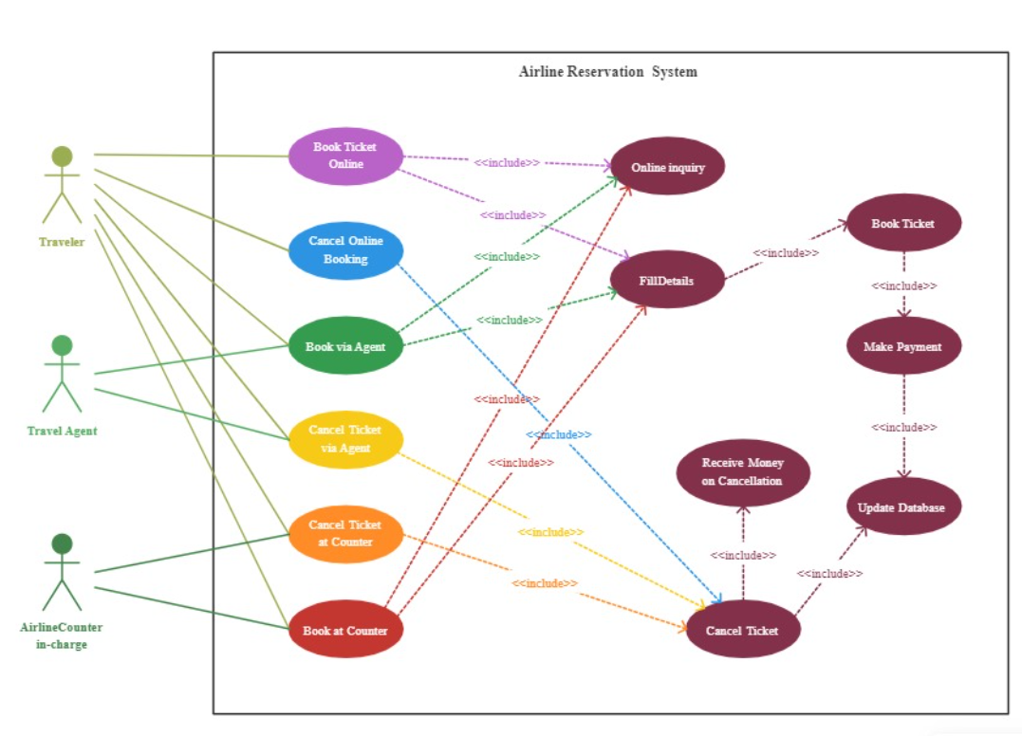

**ER DIAGRAM**

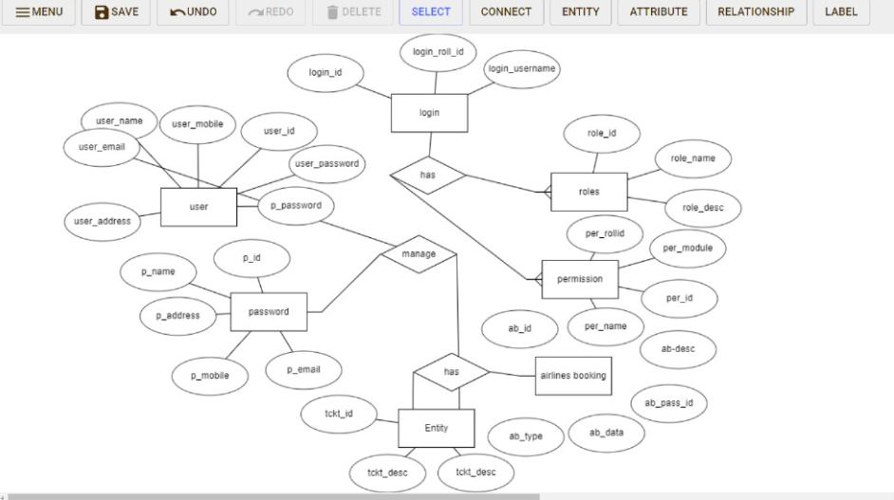

The Online Airline reservation system provides online real time information about the flights based on various criteria and make reservation corresponding to availability of flights. Administrators will have access to functionalities such as managing flight schedules, user accounts, and handling reservations.

USER CLASSES AND CHARACTERISTICS

The system provides different types of services based on the type of users. The staff will be acting as the controller and he will have all the privileges of an administrator.

THE FEATURES AVAILABLE TO THE STAFFS ARE:

* Administrators should be able to view and manage all reservations.
* Administrators should be able to add, edit, or delete flight information, including schedules and availability.
* Administrators should be directed to a dashboard displaying key system metrics, recent activities, and alerts.
* Administrators should be able to add new flights to the system, specifying details such as departure and arrival locations, date, time, and available seats.
* Administrators should be able to deactivate or remove flights that are no longer operational.

THE FEATURES AVAILABLE TO THE USERS ARE:

* Users can be able to search for flights based on criteria such as destination, departure date, and passenger count.
* Users should have the ability to view and manage their reservations.
* Users have a dashboard or page to view their current and past reservations.
* The system should allow users to modify or cancel their reservations.
* Users can be able to choose their preferred seats based on availability.

OPERATING ENVIRONMENT

The product will be operating in windows environment. Database server to store user data, flight schedules, and other relevant information.

ASSUMPTION AND DEPENDENCIES

The assumptions are:

* The coding should be error free.
* The system should be user-friendly so that it is easy to use for the users.
* The information of all users, books and libraries must be stored in a database that is accessible by the website.
* The system should have more storage capacity and provide fast access to the database.
* The system should provide search facility and support quick transactions.
* The Library System is running 24 hours a day.
* Users may access from any computer that has Internet browsing capabilities and an Internet connection.
* Users must have their correct usernames and passwords to enter into their online accounts and do actions.

The dependencies are:

* The specific hardware and software due to which the product will be run.
* On the basis of listing requirements and specification the project will be developed and run.
* The end users (admin) should have proper understanding of the product.
* The system should have the general report stored.
* The information of all the users must be stored in a database that is accessible by the Library System.
* Any update regarding the book from the library is to be recorded to the database and the data entered should be correct

REQUIREMENTS

Software Configuration:

This software package is developed using java as front end which is supported by sun micro system. Microsoft SQL Server as the back end to store the database. Operating System: Windows NT, windows 98, Windows XP Language: Java Runtime Environment, Net beans 7.0.1 (front end) Database: MS SQL Server (back end).

DATA REQURIEMENT

The inputs consist of the query to the database and the output consists of the solutions for the query. The output also includes the user receiving the details of their reserved tickets. In this project the inputs will be the queries as fired by the users like gender, age, origin, destination, class and date etc.

EXTERNAL INTERFACE REQURIMENT

The software provides good graphical interface for the user and the administrator can operate on the system, performing the required task such as create, update, viewing the details of the flights.

* It allows user to view quick reports like seats availability and cost of each classes.

**OTHER NON-FUNCTIONAL REQUIREMENTS**

**Safety requirements**

Security requirements for an airline reservation system encompass several key elements. Firstly, robust user authentication and authorization mechanisms must be in place to control access to sensitive data and system functionalities. Data security is paramount, necessitating strong encryption protocols for both storage and transmission of passenger information and financial data. Compliance with industry regulations and standards, such as PCI DSS and GDPR, is imperative to protect user privacy and ensure secure transactions. The system should integrate monitoring tools for real-time threat detection, coupled with an effective incident response plan to address security breaches promptly. Regular security audits, vulnerability assessments, and updates are essential for maintaining a resilient defence against evolving cyber threats. Implementing secure coding practices and regularly training personnel on cybersecurity measures further fortify the system's overall security posture.

**Security requirements**

Traceability: Establish clear links between requirements, enabling easy tracking of their origins and ensuring comprehensive coverage throughout the system development process.

Priority: Assign priorities to requirements, allowing for a phased implementation approach and addressing critical features first for a prioritized development strategy.

Security: Include robust security requirements to safeguard sensitive data, prevent unauthorized access, and protect the system against potential threats and vulnerabilities.

Performance: Specify performance-related attributes, such as response times, scalability, and transaction throughput, to ensure the system meets performance expectations under various conditions.

Usability: Define usability requirements for an intuitive and user-friendly interface, enhancing the overall user experience for both customers and system administrators.

**Requirement Attributes**

The airline reservation system must adhere to a set of business rules, including policies for booking, ticketing, and seat management, as well as guidelines for fare structures and user access. These rules provide a framework for consistent and transparent operations, ensuring compliance with regulations, promoting fair pricing, and delivering a secure and reliable experience for both passengers and system administrators.

**Business rules**

Intuitive Interface: Users expect a user-friendly interface for easy navigation and seamless booking processes.

Flexible Search Options: Provide flexible search criteria for flights, including dates, times, airlines, and stopovers, enhancing the user's ability to find suitable options.

Transparent Pricing: Clearly display pricing details, including any additional fees, to ensure transparency and allow users to make informed decisions.

Booking Management: Enable users to efficiently manage their bookings, offering options for modifications, cancellations, and seat selections.

Mobile Accessibility: Ensure the system is accessible on various devices, especially mobile, to allow users to book and manage flights conveniently while on the go.