

SOFTWARE REQUIREMENTS SPECIFICATION

**For**

**Issue Tracking System**

**Prepared by:-**

*Ilakkiya S*

*Jayshree R*

*Madhu Sri P S*

# Introduction

## Purpose

An issue tracking system is a centralized platform for managing and resolving issues throughout the software development lifecycle. It facilitates collaboration among teams, streamlines issue reporting and resolution, and enhances overall project visibility and accountability. Key objectives include tracking and prioritizing issues, assigning and collaborating on issues, resolving and tracking issues, providing reporting and analytics, fostering a knowledge base, and enhancing customer support.

## Document Conventions

* + - Entire document should be justified.
    - Convention for Main title

Font face: Times New Roman Font style: Bold

Font Size: 14

* + - Convention for Sub title

Font face: Times New Roman Font style: Bold

Font Size: 12

* + - Convention for body

Font face: Times New Roman 

Font Size: 12

## Scope of Development Project

Issue tracking System is basically updating the manual issues into an internet-based application so that the teammates and manager can know the details of their issues, updation of project levels and collaboration between team mates.

The issue in the project is posted in the “Issue Tracker platform “ ,which can be viewed by all the team members and the team managers. Anyone who chooses to address the issue will be assigned to it. Additionally on solving the arised issue ,the status of it will be updated at each level.This process is essential for building high-quality software that delivers an issue-free experience to users.

We can add new features as and when we require, making reusability possible as there is flexibility in all the modules.The language used for developing the project is Java as it is quite advantageous than other languages in terms of performance, tools available, cross platform compatibility, libraries, cost (freely available), and development process.

## Definitions, Acronyms and Abbreviations

JAVA -> platform independence SQL-> Structured query Language ER-> Entity Relationship

UML -> Unified Modeling Language

IDE-> Integrated Development Environment SRS-> Software Requirement Specification

# Overall Descriptions

## Product Perspective

Use Case Diagram of Issue Tracking System

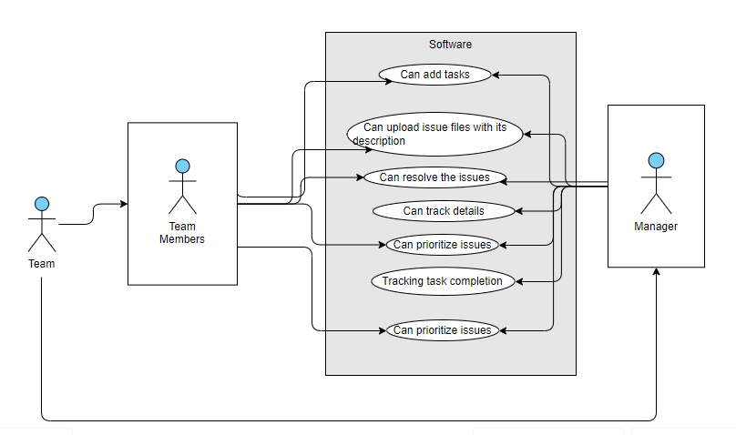

The issue tracking and management system will be a standalone web application that integrates with existing software development environments and tools.The team member willing to address the issue can request the assignee.From a product perspective, an issue tracking system for software development projects serves as a crucial tool for ensuring the smooth progression of the development lifecycle.

## Product Function

Entity Relationship Diagram of Library Management System

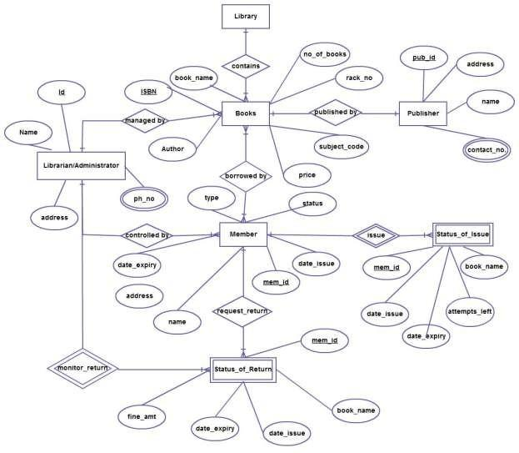

The Online Library System provides online real time information about the books available in the Library and the user information. The main purpose of this project is to reduce the manual work. This software is capable of managing Book Issues, Returns, Calculating/Managing Fine, Generating various Reports for Record-Keeping according to end user requirements. The Librarian will act as the administrator to control members and manage books. The member’s status of issue/return is maintained in the library database. The member’s details can be fetched by the librarian from the database as and when required. The valid members are also allowed to view their account information.

## User Classes and Characteristics

## The system provides different types of services based on the type of users [Manager/ Teammates]. The Manager will be acting as the controller and he will have all the privileges of an administrator. The Team member who will be accessing the issues faced by others in their part.

The features that are available to the Team Members are:-

* + - A Manager can assign task to team member.
    - Can view the different collection of status of the tasks .
    - Can view the List of issues title available in each category.
    - Can take the tasks assigned to other Team member.
    - Add status and their tasks to the database.
    - Edit the information of existing tasks.
    - Can check the report of the existing tasks.
    - Can check the report of the status tasks.
    - Can access all the accounts of the team members.

The features that are available to the Manager are:-

* + - Assigns tasks to team members.
    - Views status and progress of assigned tasks.
    - Accesses a list of issue titles in each category.
    - Manages the process of taking issues assigned to team members.
    - Adds, edits, and manages issue information in the system.
    - Generates reports on the overall status of issues.
    - Checks reports on issued and returned issues.
    - Accesses all user accounts within the system.

**Operating Environment:**

The product will be operating in windows environment. The Library Management System is a website and shall operate in all famous browsers, for a model we are taking Microsoft Internet Explorer,Google Chrome,and Mozilla Firefox.Also it will be compatible with the IE 6.0. Most of the features will be compatible with the Mozilla Firefox & Opera 7.0 or higher version. The only requirement to use this online product would be the internet connection.

The hardware configuration include Hard Disk: 40 GB, Monitor: 15” Color monitor, Keyboard: 122 keys. The basic input devices required are keyboard, mouse and output devices are monitor, printer etc.

## Assumptions and Dependencies

The assumptions are:-

* + - The coding should be error free
    - The system should be user-friendly so that it is easy to use for the users
    - The information of all users, books and libraries must be stored in a database that is accessible by the website
    - The system should have more storage capacity and provide fast access to the database
    - The system should provide search facility and support quick transactions
    - The Library System is running 24 hours a day
    - Users may access from any computer that has Internet browsing capabilities and an Internet connection
    - Users must have their correct usernames and passwords to enter into their online accounts and do actions

The dependencies are:-

* + - The specific hardware and software due to which the product will be run
    - On the basis of listing requirements and specification the project will be developed and run
    - The end users (admin) should have proper understanding of the product
    - The system should have the general report stored
    - The information of all the users must be stored in a database that is accessible by the Library System
    - Any update regarding the book from the library is to be recorded to the database and the data entered should be correct

## Requirement

Software Configuration:-

This software package is developed using java as front end which is supported by sun micro system. Microsoft SQL Server as the back end to store the database.

Operating System: Windows NT, windows 98, Windows XP Language: Java Runtime Environment, Net beans 7.0.1 (front end) Database: MS SQL Server (back end)

Hardware Configuration:- Processor: Pentium(R)Dual-core CPU Hard Disk: 40GB

RAM: 256 MB or more

## Data Requirement

The inputs consist of the query to the database and the output consists of the solutions for the query. The output also includes the user receiving the details of their accounts. In this project the inputs will be the queries as fired by the users like create an account, selecting team and putting into account. Now the output will be visible when the user requests the server to get details of their account in the form of time, date and status of the account.

# External Interface Requirement

## GUI

## The Issue Tracking System will feature a user-friendly graphical interface for both developers and administrators.

## The administrator will have access to perform tasks such as creating, updating, and viewing the details of an issue.

# The system will allow users to generate quick reports, showing the status of issues (e.g., assigned, in progress, closed) .

# Users will be able to perform searches based on various criteria, such as issue description, status, or assignee.

# Filters will be provided to refine search results for efficient issue tracking.

# Users can register by providing necessary details to create an account.

# The login interface will prompt users to enter their username and password. Incorrect entries will trigger an error message for user correction.

# System Features

The users of the system should be provided the surety that their account is secure. This is possible by providing:-

* User authentication and validation of members using their unique member ID
* Proper monitoring by the administrator which includes updating status, checking team members performance and evaluating the projects.
* Proper accountability which includes not allowing a member to see other member’s account. Only administrator will see and manage all member accounts

# Other Non-functional Requirements

## Performance Requirement

* + - Security priorities, information management and policy management use a variety of methods to protect data integrity.
    - Automated routine backups are performed to minimize potential data loss, and a well-defined recovery process is established to properly handle unexpected system failures to effectively implement User authentication is key.
    - Access controls, distinguish between different user roles, limit access to specific roles, such as new states of feedback, maintain advanced auditing techniques though prevent unauthorized changes, log user activity and system events.

## Safety Requirement

## The database may get crashed at any certain time due to virus or operating system failure. Therefore, it is required to take the database backup so that the database is not lost. Proper UPS/inverter facility should be there in case of power supply failure.

## Security Requirement

* + - Security is paramount, with the system using data encryption protocols to protect messages between the user interface and the server .
    - Secure session management practices to prevent unauthorized access to user accounts, including timeouts and secure token usage.
    - Enabling the system behind a firewall provides an additional layer of protection including from potential security threats from unauthorized access.

## Requirement attributes

* + - There may be multiple admins creating the project, all of them will have the right to create changes to the system. But the members or other users cannot do changes
    - The project should be open source
    - The Quality of the database is maintained in such a way so that it can be very user friendly to all the users of the database
    - The user be able to easily download and install the system

## Business Rules

Performance is ensured by meeting stringent response time requirements and scalability specifications. The system responds rapidly to user requests and can scale incrementally to accommodate the growing number of users and data.

## User Requirement

* + - Ensure an efficient backup and recovery system to safeguard against data loss and provide a straightforward recovery process for users.
    - Implement a "Forgot Password" feature for users to securely reset or recover their login credentials.
    - Implement data replication to safeguard against data loss, ensuring redundancy and reliability across the system.
    - Integrate auto-recovery to regularly save user data, reducing the risk of loss. Enable effective file organization for user tasks and information.
    - Regularly maintain and update the server for optimal performance and security. Provide clear guidelines and notifications to users about scheduled maintenance periods.

# Other Requirements

## Data and Category Requirement

Regular maintenance and updates of the server should be conducted to optimize system

performance and address any potential vulnerabilities. The system should provide clear guidelines and

notifications to users about scheduled maintenance periods to minimize disruptions.

## Appendix

A: Admin, Abbreviation, Acronym, Assumptions; B:Business rules; C: Class, Client, Conventions; D: Data requirement, Dependencies; G: GUI; K: Key; N:Non-functionalRequirement;O:OperatingEnvironment;P:Performance,Perspective,Purpose; R: Requirement, Requirement attributes; S: Safety, Scope, Security, System features; T: Team Member;U: User, User class and characteristics, User requirement;

## Glossary

The following are the list of conventions and acronyms used in this document and the project as well:

* + - Administrator: A login id representing a user with user administration privileges to the software
    - User: A general login id assigned to most users
    - Client: Intended users for the software
    - SQL: Structured Query Language; used to retrieve information from a database
    - SQL Server: A server used to store data in an organized format
    - Layer: Represents a section of the project
    - User Interface Layer: The section of the assignment referring to what the user interacts with directly
    - Application Logic Layer: The section of the assignment referring to the Web Server. This is where all computations are completed
    - Data Storage Layer: The section of the assignment referring to where all data is recorded
    - Use Case: A broad level diagram of the project showing a basic overview
    - Class diagram: It is a type of static structure diagram that describes the structure of a system by showing the system’s cases, their attributes, and the relationships between the classes
    - Interface: Something used to communicate across different mediums
    - Unique Key: Used to differentiate entries in a database

## Class Diagram

A class is an abstract, user-defined description of a type of data. It identifies the attributes of the data and the operations that can be performed on instances (i.e. objects) of the data. A class of data has a name, a set of attributes that describes its characteristics, and a set of operations that can be performed on the objects of that class. The classes’ structure and their relationships to each other frozen in time represent the static model. In this project there are certain main classes which are related to other classes required for their working. There are different kinds of relationships between the classes as shown in the diagram like normal association, aggregation, and generalization. The relationships are depicted using a role name and multiplicities. Here ‘Librarian’, ‘Member’ and ‘Books’ are the most important classes which are related to other classes.

