SOFTWARE REQUIREMENTS SPECIFICATION

**For**

**Online Survey System**

**Prepared by:-**

*Lunatics*

# Introduction

## Purpose

The main purpose of this document is to illustrate the requirements of the project

Online survey system. The report gives the detailed description of the functional and non-

functional requirements proposed by the client. The purpose of the project is to provide a

smart survey which is user friendly to the company and the customer who under take the

survey. The primary purpose is to provide a better survey analysis to the company from

their customers. This project describes the hardware and software interface requirements

using ER diagrams and UML diagrams.

## Document Conventions

* + - Entire document should be justified.
    - Convention for Main title

Font face: Times New Roman Font style: Bold

Font Size: 14

* + - Convention for Sub title

Font face: Times New Roman Font style: Bold

Font Size: 12

* + - Convention for body

Font face: Times New Roman Font Size: 12

## Scope of Development Project

Online Survey System is basically a smart way of upgrading the client market by taking survey online instead of a manual survey taken offline. An online survey system is a application that allows users to create, distribute, and analyze surveys.

It can be used by businesses, researchers, and organizations to collect data from a large number of people in a short amount of time. Scope of developing such a project is vast and can be customized to meet the specific needs of the user. To create an effective survey project plan, it is important to understand the scope and importance of the survey to your organization and how the information you gather can realistically benefit your work.

The survey value depends on three main factors: a clear definition of the decisions you need to make, the relative cost of making an error in those decisions, and the amount of information you need to make those decisions .The benefits of an online survey system include efficient data collection, data analysis, and enhanced programming skills.

## Definitions, Acronyms and Abbreviations

JAVA -> platform independence SQL-> Structured query Language ER-> Entity Relationship

UML -> Unified Modeling Language

IDE-> Integrated Development Environment SRS-> Software Requirement Specification

## References

* + - Books

 Software Requirements and Specifications: A Lexicon of Practice, Principles and Prejudices (ACM Press) by Michael Jackson

Software Requirements (Microsoft) Second EditionBy Karl E. Wiegers

Software Engineering: A Practitioner’s Approach Fifth Edition By Roger S. Pressman

* + - Websites

[**http://www.slideshare.net/**](http://www.slideshare.net/)

[**http://ebookily.net/doc/srs-library-management-system**](http://ebookily.net/doc/srs-library-management-system)

# Overall Descriptions

## Product Perspective

Use Case Diagram of Library Management System

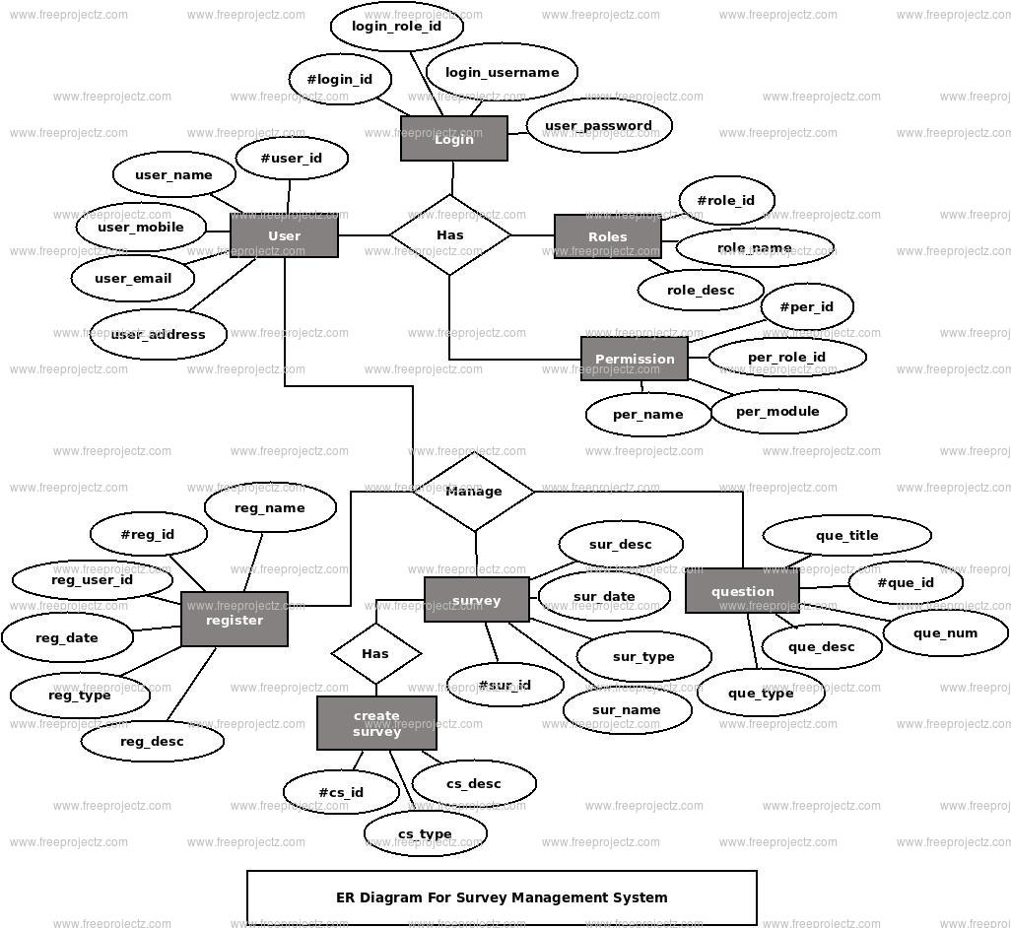

This is a broad level diagram of the project showing a basic overview. The users are customers and the clients. By using this system, the clients will be able to gather effective information from online survey. This system provides the analysis of the data received from the customers. A set of questions will be provided to the customers. The responses to these questions can provide valuable information about customer preferences, opinions, satisfaction levels, and behaviors.

It is more like a feedback from the customers. The data collected contributes to the development according to the customer's expectations.

## Product Function

Entity Relationship Diagram of Online Survey System

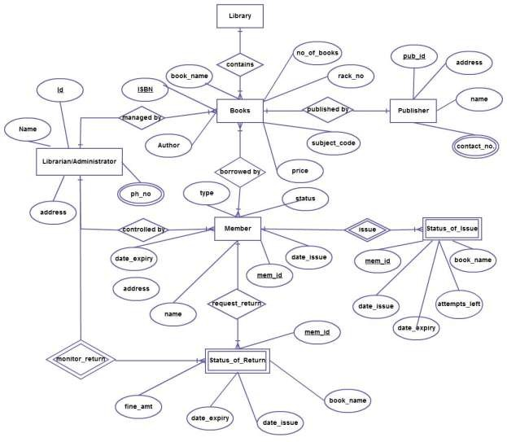

The Online Survey System provides online real time information about the experience and expectations of the customers. Conducting surveys online is more affordable and comfortable than traditional methods. There are no printing or postage works, and participants can complete surveys at their convenience from anywhere with an internet connection. Client can choose multiple questions according to their need. Surveys estimates the customer satisfaction levels. High satisfaction indicates loyalty, while low satisfaction may signal areas for improvement. The data are maintained in the database. The customer's details are securely stored.

## User Classes and Characteristics

The system provides different types of services based on the type of users [client]. The client will be acting as the controller and he will have all the privileges of an administrator. The user can only under take the survey online through forms.

The features that are available to the client are:-

* + - Client can create surveys using a variety of question types, such as multiple-choice, open-ended, and rating scales.
    - They can also customize the look and feel of the survey to match their branding
    - Client can distribute surveys to participants through email, social media platforms and web link.
    - Add dtas and their information to the database
    - They can also track response rates and send reminders to participants who have not yet completed the survey.
    - Client can view and analyze survey results in real-time.
    - They can also filter and segment data to gain deeper insights into specific groups of participants.
    - Client can create and manage online communities and panels for engaging with your target audience and collecting feedback on a regular basis

The features that are available to the User are:-

* + - Can view and undertake the survey by scanning the QR code.

## Operating Environment

The product will be operating in windows environment. The Online Survey System is a website and shall operate in all famous browsers, for a model we are taking Microsoft Internet Explorer,Google Chrome,and Mozilla Firefox.Also it will be compatible with the IE 6.0. Most of the features will be compatible with the Mozilla Firefox & Opera 7.0 or higher version. The only requirement to use this online product would be the internet connection.

The hardware configuration include Hard Disk: 40 GB, Monitor: 15” Color monitor, Keyboard: 122 keys. The basic input devices required are keyboard, mouse and output devices are monitor, printer etc.

## Assumptions and Dependencies

The assumptions are:-

* + - The coding should be error free
    - The system should be user-friendly so that it is easy to use for the users
    - The information of all users, books and libraries must be stored in a database that is accessible by the website
    - The system should have more storage capacity and provide fast access to the database
    - The system should provide search facility and support quick transactions
    - The Library System is running 24 hours a day
    - Users may access from any computer that has Internet browsing capabilities and an

Internet connection

* + - Users must have their correct usernames and passwords to enter into their online accounts and do actions

The dependencies are:-

* + - The specific hardware and software due to which the product will be run
    - On the basis of listing requirements and specification the project will be developed and run
    - The end users (admin) should have proper understanding of the product
    - The system should have the general report stored
    - The information of all the users must be stored in a database that is accessible by the client System
    - The Microsoft forms to develop the survey forms.

## Requirement

Software Configuration:-

This software package is developed using java as front end which is supported by sun micro system. Microsoft SQL Server as the back end to store the database.

Operating System: Windows NT, windows 98, Windows XP Language: Java Runtime Environment, Net beans 7.0.1 (front end) Database: MS SQL Server (back end)

Hardware Configuration:- Processor: Pentium(R)Dual-core CPU Hard Disk: 40GB

RAM: 256 MB or more

## Data Requirement

The inputs consist of the query to the database and the output consists of the solutions for the query. In this project the inputs will be the queries as fired by the clients like create an account, create a form. Now the output will be visible in statistical format when the user requests the server to get details of the survey.

# External Interface Requirement

## GUI

The software provides a simple and user friendly interface for the client to operate on the system and a user to take the survey, performing the essential task such as create the survey, generate the QR code, generate analytic report for the survey.

* + - It enables the client to create a survey by attaching the questions needed to improve his

Market and to target the customers.

* + - It generates a QR code using the form link.
    - It generates the statistical data modeling for the data obtained from the survey to the client.
    - All the modules provided with the software must fit into this graphical user interface and accomplish to the standard defined
    - The design should be simple and all the different interfaces should follow a standard

template

* + - The user interface should be able to interact with the user management module and a part of the interface must be dedicated to the login/logout module

Login Interface:-

In case the user is not yet registered, he can enter the details and register to create his account. Once his account is created he can ‘Login’ which asks the user to type his username and password. If the user entered either his username or password incorrectly then an error message appears.

Create:-

The client can enter questions to be mentioned in the forms and the title for the form, then he can create a Microsoft form by using his mail.

Generate QR :-

After the survey form is created then a QR code is generated which can be downloaded in jpg format and png format.

Data representation:-

This control panel will generate the statistical data models by using the data obtained from the survey undertaken.

# System Features

The users of the system should be provided the surety that their account is secure. This is possible by providing:-

* Client authentication and validation of members using their unique member ID
* Proper monitoring by the administrator which includes creating survey questions and accessing the QR image to display to the customers to undertake the survey.
* Proper accountability which includes not allowing a client to see other client’s survey. Only client will see and manage all data.

# Other Non-functional Requirements

## Performance Requirement

The proposed system that we are going to develop will be used as the Chief performance system within the different branches of the company which interacts with the customers and clients. Therefore, it is expected that the database would perform functionally all the requirements that are specified by the client.

* + - The performance of the system should be fast and accurate
    - Online Survey System shall handle expected and non-expected errors in ways that prevent loss in information and long downtime period. Thus it should have inbuilt error testing to identify invalid username/password
    - The system should be able to handle large amount of data. Thus it should accommodate high number of survey and users without any fault

## Safety Requirement

The database may get crashed at any certain time due to virus or operating system failure. Therefore, it is required to take the database backup so that the database is not lost. Proper UPS/inverter facility should be there in case of power supply failure.

## Security Requirement

* + - System will use secured database
    - Normal users can just read information but they cannot edit or modify anything except their personal and some other information.
    - System will have different types of users and every user has access constraints
    - Proper user authentication should be provided
    - No one should be able to hack users’ password
    - There should be separate accounts for admin and members such that no member can access the database and only admin has the rights to update the database.

## Requirement attributes

* + - There may be multiple admins creating the project, all of them will have the right to create changes to the system. But the members or other users cannot do changes
    - The project should be open source
    - The Quality of the database is maintained in such a way so that it can be very user friendly to all the users of the database
    - The user be able to easily download and install the system

## Business Rules

A business rule is anything that captures and implements business policies and practices. A rule can enforce business policy, make a decision, or infer new data from existing data. This includes the rules and regulations that the System users should abide by. This includes the cost of the project and the discount offers provided. The users should avoid illegal rules and protocols. Neither admin nor member should cross the rules and regulations.

## User Requirement

The users of the system are shop owners or managers who act as administrator to maintain the system. The members are assumed to have basic knowledge of the computers and internet browsing. The administrators of the system should have more knowledge of the internals of the system and is able to rectify the small problems that may arise due to disk crashes, power failures and other catastrophes to maintain the system. The proper user interface, user manual, online help and the guide to install and maintain the system must be sufficient to educate the users on how to use the system without any problems.

The admin provides certain facilities to the users in the form of:-

* + - Backup and Recovery
    - Forgot Password
    - Data migration i.e. whenever user registers for the first time then the data is stored in the server
    - Data replication i.e. if the data is lost in one branch, it is still stored with the server
    - Auto Recovery i.e. frequently auto saving the information
    - Maintaining files i.e. File Organization
    - The server must be maintained regularly and it has to be updated from time to time

# Other Requirements

## Data and Category Requirement

The system needs to store data such as surveys, questions, answers, responses, users, groups, roles, permissions, and reports. Each data element has its own attributes and relationships with other data elements. The system needs to classify the data elements into different types, such as survey types, question types, answer types, response types, user types, group types, role types, permission types, and report types. Each category has its own characteristics and functionalities

## Appendix

A: Admin, Abbreviation, Acronym, Assumptions; B: Books, Business rules; C: Class, Client, Conventions; D: Data requirement, Dependencies; G: GUI; K: Key; L: Library, Librarian; M: Member; N: Non-functional Requirement; O: Operating environment; P: Performance,Perspective,Purpose; R: Requirement, Requirement attributes; S: Safety, Scope, Security, System features; U: User, User class and characteristics, User requirement;

## Glossary

The following are the list of conventions and acronyms used in this document and the project as well:

* + - Administrator: A login id representing a user with user administration privileges to the software
    - User: A general login id assigned to most users
    - Client: Intended users for the software
    - SQL: Structured Query Language; used to retrieve information from a database
    - SQL Server: A server used to store data in an organized format
    - Layer: Represents a section of the project
    - User Interface Layer: The section of the assignment referring to what the user interacts with directly
    - Application Logic Layer: The section of the assignment referring to the Web Server. This is where all computations are completed
    - Data Storage Layer: The section of the assignment referring to where all data is recorded
    - Use Case: A broad level diagram of the project showing a basic overview
    - Class diagram: It is a type of static structure diagram that describes the structure of a system by showing the system’s cases, their attributes, and the relationships between the classes
    - Interface: Something used to communicate across different mediums
    - Unique Key: Used to differentiate entries in a database

## Class Diagram

A class is an abstract, user-defined description of a type of data. It identifies the attributes of the data and the operations that can be performed on instances (i.e. objects) of the data. A class of data has a name, a set of attributes that describes its characteristics, and a set of operations that can be performed on the objects of that class. The classes’ structure and their relationships to each other frozen in time represent the static model. In this project there are certain main classes

which are related to other classes required for their working. There are different kinds of relationships between the classes as shown in the diagram like normal association, aggregation, and generalization. The relationships are depicted using a role name and multiplicities. Here ‘Librarian’, ‘Member’ and ‘Books’ are the most important classes which are related to other classes.

