SOFTWARE REQUIREMENTS SPECIFICATION

**For**

**Library Management System**

**Prepared by:-**

Team Mugiwara

# Introduction

## Purpose

The primary goal of this document is to outline the requirements for the Task Management System project. This document provides a comprehensive description of both functional and non-functional requirements as envisioned by the client. The purpose of this project is to create an intuitive environment to manage tasks, schedules, and collaboration effectively. The main objective is to facilitate task management system an efficient task management system that leverages technology to provide various reports and insights. This project details the hardware and software interface requirements using ER diagrams and UML diagrams to model the system architecture and interactions comprehensively. It aims to simplify the process of task tracking, prioritization, and collaboration, ensuring a seamless workflow for individuals and teams alike.

## Document Conventions

* + - Entire document should be justified.
    - Convention for Main title

Font face: Times New Roman Font style: Bold

Font Size: 14

* + - Convention for Sub title

Font face: Times New Roman Font style: Bold

Font Size: 12

* + - Convention for body

Font face: Times New Roman Font Size: 12

## Scope of Development Project

The Task Manager System is designed to transition traditional task management into a comprehensive digital solution, enabling users to access details of their tasks, schedules, and collaboration efforts in real-time. This project is tailored for individuals, teams, and organizations seeking to enhance productivity through a centralized platform.

The product serves as a complete user interface for managing tasks, tracking progress, and facilitating team collaboration.The Task Manager System can be adopted by any entity looking to streamline its task creation, updates, monitoring and reporting. It is particularly beneficial for educational institutions and businesses where content can be customized to meet specific needs.

The project offers flexibility and scalability, allowing for the seamless integration of new features as required. This adaptability ensures that the System remains relevant and can evolve with the changing demands of its users. The chosen development language for this project is Java, selected for its performance, extensive tool set, cross-platform compatibility, comprehensive libraries, cost-effectiveness (open-source), and efficient development process.

## Definitions, Acronyms and Abbreviations

JAVA -> platform independence SQL-> Structured query Language ER-> Entity Relationship

UML -> Unified Modeling Language

IDE-> Integrated Development Environment SRS-> Software Requirement Specification

# Overall Descriptions

## Product Perspective

This high-level diagram provides a basic overview of the Task Management System. The users can be categorized as either team members or managers. The system will offer a search functionality to facilitate the discovery of tasks and projects. This search can be based on various criteria such as task name or assigned member. Additionally, team leaders or managers can add/update tasks and assign them to team members within the system. Users of the system can request to start, pause, or complete tasks, for which they must adhere to certain guidelines and processes. The system is designed to streamline task management and enhance productivity for both individual and collaborative efforts.

## Product Function

Entity Relationship Diagram of Task Management System

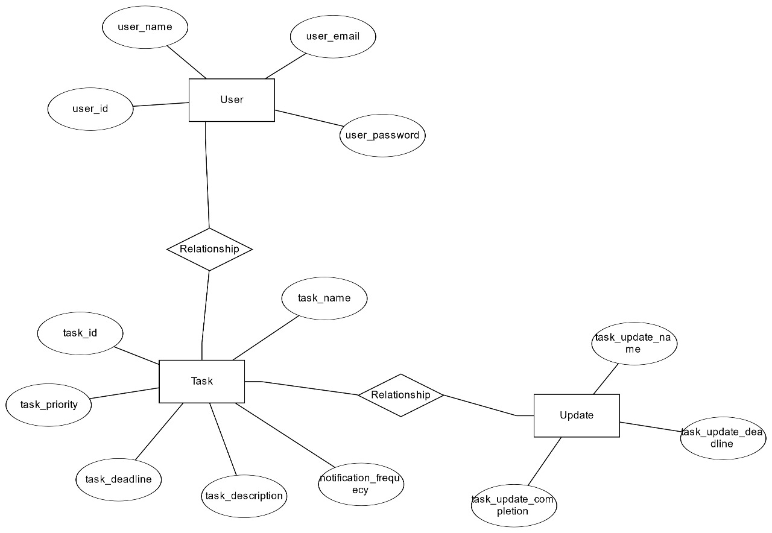

The Task Management System provides real-time online information about tasks, schedules, and user activities. The primary aim of this project is to minimize manual task tracking and enhance efficiency. This software is adept at managing task assignments, progress tracking, status updates, and calculating/managing priorities. It can also generate various reports for record-keeping tailored to the end user's needs. The Project Manager or Team Leader will act as the administrator to control team members and manage tasks. The status of task completion, ongoing work, and pending items is maintained in the task management database. Team member details and task progress can be retrieved by the project manager from the database as needed. Valid team members are also permitted to view their account information and task lists.

## User Classes and Characteristics

The system provides different types of services based on the type of users [Team Member/Project Manager]. The Project Manager will act as the controller and will have all the privileges of an administrator. The team member can be anyone within the organization who will be accessing the Task Management System online.

The features available to the Project Manager are:

* Can assign tasks to team members.
* Can view the different categories of tasks available in the system.
* Can view the list of tasks available in each category.
* Can update the status of tasks as they progress.
* Add tasks and their details to the database.
* Edit the details of existing tasks.
* Can check the report of ongoing and completed tasks.
* Can check the report of tasks assigned to each team member.
* Can access all the accounts of the team members.

The features available to the Team Members are:

* Can view the different categories of tasks available in the system.
* Can view the list of tasks available in each category.
* Can have an account in the task management system.
* Can view the tasks assigned to them.
* Can request assistance or additional resources for a task.
* Can view the history of tasks they have worked on.
* Can search for a particular task or project.

The features available to the Individual users are:

* Create tasks with specific details, deadlines, and attachments.
* Track the progress of tasks from inception to completion.
* Integrate tasks with a calendar for better time management.
* Set reminders for upcoming deadlines and send alerts for overdue tasks.
* Generate personal progress reports to analyze productivity and task completion rates.
* Prioritize tasks based on urgency or importance.
* Categorize tasks into different segments for better organization.
* Search for and filter tasks based on various criteria.
* Break down complex tasks into sub-tasks for manageable execution.
* Set tasks to recur at specified intervals.
* Earn points and badges for completing tasks consistently and punctually.

## Operating Environment

The Task Management System is designed to operate within the Windows environment. It is a desktop application that will function seamlessly on all popular browsers, including Microsoft Edge, Google Chrome, and Mozilla Firefox. Additionally, it will be compatible with the latest versions of these browsers to ensure optimal performance.

The software is intended to be used with an internet connection for synchronization and collaboration features. The recommended hardware configuration for the Task Management System includes a Hard Disk of at least 40 GB, a 15” Color monitor for clear visibility, and a keyboard with 122 keys for comfortable typing.

The basic input devices required are a keyboard and mouse, while the output devices include a monitor and printer for any physical documentation needs. This setup ensures that users have a smooth and efficient experience while managing their tasks.

## Assumptions and Dependencies

The assumptions for the Task Management System are:- The coding should be error-free to ensure reliability.- The system should be user-friendly, allowing for easy navigation and use by all users.- All user information, tasks, and project details must be stored in a database that is accessible through the application.- The system should have ample storage capacity and provide fast access to the database.- It should offer a search facility and support quick transactions for task management.- The Task Management System is available 24 hours a day, accessible from any computer with internet browsing capabilities and an internet connection.- Users must have their correct usernames and passwords to log into their online accounts and perform actions. The dependencies for the Task Management System are:- The specific hardware and software required to run the product effectively.- The project will be developed and run based on the listed requirements and specifications.- The end users (admins and team members) should have a proper understanding of the product.- The system should store general reports and maintain a record of all activities.- All user information must be stored in a database that is accessible through the Task Management System.- Any updates regarding tasks or projects from the team should be recorded in the database, and the data entered must be accurate.

## Requirement

Software Configuration:-

This software package is developed using java as front end which is supported by sun micro system. Microsoft SQL Server as the back end to store the database.

Operating System: Windows NT, windows 98, Windows XP Language: Java Runtime Environment, Net beans 7.0.1 (front end) Database: MS SQL Server (back end)

Hardware Configuration:-

Processor: Pentium(R)Dual-core CPU

Hard Disk: 40GB

RAM: 256 MB or more

## Data Requirement

In the Task Management System, the inputs consist of user queries to the database, such as creating an account, adding tasks, and updating task statuses. The output includes the system's responses to these queries, providing users with details of their tasks, schedules, and progress. For example, when a user requests information from the server, the output will display the date, time, and details of the tasks currently managed within their account. This ensures that users have real-time access to their task management data for effective planning and execution.

# External Interface Requirement

## GUI

The Task Management System offers a robust graphical interface for both users and administrators, allowing them to perform essential tasks such as creating, updating, and viewing task details. Key features include:

* - Quick Reports : Users can generate reports on tasks created, in progress, or completed within a specified period.
* - Task Verification : The system provides verification of task completion and a search facility based on different criteria.
* - Customizable Interface : Administrators can customize the user interface to fit their needs.
* - Module Integration : All modules are designed to integrate seamlessly into the graphical user interface and meet defined standards.
* - Simple Design : The interface follows a standard template for simplicity and consistency across different sections.

Specific interfaces include:

* - Login Interface : Unregistered users can sign up to create an account. Once registered, users can log in by entering their username and password. Incorrect login attempts trigger an error message.
* - Search : Users can search for tasks by entering relevant keywords or titles.
* - Categories View : This view displays the various task categories and allows administrators to add, edit, or delete categories.
* - Administrator’s Control Panel : This panel enables administrators to add or remove users, manage tasks, and configure task assignment options. It also includes login/logout functionalities for user account management.

# System Features

To ensure the security and integrity of user accounts within the Task Management System, the following measures are implemented:

* **User Authentication**: Users are authenticated and validated using their unique member ID to prevent unauthorized access.
* **Administrator Monitoring**: Administrators have the capability to monitor account statuses, issue alerts if a user attempts to exceed task limits set by the system’s policies, and assign consequences for missed deadlines.
* **Accountability**: Measures are in place to prevent users from accessing other members’ accounts. Only administrators have the authority to view and manage all user accounts, ensuring privacy and security.

These provisions are designed to provide users with confidence in the security of their accounts while maintaining proper oversight and accountability within the system.

# Other Non-functional Requirements

## Performance Requirement

The Task Management System we are developing will serve as the central performance system within various departments and teams. It is designed to interact seamlessly with staff and team members, fulfilling all specified requirements.

* System Performance : The system's performance should be fast and accurate, ensuring efficient task management.
* Error Handling : The Task Management System will handle both expected and unexpected errors in ways that prevent loss of information and minimize downtime. It will include built-in error testing to identify invalid usernames/passwords.
* Data Handling : The system will be capable of managing a large volume of data, accommodating a significant number of tasks and users without fault.

These performance requirements are crucial to maintain the system's reliability and effectiveness in managing tasks across the organization.

## Safety Requirement

To safeguard against potential data loss due to database crashes, virus attacks, or operating system failures, it is essential to implement regular database backups for the Task Management System. This ensures that task data and user information can be restored quickly in the event of such incidents. Additionally, having a reliable UPS/inverter setup is crucial to maintain system operations during power outages, preventing data corruption and system downtime. These measures are critical for the continuous and secure operation of the Task Management System.

## Security Requirement

* **Secured Database**: The system will utilize a secured database to protect data integrity and confidentiality.
* **User Permissions**: Normal users will have read-only access to general information but can edit their personal and certain other details.
* **Access Constraints**: Different types of users will be present within the system, each with specific access constraints to ensure appropriate levels of interaction with the system.
* **User Authentication**: Proper user authentication mechanisms will be in place to verify the identity of users before granting access.
* **Password Security**: Measures will be implemented to prevent unauthorized hacking of users’ passwords, ensuring account security.
* **Admin and User Accounts**: Separate accounts for administrators and users will be established. Users will not have access to the database, and only administrators will have the rights to update and manage the database.

## Requirement attributes

In the Task Management System:

* **Multiple Admins**: There may be multiple administrators who have the right to make changes to the system. However, members or other users will not have the capability to make system changes.
* **Open Source**: The project should be open source, allowing for community contributions and transparency in development.
* **Database Quality**: The quality of the database will be maintained to ensure it is user-friendly for all users.
* **Ease of Installation**: Users will be able to easily download and install the system, ensuring accessibility for all potential users.

These guidelines ensure that the system remains flexible, secure, and user-centric.

## Business Rules

In the context of the Task Management System, a business rule encompasses the guidelines and principles that govern the system's use and operation. These rules ensure that all users, including administrators and team members, adhere to the established policies and practices. This includes:

* Cost and Pricing : The cost of using the system and any available discount offers.
* Legal Compliance : Users must comply with all legal rules and protocols related to task management.
* Adherence to Rules : Both administrators and team members are expected to follow the system's rules and regulations without exception.

These business rules are in place to maintain order, fairness, and efficiency within the Task Management System.

## User Requirement

In the Task Management System, the users are team members and project managers who oversee the system's maintenance. Team members are expected to have a basic understanding of computers and internet browsing, while project managers should possess a deeper knowledge of the system's internals and be capable of addressing issues such as disk crashes, power failures, and other unforeseen events.

To facilitate user interaction with the system, a user-friendly interface, comprehensive user manual, online help, and installation and maintenance guides are provided. These resources are designed to educate users on how to use the system effectively.

The project manager, acting as the administrator, offers several facilities to ensure system reliability and data integrity:

* - Backup and Recovery : Regular backups and a robust recovery process to safeguard data.
* - Forgot Password : A secure method for users to reset their passwords if forgotten.
* - Data Migration : Initial user registration data is securely stored on the server.
* - Data Replication : Critical data is replicated to prevent loss in case of local failures.
* - Auto Recovery : The system frequently auto-saves information to prevent data loss.
* - File Organization : Efficient file organization for easy access and management.
* - Server Maintenance : Regular server maintenance and timely updates to ensure optimal performance.

# Other Requirements

## Data and Category Requirement

In the Task Management System, there are different categories of users such as team members, project managers, administrators, etc. Access rights are determined based on the user's category. For example, if the user is an administrator, they have the ability to modify data, delete, append, and perform other administrative tasks. All other users, except for project managers, typically have rights only to retrieve information from the database.

Similarly, there will be different categories of tasks available. According to the categories of tasks, their relevant data should be displayed. The categories and the data related to each category should be coded in a specific format to ensure consistency and ease of use within the system. This structured approach allows for efficient task management and access control based on user roles and responsibilities.

## Appendix

A: Administrator, Abbreviations, Acronyms, Assumptions; B: Business Rules; C: Categories, Clients, Conventions; D: Data Requirements, Dependencies; G: Graphical User Interface (GUI); K: Key; M: Members, Modules; N: Non-functional Requirements; O: Operating Environment; P: Performance, Perspective, Purpose; R: Requirements, Requirement Attributes; S: Safety, Scope, Security, System Features; T: Tasks, Team Members; U: Users, User Classes and Characteristics, User Requirements

## Glossary

* **Administrator**: A user with administrative privileges within the software, capable of managing system settings and user accounts.
* **User**: A general login ID assigned to team members who interact with the system.
* **Client**: The intended users or organizations for the software.
* **SQL (Structured Query Language)**: Used to retrieve and manipulate information from the system’s database.
* **SQL Server**: A server that stores data in an organized format for the Task Management System.
* **Layer**: Represents a distinct section or level of the project architecture.
* **User Interface Layer**: The part of the system that users interact with directly.
* **Application Logic Layer**: The server-side component where all computations and business logic are processed.
* **Data Storage Layer**: The component of the system where all data is stored and managed.
* **Use Case**: A high-level diagram providing an overview of the system’s functionality.
* **Class Diagram**: A static structure diagram that outlines the system’s structure, showing classes, their attributes, and the relationships between them.
* **Interface**: The means by which different components of the system communicate with each other.
* **Unique Key**: An identifier used to distinguish individual records in the database.

## Class Diagram

In the context of a Task Management System, a class is a blueprint that defines the structure of a type of data relevant to task management. It specifies the attributes of the data and the operations that can be performed on instances (i.e., objects) of the data. A class has a name, a set of attributes that describe its characteristics, and a set of operations that can be performed on the objects of that class. The static model represents the classes’ structure and their relationships at a given momen

* **Task**: Represents an individual task with attributes such as title, description, deadline, and status. Operations might include creating, updating, or completing a task.
* **Project**: A collection of tasks that form a larger goal. Attributes include project name, start date, end date, and members involved.
* **User**: Represents a person using the system, with attributes like username, password, and role. Operations include login, logout, and update profile.
* **Team**: A group of users working together. Attributes include team name and members. Operations might include adding or removing members.

These classes are related to other classes necessary for their functioning, with different types of relationships such as association, aggregation, and generalization depicted using role names and multiplicities. For example, a **User** may be associated with multiple **Tasks**, and a **Project** may aggregate multiple **Tasks**. Generalization might be used where a **Team Leader** class is a specialized form of the **User** class with additional privileges.