SOFTWARE REQUIREMENTS SPECIFICATION

**For**

**E-Learning Management System**

**Prepared by:-**

*Harish J*

*Manoj PD*

*Mukesh P*

# Introduction

## Purpose

A learning management system (LMS) is a software application for the administration, documentation, tracking, reporting, automation, and delivery of educational courses, training programs, materials, or learning and development programs. The learning management system concept emerged directly from e-learning. Learning management systems make up the largest segment of the learning system market. The first introduction of the LMS was in the late 1990s.

Learning management systems have faced a massive growth in usage due to the emphasis on remote learning during the COVID-19 pandemic. Learning management systems were designed to identify training and learning gaps using analytical data and reporting. LMSs are focused on online learning delivery but support a range of uses, acting as a platform for online content, including courses, both asynchronous-based and synchronous-based.

## Scope of Development Project

E-Learning Management System is basically updating the education system into an internet-based application so that the users can know the details of their accounts, availability of books.

The project is specifically designed for the use of E-Learning users. The product will work as a complete user interface for E-Learning management process and E-book usage from ordinary users. E-Learning Management System can be used by any existing or new E-books to manage its content, insertion and monitoring.

The project can be easily implemented under various situations. We can add new features as and when we require, making reusability possible as there is flexibility in all the modules.

The language used for developing the project is Java as it is quite advantageous than other languages in terms of performance, tools available, cross platform compatibility, libraries, cost (freely available), and development process.

## Definitions, Acronyms and Abbreviations

JAVA -> platform independence SQL-> Structured query Language ER-> Entity Relationship

UML -> Unified Modeling Language

IDE-> Integrated Development Environment SRS-> Software Requirement Specification

LMS-> Learning Management System

## References

* + - Books

 Software Requirements and Specifications: **"E-Learning: Strategies for Delivering Knowledge in the Digital Age" by Marc J. Rosenberg**

**"Software Requirements" by Karl Wiegers and Joy Beatty**

Software Engineering: How To Get the Most Out of Your First Year Using An LMS

* + - Websites

<https://elearningindustry.com/free-learning-management-system-lms-ebooks-ultimate-list>

<http://ebookily.net/doc/srs-E-learning-management-system>

# Overall Descriptions

## Product Function

Entity Relationship Diagram of Learning Management System

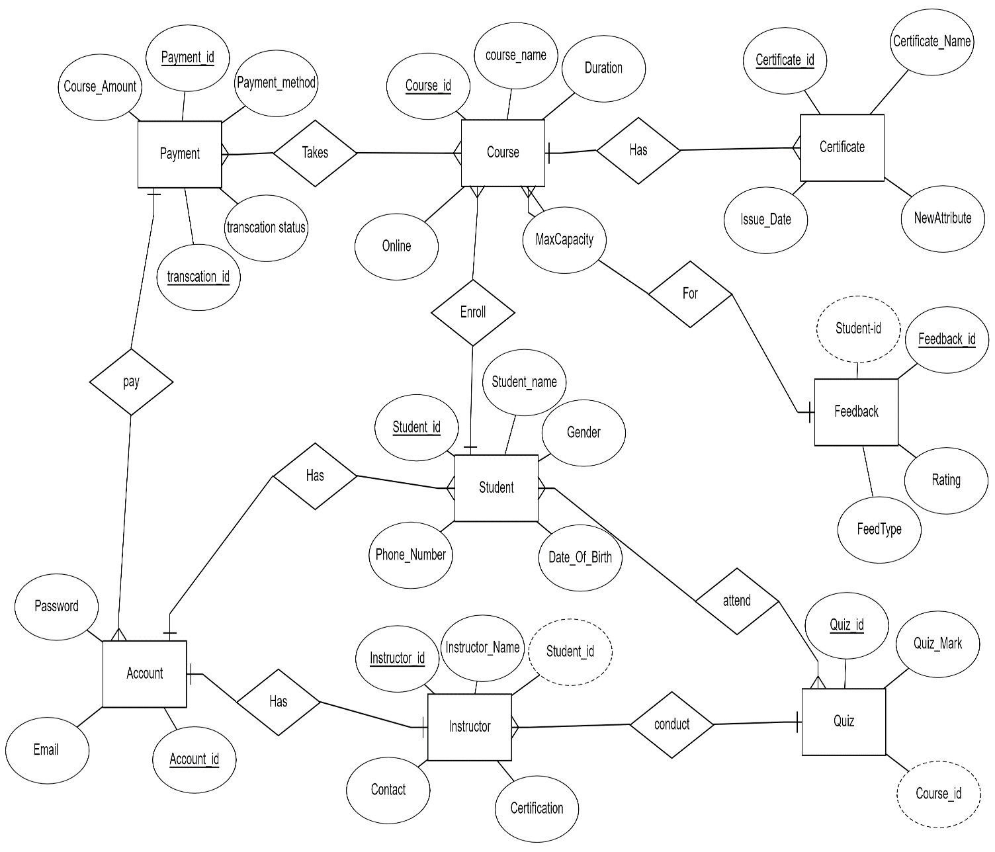

The Online Library System provides online real time information about the books available in the Library and the user information. The main purpose of this project is to reduce the manual work. This software is capable of managing Book Issues, Returns, Calculating/Managing Fine, Generating various Reports for Record-Keeping according to end user requirements. The Librarian will act as the administrator to control members and manage books. The member’s status of issue/return is maintained in the library database. The member’s details can be fetched by the librarian from the database as and when required. The valid members are also allowed to view their account information.

## 2.3User Classes and Characteristics

The logical characteristics of each interface between the software product and its user This includes the required screen formats, page or window layouts, the content of any reports or menus, or the availability of programmable function keys necessary to accomplish the software requirements. interface optimization methods and the people responsible for them. A simple list of dos and don’ts will do the trick.

A LMS can issue a book to the member

* + - Can view the different categories of e-books available in the website
    - Can view the List of mangement available in each category
    - Can take the e-book for free or paid
    - Add course and their information to the database

The features that are available to the Members are

* + - Can view the different categories of e-books available in the website
    - Can view the List of e-books available in each category
    - Can own an account in the management.
    - Can view the e-books recommended to him
    - Can put a request for a new e-book
    - Can view the history of e-books recommended to him previously
    - Can search for a particular e-book

## Operating Environment

Web technology tools have now developed to facilitate social aspects of networking such as online forums and space for online chat. These tools support online interactions in the form of dialogue and conversation to take shape within the e-learning environment

## Assumptions and Dependencies

The assumptions are

* + - The coding should be error free
    - The system should be user-friendly so that it is easy to use for the users
    - The information of all users, e-books and data must be stored in a database tha
    - Users must have their correct usernames and passwords to enter into their online accounts and do actions

The dependencies are:-

* + - The specific hardware and software due to which the product will be run
    - On the basis of listing requirements and specification the project will be developed and run
    - The end users (admin) should have proper understanding of the product
    - The system should have the general report stored
    - The information of all the users must be stored in a database that is accessible by the E- Learning System
    - Any update regarding the e-book from the website is to be recorded to the database and the data entered should be correct

## Requirement

Software Configuration

This software package is developed using java as front end which is supported by sun micro system. Microsoft SQL Server as the back end to store the database.

Operating System: Windows NT, windows 98, Windows XP Language: Java Runtime Environment, Net beans 7.0.1 (front end) Database: MS SQL Server (back end)

Hardware Configuration

Processor: Pentium(R)Dual-core CPU Hard Disk: 40GB

RAM: 256 MB or more

## Data Requirement

The inputs consist of the query to the database and the output consists of the solutions for the query. The output also includes the user receiving the details of their accounts. In this project the inputs will be the queries as fired by the users like create an account, selecting books and putting into account. Now the output will be visible when the user requests the server to get details of their account in the form of time, date and which books are currently in the account.

# External Interface Requirement

## GUI

The software provides good graphical interface for the user and the administrator can operate on the system, performing the required task such as create, update, viewing the details of the e-book.

* + - It allows user to view quick reports like Book Issued in between particular time.
    - It provides stock verification and search facility based on different criteria.
    - The user interface must be customizable by the administrator
    - All the modules provided with the software must fit into this graphical user interface and accomplish to the standard defined
    - The design should be simple and all the different interfaces should follow a template
    - The user interface should be able to interact with the user management module and a part of the interface must be dedicated to the login/logout module

Login Interface

In case the user is not yet registered, he can enter the details and register to create his account. Once his account is created he can ‘Login’ which asks the user to type his username and password. If the user entered either his username or password incorrectly then an error message appears.

Search

The member or librarian can enter the type of e-book he is looking for and the title he is interested in, then he can search for the required e-book by entering the book name.

Categories View

Categories view shows the categories of e-books available and provides ability to the learner to add/edit or delete category from the list.

Learner’s Control Panel

This control panel will allow learner to add/remove users; add, edit, or remove a resource. And manage lending options.

# System Features

The users of the system should be provided the surety that their account is secure. This is possible by providing:-

* User authentication and validation of members using their unique member ID
* Proper monitoring by the administrator which includes updating account status, showing a popup if the member attempts to issue number of e-books that exceed the limit provided by the website policy, assigning fine to members who skip the date of return
* Proper accountability which includes not allowing a member to see other member’s account. Only administrator will see and manage all member accounts

# Other Non-functional Requirements

## Performance Requirement

The proposed system that we are going to develop will be used as the Chief performance system within the different campuses of the university which interacts with the university staff and students. Therefore, it is expected that the database would perform functionally all the requirements that are specified by the university.

* + - The performance of the system should be fast and accurate
    - Leaning Management System shall handle expected and non-expected errors in ways that prevent loss in information and long downtime period. Thus it should have inbuilt error testing to identify invalid username/password
    - The system should be able to handle large amount of data. Thus it should accommodate high number of e-books and users without any fault

## Safety Requirement

The database may get crashed at any certain time due to virus or operating system failure. Therefore, it is required to take the database backup so that the database is not lost. Proper UPS/inverter facility should be there in case of power supply failure.

## Security Requirement

* + - System will use secured database
    - Normal users can just read information but they cannot edit or modify anything except their personal and some other information.
    - System will have different types of users and every user has access constraints
    - Proper user authentication should be provided
    - No one should be able to hack users’ password
    - There should be separate accounts for admin and members such that no member can access the database and only admin has the rights to update the database.

## Requirement attributes

* + - There may be multiple admins creating the project, all of them will have the right to create changes to the system. But the members or other users cannot do changes
    - The project should be open source
    - The Quality of the database is maintained in such a way so that it can be very user friendly to all the users of the database
    - The user be able to easily download and install the system

## Business Rules

A business rule is anything that captures and implements business policies and practices. A rule can enforce business policy, make a decision, or infer new data from existing data.This includes the rules and regulations that the System users should abide by. This includes the cost of the project and the discount offers provided. The users should avoid illegal rules and protocols. Neither admin nor member should cross the rules and regulations.

## User Requirement

The users of the system are members and Leaner of the university who act as administrator to maintain the system. The members are assumed to have basic knowledge of the computers and internet browsing. The administrators of the system should have more knowledge of the internals of the system and is able to rectify the small problems that may arise due to disk crashes, power failures and other catastrophes to maintain the system. The proper user interface, user manual, online help and the guide to install and maintain the system must be sufficient to educate the users on how to use the system without any problems.

The admin provides certain facilities to the users in the form of:-

* + - Backup and Recovery
    - Forgot Password
    - Data migration
    - Data replication i.e. if the data is lost in one branch, it is still stored with the server
    - Auto Recovery i.e. frequently auto saving the information
    - Maintaining files i.e. File Organization
    - The server must be maintained regularly and it has to be updated from time to time

# Other Requirements

## Data and Category Requirement

There are different categories of users namely teaching staff, Admin, students etc. Depending upon the category of user the access rights are decided.It means if the user is an administrator then he can be able to modify the data,delete, append etc. All other users except the owner only have the rights to retrieve the information about database. Similarly there will be different categories of books available. According to the categories of books their relevant data should be displayed. The categories and the data related to each category should be coded in the particular format.

## Appendix

A: Admin, Abbreviation, Acronym, Assumptions; B: Books, Business rules; C: Class, Client, Conventions; D: Data requirement, Dependencies; G: GUI; K: Key; L: Learner; M: Member; N: Non-functional Requirement; O: Operating environment; P: Performance,Perspective,Purpose; R: Requirement, Requirement attributes; S: Safety, Scope, Security, System features; U: User, User class and characteristics, User requirement;

## Glossary

The following are the list of conventions and acronyms used in this document and the project as well:

* + - Administrator: A login id representing a user with user administration privileges to the software
    - User: A general login id assigned to most users
    - Client: Intended users for the software
    - SQL: Structured Query Language; used to retrieve information from a database
    - SQL Server: A server used to store data in an organized format
    - Layer: Represents a section of the project
    - User Interface Layer: The section of the assignment referring to what the user interacts with directly
    - Application Logic Layer: The section of the assignment referring to the Web Server. This is where all computations are completed
    - Data Storage Layer: The section of the assignment referring to where all data is recorded
    - Use Case: A broad level diagram of the project showing a basic overview
    - Class diagram: It is a type of static structure diagram that describes the structure of a system by showing the system’s cases, their attributes, and the relationships between the classes
    - Interface: Something used to communicate across different mediums
    - Unique Key: Used to differentiate entries in a database

## Class Diagram

A class is an abstract, user-defined description of a type of data. It identifies the attributes of the data and the operations that can be performed on instances (i.e. objects) of the data. A class of data has a name, a set of attributes that describes its characteristics, and a set of operations that can be performed on the objects of that class. The classes’ structure and their relationships to each other frozen in time represent the static model. In this project there are certain main classes

which are related to other classes required for their working. There are different kinds of relationships between the classes as shown in the diagram like normal association, aggregation, and generalization. The relationships are depicted using a role name and multiplicities. Here ‘Owner’, ‘Member’ and ‘E-books’ are the most important classes which are related to other classes.

