SOFTWARE REQUIREMENTS SPECIFICATION

**For**

**JOB PORTAL**

By

Kasiram R

Meganathan V

Mukesh Kumar B

# Introduction

## Purpose

In a world of endless possibilities and evolving career landscapes, finding the perfect job that aligns with your skills, passions, and aspirations can be a challenging journey. That's where [Job Portal Name] comes in – your trusted partner in navigating the exciting realm of employment opportunities.

* At [Job Portal Name], we understand the significance of meaningful work and the impact it has on your life. Whether you are a seasoned professional seeking new challenges or a fresh graduate embarking on your professional journey, our job portal is designed to connect you with a diverse array of opportunities that match your unique talents and ambitions.

## Scope of Development Project

* User Profiles: Easy registration and profile creation with document upload features.
* Job Listings: Advanced search, filters, and categorized by industry, location, and experience.
* Employer Portal: Dedicated space for job posting and tools for managing listings.
* Matching Algorithms: Precision in job-seeker matching with machine learning integration.
* Communication: Messaging systems for user-employer interaction and timely notifications.
* Mobile Responsiveness: User-friendly experience across devices.
* Security: Robust measures to protect user data.
* Analytics and Reporting: Track user engagement and job listing effectiveness.
* Social Integration: Social media login and sharing features.
* Career Resources: Advice section and collaboration with experts.
* Feedback and Ratings: Systems for user reviews and employer ratings.
* Global Support: Multi-language features for a global user base.
* Monetization: Explore subscription plans, sponsored listings, and freemium models.
* Continuous Improvement: Regular updates based on user feedback and market trends.

## Definitions, Acronyms and Abbreviations

JAVA -> platform independence SQL -> Structured

query Language

ER -> Entity Relationship

UML -> Unified Modeling Language

IDE -> Integrated

Development Environment

SRS -> Software

Requirement Specification

## References

* + - Books

 Software Requirements and Specifications: A Lexicon of Practice, Principles and Prejudices (ACM Press) by Michael Jackson

Software Requirements (Microsoft) Second Edition By Karl E. Wiegers

Software Engineering: A Practitioner’s Approach Fifth Edition By Roger S. Pressman

* + - Websites

[**http://www.slideshare.net/**](http://www.slideshare.net/)

[**http://ebookily.net/doc/srs-library-management-system**](http://ebookily.net/doc/srs-library-management-system)

# Overall Descriptions

## Product Perspective

Use Case Diagram of Library Management System

The use case diagram for the job portal illustrates the essential interactions between job seekers, employers, and the system. Job seekers log in, create profiles, and search for jobs, while employers post openings, review applications, and communicate with candidates. The system facilitates these interactions, ensuring a seamless experience.

Use cases include profile management, job searching, application processes, and communication tools, collectively enhancing the overall functionality and efficiency of the job portal.

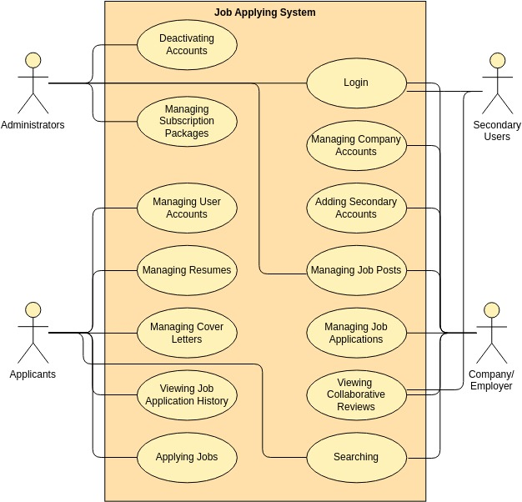

## Product Function

Entity Relationship Diagram of Library Management System

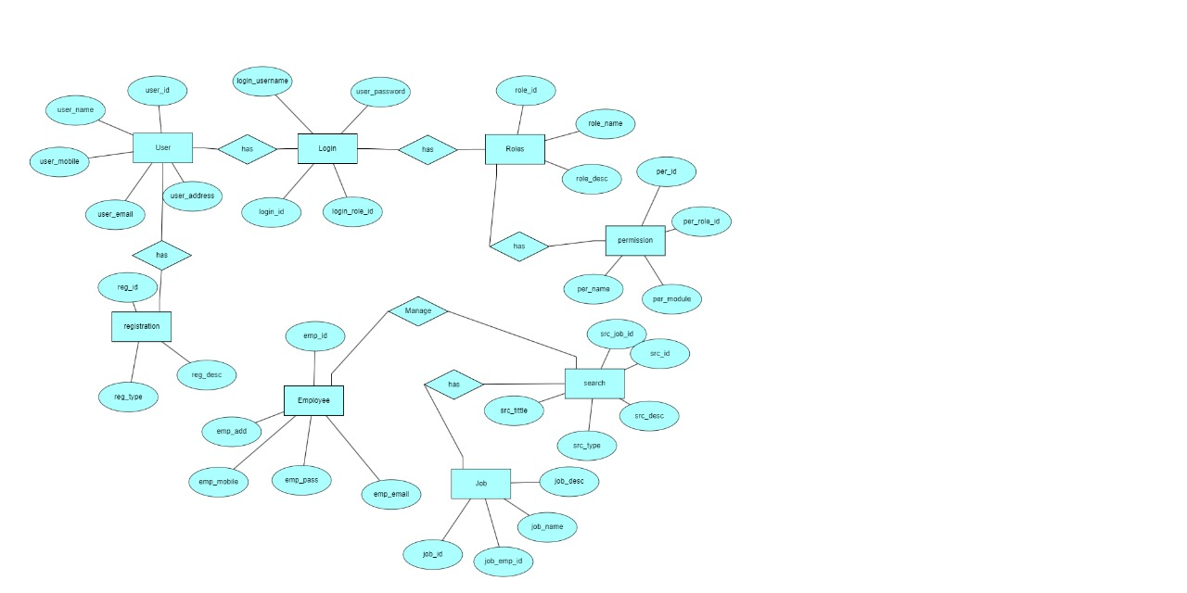

The Online Library System provides online real time information about the books available in the Library and the user information. The main purpose of this project is to reduce the manual work. This software is capable of managing Book Issues, Returns, Calculating/Managing Fine, Generating various Reports for Record-Keeping according to end user requirements. The Librarian will act as the administrator to control members and manage books. The member’s status of issue/return is maintained in the library database. The member’s details can be fetched by the librarian from the database as and when required. The valid members are also allowed to view their account information.

## 2.3 User Classes and Characteristics

* + - Individual Professionals: Job seekers encompass a wide range of professionals, from recent graduates to experienced professionals seeking new opportunities.
    - Diverse Skill Sets: Users possess varied skill sets, educational backgrounds, and experience levels across different industries.
    - Career Goals: Motivated by different career goals, including career growth, job satisfaction, and alignment with personal values.
    - Employers:
    - Small Businesses to Enterprises: Employers on the portal may range from small businesses to large enterprises, each with distinct hiring needs.
    - HR Professionals and Hiring Managers: Users represent HR professionals and hiring managers responsible for talent acquisition and recruitment.
    - Industry Specifics: Characteristics vary based on the industry, with diverse requirements for skill sets, experience, and qualifications.

## 

## 2.4 Operating Environment

The product will be operating in windows environment. The Library Management System is a website and shall operate in all famous browsers, for a model we are taking Microsoft Internet Explorer , Google Chrome ,and Mozilla Firefox .Also it will be compatible with the IE 6.0. Most of the features will be compatible with the Mozilla Firefox & Opera 7.0 or higher version. The only requirement to use this online product would be the internet connection.

The hardware configuration include Hard Disk: 40 GB, Monitor: 15” Color monitor, Keyboard: 122 keys. The basic input devices required are keyboard, mouse and output devices are monitor, printer etc.

## 

## 2.5 Assumptions and Dependencies

The assumptions are:-

* + - The coding should be error free
    - The system should be user-friendly so that it is easy to use for the users
    - The information of all users, books and libraries must be stored in a database that is accessible by the website
    - The system should have more storage capacity and provide fast access to the database
    - The system should provide search facility and support quick transactions
    - The Library System is running 24 hours a day
    - Users may access from any computer that has Internet browsing capabilities and an Internet connection
    - Users must have their correct usernames and passwords to enter into their online accounts and do actions

The dependencies are:-

* + - The specific hardware and software due to which the product will be run
    - On the basis of listing requirements and specification the project will be developed and run
    - The end users (admin) should have proper understanding of the product
    - The system should have the general report stored
    - The information of all the users must be stored in a database that is accessible by the Library System
    - Any update regarding the book from the library is to be recorded to the database and the data entered should be correct

## Requirement

Software Configuration:-

This software package is developed using java as front end which is supported by sun micro system. Microsoft SQL Server as the back end to store the database.

Operating System: Windows NT, windows 98, Windows XP Language: Java Runtime Environment, Net beans 7.0.1 (front end) Database: MS SQL Server (back end)

Hardware Configuration:-

Processor: Pentium(R)Dual-core CPU Hard Disk: 40GB

RAM: 256 MB or more

## Data Requirement

The inputs consist of the query to the database and the output consists of the solutions for the query. The output also includes the user receiving the details of their accounts. In this project the inputs will be the queries as fired by the users like create an account, selecting books and putting into account. Now the output will be visible when the user requests the server to get details of their account in the form of time, date and which books are currently in the account.

# 3.External Interface Requirement

## GUI

User Authentication:

* Integration with external systems for secure user authentication, possibly through social media logins or third-party identity verification services.
* Resume and Document Upload:
* Compatibility with various file formats, such as PDF and Word, for resume and document uploads.
* Integration with cloud storage services like Google Drive or Dropbox.
* Job Aggregator Integration:
* API integration with external job aggregators for additional job listings and real-time updates.
* Communication Channels:
* Integration with email services for notifications and communication between users and employers.
* Facilitation of communication through external messaging platforms if desired.
* Social Media Integration:
* Enable users to share job listings or their profiles on social media platforms.
* Allow users to register or log in using their social media accounts.
* Mobile Responsiveness:
* Cross-platform compatibility, ensuring the GUI is responsive and compatible with various devices.
* Integration with mobile applications if applicable for a seamless transition between web and app experiences.
* Payment Gateway:
* Integration with external payment gateways for secure transactions, especially for premium features or subscription plans.
* Analytics and Tracking Tools:
* Interface with external analytics tools to track user behavior, engagement, and website traffic.
* Optimization for search engines with SEO tools and plugins.
* Career Resources and Content:
* Inclusion of external content, such as career advice articles, webinars, or industry-related news.
* Feedback and Review Platforms:
* Interface with external review platforms to display employer ratings and reviews.
* Provision of external links or forms for users to submit feedback.
* Language Translation Services.
* Integration with external translation services for multi-language support, catering to a global audience.

# 4.System Features

User Registration and Profiles:

* + - User-friendly registration process.
    - Comprehensive user profiles with sections for education, experience, skills, and contact information.
    - Job Listings:
    - Advanced search and filter options for job seekers.
    - Easy-to-use job posting interface for employers.
    - Application Management:
    - Seamless application process for job seekers.
    - Application tracking and management tools for both job seekers and employers.
    - Resume and Document Upload:
    - Capability for users to upload and manage resumes and supporting documents.
    - Option for employers to view and download applicant documents.
    - Matching Algorithms:
    - Smart algorithms for personalized job recommendations.
    - Compatibility matching based on skills, qualifications, and job requirements.
    - Communication Tools:
    - Messaging system for direct communication between job seekers and employers.
    - Notifications for application updates, interview requests, and other relevant information.
    - Employer Accounts:
    - Dedicated portal for employers to post and manage job listings.
    - Tools for employers to review applicant profiles and communicate with potential hires.
    - Mobile Responsiveness:
    - Mobile-friendly design for easy access on smartphones and tablets.
    - Native mobile applications for enhanced user experience.
    - Security Measures:
    - Robust data security features to protect user information.
    - Secure authentication and authorization protocols.
    - Analytics and Reporting:
    - Tracking and reporting tools for user engagement, job listing effectiveness, and other relevant metrics.
    - Insights for employers on the performance of their job listings.
    - Social Media Integration:
    - Social media login options for users.
    - Sharing features for job listings on social platforms.
    - Career Resources Section:
    - Articles, guides, and resources for career development.
    - Integration with external content providers for additional resources.
    - Feedback and Ratings:
    - Systems for users to provide feedback on job listings and employers.
    - Employer ratings and reviews to assist job seekers in decision-making.
    - Global Support:
    - Multi-language support for a global user base.
    - Consideration of regional job markets and industry-specific needs.
    - Monetization Strategies:

## Performance Requirement

The proposed system that we are going to develop will be used as the Chief performance system within the different campuses of the university which interacts with the university staff and students. Therefore, it is expected that the database would perform functionally all the requirements that are specified by the university.

4.1.1 The performance of the system should be fast and accurate

4.1.2 Library Management System shall handle expected and non-expected errors in ways

that prevent loss in information and long downtime period.

Thus it should have inbuilt error testing to identify invalid username/password

4.1.3 The system should be able to handle large amount of data.

Thus it should accommodate high number of books and users without any fault

## Safety Requirement

The database may get crashed at any certain time due to virus or operating system failure. Therefore, it is required to take the database backup so that the database is not lost. Proper UPS/inverter facility should be there in case of power supply failure.

## 4.3 Security Requirement

* + - Implement secure authentication measures, including robust password storage, multi-factor authentication, and regular password policy enforcement.
    - Utilize encryption protocols (SSL/TLS) to secure data transmission, safeguarding user credentials and personal information during communication.
    - Access Control:
    - Establish role-based access control to limit user privileges based on responsibilities, preventing unauthorized access to sensitive functionalities and data.
    - Vulnerability Management:
    - Conduct regular security audits and vulnerability assessments to identify and address potential weaknesses. Apply timely updates and patches to all system components.
    - Protection Against Web Attacks:
    - Implement measures to protect against common web application attacks, such as SQL injection and cross-site scripting, ensuring the integrity of the system's codebase.
    - Data Privacy and Compliance:
    - Ensure compliance with data protection regulations (e.g., GDPR, HIPAA), including obtaining user consent, transparent privacy policies, and mechanisms for data deletion upon user request.

## 4.4 Requirement attributes

* + - There may be multiple admins creating the project, all of them will have the right to create changes to the system. But the members or other users cannot do changes
    - The project should be open source
    - The Quality of the database is maintained in such a way so that it can be very user friendly to all the users of the database
    - The user be able to easily download and install the system

## 4.5 Business Rules

A business rule is anything that captures and implements business policies and practices.

A rule can enforce business policy, make a decision, or infer new data from existing data.

This includes the rules and regulations that the System users should abide by. This includes the cost of the project and the discount offers provided. The users should avoid illegal rules and protocols. Neither admin nor member should cross the rules and regulations.

## 4.6 User Requirement

The users of the system are members and Librarian of the university who act as administrator to maintain the system. The members are assumed to have basic knowledge of the computers

and internet browsing. The administrators of the system should have more knowledge of the internals of the system and is able to rectify the small problems that may arise due to disk crashes, power failures and other catastrophes to maintain the system. The proper user interface, user manual, online help and the guide to install and maintain the system must be sufficient to educate the users on how to use the system without any problems.

The admin provides certain facilities to the users in the form of:-

* + - Backup and Recovery
    - Forgot Password
    - Data migration i.e. whenever user registers for the first time then the data is stored in the server
    - Data replication i.e. if the data is lost in one branch, it is still stored with the server
    - Auto Recovery i.e. frequently auto saving the information
    - Maintaining files i.e. File Organization
    - The server must be maintained regularly and it has to be updated from time to time

# 5. Other Requirements

## Data and Category Requirement

A robust job portal requires a well-structured and organized system for managing data and categories to effectively connect job seekers with suitable opportunities. This involves two primary components: user data and job data.

On the user side, comprehensive profiles are essential. The system needs to capture diverse information, including educational background, work experience, skills, and contact details. Additionally, the portal should facilitate the seamless upload and management of resumes and supporting documents, providing a holistic view of each candidate's qualifications.

Job data is equally crucial. The system should allow employers to post detailed job listings, including information on job requirements, responsibilities, qualifications, and application deadlines. Advanced categorization based on industry, location, experience level, and job type enhances search functionalities for job seekers, ensuring they can efficiently find relevant opportunities.

Implementing matching algorithms is key to the success of a job portal. These algorithms leverage

the data collected to suggest personalized job recommendations to users based on their skills,

qualifications, and preferences. Smart categorization and filtering mechanisms play a vital role in optimizing

search results and enhancing the overall user experience.

## 5.2 Appendix

A: Admin, Abbreviation, Acronym, Assumptions; B: Books, Business rules;

C: Class, Client, Conventions; D: Data requirement, Dependencies; G: GUI; K: Key; L: Library,

Librarian; M: Member; N: Non-functional Requirement; O: Operating environment; P: Performance,Perspective,Purpose; R: Requirement, Requirement attributes;

S: Safety, Scope, Security, System features; U: User, User class and characteristics, User requirement;

## 5.3 Glossary

The following are the list of conventions and acronyms used in this document and the project as well:

* + 1. Administrator: A login id representing a user with user administration privileges to the software
    2. User: A general login id assigned to most users
    3. Client: Intended users for the software
    4. SQL: Structured Query Language; used to retrieve information from a database
    5. SQL Server: A server used to store data in an organized format

5.1.6 Layer: Represents a section of the project

5.1.7 User Interface Layer: The section of the assignment referring to what

the user interacts with directly

5.1.8 Application Logic Layer: The section of the assignment referring to

the Web Server. This is where all computations are completed

5.1.9 Data Storage Layer: The section of the assignment referring to where all

data is recorded

* + 1. Use Case: A broad level diagram of the project showing a basic overview
    2. Class diagram: It is a type of static structure diagram that describes

the structure of a system by showing the system’s cases, their

attributes, and the relationships between the classes

* + 1. Interface: Something used to communicate across different mediums
    2. Unique Key: Used to differentiate entries in a database

## Class Diagram

A class is an abstract, user-defined description of a type of data. It identifies the attributes of the data and the operations that can be performed on instances (i.e. objects) of the data. A class of data has a name, a set of attributes that describes its characteristics, and a set of operations that can be performed on the objects of that class. The classes’ structure and their relationships to each other frozen in time represent the static model. In this project there are certain main class

Which are related to other classes required for their working. There are different

kinds of relationships between the classes as shown in the diagram like normal

association, aggregation, and generalization. The relationships are depicted using a role

name and multiplicities. Here ‘Librarian’, ‘Member’ and ‘Books’ are the most important

classes which are related to other classes.

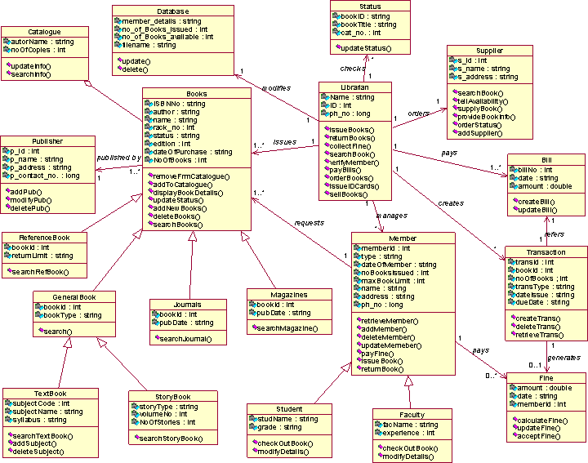 Class diagram representation :