SOFTWARE REQUIREMENTS SPECIFICATION

**For**

**Event management System**

**Prepared by:-**

*A.Barani Priyadharshini*

*S.Kavinaya*

*S.Jeyagowtham*

# Introduction

## Purpose

The primary aim of this document is to delineate the requisites for the Event Management System project. This document offers a comprehensive overview of the functional and non-functional requirements set forth by the client. The project seeks to establish an efficient platform for orchestrating and managing various events seamlessly. The overarching goal is to create a user-friendly environment for organizing and overseeing events, ensuring a streamlined process.

## Document Conventions

* + - Entire document should be justified.
    - Convention for Main title

Font face: Times New Roman Font style: Bold

Font Size: 14

* + - Convention for Sub title

Font face: Times New Roman Font style: Bold

Font Size: 12

* + - Convention for body

Font face: Times New Roman Font Size: 12

## Scope of Development Project

The Event Management System project aims to transition traditional event planning methods into an internet-based application, offering users a comprehensive platform to access critical event details. This system caters specifically to event planners and participants, serving as an intuitive user interface for the entire event management lifecycle. Its functionalities include event scheduling, venue selection, participant registration, and communication tools. The system ensures efficient collaboration among event organizers and provides real-time information on event status, attendee lists, and scheduling. This versatile project is adaptable to various scenarios, allowing for the incorporation of new features and modifications to meet evolving requirements. The flexibility in modules facilitates easy implementation, making it suitable for both existing and new event management scenarios. Developed using Java, the system leverages the language's performance, cross-platform compatibility, extensive libraries, and cost-effectiveness, ensuring a robust and user-friendly solution for optimizing the event planning process.

## Definitions, Acronyms and Abbreviations

JAVA -> platform independence SQL-> Structured query Language ER-> Entity Relationship

UML -> Unified Modeling Language

IDE-> Integrated Development Environment SRS-> Software Requirement Specification

## References

* + - Books

 Event Management and Specifications: A Lexicon of Practice, Principles and Prejudices (ACM Press) by Michael Jackson

Event Requirements (Microsoft) Second Edition by Karl E. Wiegers

Event Engineering: A Practitioner’s Approach Fifth Edition by Roger S. Pressman

* + - Websites

[**http://www.slideshare.net/**](http://www.slideshare.net/)

[**Event Management System Specification on ebookily.net**](http://ebookily.net/doc/srs-event-management-system)

# Overall Descriptions

## Product Perspective

Use Case Diagram of Event Management System

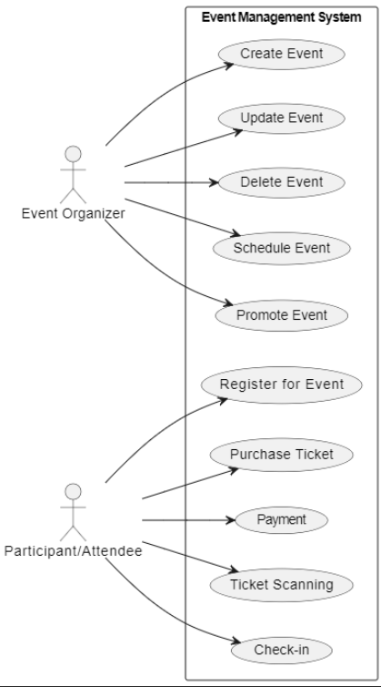

This use case diagram provides a structured representation of the interactions and functionalities of an Event Management System, considering the roles of staff members (event organizers) and students (attendees). It outlines the key processes such as event creation, management, registration, and feedback.