SOFTWARE REQUIREMENTS SPECIFICATION

**For**

**Pet Adoption System**

**Prepared by:-**

*Algotutor Academy*

# Introduction

## Purpose

The primary objective of a pet adoption system application is to streamline and simplify the pet adoption process, making it easier for potential adopters to find and adopt suitable pets. By providing a user-friendly interface, comprehensive pet profiles, and efficient matching algorithms, the app encourages responsible pet ownership and reduces the number of animals in shelters. This project describes the hardware and software interface requirements using ER diagrams and UML diagrams.

## Document Conventions

* + - Entire document should be justified.
    - Convention for Main title

Font face: Times New Roman Font style: Bold

Font Size: 14

* + - Convention for Sub title

Font face: Times New Roman Font style: Bold

Font Size: 12

* + - Convention for body

Font face: Times New Roman Font Size: 12

## Scope of Development Project

The scope of development for a pet adoption system application encompasses a range of features and functionalities designed to streamline the adoption process, enhance animal welfare, and foster community engagement.

The core functionalities include managing a comprehensive database of adoptable pets, enabling potential adopters to search and filter based on specific criteria, facilitating online adoption applications, and providing communication channels between shelters and adopters.

Additional features can include personality-based matching algorithms, enhanced pet profiles with videos and breed-specific information, a gamification system to reward responsible pet ownership practices, and integration with social media platforms for sharing pet profiles and adoption stories.

## Definitions, Acronyms and Abbreviations

JAVA -> platform independence SQL-> Structured query Language ER-> Entity Relationship

UML -> Unified Modeling Language

IDE-> Integrated Development Environment SRS-> Software Requirement Specification

## References

* + - Websites

Adoptapet - **https://sketchelements.com/adopt-a-pet-app/**

**Petfinder -** [**https://petfinder.com/tools-widgets/custom-pet-list/getting-started/**](https://petfinder.com/tools-widgets/custom-pet-list/getting-started/)

**Benji - https://shoutoutla.com/meet-krisztina-marosi-founder-ceo-find-benji/**

**Pet Search -** [**https://search.muz.li/OThlNWMyYzUz**](https://search.muz.li/OThlNWMyYzUz)

# Overall Descriptions

## Product Perspective

Use Case Diagram of Library Management System

*searches*

1

1 *requests*

1

1

1..*

*

search_book



1..*

check_limit

check_availability

Adoptor1

issue_book

*request_renew*

<<include>>

*monitors_request*

1

*monitors_renew* 1

1

*performs*

<<include>>

0..*

1..*

renew_book

verify_member

<<include>>

*take_book*

1

1 Adoption center

Student

0..*

1..*

*adds_new_book*

*perform_transaction_updation*

Staff

*

return_book

View_logs

<<extend>>

add_book

*

calculate_fine

update_record

This is a broad level diagram of the project showing a basic overview. The users can be either staff or student.. This System will provide a search functionality to facilitate the search of resources. This search will be based on various categories viz. book name or the ISBN. Further the library staff personnel can add/update the resources and the resource users from the

system.The users of the system can request issue/renew/return of books for which they would have to follow certain criteria.

## Product Function

Entity Relationship Diagram of Pet Adoption System

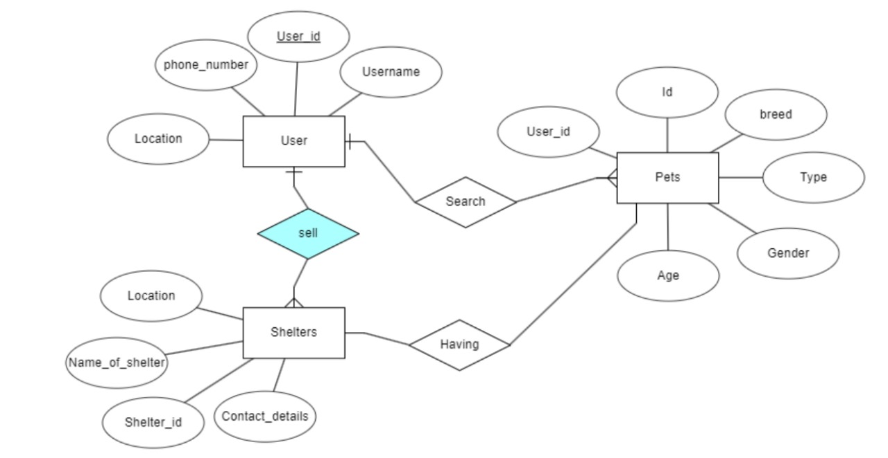

The Pet Adoption System provides online real time information about the pets available in the local shelters and the shelters informations . The main purpose of this project is to connect the adopters with the shelthers. This software is capable of tracking user preferences, location-based connections for adopters. The Shelters will act as the administrator to contact with users and manage their pets accordingly . The pet’s status of adopted/requested is maintained in the adoption database. The user’s details can be fetched from the database as and when required. The valid members are also allowed to view their account information.

## User Classes and Characteristics

The system provides different types of services based on the type of users [Adopter/Shelters]. The Shelter will be acting as the controller and he will have all the privileges of an administrator. The adopter can be the one who will be adopt or sell the pets to the shelters.

The features that are available to the Shelters are:-

* + - A Shelter can post pets informations.
    - Can view the different categories of pets available in the shelter
    - Can view the List of pets available in each category
    - Can take the pets from the users
    - Add pets and their information to the database
    - Edit the information of existing pets in the database
    - Can check the report of the existing pets

The features that are available to the users are:-

* + - Can view the different categories of pets available in the shelter
    - Can view the List of pets available in each category
    - Can adopt/sell an pet from/to the shelter.
    - Can search for a particular pets

## Operating Environment

The product will be operating in windows environment. The Pet adoption System is a website and shall operate in all famous browsers, for a model we are taking Microsoft Internet Explorer,Google Chrome,and Mozilla Firefox.Also it will be compatible with the IE 6.0. Most of the features will be compatible with the Mozilla Firefox & Opera 7.0 or higher version. The only requirement to use this online product would be the internet connection.

The hardware configuration include Hard Disk: 40 GB, Monitor: 15” Color monitor, Keyboard: 122 keys. The basic input devices required are keyboard, mouse and output devices are monitor, printer etc.

## Assumptions and Dependencies

The assumptions are:-

* + - The coding should be error free
    - The system should be user-friendly so that it is easy to use for the users
    - The information of all users, shelters and pets must be stored in a database that is accessible by the website
    - The system should have more storage capacity and provide fast access to the database
    - The system should provide search facility and filter facilities
    - The shelters need to be connected with respective user in their location radius
    - Users may access from any computer that has Internet browsing capabilities and an

Internet connection

* + - Users must have their correct usernames and passwords to enter into their online accounts and do actions

The dependencies are:-

* + - The specific hardware and software due to which the product will be run
    - On the basis of listing requirements and specification the project will be developed and run
    - The end users (admin) should have proper understanding of the product
    - The system should have the general report stored
    - Any update regarding the pets from the shelter is to be recorded to the database and the data entered should be correct

## Requirement

Software Configuration:-

This software package is developed using java as front end which is supported by sun micro system. Microsoft SQL Server as the back end to store the database.

Operating System: Windows NT, windows 98, Windows XP Language: Java Runtime Environment, Net beans 7.0.1 (front end) Database: MS SQL Server (back end)

Hardware Configuration:- Processor: Pentium(R)Dual-core CPU Hard Disk: 40GB

RAM: 256 MB or more

## Data Requirement

The inputs consist of the query to the database and the output consists of the solutions for the query. The output also includes the user receiving the details of their accounts. In this project the inputs will be the queries as fired by the users like create an account, selecting pets and putting into account. Now the output will be visible when the user requests the server to get details of their account in the form of time, date and which books are currently in the account.

# External Interface Requirement

## GUI

The software provides good graphical interface for the user and the administrator can operate on the system, performing the required task such as create, update, viewing the details of the pets.

* + - It allows user to view quick reports like pets in their area.
    - It provides stock verification and search facility based on different criteria.
    - The user interface must be customizable by the administrator
    - All the modules provided with the software must fit into this graphical user interface and accomplish to the standard defined
    - The design should be simple and all the different interfaces should follow a standard

Template

* + - The user interface should be able to interact with the user management module and a part of the interface must be dedicated to the login/logout module

Login Interface:-

In case the user is not yet registered, he can enter the details and register to create his account. Once his account is created he can ‘Login’ which asks the user to type his username and password. If the user entered either his username or password incorrectly then an error message appears.

Search:-

The adoptor can enter the type of pet he is looking for and the type and breed he is interested in, then he can search for the required pets by location.

Categories View:-

Categories view shows the categories of pets available and provides ability to the shelters to add/edit or delete pets from the list.

# System Features

The users of the system should be provided the surety that their account is secure. This is possible by providing:-

* User authentication and validation of members using their unique member ID

# Other Non-functional Requirements

## Performance Requirement

The proposed system that we are going to develop will be used as the Chief performance system within the different shelters of the city which interacts with the adoptors and contributors. Therefore, it is expected that the database would perform functionally all the requirements that are specified by the users.

* + - The performance of the system should be fast and accurate
    - Pet adoption System shall handle expected and non-expected errors in ways that prevent loss in information and long downtime period. Thus it should have inbuilt error testing to identify invalid username/password
    - The system should be able to handle large amount of data. Thus it should accommodate high number of pets and users without any fault

## Safety Requirement

The database may get crashed at any certain time due to virus or operating system failure. Therefore, it is required to take the database backup so that the database is not lost. Proper UPS/inverter facility should be there in case of power supply failure.

## Security Requirement

* + - System will use secured database
    - Normal users can just read information but they cannot edit or modify anything except their personal and some other information.
    - System will have different types of users and every user has access constraints
    - Proper user authentication should be provided
    - No one should be able to hack users’ password
    - There should be separate accounts for admin and members such that no member can access the database and only admin has the rights to update the database.

## Requirement attributes

* + - There may be multiple admins posting the details of the pets, all of them will have the right to create changes to the system. But the members or other users cannot do changes
    - The posts should be public
    - The Quality of the database is maintained in such a way so that it can be very user friendly to all the users of the database
    - The user be able to easily download and install the system

## Business Rules

A business rule is anything that captures and implements business policies and practices. A rule can enforce business policy, make a decision, or infer new data from existing data.This includes the rules and regulations that the System users should abide by. This includes the cost of the pets and the discount offers provided. The users should avoid illegal rules and protocols. Neither shelter nor user should cross the rules and regulations.

## User Requirement

The users of the system are shelters and adoptors of the pets, shelters act as administrator to maintain the system. The members are assumed to have basic knowledge of the computers and internet browsing. The proper user interface, user manual, online help and the guide to install and maintain the system must be sufficient to educate the users on how to use the system without any problems.

The admin provides certain facilities to the users in the form of:-

* + - Backup and Recovery
    - Forgot Password
    - Data migration i.e. whenever user registers for the first time then the data is stored in the server
    - Data replication i.e. if the data is lost in one branch, it is still stored with the server
    - Auto Recovery i.e. frequently auto saving the information
    - Maintaining files i.e. File Organization
    - The server must be maintained regularly and it has to be updated from time to time

# Other Requirements

## Data and Category Requirement

There are different categories of users namely adopters and shelters. Depending upon the category of user the access rights are decided. All other users except the shelters only have the rights to retrieve the information about database. Similarly there will be different categories of pets available. According to the categories of pets their relevant data should be displayed. The categories and the data related to each category should be coded in the particular format.

## Glossary

The following are the list of conventions and acronyms used in this document and the project as well:

* + - shelters: A login id representing a user with user administration privileges to the software
    - User: A general login id assigned to most users
    - Client: Intended adoptors for the software
    - SQL: Structured Query Language; used to retrieve information from a database
    - SQL Server: A server used to store data in an organized format
    - Layer: Represents a section of the project
    - User Interface Layer: The section of the assignment referring to what the user interacts with directly
    - Application Logic Layer: The section of the assignment referring to the Web Server. This is where all computations are completed
    - Data Storage Layer: The section of the assignment referring to where all data is recorded
    - Use Case: A broad level diagram of the project showing a basic overview
    - Class diagram: It is a type of static structure diagram that describes the structure of a system by showing the system’s cases, their attributes, and the relationships between the classes
    - Interface: Something used to communicate across different mediums
    - Unique Key: Used to differentiate entries in a database