SOFTWARE REQUIREMENTS SPECIFICATION

**For**

**Blog Platform**

**Prepared by:-**

*Hari Prasath. M*

*Dhilip Kumar. R*

*Guru Balaji. S*

# Introduction

## Purpose

The main objective of this document is to illustrate the requirements of the project Blog Platform. The document gives the detailed description of the both functional and non-functional requirements proposed by the client. The purpose of this project is to provide a friendly environment to maintain the details of Blog data content .The main purpose of this project is to create the blog, edit, delete their blog post and engage with comments . This project describes the hardware and software interface requirements using ER diagrams and UML diagrams.

## Document Conventions

* + - Entire document should be justified.
    - Convention for Main title

Font face: Times New Roman Font style: Bold

Font Size: 14

* + - Convention for Sub title

Font face: Times New Roman Font style: Bold

Font Size: 12

* + - Convention for body

Font face: Times New Roman Font Size: 12

## Scope of Development Project

Blog Platform is basically up to create the blog, edit blog, delete blog and maintain blogs in the platform so that the users can create the blog, view the blog to know the content of their blog post and others.

The project is specifically designed for the use of bloggers. The platform will work as a complete user interface for the blog users. Blog platform can be used to allow users to create accounts and log in securely and enable users to create, edit, publish the blog post. It is especially useful for any branders to help your company rank on search engines, share information about a given topic and become an expert in an industry,to attract visitors to your site, and turn those visitors into leads. and to cultivate an online community and engage with an audience.

The project can be easily implemented under various situations. We can add new features as and when we require, making reusability possible as there is flexibility in all the modules.

The language used for developing the project is Java as it is quite advantageous than other languages in terms of performance, tools available, cross platform compatibility, libraries, cost (freely available), and development process.

## Definitions, Acronyms and Abbreviations

JAVA -> platform independence SQL-> Structured query Language ER-> Entity Relationship

UML -> Unified Modeling Language

IDE-> Integrated Development Environment SRS-> Software Requirement Specificatio

## References

* + - Books

 “The Art of Blogging: A Beginner’s Guide to starting a Blog, Blog Writing and Blog Marketing” by Mark Gray.

“Everybody Writes:Your Go-To-Guide Creating Ridiculously Good Content” by AnnHandley

“The One-Person Business: Make Great Money. Work the way You Like. Have the life You Want” by Elaine Pofeldt.

* + - Websites

**https://wordpress.org/**

**https://www.wix.com/**

# Overall Descriptions

## Product Perspective

Use Case Diagram of Library Management System

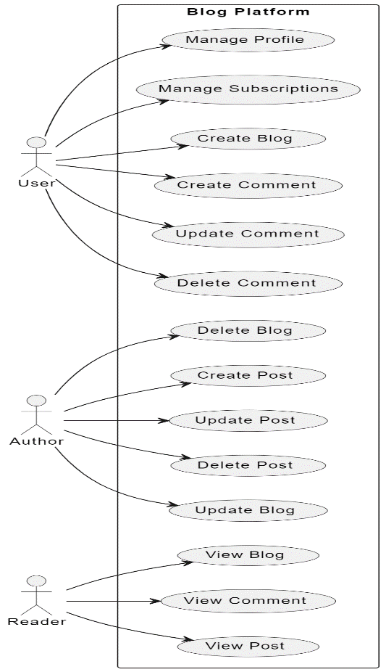

This is a broad level diagram of the project showing a basic overview. The users can be either staff or student.. This System will provide a search functionality to facilitate the search of resources. This search will be based on various categories viz. book name or the ISBN. Further the library staff personnel can add/date the resources and the resource users from system. The users of the system can request issue/renew/return of books for which they would have to follow certain criteria.

## Product Function

Entity Relationship Diagram of Library Management System

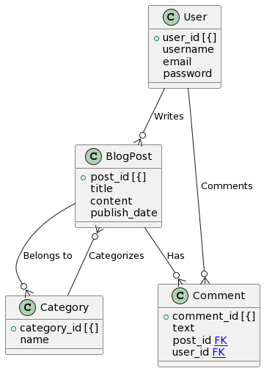

The Blog platform provides online real time information about the blog available in the database of blog posts and the user information. This software is capable of managing many blog post, create, edit blog post for according to the audience requirement .Keeping according to end user requirements. The user will act as the administrator to control blogs and manage blogs. The member’s status of creation/deletion is maintained in the blog database. The member’s details can be fetched by the profile of user from the database as and when required. The valid members are also allowed to view their blog post and others.

## User Classes and Characteristics

User classes for a blog platform represent different types of users who interact with the system, each with distinct roles, needs, and permissions. Here are several user classes for a typical blog platform, along with descriptive details about their roles and the characteristics of a blog platform encompass a range of features and attributes that collectively define its functionality, user experience, and overall capabilities. Here are key characteristics commonly associated with a blog platform:

User-Friendly Interface:

Description: A blog platform should have an intuitive and user-friendly interface, making it easy for both content creators and readers to navigate, create, and interact with content.

Content Creation and Editing:

Description: Content creators should have tools for easily creating, editing, and formatting blog posts. This includes support for text, images, multimedia, and other relevant content elements.

Content Management:

Description: The ability to organize and manage content effectively, including features such as categorization, tagging, and archiving. This helps users find and explore relevant content.

Commenting and Interaction:

Description: Users should be able to engage with blog posts through comments, likes, and social media sharing. The platform should support threaded discussions and provide a means for community interaction.

User Profiles:

Description: Users, especially content creators, should have customizable profiles where they can showcase their information, bio, and other relevant details. This contributes to a sense of community.

Search Functionality:

Description: A robust search feature enables users to find specific blog posts or topics efficiently. This is particularly important as the content library grows.

Responsive Design:

Description: The platform should be responsive, adapting to various devices and screen sizes. This ensures a consistent and enjoyable user experience across desktops, tablets, and smartphones.

Categories and Tags:

Description: Categories and tags help organize content, making it easier for users to discover related posts and navigate through the platform based on their interests.

Analytics and Insights:

Description: The inclusion of analytics tools provides content creators with insights into the performance of their posts. This may include data on page views, user engagement, and popular content.

Social Media Integration:

Description: Seamless integration with social media platforms allows users to share blog posts easily, extending the reach of the content and promoting community engagement.

Security Features:

Description: Security is crucial for protecting user data and maintaining platform integrity. This includes secure authentication, data encryption, and measures against common web vulnerabilities.

Monetization Options:

Description: For platforms supporting monetization, features such as ad management, subscription models, and affiliate marketing capabilities may be included.

Notification System:

Description: Users should receive notifications for relevant activities, such as new comments on their posts or responses to their comments.

Customization and Theming:

Description: Content creators often appreciate the ability to customize the appearance of their blogs. Theming options allow for personalization and brand representation.

Accessibility:

Description: Ensuring that the platform is accessible to users.

## Operating Environment

The product will be operating in windows environment. The Library Management System is a website and shall operate in all famous browsers, for a model we are taking Microsoft Internet Explorer, Google Chrome, and Mozilla Firefox. Also it will be compatible with the IE 6.0. Most of the features will be compatible with the Mozilla Firefox & Opera 7.0 or higher version. The only requirement to use this online product would be the internet connection.

The hardware configuration include Hard Disk: 40 GB, Monitor: 15” Color monitor, Keyboard: 122 keys. The basic input devices required are keyboard, mouse and output devices are monitor, printer etc.

## Assumptions and Dependencies

The assumptions are:-

* + - Users generally assume a stable and reliable internet connection to access and manage their blog platform.
    - Most blog platforms are designed to work seamlessly with popular web browsers (e.g., Chrome, Firefox, Safari).
    - Blog platforms are often designed to be responsive and accessible across various devices (desktops, laptops, tablets, smartphones).
    - Users often assume that they have ownership and control over their content on the blog platform.
    - Users expect the blog platform to have security measures in place to protect their data and content.
    - Many bloggers rely on third-party integrations (e.g., social media, analytics) for enhanced functionality.

* + - Users may assume that the blog platform provides backup and recovery options for their content.
    - Users often assume that they can customize the appearance and functionality of their blog to suit their preferences.

The dependencies are:-

* + - Limited or unreliable internet connectivity can hinder the ability to create, edit, or publish content.
    - Users may experience issues if they use outdated or less common web browsers.
    - Platform performance may vary on devices with smaller screens or less processing power.
    - Understanding the platform's terms of service and content ownership rights is crucial; some platforms may have restrictions or licensing agreements.
    - Users must follow best security practices (e.g., strong passwords, two-factor authentication) to enhance their own account security.
    - Compatibility with and availability of third-party integrations can affect the overall user experience.

## Requirement

Software Configuration:-

This software package is developed using java as front end which is supported by sun micro system. Microsoft SQL Server as the back end to store the database.

Operating System: Windows NT, windows 98, Windows XP Language: Java Runtime Environment, Net beans 7.0.1 (front end) Database: MS SQL Server (back end)

Hardware Configuration:-

Processor: Pentium(R)Dual-core CPU Hard Disk: 40GB

RAM: 256 MB or more

## Data Requirement

The inputs consist of the query to the database and the output consists of the solutions for the query. The output also includes the user receiving the details of their accounts. In this project the inputs will be the queries as fired by the users like create an blog, edit the blog of content before posting, delete blog post. Now the output will be visible when the user requests the server to give blog post of view in the form of time, date and location are currently in the user account.

# External Interface Requirement

## GUI

The software provides good graphical interface for the user and the administrator can operate on the system, performing the required task such as create, delete, view, edit blog posts.

User Registration and Login:

Requirement: Provide a user-friendly registration form with fields for username, email, and password. Include a login interface with secure authentication.

Social Media Integration:

Requirement: Allow users to log in or register using social media accounts (e.g., Facebook, Google). Enable sharing of blog posts on social media platforms.

Content Creation and Editing:

Requirement: Intuitive and easy-to-use interfaces for creating and editing blog posts. Support for rich text editing, image uploads, and multimedia embedding.

Commenting System:

Requirement: Include a comment section below each blog post with a user-friendly interface for adding and viewing comments. Support for threaded discussions and moderation tools.

Search Functionality:

Requirement: Incorporate a search bar with advanced search options, allowing users to find specific blog posts or topics efficiently.

Responsive Design:

Requirement: Ensure that the GUI is responsive and adapts to various screen sizes, including desktops, tablets, and mobile devices.

# System Features

The users of the system should be provided the surety that their blog post is secure. This is possible by providing:-

* User authentication and validation of members using their unique user name.
* Proper monitoring by the administrator which includes updating blog post, showing a popup if the blog post created and shared.
* It includes allowing a user to see other member blog post.

# Other Non-functional Requirements

## Performance Requirement

* + - The blog platform should have an average response time of X seconds for loading pages and displaying content. This ensures a responsive and snappy user interface.
    - Define the number of concurrent users the platform should support and specify the throughput in terms of requests per second or transactions per minute.
    - Specify the minimum acceptable uptime for the blog platform. This could be expressed as a percentage, such as 99.9% availability over a specified time period.
    - Conduct regular load testing to ensure the system can handle peak traffic without performance degradation. Define the criteria for acceptable performance under load.
    - Define performance expectations for database queries, indexing, and data retrieval. Optimize database design to ensure efficient data access.
    - Specify acceptable network latency for data transmission between the client and server. Optimize content delivery for faster loading times.
    - Utilize Content Delivery Networks (CDNs) to enhance the delivery speed of static content, such as images and stylesheets, to users worldwide.
    - Performance of security features, such as encryption and authentication, should not significantly degrade the overall system performance.
    - Specify how the system should handle performance-related failures, such as slow response times or temporary unavailability, to maintain a positive user experience.

## Safety Requirement

The database may get crashed at any certain time due to virus or operating system failure. Therefore, it is required to take the database backup so that the database is not lost. Proper UPS/inverter facility should be there in case of power supply failure.

## Security Requirement

* + - Implement secure user authentication mechanisms, including strong password policies, multi-factor authentication (MFA), and account lockout mechanisms.
    - Enforce proper access controls to restrict user access based on roles and permissions. Ensure that users can only perform actions for which they have explicit authorization.
    - Use encryption protocols (e.g., HTTPS) to secure data transmission between the client and the server. Encrypt sensitive data at rest, such as user passwords.
    - Employ secure session management practices, including session timeouts, secure session storage, and protection against session hijacking.

## Requirement attributes

## Requirement attributes provide additional information and context about each requirement, helping to ensure that the requirements are clear, measurable, and testable. When defining requirements for a blog platform.

## By including these attributes, you enhance the clarity and manageability of the requirements, making them more actionable and traceable throughout the project lifecycle.

## Business Rules

A blog platform, various business roles contribute to the creation, management, and success of the platform. Here are some key business roles community events, contests, or promotions.

Developing and executing marketing strategies to promote blog content. Collaborating with content creators to enhance search engine optimization. Managing social media accounts to increase platform visibility. Analyzing marketing metrics and adjusting strategies for optimal performance. Designing and optimizing the overall user experience of the blog platform. Creating visually appealing and user-friendly interfaces for both web and mobile platforms. Ensuring consistency in branding elements and visual identity. Incorporating design elements that enhance accessibility for a diverse audience.

## User Requirement

The users of the system are members of the blog platform who act as administrator to maintain the system. The members are assumed to have basic knowledge of the computers and internet browsing. The administrators of the system should have more knowledge of the internals of the system and is able to rectify the small problems that may arise due to disk crashes, power failures and other catastrophes to maintain the system. The proper user interface, user manual, online help and the guide to install and maintain the system must be sufficient to educate the users on how to use the system without any problems.

The admin provides certain facilities to the users in the form of:-

* + - Backup and Recovery
    - Forgot Password
    - Data migration i.e. whenever user registers for the first time then the data is stored in the server
    - Data replication i.e. if the data is lost in one branch, it is still stored with the server
    - Auto Recovery i.e. frequently auto saving the information
    - Maintaining files i.e. File Organization
    - The server must be maintained regularly and it has to be updated from time to time

# Other Requirements

## Data and Category Requirement

When designing a blog platform, it's crucial to consider both the data requirements and the diverse categories of users who will interact with the platform. Understanding the diverse user categories and their specific needs helps in tailoring the platform to cater to a wide audience. Meanwhile, the proper handling of data is crucial for security, performance, and user experience. Additionally, ensuring compliance with legal and privacy standards is essential for maintaining trust among users.

## Appendix

A: Admin, Abbreviation, Acronym, Assumptions; B: Books, Business rules; C: Class, Client, Conventions; D: Data requirement, Dependencies; G: GUI; K: Key; M: Member; N: Non-functional Requirement; O: Operating environment; P: Performance, Perspective,Purpose; R: Requirement, Requirement attributes; S: Safety, Scope, Security, System features; U: User, User class and characteristics, User requirement;

## Glossary

The following are the list of conventions and acronyms used in this document and the project as well:

* + - Administrator: A login id representing a user with user administration privileges to the software
    - User: A general login id assigned to most users
    - Client: Intended users for the software
    - SQL: Structured Query Language; used to retrieve information from a database
    - SQL Server: A server used to store data in an organized format
    - Layer: Represents a section of the project
    - User Interface Layer: The section of the assignment referring to what the user interacts with directly
    - Application Logic Layer: The section of the assignment referring to the Web Server. This is where all computations are completed
    - Data Storage Layer: The section of the assignment referring to where all data is recorded
    - Use Case: A broad level diagram of the project showing a basic overview
    - Class diagram: It is a type of static structure diagram that describes the structure of a system by showing the system’s cases, their attributes, and the relationships between the classes
    - Interface: Something used to communicate across different mediums
    - Unique Key: Used to differentiate entries in a database

## Class Diagram

A class is an abstract, user-defined description of a type of data. It identifies the attributes of the data and the operations that can be performed on instances (i.e. objects) of the data. A class of data has a name, a set of attributes that describes its characteristics, and a set of operations that can be performed on the objects of that class. The classes’ structure and their relationships to each other frozen in time represent the static model. In this project there are certain main classes

which are related to other classes required for their working. There are different kinds of relationships between the classes as shown in the diagram like normal association, aggregation, and generalization. The relationships are depicted using a role name and multiplicities. Here ‘Librarian’, ‘Member’ and ‘Books’ are the most important classes which are related to other classes.

