E-LEARNING MANAGEMENT SYSTEM

PURPOSE:

THE PURPOSE OF THIS DOCUMENT IS TO SPECIFY THE REQUIREMENTS FOR THE DEVELOPMENT OF THE E-LEARNING MANAGEMENT SYSTEM.

SCOPE:

THE E-LEARNING MANAGEMENT SYSTEM WILL PROVIDE A PLATFORM FOR THE CREATION, DELIVERY, AND MANAGEMENT OF ONLINE COURSES, ASSESSMENTS, AND OTHER EDUCATIONAL CONTENT.

PRODUCT FEATURES:

1. USER MANAGEMENT
2. COURSE MANAGEMENT
3. ASSESSMENT AND EVALUATION
4. COMMUNICATION
5. REPORTING AND ANALYTICS
6. ADMINISTRATION

USERS:

1. STUDENTS
2. INSTRUCTORS
3. ADMINISTRATORS

STUDENTS:

* BUYS THE COURSE AND ENROLL IN IT.
* COMPLETES THE ASSESSMENTS.
* TRACKS THE PROGRESS.

INSTRUCTORS:

* CREATES OR ADD THE COURSES.
* MANAGES THE COURSES.
* CONDUCTS ASSESSMENTS.
* MANAGES THE STUDENTS.

ADMINISTRATORS:

* MANAGES THE SYSTEM CONFIGURATION.
* MANAGES THE USER ROLES.

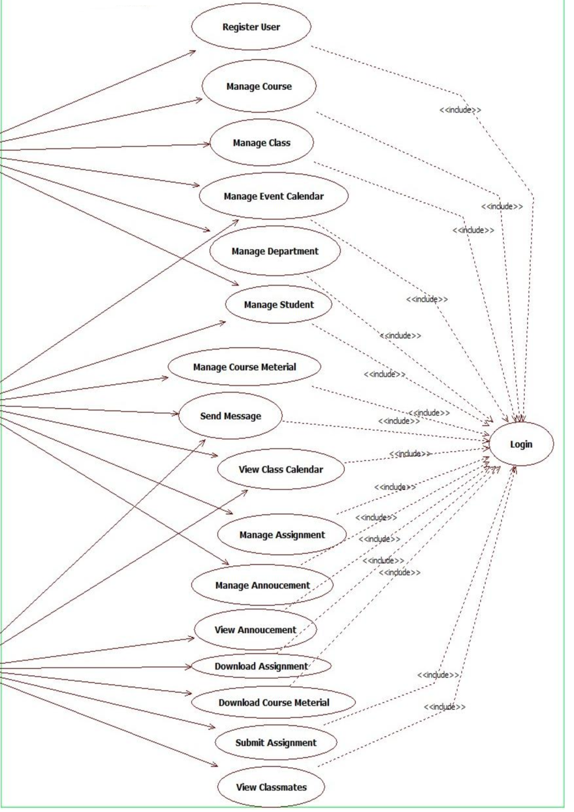

Instructor

Student

Admin

E.R DIAGRAM:

