SOFTWARE

REQUIREMENTS

SPECIFICATION

For

Recipe Management System

Prepared by

TEAM SPARTANS

1. Introduction

1.1 Purpose

The purpose of this software is to provide users with a platform to manage and share recipes, including ingredients and cooking instructions. From Recipe binders, to recipe cards, to recipe books - keeping all your favorite recipes up-to-date and organized can get complicated fast.

1.2 Document Conventions

Entire document should be justified.

Convention for Main title

* Font face: Times New Roman
* Font style: Bold
* Font Size: 14

Convention for Sub title

* Font face: Times New Roman
* Font style: Bold
* Font Size: 12

Convention for body

* Font face: Times New Roman
* Font Size: 12

1.2 Scope of Development Project

The system will allow users to create, edit, and delete recipes. It will also provide features to try existing and organizing recipes. This project is specifically designed for the use of managing and publishing the recipes. The product will work as a complete user-friendly interface. This management system can be used to add, edit and try out the existing recipe.

This project can be implemented in various Restaurants and Hotels to order the necessary without any complication.

1.3 References

* Users can access private recipes shared with them.
* Person who can manage the all system and can add recipes.
* Each user can have separate profiles

1.4 Definitions, Acronyms and Abbreviations

JAVA -> platform independence

SQL-> Structured query Language

ER-> Entity Relationship

UML -> Unified Modeling Language

IDE-> Integrated Development Environment

SRS-> Software Requirement Specification

Overall Descriptions:

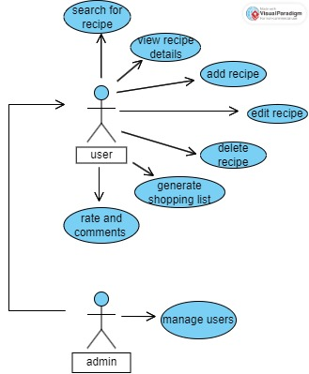

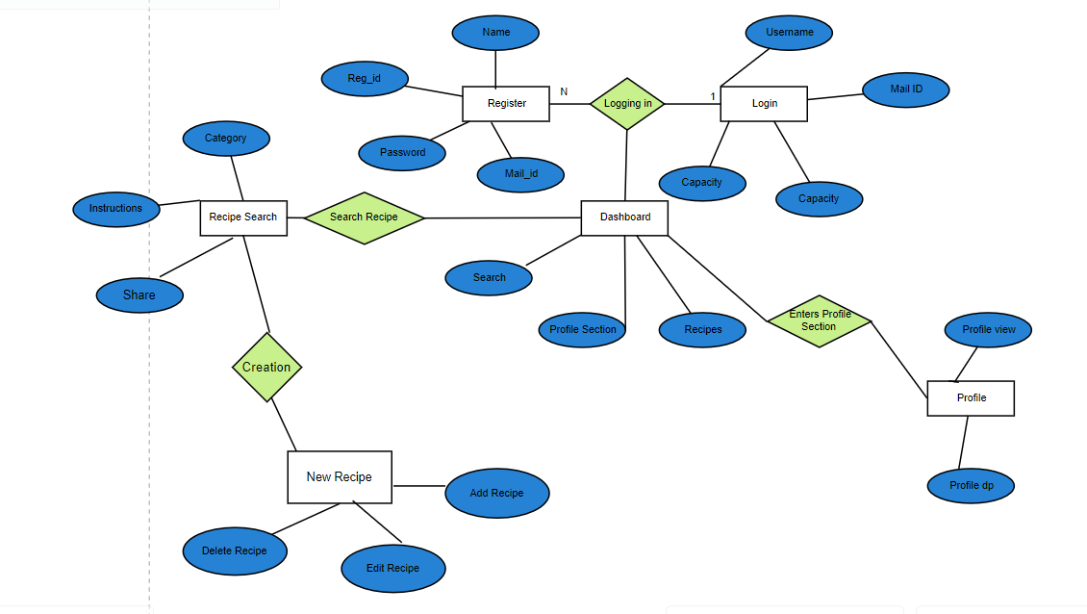

This is a board level diagram of the project showing a basic overview. The users can be either admin or consumers this system will provide a search, add, edit and share the recipes. This search will be based on various categories viz food item (veg, non-veg).

Product function

“dia”

3. User Classes and Characteristics

* Users of the system can be divided into two classes: regular users and administrators.
* Regular users can create, edit, and delete their own recipes, as well as access recipes shared with them.
* Administrators have additional privileges, such as managing the entire system and adding recipes on behalf of other users.

4. Requirements

4.1 Functional Requirements

* The system should allow users to create new recipes by adding ingredients and cooking instructions.
* Users should be able to edit existing recipes, including updating ingredients and instructions.
* Users should be able to delete recipes they no longer want to keep.
* The system should provide a search functionality for users to find recipes based on various criteria.
* The system should allow users to organize recipes into categories or folders for easier management.
  1. Non-Functional Requirements
* The system should be user-friendly and intuitive, with a clear and easy-to-use interface.
* The system should be accessible from different devices and platforms, such as desktop and mobile.
* The system should ensure the security and privacy of user data, especially for private recipes.

5. Operating Environment

* The system should be compatible with popular web browsers, such as Google Chrome, Mozilla Firefox, and Safari.
* The system should be hosted on a reliable and secure server.

6. Design and Implementation Constraints

* The system should be developed using a web-based technology stack, such as HTML, CSS, JavaScript, and a back-end framework like Django or Ruby on Rails.

7. User Documentation

* This system should provide user documentation, including a user manual and online help resources, to guide users on how to use the system effectively.

8. Assumptions and Dependencies

* The system assumes that users have basic computer literacy and internet access.
* The system depends on a stable and reliable internet connection for users to access and interact with the system.

9. Requirement

Software Configuration:-

This software package is developed using java as front end which is supported by sun micro

system. Microsoft SQL Server as the back end to store the database.

Operating System: Windows NT, windows 98, Windows XP

Language: Java Runtime Environment, Net beans 7.0.1 (front end)

Database: MS SQL Server (back end)

Hardware Configuration:-

Processor: Pentium(R)Dual-core CPU

Hard Disk: 40GB

RAM: 256 MB or more

**10. CLASS DIAGRAM**

