SOFTWARE REQUIREMENTS SPECIFICATION

**For**

**Employee Leave Management System**

**Prepared by:-**

*R.Dinesh*

*S.Muthu raja*

*T.Elango*

# 1. Introduction

## 1.1 Purpose

The main objective of this document is to illustrate the requirements of the project Employee Leave Management system .This project can be used to automate the workflow of leave applications and their approvals.

**1.2 Document Conventions**

* + - Entire document should be justified.
    - Convention for Main title

Font face: Times New Roman Font style: Bold

Font Size: 14

* + - Convention for Sub title

Font face: Times New Roman Font style: Bold

Font Size: 12

* + - Convention for body

Font face: Times New Roman

Font Size: 12

## 1.3 Scope of Development Project

This Employee Leave Management system focuses on providing an efficient and responsive solution for managing employee leave, ensuring streamlined processes for request submission, approval workflows, and real-time leave balance tracking and report generation.

The project is specifically designed for the use of company employees and management. The product will work as a complete user interface for the Employee Leave Management process .Employee Leave Management System can be used by any companies to manage its employees’ leave application ,monitoring and confirmation.

The project can be easily implemented under various situations. We can add new features as and when we require, making reusability possible as there is flexibility in all the modules.The language used for developing the project is Java as it is quite advantageous than other languages in terms of performance, tools available, cross platform compatibility, libraries, cost (freely available), and development process.

There are many advantages of this leave management system are:

* + Eliminates paper based leave application forms.
  + Leave applications can be submitted online
  + Leave applications can be approved online
  + Both the leave applicant as well as the approver can view the remaining leave days

as well as historical leave applications.

## 1.4 Definitions, Acronyms and Abbreviations

JAVA -> platform independence SQL-> Structured query Language ER-> Entity Relationship

UML -> Unified Modeling Language

IDE-> Integrated Development Environment SRS-> Software Requirement Specification

## 1.5 References

Websites:

* <https://www.quora.com/How-does-the-leave-management-software-works-to-manage-leaves>
* [**https://www.studocu.com**](https://www.studocu.com)
* [**https://chat.openai.com/**](https://chat.openai.com/)
* [**https://www.perforce.com/blog/alm/how-write-software-requirements-specification-srs-document**](https://www.perforce.com/blog/alm/how-write-software-requirements-specification-srs-document)

# 2. Overall Descriptions

## 2.1 Product Function

Entity Relationship Diagram of Employee Leave Management System

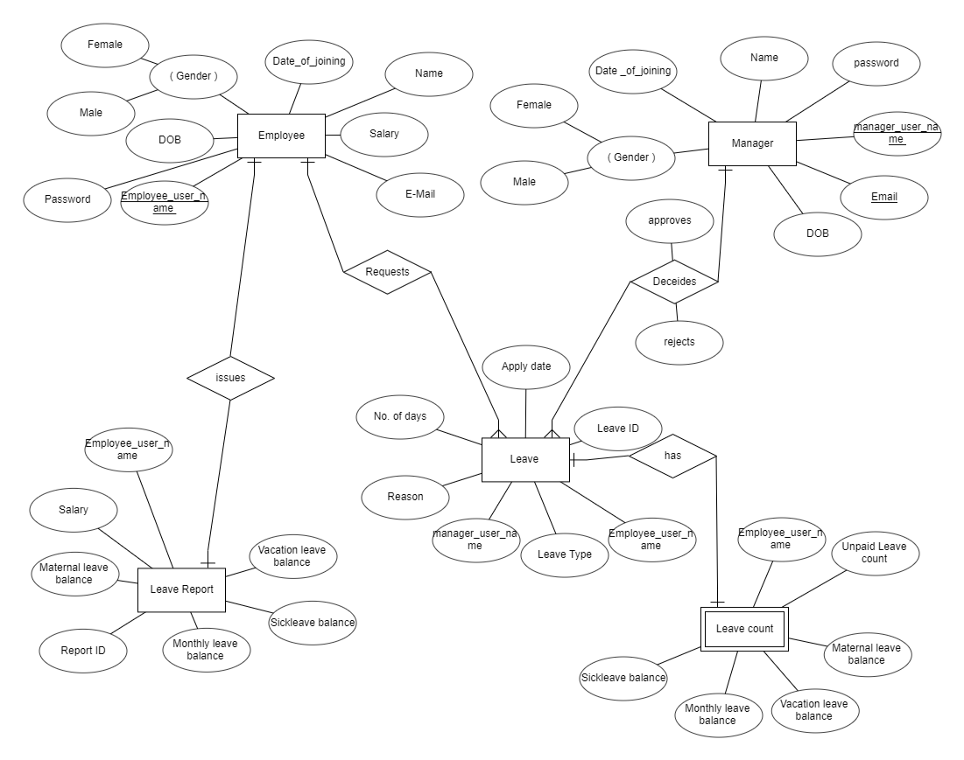

## 

## 2.2 User Classes and Characteristics

The system provides different types of services based on the type of users [Employee/Manager]. The manager will be acting as the controller and he will have all the privileges of an administrator. The member can be the employee of the company.

The features that are available to the Manager are:-

* + - Manager can get the leave request online which has been applied by the employee.
    - The Manager can view the leave history of the employee who has applied leave.
    - The management can set the leave policy configuration which will be verified by the manager.
    - The manager can issue or reject the leave of the respective applied employees.

The features that are available to the Employees are:-

* + - Can monitor their leave progression.
    - Can view all categories of leave which take place in the leave policy configuration.
    - Can apply leave to the manager with a valid reason.
    - Can get a paid leave and unpaid leave as well.

## 2.3 Operating Environment

The operating environment for an Employee Leave Management System can be set up as follows:

**Operating System:**

The product will be operating in a Windows environment, compatible with Windows 6.0 and later versions.

**Browsers**:

The Employee Leave Management System will be accessible through popular browsers such as Google Chrome, Mozilla Firefox, and Opera 7.0 or higher versions.

**Hardware Configuration:**

The basic hardware requirements for using this online product include a 40 GB hard disk, a 15" color monitor, and a 122-key keyboard.

**Input and Output Devices:**

The system will require input devices like a keyboard and mouse, and output devices like monitor and printer for generating hardcopy of the report.

**Connections:**

The Employee Leave Management System is a web-based application, it will rely on an internet connection to function properly.

## 2.4 Assumptions and Dependencies

The assumptions are:-

* + - The coding should be error free
    - The system should be user-friendly so that it is easy to use for the users
    - The information of leave progression under all employees must be stored in a database .
    - The system should have more storage capacity and provide fast access to the database
    - The system should provide search facility and support quick transactions
    - The employee leave management is running 24 hours a day
    - Users may access from any computer that has Internet browsing capabilities and an Internet connection
    - Users must have their correct usernames and passwords to enter into their online accounts and do actions

The dependencies are:-

* + - The specific hardware and software due to which the product will be run
    - On the basis of listing requirements and specification the project will be developed and run
    - The end users (employee) should have proper understanding of the product
    - The information of all the employees must be stored in a database that is accessible by the Management System
    - employees and managers must have their correct usernames and passwords to enter into their online accounts and do actions

## 2.5 Requirement

**Software Configuration:-**

This software package is developed using java as front end, MySQL Server as the back end to store the database.

Operating System: Windows 11.

Language: Java Runtime Environment, intellj (front end)

Database: MySQL Server (back end)

**Hardware Configuration:-**

Processor: Intel Core i5 11th gen

SSD:475 Gb

RAM: 8Gb

## 2.6 Data Requirement

The inputs consist of the query to the database and the output consists of the solutions for the query. The output also includes the user receiving the details of their accounts. In this project the inputs will be the queries as fired by the users like creating an account and applying leave . Now the output will be visible when the user requests the server to get details of their account in the form of time, date and status of leave application.

# 3.External Interface Requirement

## 3.1 GUI

The software provides good graphical interface for the user and the administrator can operate on the system, performing the required task such as applying, verification, confirmation of the applied leave

* + - It allows employees to apply for leave online.
    - It provides leave application facilities based on different criteria.
    - The user interface must be customizable by the administrator
    - All the modules provided with the software must fit into this graphical user interface and accomplish to the standard defined
    - The design should be simple and all the different interfaces should follow a standard template
    - The user interface should be able to interact with the user management module and a part of the interface must be dedicated to the login/logout module

**Login Interface:-**

In case the employee or manager is not yet registered, he can enter the details and register to create his account. Once his account is created he can ‘Login’ which asks the user to type his username and password. If the user entered either his username or password incorrectly then an error message appears.

**Employee’s View:-**

Employee will be provided with his leave progression and the Categories of leaves which were enlisted by the leave policy configuration and he can access the apply button which will be placed in all types of categories of leave. He can access the reason criteria to enlist his reason for leave and then he can access the request button for the verification of leave by his manager.

**Manager’s View:-**

Manager can view the leave request applied by the employees. He is provided with leave progression of the respective employee who applied for the leave.He can access the grant or reject button to grant or reject the leave application and can also state the reason if leave was rejected.

# 4.System Features

The users of the system should be provided the surety that their account is secure. This is possible by providing:-

* User authentication and validation of members using their unique member ID
* Proper accountability which includes not allowing a member to see another member’s account. Only administrator will see and manage all member accounts.

# 5.Other Non-functional Requirements

## 5.1 Performance Requirement

* + Employee Leave Management System shall handle expected and unexpected errors in ways that prevent loss in information and long downtime period. Thus it should have inbuilt error testing to identify invalid username/password
  + The system should be able to handle large amounts of data. Thus it should accommodate high number of Employees without any fault
  + The performance of the system should be fast and accurate

## 5.2 Safety Requirement

The database may get crashed at any certain time due to virus or operating system failure. Therefore, it is required to take the database backup so that the database is not lost. Proper UPS/inverter facility should be there in case of power supply failure.

## 5.3 Security Requirement

* + - System will use secured database
    - Normal users can just read information but they cannot edit or modify anything except their personal and some other information.
    - System will have different types of users and every user has access constraints
    - Proper user authentication should be provided
    - No one should be able to hack users’ password
    - There should be separate accounts for admin and members such that no member can access the database and only admin has the rights to update the database.

## 5.3 Security Requirement

* + - System will use secured database
    - Normal users can just read information but they cannot edit or modify anything except their personal and some other information.
    - System will have different types of users and every user has access constraints
    - Proper user authentication should be provided
    - No one should be able to hack users’ password
    - There should be separate accounts for admin and members such that no member can access the database and only admin has the rights to update the database.

## 5.4 Requirement attributes

* + - There may be multiple admins creating the project, all of them will have the right to create changes to the system. But the members or other users cannot do changes
    - The project should be open source
    - The Quality of the database is maintained in such a way so that it can be very user friendly to all the users of the database
    - The user be able to easily download and install the system

## 5.5 User Requirement

The users of the system are Managers and Employees of the company who act as administrator to maintain the system. The members are assumed to have basic knowledge of computers and internet browsing. The administrators of the system should have more knowledge of the internals of the system and are able to rectify the small problems that may arise due to disk crashes, power failures and other catastrophes to maintain the system. The proper user interface, user manual, online help and the guide to install and maintain the system must be sufficient to educate the users on how to use the system without any problems.

The admin provides certain facilities to the users in the form of:-

* + - Backup and Recovery
    - Forgot Password
    - Data migration i.e. whenever user registers for the first time then the data is stored in the server
    - Data replication i.e. if the data is lost in one branch, it is still stored with the server
    - Auto Recovery i.e. frequently auto saving the information
    - Maintaining files i.e. File Organization
    - The server must be maintained regularly and it has to be updated from time to time

# 6.Other Requirements

## 6.1 Data and Category Requirement

There are different categories of users namely Manager and Employee. Depending upon the category of user the access rights are decided. It means if the user is an administrator then he can be able to modify the data ,delete, append etc. All other users except the Administrator only have the rights to retrieve the information about the database. Similarly there will be different categories of leaves available.. The categories and the data related to each category should be coded in the particular format.

## 6.2Glossary

The following are the list of conventions and acronyms used in this document and the project as well:

* + - Administrator: A login id representing a user with user administration privileges to the software
    - User: A general login id assigned to most users
    - Client: Intended users for the software
    - SQL: Structured Query Language; used to retrieve information from a database
    - SQL Server: A server used to store data in an organized format
    - Layer: Represents a section of the project
    - User Interface Layer: The section of the assignment referring to what the user interacts with directly
    - Application Logic Layer: The section of the assignment referring to the Web Server. This is where all computations are completed
    - Data Storage Layer: The section of the assignment referring to where all data is recorded
    - Use Case: A broad level diagram of the project showing a basic overview
    - Class diagram: It is a type of static structure diagram that describes the structure of a system by showing the system’s cases, their attributes, and the relationships between the classes
    - Interface: Something used to communicate across different mediums
    - Unique Key: Used to differentiate entries in a database

## 6.3 Class Diagram

A class is an abstract, user-defined description of a type of data. It identifies the attributes of the data and the operations that can be performed on instances (i.e. objects) of the data. A class of data has a name, a set of attributes that describes its characteristics, and a set of operations that can be performed on the objects of that class. The classes’ structure and their relationships to each other frozen in time represent the static model. In this project there are certain main classes which are related to other classes required for their working. There are different kinds of relationships between the classes as shown in the diagram like normal association, aggregation, and generalization. The relationships are depicted using a role name

and multiplicities.