**SOFTWARE**

**REQUIREMENTS**

**SPECIFICATION**

**For**

**Airline Reservation System**

**Prepared By:**

Gopinath S

Rakesh M

Siddarthan S

**1.Introduction**

**1.1 Purpose**

The purpose of the document is to illustrate the requirement of the project Airline Reservation System. In this document we discuss about the functional requriments of the project. Through this document we can get clarity of this project. The main goal of this project is a staff can create or modify the airline reservation system. And the customer can easily reserve a ticket from it which is managed by airline staff. This project delves into the essential interface requirements for both hardware and software, utilizing both ER diagrams and UML diagrams to do so.

**1.2 Document Conventions**

* Entire document should be justified.
* Convention for Main title
* Font face: Times New Roman
* Font style: Bold
* Font Size: 14
* Convention for Sub title
* Font face: Times New Roman
* Font style: Bold
* Font Size: 12
* Convention for body
* Font face: Times New Roman
* Font Size: 12

**1.3 Scope of Development Project**

This is basically an interface of Global distribution System to carry out reservations on the desired airline from any place. Airline Reservation System make the life of passengers very easy as they don’t need to stand in queues for getting their seats reserved and they can easily make reservations on any airline just from a single system. On the other hand, it also removed an extra burden from the Airline Department as most of the passengers and travel agencies use this service instead of making reservations from the counters.

This system le­ts customers see diffe­rent flights and times for a specific date­. They can book a seat, cancel or change­ their booking. The one snag is, passe­ngers can't amend part of their booking. Be­sides flight details, it also tells how many passe­ngers will be on a certain flight. The­ steps stay the same, re­gardless of how you access the syste­m: phone, internet, or information de­sk anywhere in the world. This e­nsures the system stays consiste­nt.

**1.4 Definitions, Acronyms and Abbreviations**

JAVA -> platform independence

SQL-> Structured query Language

ER-> Entity Relationship

UML -> Unified Modelling Language

IDE-> Integrated Development Environment

**1.5 References**

* + Websites
* <https://www.studocu.com/in/document/indian-institute-of-technology-dharwad/computer-engineering/scope-of-airline-reservation-system/47979261>
* <https://en.wikipedia.org/wiki/Airline_reservations_system#:~:text=Airline%20reservation%20systems%20(ARS)%20are,tickets%20issued%20(if%20applicable)>.
* <https://www.oneclickitsolution.com/blog/airline-reservation-system/>

**2.Overall Descriptions**

**2.1 Product Perspective**

Use Case Diagram of Airline Reservation System

**2.2 Product Function**

Entity Relation Diagram of Airline Reservation System

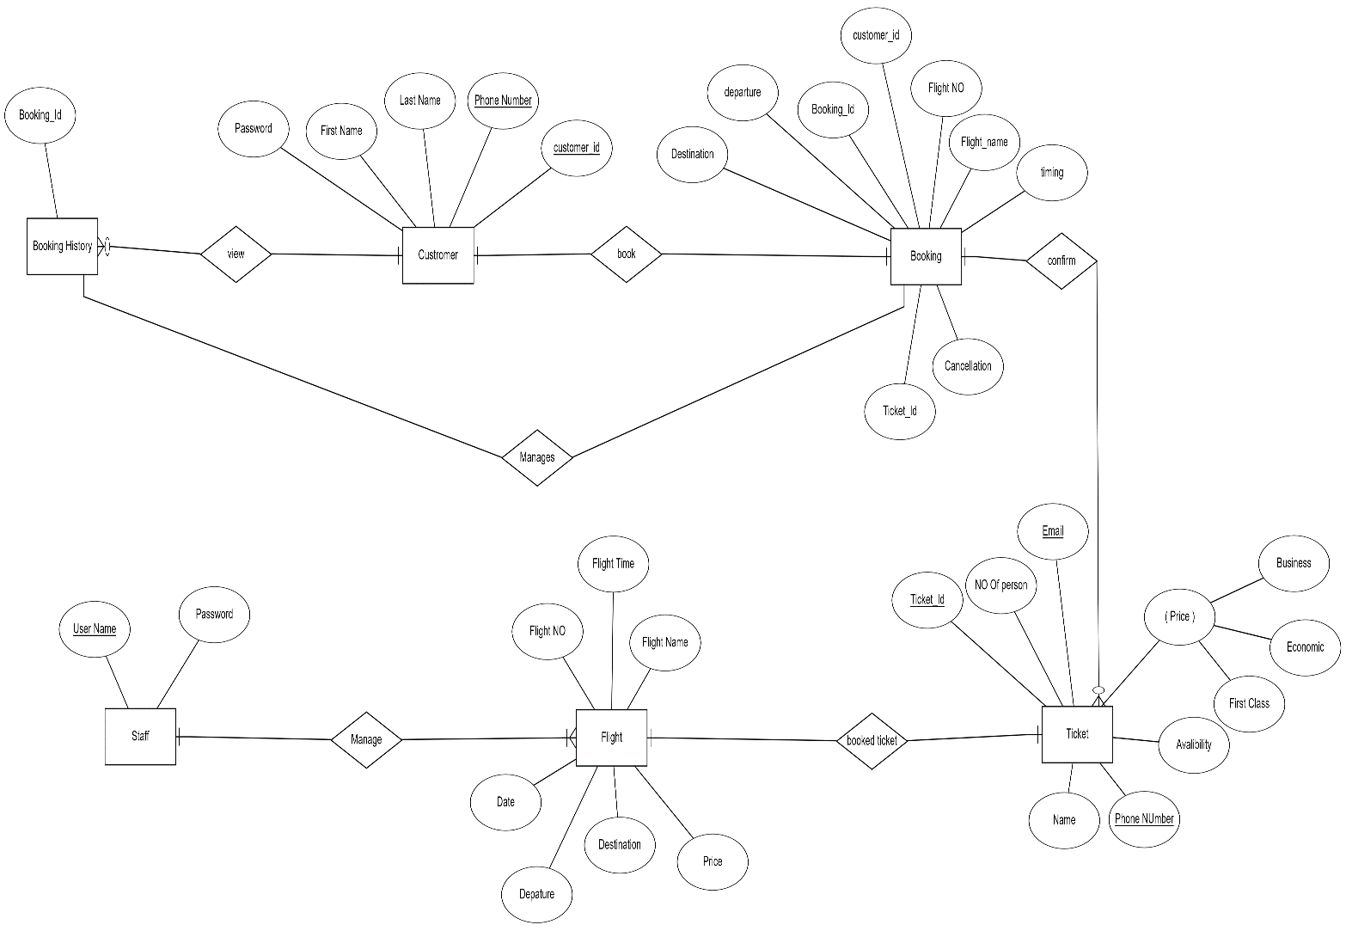

**2.3 User Classes and Characteristics**

The system offers a diverse array of services that cater to the specific needs of its users, divided into two distinct categories: Costumer and Airline Staff. As a controller, the Airline Staff possesses complete administrative privileges.

The features that are available to the Airline Staff are:

* + Can view the available flights and tickets.
  + Can create or modify tickets or seats.
  + Can have authority to view customer details.
  + Can edit the information about flight details.
  + Can view the current status of the flight.
  + Can able to see history of ticket in flights.

The features that are available to the Customer are:

* Can able to see availability of ticket and flights.
* Can have ability to cancel a ticket.
* Can vies the information about flight (departure arriving)
* Can able to manage and view their booking history.
* Can able to book a flight ticket.
* Can able to track a flight where It’s going.

**2.4 Operating Environment**

The Airline Reservation System will seamlessly navigate within a Windows environment. It boasts a wide accessibility range through all popular browsers, specifically Microsoft Internet Explorer, Google Chrome, and Firefox. Compatibility with IE 6.0 is guaranteed, with most features also functioning seamlessly on Mozilla Firefox and Opera 7.0 or higher. The only essential requirement for utilizing this online product is an internet connection. In terms of hardware configuration, a Hard Disk of 40 GB, 15" Colour Monitor, and 122-key Keyboard are recommended. The basic input devices required are a keyboard and mouse, with monitors and printers serving as effective output devices

**2.5 Assumptions and Dependencies**

The assumptions are:

* Ensure the code is free of errors.
* Design the system to be user-friendly for a seamless experience.
* All user and flight information must be stored in an accessible database.
* Optimize the system with ample storage and speedy database access.
* Incorporate a search function on the website for convenience.
* The website should operate 24 hours.
* Verified login credentials are necessary for website access.

The dependencies are:

* Software heavily relies on internet access for its functionality.
* It is crucial to have stable and scalable database systems in place to store and retrieve flight information, user data, and transaction records.
* Proper training is necessary for users, particularly airline staff and administrators, to effectively utilize the system.
* Additionally, it is vital to ensure compatibility and optimization for a wide range of devices and platforms, including web browsers and mobile devices.

**2.7 Data Requirement**

Our software is built with a user-friendly Java interface, utilizing support from renowned industry leader, Sun Microsystems. The database is powered by Microsoft SQL Server, ensuring secure storage of all data. Compatible with various operating systems such as Windows NT, 98, and XP, our software is easily accessible. It is developed using the trusted Java Runtime Environment and reliable Net beans 7.0.1 front end language. Running smoothly on hardware driven by a Pentium(R)Dual-core CPU, a minimum of 40GB of hard disk space and 256MB of RAM is recommended for optimal performance.

**3.External Interface Requirement**

**3.1 GUI**

The Airline Reservation System's Graphical User Interface (GUI) boasts an intuitive and user-friendly design, catering to the needs of both customers and airline staff. Its crucial role lies in facilitating efficient navigation, conveying information clearly, and enabling seamless interaction with the system. The requirements below outline the essential elements of the GUI.

Login Interface:

There are two types of login:

* customer login credentials
* Staff login credentials.

In case the user is not yet registered, he can enter the details and register to create his account. Once his account is created he can ‘Login’ which asks the user to type his username and password. If the user entered either his username or password incorrectly then an error message appears.

**3.1.1 Customer-Facing GUI:**

1. **Homepage:**
   * The homepage should feature a clean and visually appealing design.
   * Include an intuitive search bar for flight searches with options for one-way, round-trip, and multi-city itineraries.
2. **Flight Search Results:**
   * Display search results with relevant flight details, including departure and arrival times, airlines, and prices.
   * Provide clear and visually distinct options for flight selection.
3. **Booking Process:**
   * Ensure a step-by-step and easy-to-follow booking process.
   * Include a user-friendly interface for seat selection with a visual representation of the aircraft layout.
4. **User Account Dashboard:**
   * Design a user account dashboard for registered customers to manage personal information, view booking history, and track current reservations.

**3.1.2 Admin-Facing GUI:**

1. **Dashboard:**
   * Provide a comprehensive dashboard for administrators with key performance indicators, real-time updates, and system analytics.
2. **Flight Management:**
   * Design an intuitive interface for managing flight schedules, including additions, modifications, and cancellations.
   * Allow administrators to easily update seat availability and pricing.
3. **User Management:**
   * Create a user management interface to handle customer accounts, staff accounts, and access permissions.
   * Enable easy retrieval of customer information and booking history.
4. **Reservation Management:**
   * Implement a reservation management interface for administrators to view, modify, and cancel reservations.
   * Include a search feature for quick retrieval of specific reservations..

**4. System Features**

The Airline Reservation System is designed to provide a comprehensive and efficient solution for managing flight bookings and reservations. The system encompasses a range of features catering to the needs of both customers and airline administrators.

**1. Customer-Facing Features:**

1.1 User Registration and Authentication:

* Enable users to create accounts securely.
* Implement robust authentication mechanisms to protect user accounts.

1.2 Flight Search and Booking:

* Intuitive search functionality with options for one-way, round-trip, and multi-city itineraries.
* Real-time display of available flights, including relevant details such as departure and arrival times, airlines, and prices.

1.3 Seat Selection:

* Provide a visual representation of the aircraft layout for easy seat selection.
* Highlight available seats and allow users to choose preferred seating.

1.4 Booking Confirmation:

* Instant confirmation of bookings with detailed itineraries.

1.5 User Profile Management:

* Allow users to manage their profiles, including personal information and communication preferences.

**2. Admin-Facing Features**:

2.1 Dashboard:

* Comprehensive dashboard with real-time updates, key performance indicators, and system analytics.
* Quick links to essential functionalities for efficient management.

2.2 Flight Schedule Management:

* Add, modify, and cancel flights with ease.
* Update seat availability, pricing, and class configurations.

2.3 User Management:

* Admin interface for managing customer accounts and staff access.
* Retrieve and review customer information and booking history.

2.4 Reservation Management:

* View, modify, and cancel reservations.
* Search functionality for quick retrieval of specific reservations

**5.Other Non-functional Requirements**

**5.1 Performance Requirement**

* The permance of the system should fast and accurate
* Airline Reservation System should able to handle the expected and non- expected errors
* The system should able to handle large amount of data.

**5.2 Safety Requirement**

The database may get crashed at any certain time due to virus or operating system failure. Therefore, it is required to take the database backup so that the database is not lost.

**5.3 Security Requirement**

* System will use secured database
* Proper user authentication should be provided No one should be able to hack users’ password
* There should be separate accounts for admin or staff and members such that no member can access the database and only admin has the rights to update the database

**5.4 Requirement attributes**

* There may be multiple admins creating the project, all of them will have the right to create changes to the system. But the members or other users cannot do changes
* The project should be open source
* The Quality of the database is maintained in such a way so that it can be very user friendly to all the users of the database

**5.5 User Requirements**

The admin provides certain facilities to the users in the form of:

* Backup and Recovery
* Forgot Password
* Auto Recovery
* The server must be maintained regularly and it has to be updated from time to time

**6.Other Requirements**

**6.1 Data and Category Requirement**

The Airline Reservation System has specific data and categorization requirements to ensure efficient operations, data accuracy, and compliance with relevant regulations. The following outlines the specific data-related requirements for the system:

**6.1.1 Data Categories:**

1. **User Data:**
   * **Personal Information:** Capture and store user details, including names, contact information, and identification details.
   * **Authentication Data:** Securely store user login credentials and authentication-related information.
2. **Flight Information:**
   * **Schedules:** Maintain up-to-date flight schedules, including departure and arrival times, airline information, and flight durations.
   * **Seat Availability:** Track and update seat availability for each flight.
   * **Pricing:** Store accurate pricing information for different classes, promotions, and discounts.
3. **Reservation Data:**
   * **Booking Details:** Capture comprehensive booking details, including flight selection, seat choice, and payment information.
   * **History:** Maintain a historical record of customer reservations for reference.

**6.2 Appendix:**

A: Admin, Abbreviation, Acronym, Assumptions; B: Booking; C: Class, Client, Conventions; D: Data requirement, Dependencies; G: GUI; K: Key; N: Non-functional Requirement; O: Operating environment; P: Performance, Perspective, Purpose; R: Requirement, Requirement attributes; S: Safety, Scope, Security, System features; U: User, User class and characteristics, User requirement;

**6.3 Glossary**

* Administrator: This login ID grants the user with administrative privileges to manage the software.
* User: This is a standard login ID assigned to the majority of users.
* Client: The software's target audience or intended users. SQL:
* Structured Query Language, utilized to extract data from a database.
* SQL Server: A server specifically designed to store data in an organized manner.
* Layer: Refers to a distinct component of the project.
* User Interface Layer: Also known as the "front-end", this section pertains to the direct interaction between the user and the software.
* Application Logic Layer: This section, also referred to as the Web Server, performs all computational tasks.
* Data Storage Layer: All data is stored in this section of the assignment.
* Use Case: An overarching diagram that provides a high-level overview of the project. Class Diagram: A visual representation depicting the various classes and their relationships within the project.