SOFTWARE REQUIREMENTS SPECIFICATION

For

HOSPITAL SCHEDULE MANAGEMENT SYSTEM

Prepared by:-
TEAM MEMBERS:
HEMA PRIYA SHREE S
SREE HARI M
JOE ASWIN F

Introduction

Purpose
The purpose of the hospital appointment scheduler is to streamline and automate the process of scheduling and managing patient appointments within a hospital or healthcare facility. This system aims to enhance overall efficiency, reduce waiting times, and improve the overall patient experience.This project describes the hardware and software interface requirements using ER diagrams and UML diagrams.

Document Conventions
    - Entire document should be justified.

    - Convention for Main title
Font face: Times New Roman Font style: Bold
Font Size: 14
    - Convention for Sub title
Font face: Times New Roman Font style: Bold
Font Size: 12

    - Convention for body
Font face: Times New Roman Font Size: 12

Scope of Development Project
- Efficiently manage patient appointments.
- Scheduling, rescheduling, and cancellation of appointments.
- Real-time availability of doctors and resources.
- Automated reminders for patients and staff.
- Administrative role for overseeing and coordinating scheduling processes.
- Avoiding overbooking and resource conflicts.
- Dynamic updating of doctor availability.
- Instant notification of appointment changes.
- Ensure the security and compliance of patient data.
- Access controls and user authentication.

Definitions, Acronyms and Abbreviations
JAVA -> platform independence SQL-> Structured query Language ER-> Entity Relationship
IDE-> Integrated Development Environment SRS-> Software Requirement Specification
JAVA GUI-> Java Graphical User Interface
JAVA FX->Java Effects

References
    - Websites
https://www.edrawsoft.com/article/er-diagrams-for-hospital-management-system.html
https://www.freeprojectz.com/entity-relationship/hospital-management-system-er-diagram

Overall Descriptions

Product Perspective
Use Case Diagram of Hospital Appointment Schedule Management System

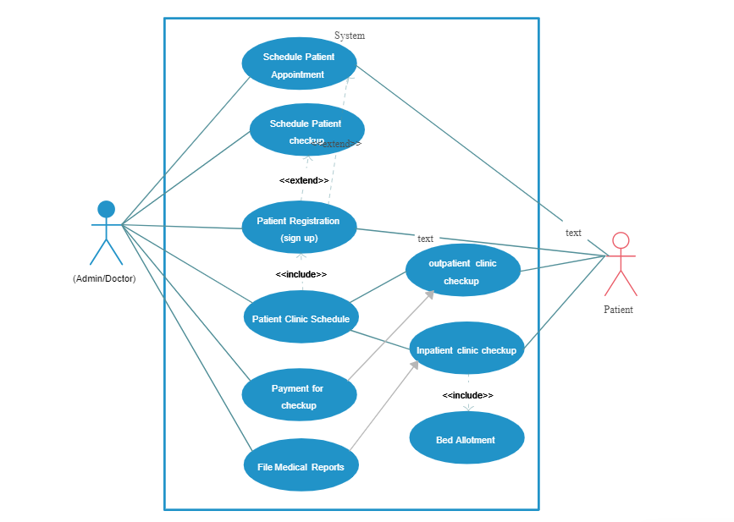

This is a broad level diagram of the project showing a basic overview. The users can be either doctor or patient. This System will provide a search functionality to facilitate the search of requirements. Further the hospital staff personnel can add/update the resources and the resource from the user.

Product Function
Entity Relationship Diagram of Hospital Appointment Schedule Management System

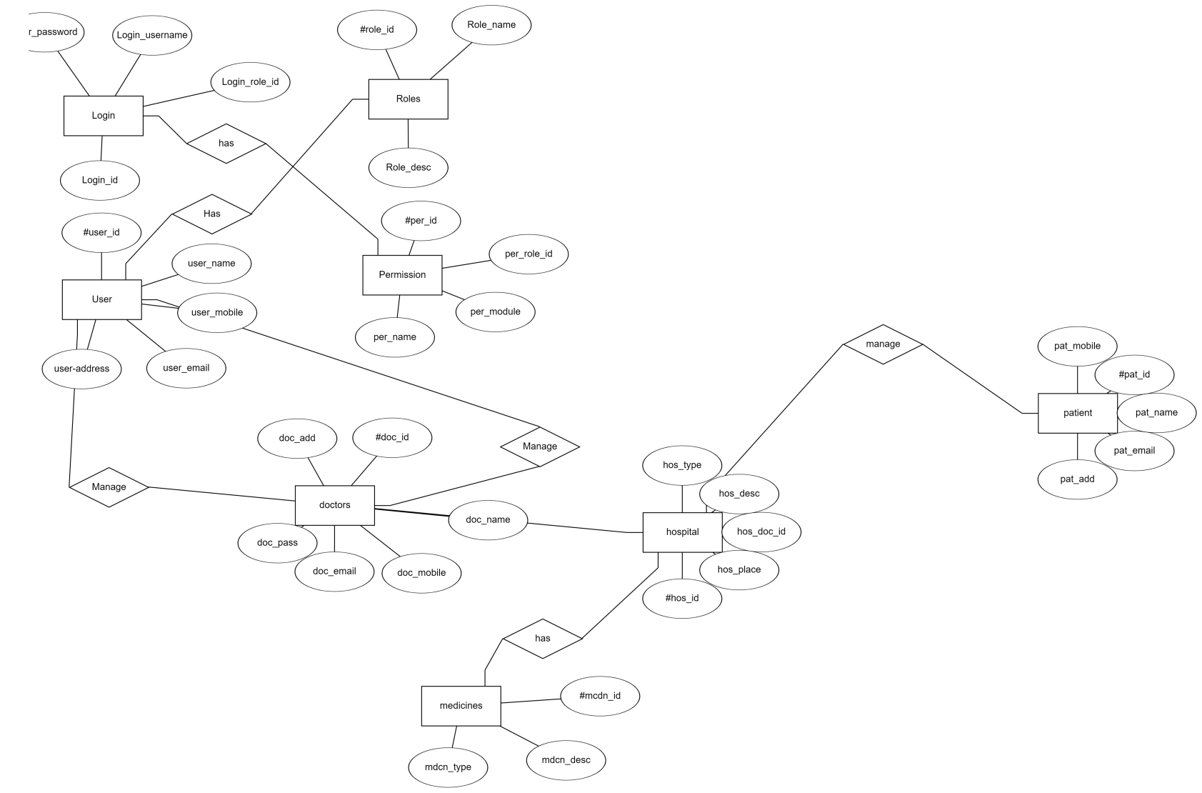

The Hospital Schedule Management System offers real-time online access to information regarding the scheduling of appointments and relevant user data. The primary objective of this project is to streamline and automate manual processes. The software effectively handles appointment scheduling, cancellations, and returns, while also managing calculations and records of fines. Various reports are generated to meet specific record-keeping needs. The administrative role, akin to a Librarian in the library system, is undertaken by hospital staff to oversee and control member access and schedule-related information. The system maintains a database of appointment statuses, and authorized personnel can retrieve patient details as needed. Valid patients can also access their appointment information through their accounts.

User Classes and Characteristics

The system provides different types of services based on the type of users [Patient/Hospital]. The Hospital will be acting as the controller and he will have all the privileges of an administrator. The patient who will be accessing the hospital online.
The features that are available to the Hospital are:-

- Creating and editing appointments
- Managing patient lists
- Sending appointment reminders
- Tracking patient history
- Creating and editing schedules
- Assigning doctors and nurses to shifts
- Accessing patient records
- Updating patient information
- Viewing patient medication lists

The features that are available to the Patients are:-
- Patients can view their upcoming appointments, including the date, time, location, and doctor.
- Patients can request new appointments online or by phone. They can select the doctor they want to see and the date and time that works best for them.
- Patients can cancel or reschedule their appointments online or by phone.
- Patients can view their past appointments, including the date, time, location, doctor, and notes.
- Patients can update their contact information, such as their address, phone number, and email address.
- Patients can access the patient portal to view their medical records, pay bills, and communicate with their doctors.

Operating Environment
The product will be operating in windows environment. The Hospital Schedule Management System is a website and shall operate in all famous browsers, for a model we are taking Microsoft Internet Explorer,Google Chrome,and Mozilla Firefox.Also it will be compatible with the IE 6.0. Most of the features will be compatible with the Mozilla Firefox & Opera 7.0 or higher version. The only requirement to use this online product would be the internet connection.
The hardware configuration include Hard Disk: 40 GB, Monitor: 15” Color monitor, Keyboard: 122 keys. The basic input devices required are keyboard, mouse and output devices are monitor, printer etc.

Assumptions and Dependencies
The assumptions are:-
- The coding should be error free
- The system should be user-friendly so that it is easy to use for the users
- The information must be stored in a database that is accessible by the website
- The system should have more storage capacity and provide fast access to the database.
- The system should provide search facility and support quick transactions
- The Hospital Schedule System is running 24 hours a day
- Users may access from any computer that has Internet browsing capabilities and
- Internet connection
- Users must have their correct usernames and passwords to enter into their online accounts and do actions.

- The dependencies are:-
- The specific hardware and software due to which the product will be run.
- On the basis of listing requirements and specification the project will be developed and run.
- The end users (admin) should have proper understanding of the product.
- The system should have the general report stored.
- The information of all the users must be stored in a database that is accessible by the hospital schedule management system.
- Any update regarding the patient is to be recorded to the database.

Requirement
Software Configuration:-
This software package is developed using java as front end which is supported by sun micro system. Microsoft SQL Server as the back end to store the database.
Operating System: Windows NT, windows 98, Windows XP Language: Java Runtime Environment, Net beans 7.0.1 (front end) Database: MS SQL Server (back end)

Hardware Configuration:- Processor: Pentium(R)Dual-core CPU Hard Disk: 40GB
RAM: 256 MB or more
- ld be correct.

Data Requirement:
The inputs consist of the query to the database and the output consists of the solutions for the query. The output also includes the user receiving the details of their accounts. In this project the inputs will be the queries as fired by the users like create an account, selecting appoinments . Now the output will be visible when the user requests the server to get details of their account in the form of time, date and External Interface Requirement.

GUI
The software provides good graphical interface for the user and the administrator can operate on the system, performing the required task such as create, update, viewing the details of the patient.
    - The user interface must be customizable by the administrator
    - All the modules provided with the software must fit into this graphical user interface and accomplish to the standard defined
The design should be simple and all the diffetemplate
    - The user interface should be able to interact with the user management module and a part of the interface must be dedicated to the login/logout module
Login Interface:-
In case the user is not yet registered, he can enter the details and register to create his account. Once his account is created he can ‘Login’ which asks the user to type his username and password. If the user entered either his username or password incorrectly then an error message appears.

Search:-
The patient can select the appointment he is looking for.

Hospital Control Panel:-
This control panel will allow librarian to add/remove patients; add, edit, or remove a resource. And manage lending options.

System Features
The users of the system should be provided the surety that their account is secure. This is possible by providing:-
- User authentication and validation of members using their unique member ID
- Proper monitoring by the administrator which includes updating account status, showing a popup.
- Proper accountability which includes not allowing a member to see other member’s account. Only administrator will see and manage all patients account.

Other Non-functional Requirements

4.1:Safety Requirement
The database may get crashed at any certain time due to virus or operating system failure. Therefore, it is required to take the database backup so that the database is not lost. Proper UPS/inverter facility should be there in case of power supply failure.

4.2:Security Requirement
    - System will use secured database
    - Normal users can just read information but they cannot edit or modify anything except their personal and some other information.
    - System will have different types of users and every user has access constraints
    - Proper user authentication should be provided
    - No one should be able to hack users’ password
    - There should be separate accounts for admin and members such that no member can access the database and only admin has the rights to update the database.

Requirement attributes
    - There may be multiple admins creating the project, all of them will have the right to create changes to the system. But the members or other users cannot do changes
    - The project should be open source
    - The Quality of the database is maintained in such a way so that it can be very user friendly to all the users of the database
    - The user be able to easily download and install the system

Business Rules
A business rule is anything that captures and implements business policies and practices. A rule can enforce business policy, make a decision, or infer new data from existing data.This includes the rules and regulations that the System users should abide by. This includes the cost of the project and the discount offers provided. The users should avoid illegal rules and protocols. Neither admin nor member should cross the rules and regulations.

Other Requirements

Data and Category Requirement
In the context of the hospital schedule management system, various user roles exist, including medical staff, administrative personnel, and patients. Access privileges are determined based on the user's role. For instance, administrators possess the capability to modify, delete, and append data within the system. All user roles, with the exception of medical staff other than doctors, have rights limited to retrieving information from the database. Additionally, diverse categories of scheduling information are present, each requiring specific data display formats. The system is designed to organize and present data in a structured manner, ensuring efficient management and accessibility based on the distinct categories of scheduling information.

Appendix
A: Admin, Abbreviation, Acronym, Assumptions; B: Business rules; C: Class ; D: Doctor,Data requirement, Dependencies; G: GUI; K: Key;H:Hospital ; N: Non-functional Requirement; O: Operating environment; P: Performance,Perspective,Purpose,Patient; R: Requirement, Requirement attributes; S: Safety, Scope, Security, System features; U: User, User class and characteristics, User requirement

Glossary
The following are the list of conventions and acronyms used in this document and the project as well:
    - Administrator: A login id representing a user with user administration privileges to the software
    - User: A general login id assigned to most users
    - Client: Intended users for the software
    - SQL: Structured Query Language; used to retrieve information from a database
    - SQL Server: A server used to store data in an organized format
    - Layer: Represents a section of the project
    - User Interface Layer: The section of the assignment referring to what the user interacts with directly
    - Application Logic Layer: The section of the assignment referring to the Web Server. This is where all computations are completed
    - Data Storage Layer: The section of the assignment referring to where all data is recorded
    - Use Case: A broad level diagram of the project showing a basic overview
    - Class diagram: It is a type of static structure diagram that describes the structure of a system by showing the system’s cases, their attributes, and the relationships between the classes
    - Interface: Something used to communicate across different mediums
    - Unique Key: Used to differentiate entries in a database

Class Diagram
A class is an abstract, user-defined description of a type of data. It identifies the attributes of the data and the operations that can be performed on instances (i.e. objects) of the data. A class of data has a name, a set of attributes that describes its characteristics, and a set of operations that can be performed on the objects of that class. The classes’ structure and their relationships to each other frozen in time represent the static model. In this project there are certain main classes

which are related to other classes required for their working. There are different kinds of relationships between the classes as shown in the diagram like normal association, aggregation, and generalization. The relationships are depicted using a role name and multiplicities. Here ‘Doctor’, ‘Patient’ and ‘Appointment’ are the most important classes which are related to other classes.

